

COMPONENT 3 project – Maze solver

14/05/2021



Contents

Analysis 3

Features 3

Identification 3

Implementation Limitations 6

Implementation Requirements 7

Computational Advantages 7

Stakeholders 8

Identification 8

Suitability 8

Research 9

`Maze Generation Algorithms and Visualizations` 9

`Visualizing Maze Generation` 10

‘MazeGeneration.net’ 12

Think Labyrinth: Maze Algorithms 13

‘Maze Generator’ 14

‘Huffman Coding’ 15

My Compression Method 16

Crucial Features and Limitations 16

Requirements 18

Implementation Success Criteria 18

Design 19

Problem decomposition 19

Core components 19

Component decomposition 19

The Maze 19

Maze Solutions 20

User Interaction 21

Problem Hierarchy diagrams 22

Solution description 24

Main Flow Chart 25

Algorithms and abstract data structures 25

Usability 29

Defining usability 29

Implementing usability 30

Testing approaches 31

Variable Table 31

Classes and data structures 33

Validation 37

Final Test Table 37

Development 39

Phase 1 (The GUI Design – Version 1.0) 39

Design 39

Evaluation 41

Phase 2 (The GUI Implementation – Version 1.0) 41

Design 41

Implementation 43

Testing 50

Evaluation 51

Phase 3 (The Maze – Maze Generation) 51

Design 51

Implementation 52

Testing 65

Evaluation 66

Phase 4 (The Maze – Maze Solving) 66

Design 66

Implementation 67

Testing 74

Evaluation 75

Phase 5 (The Maze – User Solution Verification) 75

Design 75

Implementation 76

Testing 100

Evaluation 101

Phase 6 (Data – Processing and Saving Maze Data) 102

Design 102

Implementation 103

Testing 141

Evaluation 143

Phase 7 (Maze Solving and Maze Generation and the Manual - Finale) 143

Design 144

Implementation 144

Testing 194

Evaluation 195

Bibliography 196

# Analysis

## Features

### Identification

The maze solver explores a specific area of computer science and mathematics and helps identify the advantages of using different approaches for different scenarios. Mazes can appear in a variety of different ways, long hall-ways, short hall-ways and even mazes so large that it would be impossible to navigate to solve by a human or to even identify that the maze is even solvable in a given life-time. This problem is addressed by these issues and solved using this project and proposes an understanding as to how different algorithms are used to develop solutions to complex mazes and algorithms which demonstrate the different types of mazes available. Furthermore, this type of project acts as an abstraction of real-life technology used today such as Google Maps and GPS which are used to navigate to a desired destination using the techniques involved in solving maze related problems.

The world is a perfect example of a vast maze which feels almost impossible to navigate without the assistance from maps or technologies such as the GPS. Maze solvers are very important to understand for topics which may not even be related to mazes, any problem involved in navigation would require knowledge of how maze problems would be tackled. For example, a graph is not necessarily a maze but are used in maze traversals and knowing how to traverse a graph makes it easier to traverse a maze too due to the similar ideas which they both share, the opposite applies, understanding how to traverse a maze would help with understanding how graph traversals work in mathematics and computer science such as for matrices and graph data structures.

There are specific elements which apply to solving this problem and they include:

* Path Finding Algorithms (DFS, BFS, A* and Dijkstra)
* Data structures such as graphs, stacks and queues
* Maze generation algorithms using recursion, pipelining and DFS
* Start node and end node indicating the start and end destination
* Selection for the choice of search algorithm and maze generation algorithm
* Visual feedback such as highlighting the start and end node and colouring the path which the algorithm has decided to take.
* Variables which can be changed at run-time so the user can use the software for their personal needs. Such as a slider to change the width and height of the maze and options to change the maze algorithms and search algorithm.

#### Features of the project:

1. start and end node
   1. Criteria: where the start node is searching for the end node, these will be placed somewhere by the user after the maze has been generated
   2. Justification: this typically simulates the idea of having a location where the user is located regards to a map and the end node which represents the user’s desired destination, similar to Google Maps and GPS.
2. An N by N matrix of cells
   1. Criteria: which will need to be constantly accessed once the maze has been generated in order to be highlighted once a path has been chosen by the algorithm, this can be done by storing the matrix inside an array which can then be accessed using iterations to edit and manipulate individual cells. Walls will be procedurally added to the matrix given by the chosen maze generation algorithm selected, this can be done by a simple iteration, defining whether each node is either a wall or a path. It will measure the time it takes to find the end node and the distance travelled in order to get to the node, which can be used by keeping track of the number of nodes traversed before it reaches the end node which can then be given to the user for their own personal reasons.
   2. Justification: This is needed because the user needs to be able a way of visualising the algorithms and storing this data in an array will allow for easy access to nodes and manipulate them based on the algorithm selected.
3. Generation of mazes and maze traversal
   1. Criteria: DFS, BFS, graphs and stacks, their implementation is necessary for this solution because they allow for back tracking to be used, allowing for an exhaustive approach, where worst case scenario, all the nodes are checked and there is no solution to the maze, where stacks and queues are good for maintaining an object’s state while it exists in another state which would override previous states. Predominately, this problem is computationally suitable because of the methods involved in maze generation and maze traversal including data structures such as Graphs, stacks and algorithms such as DFS, BFS and recursion which are typically used within maze related problems and are easily implemented using a programming language and the use of the computer’s resources makes the problem suitable for a computer to­ tackle such as RAM, Cache and the CPU. Computers can perform recursive methods to generate random mazes within seconds making the process of maze generation far faster compared to other methods such as human computation, methods such as recursion have a high memory complexity being O(n) where n is the number of function calls, which could possibly be the number of cells within the maze which is what makes a computer very useful for maze generation, for each function call during a recursive process a variable in memory is created in order to store the function, only until the recursive process finishes is the function finally called and freed from memory.­­
   2. Justification: This is needed because the problem being solved is to visualise maze algorithms and solving those maze algorithms with maze traversal algorithms. Furthermore, different mazes generations are needed because being limited to only one type of maze generation algorithm could seem futile if the user wants to see a specific algorithm visualised. Also, maze solving algorithms should vary because the user might want to also visualise a specific algorithm for the solving process.

1. Statistical Data
   1. Criteria: To provide the user with statistical data related to the maze solution.
   2. Justification: This would allow the user to identify the advantages of the different traversal methods when it comes to different mazes; since the data is digital they can use the generated data (times, distances, algorithms used, width and height) to quantify which algorithm is better. The times will be stored inside of a text file and can then be analysed by the user such as by plotting the data on graphs to determine the efficiency between the different algorithms, enough data will be provided to not limit the user to specific needs, opening the software to a variety of users. Prior knowledge such as back tracking will be an extremely important concept when implementing the solution to the problem, for example, it is going to be important when implementing the BFS and DFS since those algorithms will exhaust specific paths within the maze where there is the case where the chosen path is not the right one, which is where the stack data structure can be used in order to keep track of previous moves, pushing positions onto the stack and popping them if the chosen path was not successful in finding the end node. Rules can be securely implemented such as not passing over walls and finding the shortest path possible, clearly illustrating the importance of this type of simulation for real world applications such as a GPS or websites such as google maps. The user should be able to place the nodes only where a path exists and not on top of a wall.
2. Difficulty selection
   1. Criteria: give the user a clear idea of what each type of maze generation algorithm provides, such as the difficulty, ranging from easy, medium and hard mazes where the properties of the maze such as: lots of dead ends, no dead ends, lots of solutions and unique solutions will determine the difficulty of the maze.
   2. Justification: This will allow for a range of users to use the program without being held back by the fixed difficulty rating, they can choose between a range of algorithms defined by their difficulty to suit their needs and understanding.
3. Solution Verification
   1. Criteria: allow the user to enter their solution in order to verify whether their solution will solve the maze or not, a function will be used and will return a Boolean value representing whether the maze was solved or not.
   2. Justification: This will be necessary because if the user finds a solution which has not been identified, the user can now enter their solution providing the solution in the maze notation. This allows the user to interact and experiment with different solutions.
4. Visualisation toggle
   1. Criteria: Allow the user to choose between seeing a slow visualisation or just the finished solution. Which will be toggled by pressing a button where the slow visualisation will show a live update of the search process, where the other will provide the solution without any time spent slowly generating the highlighted path.
   2. Justification: This will allow the user to choose what they prioritise more because they might be more interested in seeing how an algorithm works or seeing the solution to the maze. Which extends the programs usability by making it suitable for a range of people using it.

### Implementation Limitations

The project however does have some limitations.

1. Maze dimensions
   1. Limit: the fact that the mazes produced will only be square-based and only 2 dimensional and some algorithms performed on the maze may only be suitable for smaller dimensions.
   2. Reason: This is going to be limiting because some users might want a maze which explores multiple dimensions. However, 3 dimensional mazes are harder to solve by human-means and is also hard to implement given the vast components that are already needing to be implemented. Therefore, it is certain that the maze will be constrained to only 2 dimensions. Simplifying complexity and the efficiency of the program.
2. Algorithm development
   1. Limit: It will also be limited to the fact that there is only so little time to produce and develop every possible algorithm, which can seem problematic if the user wishes to see the visualisation of an algorithm and can’t because the desired algorithm was not implemented.
   2. Justification: Due to the little time and the various different algorithms that are used to generated and traverse mazes it is going to be hard to implement them all. Therefore, I am only going to be implementing mazes which have different properties (long hallways, small hallways, lots of dead-ends, no dead-ends, etc…).
3. Memory consumption
   1. Limit: Some algorithms require extra memory to hold assist data structures such as in BFS and DFS and function calls such as in recursion. Therefore, the software will be heavily reliant on the user having sufficient memory available to be used. Also, some algorithms are very process heavy and will require a lot of cycles in order to fully complete which is limited based on the user’s processor where a better processor would benefit them. Algorithms such as recursion will require various cycles and could take a very long time for mazes which begin to scale past 100x100 cells. Therefore, it would limit the user to mazes of very small sizes and although I will give them the capability of changing the maze dimensions however they like to, it is going to limit what algorithms they can carry out for the reason of maintaining quality performance. Furthermore, as I have already discussed was the memory complexity of a recursive algorithm which is O(n) where n is the number of function calls stored in memory, where each function calls is respect to the number of cells in the maze. Therefore, if the maze is extremely large, say 100x100 the number of function calls could possibly be 10,000 and would consume memory extremely fast. Which it would most likely not be appropriate to perform recursive algorithms for large mazes dimensions and could be a possible limitation of the proposed solution, making it so recursive algorithms are limited to specific dimensions.
   2. Justification: Therefore, as a result of this limit I am going to prevent the user from using maze dimensions for specific algorithms, which is very limiting to certain users who have PCs which can handle such a process heavy and memory heavy process.

Finally, there could be some limitations related to the API being used to build the project because it could be difficult to implement certain aspects listed and they may not be support for certain features such as printing documents and live-updating for trying to display the algorithm process live, unless I implement an ISR-type (Interrupt Service Routine) approach where there are interrupts related to updating the screen every time a pixel has been updated, unless this is a feature.

### Implementation Requirements

**Data structures** are an essential part in this project and are easily implemented and managed using a programming language. Graphs, stacks and queues are essential for this project when it comes to representing the maze, scheduling BFS and DFS algorithms and manipulating the connected paths to find a solution to the given maze. Specialised structures like Graphs are a series of interconnected nodes which can be used to represent mazes. They are traversed by algorithms such as DFS. DFS works by selecting a node from the graph and traversing its child nodes until the target is found if the target is not found, it will then proceed to back track where it will perform the same process until finally either the target is found or no target exists within the graph.

**Computational Methods and Computational features** are essential for this project since the small problems involved such as generating the maze are going to be easily generated through the use of a computer. Easily abstracting the unnecessary aspects of the maze to speed up processing and performing things simultaneously such as timing to improve the usability of the project. Storing the data digitally makes easier to manage compared to physically as it can be lost and not as easily transferred to other software to compare the data. Furthermore, computers have a specific set of hardware components which can be used to increase the speed of this project. The Hard drive allows for the storage of data, RAM allows for temporary storage which is needed to store the maze matrix and node positions and other program variables, CPU allows for the processing of a large amount of instructions where the clock speed measured in Hz defines how many cycles are performed each second. These components which compose a computer are extremely handy for this project since the project is heavily demanding when it comes to computational power, for example, recursion which is easily carried out on a computer compared to other means, such as by hand.

Furthermore, I need to make sure that I carry out valid research when needed in order to carry out these tasks; Researching specified algorithms, UI design techniques, colour schemes to not only make the software functional, but to make the software pleasant to look at and easy to interpret and understand.

Finally, to allow the user to fully visualise the process, not to limit the user to something specific and to provide enough visual feedback and information where the user can fully interpret the algorithm in their own way. I also need to make sure that the client can specifically choose the data they want not to flood them with unnecessary information, for example, if someone wanted to determine the relationship between distance between nodes and the times, they wouldn’t want to have the width and height of the given maze stored in their file, since the text file is mostly going to be stored in a CSV format where it can be easily transferred to software such as excel to be graphically visualised.

### Computational Advantages

Tackling this problem using a computer compared to a human manually solving the maze would be a lot more accurate and time efficient compared to a human solving the maze and comparing times by hand, it is far better to use the computer’s specialised resources and brute force power which is required when implementing BFS and DFS searches since they tend to exhaust all possible cases until they have found one of many possible solutions. Since computers also have things such as cache in order to remember recently used parts of memory it will make recursive methods far more efficient since recursive approaches have calls to themselves making the cache very useful in this scenario. Furthermore, a large RAM is going to be required when executing recursive algorithms as the functions are going to passed into memory until they are finally called, filling up memory until the maze has finally stopped recursively calling itself which for mazes with large dimensions could take a long time and human approaches to recursive methods would be extremely time consuming since the human’s brain would not be able to execute this type of method. The use of a computer when tackling this type of problem is involved with how the computer has general features allowing it to specialise in dealing with large iterations. It has a GPU which is suitable for rendering the mazes to the screen and since it is a parallel piece of hardware it can render different things simultaneously. Furthermore, CPUs with high clock speeds allowing the algorithms to be performed with greater speed, carrying out the simulation a lot quicker than a human approach. Also, a computer allows the user to not only solve the maze themselves once they have been generated but see how they can be solved in different ways too without the need to solve the maze manually and possibly wasting time finding a solution that does not exist.

## Stakeholders

### Identification

The client is going to be a math teacher, specifically Mr Rees who is a maths teacher at Thomas Telford School. He teaches Sixth Form Mathematics and Further Mathematics and he would be a suitable client because he can provide information where the software could be used to be more suitable to a mathematician and define some preferred design features for the software that are appropriate for mathematicians. Also, the stake holders will be mathematics and computer science students. They would like to use it for analysing the complexity of the different algorithms as they could plot graphs, determining the nature of the curve and perhaps why the curve is behaving the way it does to identify the properties of the algorithm. Furthermore, many areas of maths can be applied for a maze solver such as the probability of locating the end node with no back tracking required or even the number of possible paths that can be taken before reaching the end node and computer science students can use the software to learn about the algorithms such as DFS and BFS needed for the computer science courses, understanding visually how the implementation should look, and it could also improve understanding of concepts such as recursion and backtracking.

### Suitability

Math teachers would be a suitable client since it would be suitable in expressing how there are different methods to approaching a problem and why these methods exist for different situations, identifying this will be suitable because this is to be explored by the mathematics and computer science students. It could be mathematically modelled to then used to predict the outcome of a maze of length n, width n for a selected algorithm to predict the time it would take to complete the maze. Computer science and maths students can also use the program to further understand computational methods such as in mathematics and understanding the application of mathematics in real situations or time complexity such as in computer science to identify the efficiency of the algorithm. Furthermore, this could be a great learning resource when attempting to visually understand specific algorithm implementations such as BFS and DFS. The intended end users would be anyone involved in mathematics and computer related academia as they would use it for their own research purposes and would help them understand because it abstracts the idea of how something like a GPS functions on a smaller scale.

The user will not be limited to what they receive so it can be suitable to their needs based on the particular information they will need. [1] `Maze generations: Algorithms and Visualizations` it was said: “Maze provides the experience of problem solving.”, “mazes assist anyone to calm down, make transitions and focus” and “Mazes particularly help children to develop skills such as: Planning and brainstorming various strategies, getting spatial representation and developing orientation”. These are all very important aspects of mathematics and is why a maths stakeholder is suitable for this project, topics such as matrices, coordinate geometry require a good sense of spatial representation of the geometrical shapes and to visually plan this out during the process of solving a maze can provide very helpful when tackling these types of problems.

Furthermore, mathematicians are always presented with a comprehensive exam where they have to read a piece of real-world mathematics and then apply mathematical skills to the given situation. For example, the situation could be related to anything, including mazes, where the mathematicians could benefit from this form of problem solving because it helps with developing problem-solving skills.

## Research

### `Maze Generation Algorithms and Visualizations`

This document explains the importance of maze generation algorithms and how they can be visualized. [1] “Binary Tree Maze Generator is one of the very rare algorithms with the ability to generate a perfect maze without keeping any state at all: it is an exact memory-less Maze generation algorithm”, which implies that this algorithm is far more memory efficient than the recursive approach. A binary tree is a data structure which is similar to a linked list where instead of pointing to only one other node, it points to its left and right side, which is why it is called a binary tree, two nodes are being pointed two and the structure is connected with other instantiations of its structure, main properties are considered that the memory for the data structure does not need to be contiguous since the data structure uses pointers to hold the address of its left and right nodes. This allows for the memory management to be a lot easier to because the nodes do not need to be next to each other since the address of the two traversable nodes are held within the structure. Making this data structure suitable to be used and important for the implementation because it has a maze-like structure where the left and right pointers represent two paths to be taken. Furthermore, since the tree does not have cycles meaning the tree will not have paths which intersect and many dead ends due to the many paths which are left, where there will only be one method of getting to the end.

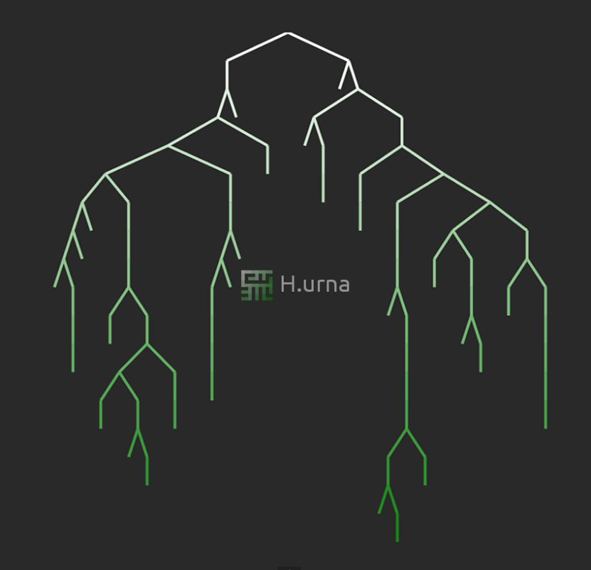

A clear visualization of the binary tree structure. [1] “Steps: For each existing cell in the grid: Get if they exist, north or west neighbours, toss a coin to connect with one of them”, It is outlining the basics of the implementation, needing to have a randomly number generator to randomly select adjacent nodes referring to the left and rights of the binary tree. [1] “There will never be a crossroads, and all dead ends have passages pointing down or right, and never up or left” this suggests that one type of maze is generated using the binary tree method and has very unique features which could be easily compared to other mazes where their dead ends and paths may vary. [1] “The Maze tends to have a strong diagonal bias” which is useful when testing the different types of algorithms as it could be explored which algorithm is best to approach a maze whose bias is towards diagonal hallways. [1] “Depth First Search (DFS) Maze Generator is a randomized version of the depth-first search traversal algorithm. Implemented with a stack”. Confirming that the stack data structure is going to be needed, it allows for back tracking if the path taken does not lead to the end node. I will be including the methods highlighted in this document as it confirms my current ideas and further highlights the binary tree data structure.

#### Java Code

[2] `Binary Tree | Set 1 (Introduction)`

Class Node

{

int key;

Node left, right

Public Node(int item){

Key = item

Left = right = null;  
}

}

This is the data structure of the binary tree and shows the two pointers left and right which are nodes which can also point to left and right nodes, traversals would traverse these left and right nodes until the node pointed to null, where back tracking could be used, using a stack, to return back and traverse down the other node left to be checked. I am going to include this in my project because it is a useful structure which shares features of other structures which are also going to be used and abstracts the maze into a chain of interconnected structures which are connected to form the desired maze. However, the document outlines an algorithm: [1] “Sidewinder Maze Generator is very similar to the Binary Tree algorithm” I want to avoid using methods which are too similar where the objective of the project is to identify and show different mazes with different properties to clearly identify how algorithms can solve different maze problems not the same ones.

### `Visualizing Maze Generation`

This article is a project related to showing how the maze generation algorithms work by highlighting the pixels as the algorithm is processing the maze. I would like to use this idea of highlighting the pixels live whilst the algorithm is being processed because showing a final image of the maze after the algorithm has processed it would not show how the algorithm is actually generating the maze and the user would like to see the process rather than the ending solution, so showing the maze whilst it is still being generated allows the user to understand to better degree of how the maze is actually being generated. [3] “In this first approach, the algorithm works in two stages: Generate the complete solution from start to finish then create decoy paths and fill out the rest of the available space”. This seems like an appropriate solution because updating the display whilst the algorithm is still processing will give the user live-feedback of what the algorithm is actually doing, however it would seem time consuming and could be too slow for mazes that scale past 100x100 cells. However, a second approach is outlined and links in with the previous document [1] `Maze Generation Algorithms and Visualization` where the writer introduces a better approach using graphs.

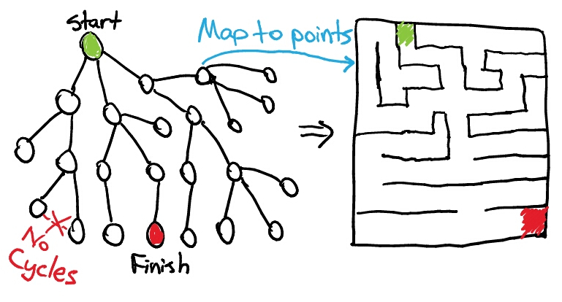

[3] An image from the document where it is clear how the graph relates to the structure of the maze. “If we restrict out graph to having no cycles, this representation becomes quite convenient. A graph without any cycles is equivalent to a tree structure.”. However, this is not a binary tree but a tree with varying amounts of pointers. This is still just a graph but the graph does not have connections between child nodes from different parents. “Selecting the solution can now be done more robustly because all the information about the entire maze is available for use”. Storing the maze within a structure makes it a lot easier for the maze generation algorithms to find their solutions because I would now have a structure where everything about the maze is present. This is convenient because I want to have each cell of the maze easily accessible so I can change their state and colour whilst the program is being run. Furthermore, we can choose where the start and end node exist on the tree, making it so we can calculate the distance between the two nodes on the tree and give the user the choice to place the start and end node. However, the start node in this project is fixed and cannot be moved meaning I will need to find an alternative method when using graphs to traverse from the start node given at any point from the maze, not just the point at which the maze was generated. I can work around this by making it so the start and end nodes are separate from the graph and are their own individual objects. Once placed, their coordinates relative to the maze can be accessed and used to simulate the search between those two nodes on the tree.

### ‘MazeGeneration.net’

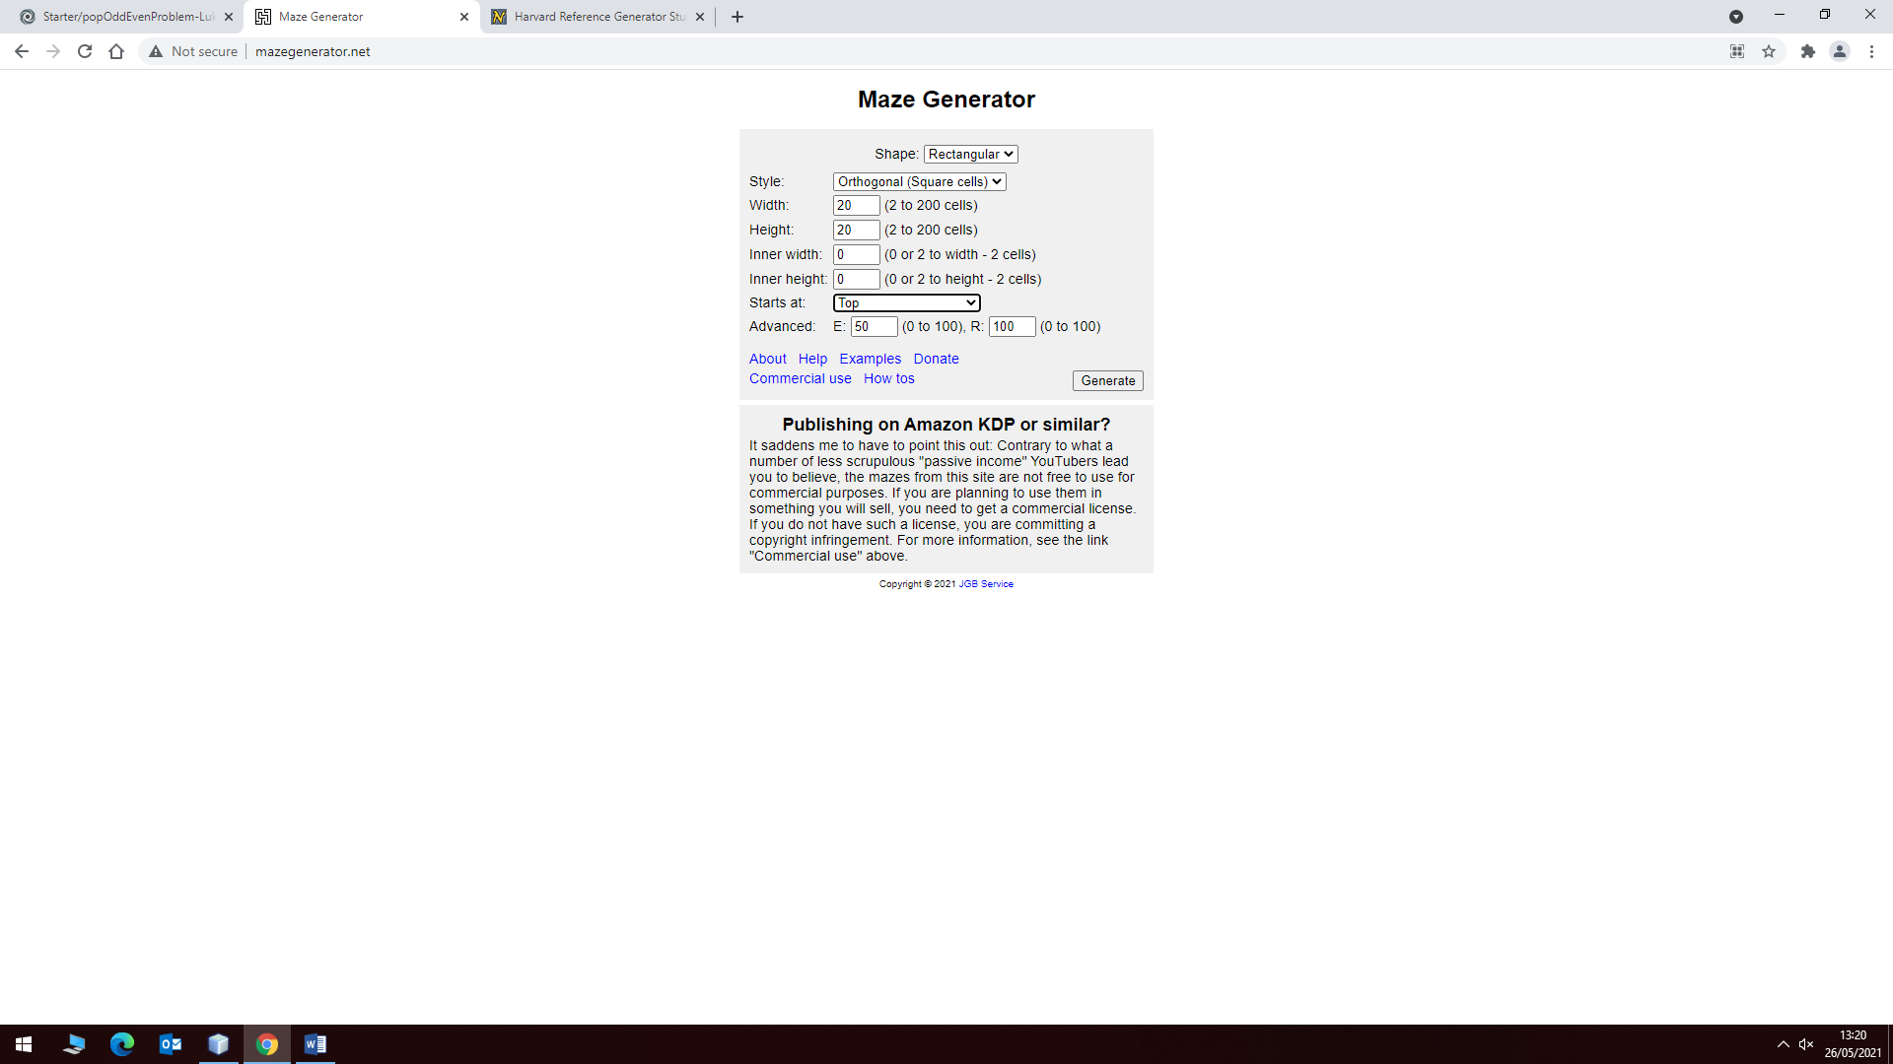

This is a website which displays the maze and the solution to the maze extremely quickly. It allows the user to change the shape of the maze being: square, circle, triangle and a hexagon. However, it does not display the method of traversal or show the traversal, only a simple line showing the path the traversal method had taken in order to solve the maze. This could be a useful implementation because the user might just be interested in seeing the solution to the maze rather than the entire traversal process. Therefore, it is useful to consider that the project has a feature to decide whether to display the traversal or to show each step of the traversal from cell to cell. Furthermore, I really like the idea of different maze shapes because not all mazes are square, however it is something I am going to avoid in order to reduce complexity of the initial solution. Also, the software allows the user to customize the dimensions of the maze and the size of individual cells themselves defining width, height, inner-width and inner-height, which seems like another feature necessary in order to avoid preventing the user from full customizability and it also gives the user the choice of printing off the maze, which also seems necessary because the user cannot complete the maze when the maze is not physical, therefore it is also a possibility that this idea will be translated to my project.

It provides the option to change the location of the start node, where the algorithm starts but it does not give full customizability to the user, it only provides the user with top and bottom of the maze and it is not very clear what some of the text boxes do, such as E and R where it is not very clear what is carried out when these values are changed, more applicable names would help the user to understand the functions of these two areas. I would need to make sure that I have clearly named buttons and labels so that it is easy to understand what things do within the program, although the software is going to be aimed towards mathematics and computer science students, that it is easily understandable by them by not implying that they know what certain things are such as E and R used in this example.

### Think Labyrinth: Maze Algorithms

The article has sections to outline the different types of algorithms used to generate and traverse mazes. Where it categorises them into sections given by: [5] “Dimension, Hyper-dimension, Topology, Tessellating, Routing, Texture and Focus”. “The dimension class is basically how many dimensions the Maze covers” Where my maze will only cover 2 dimensions making a 2D dimensional maze. Hyper-dimensions will not be explored in the project because they require 3D techniques to create as it is making the start and end nodes appear 3 dimensional. “The topology class describes the geometry of the space the maze as a whole exists” which will be a standard topology being a maze which does not have any abnormal features, it will simply have the conventional features of the maze. “The tessellation class is the geometry of the individual cells that compose the Maze.” Where my maze will simply cover the 2nd dimension only, it will have perfect routing which means that the maze will not have any loops which is where the unclosed graph data structure will be used. I like how the article outlines the different aspects for a which a maze can be composed of and helps to really identify where my mazes fit within conventional mazes. Most importantly about the article is that it shows desired statistics relating to the algorithm in use.

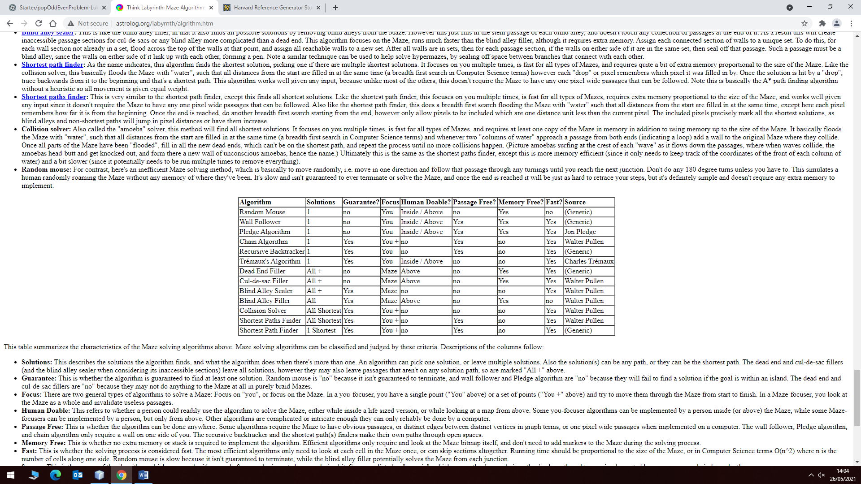

It defines the number of solutions provided by the choice of maze generation algorithm. Whether a solution to the maze is guaranteed, human doable, passage free, memory free and if the algorithm is fast. The information being provided on this website shows that statistics such as these are important and should be implemented and provided to the user when they are using the software. The number of solutions should be presented in order to prevent wasting the person’s time and whether the maze is even doable. Therefore, I am going to implement the accessibility to data related to algorithm efficiency for both traversal and generation algorithms. [6] here the writer talks about how to create interesting and difficult mazes defining the important features being: [6] “Size Ratio”, “Solution Count”, “Loops”, “Curves” and “Repetition”. Creating a maze with a larger size ratio is going to be harder to solve because there is more area of the maze for which you could possibly find yourself lost within.

A smaller solution count will make the maze harder, more loops will make it easier because this will extend the number of solutions because paths become intersected within each other therefore making less dead ends to get lost in, repetition can be misleading however because mazes which repeat can make it easier to traverse or make it harder to traverse because there is no unique landmark to identify and help gauge the solvers surroundings, assuming the solver uses the maze layout in real life.

Therefore, it would be a good idea to implement a difficulty margin where these factors are to be taken into consideration. Algorithms will have certain properties making them easier or harder to solve. Also, I really like the idea of using solution notation to identify a more human readable maze solution, for example, “L4U2L4U4R5D2” would indicate a series of moves which should be taken to solve the given maze where ‘L’ means ‘Left’, ‘R’ means ‘Right’, ‘U’ means ‘Up’ and ‘D’ means ‘Down’. I would like to add this in if the user wanted to have an instructional approach to solving the maze. Furthermore, you can use the notation to reverse a solution to a maze which could be used by the user if necessary. A record of all possible solutions can be listed in this format to identify the different ways of solving the given maze and which is the best solution where it would be the least number of moves.

### ‘Maze Generator’

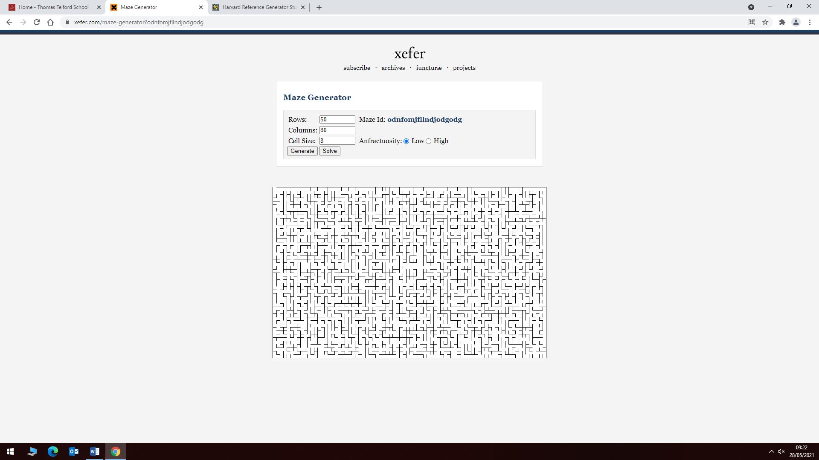

This is a website which has very basic features however it has a feature that stood out to me and would be very useful, Maze Id. Which uniquely identifies the maze, generating a unique URL where anyone can go to in order to access the same randomly generated maze. This seems like a useful feature which could be implemented because if within the included statistics the data does not have a corresponding maze to go along with it, it is going to be hard to randomly generate the same maze again. Therefore, having a method of uniquely identifying the maze, this maze could be saved within as a simple readable file format containing the width and height of the maze and numbers which can be interpreted as binary to determine between walls and paths which would make it less storage consuming if a lot of mazes are being stored on the user’s computer. However, the unique string could be compressed and stored in a file to reduce storage consumption even further using Huffman coding or other techniques in order to save space on the computer. For example, a string could be compressed and then uncompressed to unveil a string consisting of the width, height, and the pattern of the maze where the pattern could be presented in terms of numbers to save more space.

### ‘Huffman Coding’

Huffman coding is a method of compression which I want to explore as a result of the Maze Id method in order to save space on the user’s computer. The compression algorithm method is outlined by the article [8] ‘Huffman encoding’ where it says “Huffman coding assigns codes to characters such that the length of the code depends on the relative frequency of weight of the corresponding character” where the codes are then placed within a binary tree where once the decoding process is being performed the tree is traversed in order to located the letter corresponding to that specific code. Higher frequency letters have smaller length codes assigned which is what makes the compression algorithm work.

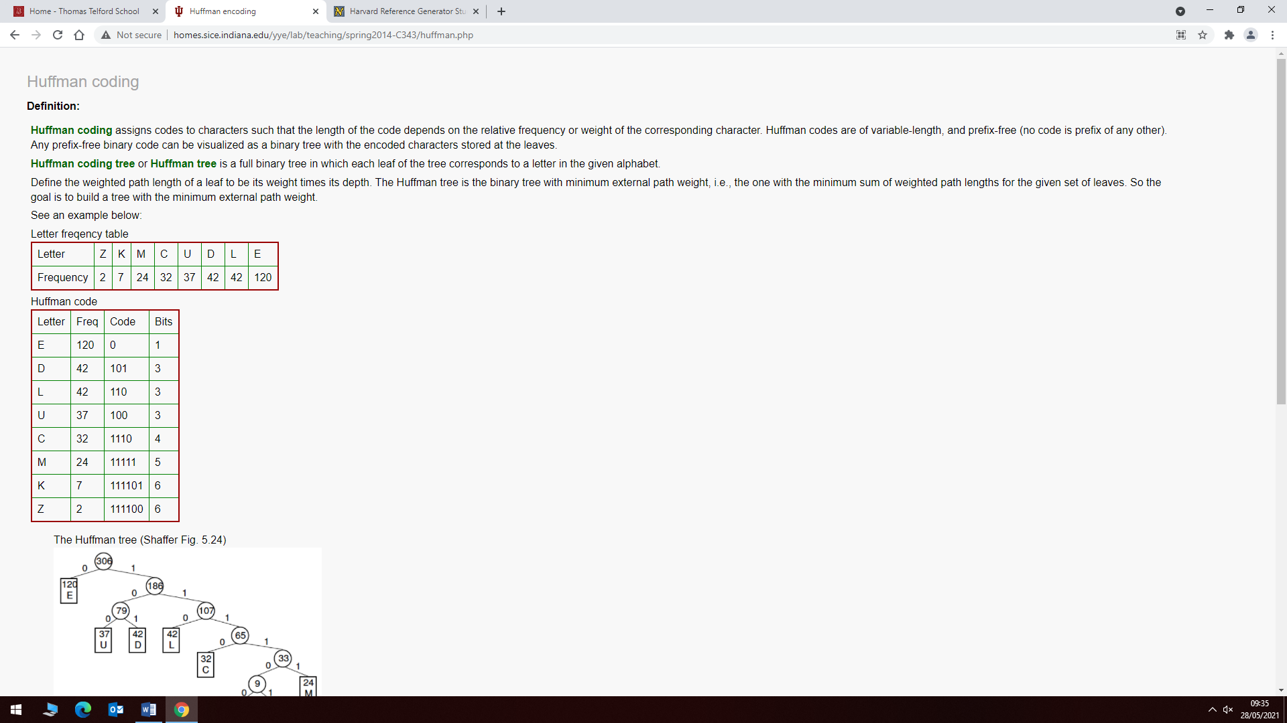

The table above shows an example of how the Huffman coding would work for a document consisting of the letters shown in the table. For example, “DEED 10100101” where the letters were replaced with their code equivalent and instead of occupying 4 bytes it now occupies 1 byte.

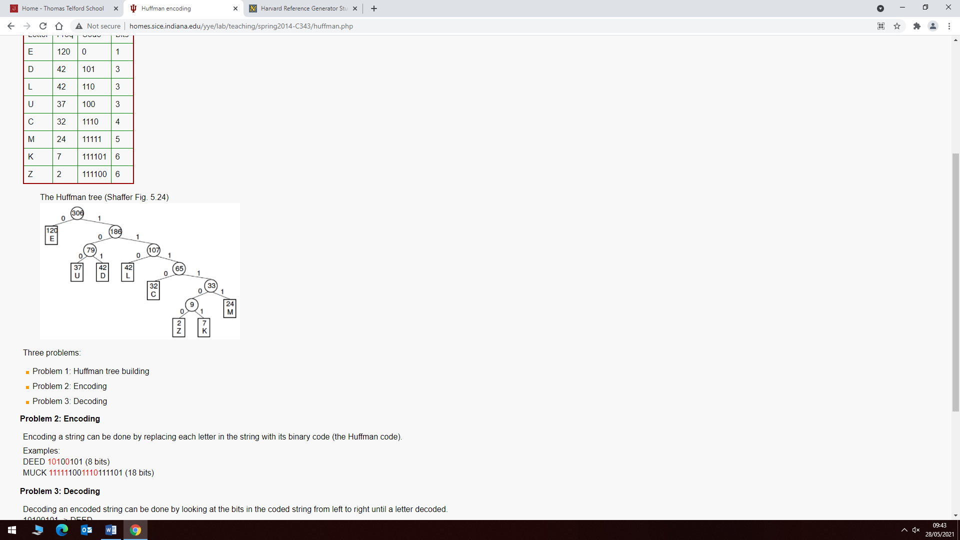

This is the binary tree for which is used in the decoding process. For example, using 10100101 would return ‘DEED’ which was the original word before the compression was performed. I want to use this in order to save space on the user’s computer when handling the unique ids for the mazes saved on the user’s computer. This is suitable because it also shares some features of the required solution as both require tree’s in order to carry out the task, which would be helpful when trying to develop an understanding of the tree data structure.

### My Compression Method

A method which can be used instead of Huffman coding which is more efficient in relation to the data which may be stored. This method is more suitable for the compression of a maze. However, the problem is addressed by this: If I want to store the maze, how will I represent the maze?, well I can represent the maze as characters where each wall is a ‘#’ and each path is ‘-‘, where each character is 1 byte where the number of bytes consumed will be very large assuming that the user would have dimensions which are very large. However, an alternative method is to use long integers which have a width of 64 bits, where the bits inside the number represent whether on that row where the walls and paths are, storing these inside a file as their decimal equivalent can reduce the size but the constraints of the maximum size would have to be reduced to 64x64 because it would be hard to represent a row of a maze any larger given a long integer. Storing the data in its hexadecimal format will reduce the number of bytes consumed and would compress the file a lot better compared to storing the data using ‘#’ and ‘-‘.

### Crucial Features and Limitations

Therefore, the various solutions researched share many features and features which differ but also extend the usefulness of the proposed solution:

* Data Structures such as: Stacks, Graphs and Trees
* Backtracking
* Visualisation
* Search choice
* Algorithm statistics
* Customizability

These features are shared frequently between the proposed solutions analysed and clearly outline the essential properties of this kind of solution.

Therefore, I am going to use these ideas for the solution, a large container of cells will be placed in the centre of the frame where the maze will be located this will be implemented using an array of N by N cells where each cell will represent a wall or a path, the wall and the path will be an abstract data structure I will create called a Cell which will contain an integer. The bits of the integer will represent the state of the cell where I can use an enum to help identify the states of the integer, for example I will have an enum called CellStates which will be powers of 2 where I can set the bits of the Cell Integer to determine whether the Cell is a wall or it is visited etc, this is a necessary implementation because in order to display the visualisation I need a set of cells which can be manipulated to represent a maze. By making the state an individual integer it will improve the memory complexity of the cell structure and will reduce the memory consumed by the program.

I will also make sure I have uniquely named buttons will be placed on the bottom of the screen prompting the change of width, height, search algorithm, maze algorithm, node position, end position where the user can freely customize under some constraints, due to the limitations listed previously, the user will be limited to using certain dimensions when certain algorithms are selected in order to prevent stack overflows and to make it more accessible if the user doesn’t have the system requirements because certain algorithms require a lot of memory to operate such as a recursive maze generation algorithm, which could possible crash the program if too much memory is being occupied, this will be implemented using calls to the swing API in order to create these buttons and place them within the frame.

Also, Backtracking is a necessary feature when implementing any of the algorithms where the stack data structure needs to be used. This will be implemented by creating another abstract class called a stack, whose attributes will be an array and methods will consist of popping and pushing elements to the dynamic array. Where the last element added will be popped when the pop function is called and elements will be pushed on the end of the stack.

The user can select what type of data they want to be stored when carrying out the searches where the data will be saved to a file named by the user and placed on their computer, the same directory as the program, this will store the information that the user has chosen and in a separate formatted file, if the user wants to save the mazes, a compressed version of the mazes will be stored in a separate file. Visualisation will be optional for whether the user wants to see the process slowly or instantly, where the user would prioritise the solution over the process, this would be implemented using a button which toggles whether the user wants a visualisation or not and will be visualised by highlighting the cells within the maze.

Compression is also a desired feature for the solution due to the way the mazes might be stored on the user’s computer mentioned previously and this will be achieved by using Huffman Coding where another abstract data structure will be needed called a Binary Tree which will store the frequencies of the letters or words in and transfer them into a smaller sizes, typically into a binary format where words which are bytes long are now compressed to bits instead and this will be used because storing the entire matrix data for the maze would be very storage heavy as more mazes are saved on the computer. This will be stored in a compressed format which can be interpreted by the program.

I will also be implementing the human-readable maze notation where, similar to something like count down, all the solutions will be listed and given in the maze notation. The maze notation denotes the directions needed to be taken in order to complete the given maze. This would be useful because having to wait through all the visualisations to identify possible solutions could be time consuming where this program is meant to increase the speed of solving such mazes therefore this would provide useful for its purpose. This will be implemented by exhausting every possible path until there are no more unique paths to be taken where algorithms such as DFS can be used in order to provide all possible solutions. However, I have abstracted the program to be limited to very specific mazes, where the real world is not formulated by these algorithms and cannot represent real life like Google Maps can, Google Maps is a fully developed, useful and professional solution to this type of problem because people use it all the time. It helps navigate to everyday destinations and my program will not have implemented methods to traverse real places, only mazes generated with algorithms selected.

## Requirements

The user when using this software will have to have a lot of RAM such as 4-8GB, especially when handling larger mazes such as NxN > 10^4 Cells because recursion can cause a stack overflow which will cause the program to crash. In order for the software to perform as expected the CPU should have a clock speed of minimum 1.8 GHz. GPU is not essential but a graphics card with a high clock speed such as 215 MHz should be suitable to run this program. Also, the user should have a Java Virtual Machine installed in order for the program to be understood on their system. Furthermore, the user should have a reasonable amount of storage if they want to save the mazes onto their system, they would need minimum 50KB of storage available on their system where the minimum would be to save ~50 mazes on their system with the given compression.

## Implementation Success Criteria

I have spoken to my client (Mr Rees) and have agreed and generated a basis of the program’s possible features and features that should also be included:

1. An N by N matrix of cells which represent the available path (white) and the walls (black), where the traversed path will be highlighted (red), where the start and end node will be highlighted in green at the top-left and bottom-right of the maze. This is important because the matrix will store the maze, which is to be traversed by the maze algorithms selected by the user.
2. There will be statistical data generated after the maze has been generated and can be optionally saved onto the user’s computer on a file specified by the user.
3. There will be an option to test a human-generated solution to see if the solution is valid for the maze generated.
4. The mazes generation algorithms will range in different properties such as: long hallways, short hallways, dead-ends, no dead-ends, etc…
5. The program will use Huffman coding in order to reduce the storage consumed if the user decides to save the mazes onto their computer. However, this is a volatile idea because assuming it is agreed that the user is not going to want to solve a maze large than 64x64 size. Then an alternative integer compression approach can be used which is far more efficient than the Huffman coding approach for this type of data (maze). This method has been explained more in depth in ‘My Compression Method’.
6. There will be maze notation which defines a readable version of the maze solution for which a human-generated solution can be entered for verification.
7. Layout consisting of the maze to be centred in the frame and the options to be displayed underneath the maze.
8. Option to choose between live visualisation or instant solution if the user cares for the solution rather than the algorithmic process.

# Design

This is the overall design of the project and will easily be changed based on general development and client feedback.

## Problem decomposition

Firstly, the program is to be split into smaller components which can be turned into procedures and classes to help break down the problem.

### Core components

Here are the core components which will need to be broken down into smaller problems to be tackled:

* An N by N Maze
* Start Node and End Node
* Maze Generation
* Maze Solution
* Statistical analysis
* Solution verification
* Solution visualisation

### Component decomposition

### The Maze

#### The N by N matrix

**Explanation**: This can be broken down into cells which make up the individual paths and walls which compose the maze. These cells will be made a structure (class with public attributes) which is composed of an integer which represents its state in the maze and a panel object which will be used to render the cell to the frame, as mentioned previously this will work alongside an enum containing powers of 2 to access the bits of the integer, this will be used to toggle the state of the cell in the maze. The matrix will then be composed of N by N cells which are stored inside an array which can then be iterated over in order to toggle state and generate the maze. Making this a structure compared to a class with private attributes will reduce the time spent calling getters and setters on the object. The Cell class will not have any member functions, it is only created to represent a path or a wall in the maze.

**Justification**: This needs to be decomposed in order to simplify the developed, this is useful to decompose because now with the Cell structure I can use it in other aspects of the project such as representing the start and end node. Furthermore, it simplifies the maze into nodes which can be handled individually and stored contiguously.

##### Start and End Node

**Explanation:** This can also be broken down into cells where a specific bit within the integer will represent whether that cell is the start or end node. Cells will not need to store their position because their position is based on their index within the array they are stored. As previously said for the matrix, these cells will be composed of a structure with the same attributes. These can be identified by using a power of two from the enum within the integer to represent the start and end nodes of the maze.

**Justification**: Since the start and end nodes are amongst two cells of the N by N matrix, they will need to share similar features of the matrix and will therefore include the Cell structure, they add additional functionality to the Cell structure by adding an extra macro to the enum in order to identify the start and end node within the matrix. This will help prevent time in development of another structure to and will allow it to be stored within the matrix of cells and be accessed in the shared matrix array.

### Maze Solutions

#### Maze generation

**Explanation:** Maze generation will be composed as a procedure which will take the array of cells as an argument. Where the algorithm will set the state of each cell regarding whether the cell is a wall or a path based on the algorithm chosen. The algorithms will be procedures to increase usability throughout the program because functions will need to be called for different operations when the user has chosen to call them and to make the code more readable and easier to manage when the program gets bigger. The different algorithms will be procedures as they do not return data.

**Justification**: The Maze generation algorithms need to be procedures so every instance where the algorithm needs to be used can be inserted with a call to the procedure. This saves time and prevents time wasted fixing the same bug, where it now only needs to be fixed in one location. Furthermore, this allows the problem to solved using computational methods such as procedures and functions.

#### Maze solution

**Explanation**: Maze solutions will be composed as functions which will take the array of cells too as an argument. Where the algorithm will start at the start node and will traverse the paths in order to find the end node which will return whether a path was found and assuming the user didn’t want to see the visualisation of the algorithm or not, will be prompted with either a path to the start and end node, or a warning that the maze did not have a solution or could not find one.

**Justification**: The maze solution will be functions because they will return whether a solution to the maze has been found or not (Boolean). This is suitable for computational solutions because it consists of iteration and heavy memory consumption which only a computer can possibly handle. Recursion is an example of a method of maze generation which will consume a lot of memory, performing recursion with other methods besides computational would be very inefficient and very time consuming.

#### Solution visualisation

**Explanation**: If the user wants to choose between seeing the visualisation process vs just seeing the solution, the user can toggle the visualisation setting, this will be a simple procedure which is implemented which will slow down the process of the algorithm to either solve the maze slowly or instantly. This can be broken down even further into a colour algorithm which will set the cell colour based on the path the algorithm has taken. This will be a simple procedure which would take the current index and the array and can be used to simplify the solution visualisation procedure.

**Justification**: The solution visualisation will be a procedure and will be used to display the solution onto the maze, it will be visualised slowly or fast based on how the algorithm performs, it will be integrated into every solver and will be a standalone procedure and will be called to change the state of the cell being traversed. However, if the user only cares about the solution rather than the process, this will be a procedure which can be called once the algorithm has generated a valid solution.

**Component Decomposition Justification**: The process of diving the solution into smaller problems makes it more organised and makes the problem easier to tackle compared to thinking of the problem as a whole. It saves time by turning certain problems into smaller problems which can be solved by computational methods and also highlights how the problem is solvable by these methods. Breaking down these problems into classes, procedures and functions converts the problem into something which is programmable, easier to manage and understand.

### User Interaction

#### Statistical analysis

**Explanation**: Statistical analysis will be built into the maze solution algorithms and will be subroutines which are called within the maze solution process. The statistical analysis will be a procedure which will write data to file if prompted or pass the data to a console where the user can see the data related to the current maze search. This can then be called within each maze solution algorithm which will reduce time spent programming the same statistical algorithms in each maze solution algorithm.

**Justification**: This will save time writing the same sequence of commands for every occurrence of the algorithm and helps with fixing bugs if and when they take place. Furthermore, by turning this process into a procedure it helps if the procedure is needed anywhere else. The statistical analysis section will be a method of saving data to a file and will allow the user to create a new file or to overwrite existing data on a currently used file with the data they wish to save.

#### Solution Verification

**Explanation**: If the user wants to solve the maze manually and the algorithm has not generated a solution that the user has found, the user can pass their solution into a text-field using maze-notation. This solution verification algorithm will be a function which will return a Boolean which will suggest that the user has found a valid solution or not. The verification process could also call a solve function to display the process visually so the user can see why their solution was right or wrong for the maze. There will be a function which will verify the given solution by interpreting the maze-syntax supplied by the user and converting it into a traversal through the maze to see if the maze was completed or not.

**Justification**: The solution verification will be a function because it will return whether the solution was valid or not in terms of a Boolean expression. This will be handy when the function is needed in many locations because a call to the function is needed instead of re-writing the same sequence of commands.

## Problem Hierarchy diagrams

This is the hierarchal structure of the project and splits the program into 3 main categories.

1. The Maze
   1. This is involving anything which makes up the maze, which it is composed of an N by N matrix where the N by N matrix is composed of cells. A cell is a structure (class with public attributes) which will be used to represent a cell within the matrix.

The Cells create their own structure consisting of a Cell Class which represent 4 different types of cell: Wall, Path, Start and End node.

1. Maze Solution
   1. This involves anything related to managing the cells within the maze and how they are edited and traversed in order to solve a maze.
      1. Maze Generation involves anything related to how the cells are manipulated in order to create a maze, this will be composed of many different maze generation procedures, for example, a recursive maze generation algorithm.
      2. Maze Solution involves in how the maze generated will be solved, this will be composed of maze solving functions which will return whether there was a solution to the maze or not. For example, A* Search Algorithm where if there is no clear path from the start node to the end node, false will be returned.
      3. Solution Visualisation is how the solution is presented to the user, this will be integrated within the Maze solutions but will vary based on how the user wants the solution to be presented. For example, the user might just want the solution to be presented quickly with minimal visual feedback during the solving process or slowly where the pixels are updated live whilst the algorithm processes the solution.
2. User Interaction
   1. This consists of making ways the user can interact with the program and other ways the program provides feedback to the user. This involves statistical data which can be analysed and saved on the user computer and a way to verify human generated solutions for a given maze.

The statistical analysis and solution verification can be broken down further into their core procedures and components. Statistical analysis will contain methods the user can store useful data within a file and have the ability to alter the data which will be saved. Solution verification contains a syntax parser which will read the maze-syntax and interpret it into a solution to solve the maze. The solution display will display the solution provided by the user given that the solution is valid. The Valid Solution Checker will be used to determine whether the solution is valid and should be displayed or not.

## Solution description

This section will outline the essential algorithms and data structures which will be used in the solution to the problem.

### Main Flow Chart

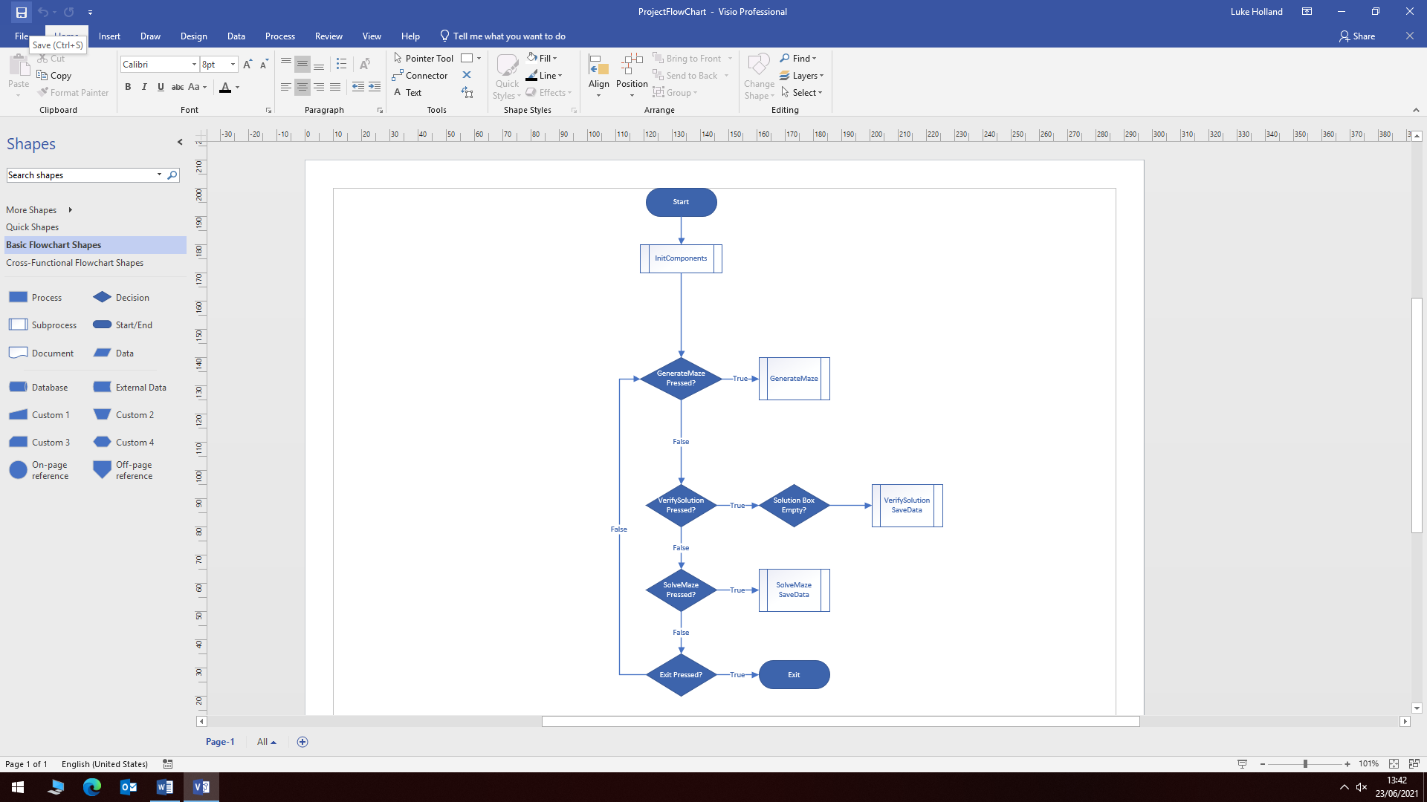

This is the main structure of the program, where the three branches represent the state of a button press. If each of the buttons are pressed, sub-routines are called, a while loop is given to constantly check the state of the buttons until the exit button is pressed where the program is exited.

### Algorithms and abstract data structures

#### CreateMaze and Cell Object

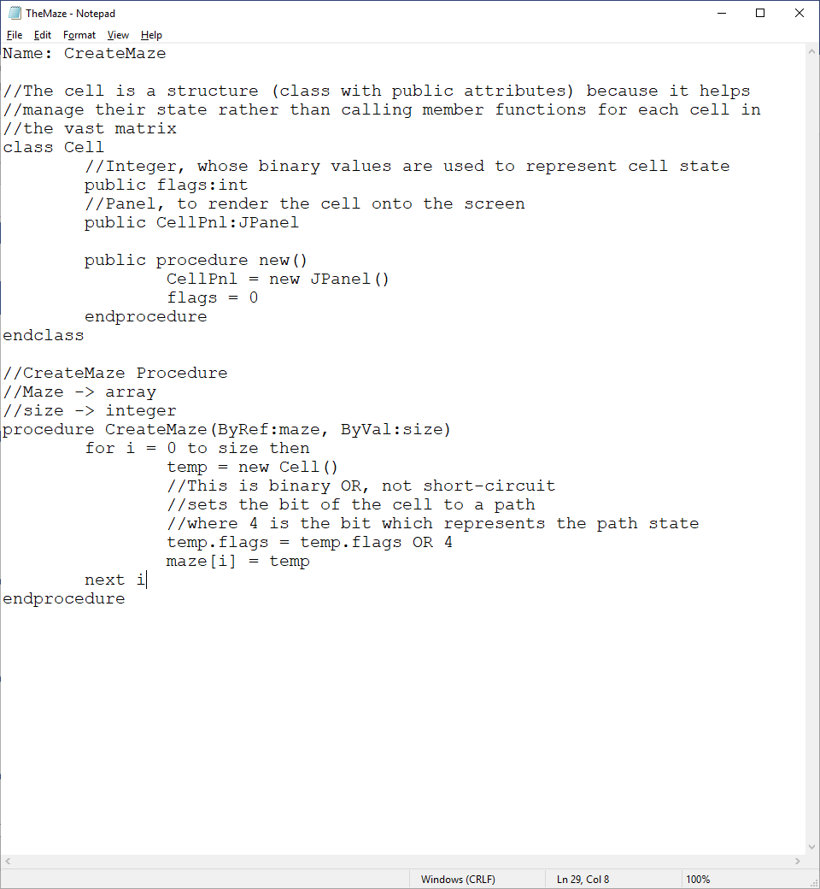

**Explanation**: Here is the pseudocode involved with filling the array with cell structures. This is used to store the cell structures into an array which will be used to represent an empty maze. The Cell Object is a class which is defined with two public attributes called flags and cellPnl where flags represent the state of the cell and cellPnl is a JPanel object which is used to render the cell to the screen. The algorithm creates a new cell and sets the 3rd bit of the 32-bit integer on which will represent the path state of the cell, then the cell is added to the maze. This algorithm is required because it will turn the maze into a manageable array of cells which can be manipulated by the maze traversal and maze generation algorithms.

**Justification:** This is needed in order to handle the maze in terms of manageable cells which maintain state and can be displayed in a window. The CreateMaze procedure is necessary for initializing the maze with all the cells for the given dimensions, where size is the product of the width and height of the maze matrix.

#### VerifySolution

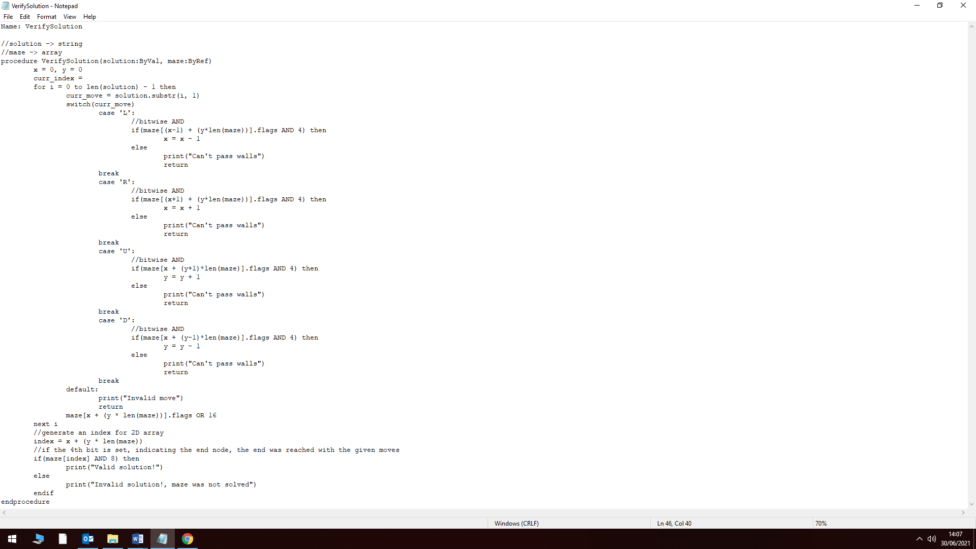

**Explanation**: This procedure will accept a solution string in the maze-solution syntax which will be parsed by the algorithm, testing to see if valid moves were made, it takes advantage of the Cell class which was defined, it checks the moves within the string by looping through each character, each character should represent a direction: left, right, up or down. If the direction is valid being it traverses a path, not a wall, then the algorithm will proceed until the series of moves have been exhausted, otherwise the algorithm will return control to the main area and tell the user that the move they chose was invalid. Furthermore, the algorithm will increment the x and y coordinates to see if the user eventually locates the end node. Also, the algorithm will set the current position will be set to a traversed cell and will be highlighted with a colour to indicate it was traversed. The 5th bit will be set which indicates the cell was traversed.

**Justification**: This is to be called when the user has entered a solution into the solution text field and wishes to verify their solution. This procedure will present the user with a visual representation of their search attempt and will see if the attempt was successful or not.

#### SaveData

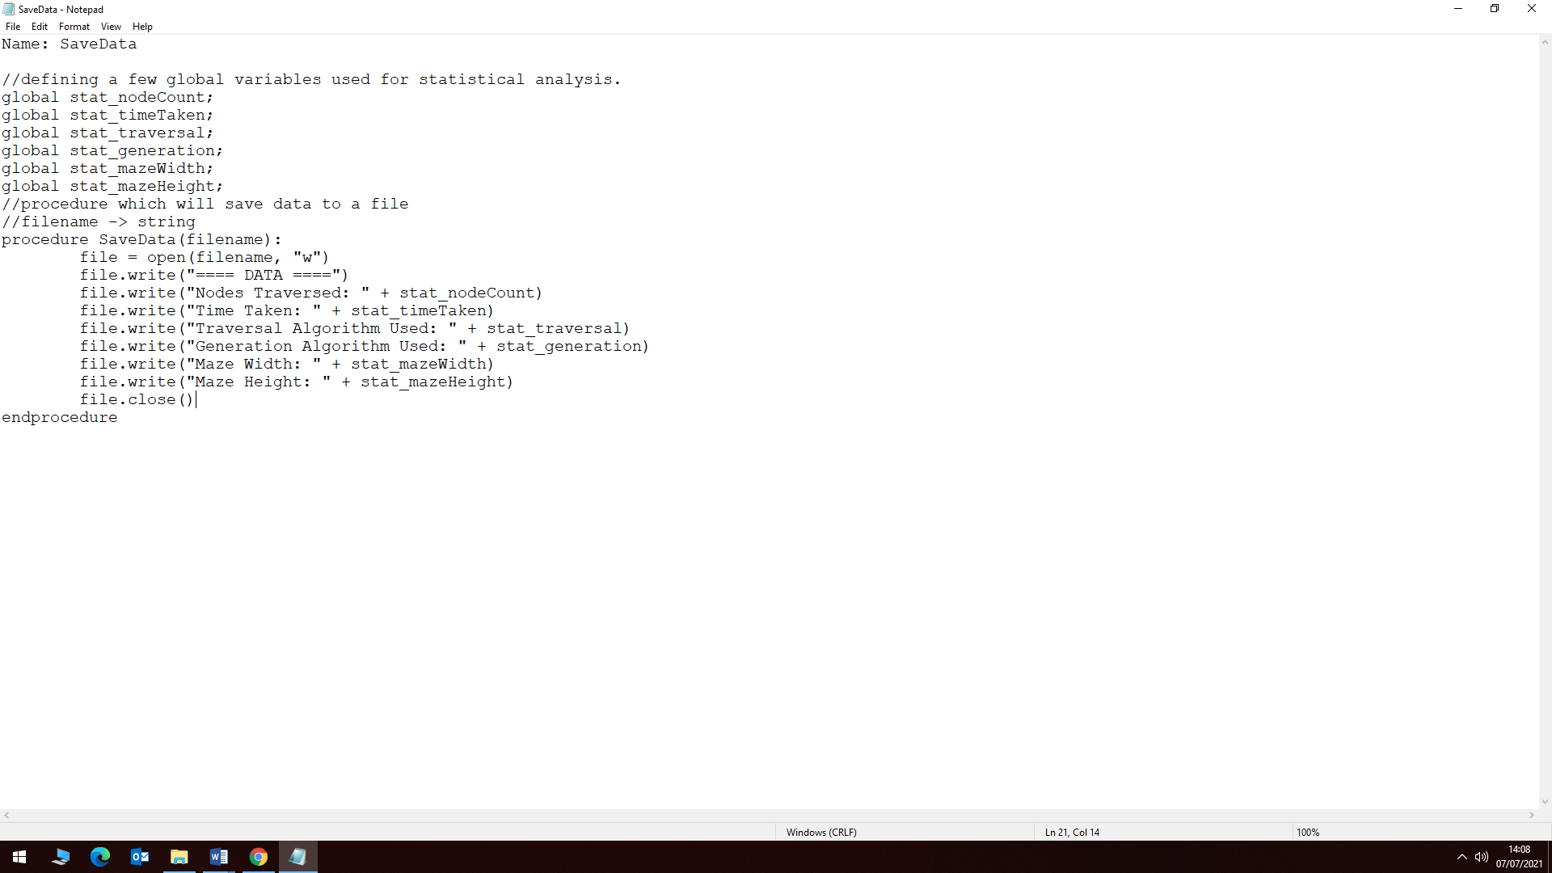

**Explanation:** The SaveData procedure will be used to save the contents of the global variables stated above to a file specified by the user, the procedure will have a lot more functionality within the project solution, however it will remain similar as the procedure will simply open a file and write the contents of these variables to it.

**Justification:** This is essential as it allows the user to store their wanted data to a file for a given solution. This procedure will be called when the save button is pressed, for which data will be saved to the file they specify. The format of the data may be changed to a CSV, replacing the colons with commas so it can be exported and use in other applications such as Microsoft Excel. An added feature could be to change the separator between each data value pair.

#### SolveMaze

**Explanation**: The SolveMaze procedure will be a procedure consisting of calls to many other calls to other subroutines based on parameters selected and defined by the user, the procedure will check which algorithm the user wants to see performed and will call that subroutine.

**Justification**: This will need to be used because it will increase the software usability by allowing the user to choose from a range of different search algorithms.

## Usability

### Defining usability

The project will be made usable by the client by making it so the user has full control over the program to use it for whatever they need to use it for. [9]” *Design* *Principles Reloaded*” Which is an article which explains important principles for usability when designing software:

1. “Effectivity: Reach the goal”, which demonstrates that the purpose of the software should be to allow the user to work effectively. If the user works less efficiently by using the software, the software is not going to be useful to the user.
2. “Reach the goal quickly” which builds on the previous point by making it so the user reaches the goal they are trying to achieve faster than other methods.
3. “Controllability: The user has the power” which suggests that the project should allow the user to have maximum control over the software when working with the software. For example, changing the dimensions of the maze and selecting different maze search and solve algorithms. The software should not enforce any policy on the user which restricts their capabilities when using it.
4. “Customisability: Everything suits the user” which is what makes it so the software supports different approaches to the same task.
5. “Consistency: Everything fits together” remain consist with the user interface and terms used so it is easy for the user to understand the software and navigate it better.
6. “Design and Layout: Comprehensible at first sight” make it so the GUI elements and colours used are not overwhelming to the user and to make sure that the user can comprehend the information being presented.
7. “Language: Speak the user’s language” since the software is going to be related to maze generation and maze solutions and is going to be generating statistical data from the solutions the statistical data presented is going to assume the user understands specific terms related to maze traversals, for example: Time Complexity.
8. “Visibility: The user recognizes his possibilities” Make it obvious what the user can do with the software, don’t hide functionality from the user.
9. “Feedback: The user is told what is going on” Let the user know what is happening behind the scenes. This is mostly done through the visual feedback of the highlighting of cells within the maze and the messages which will be presented given certain conditions within the program such as an invalid maze-syntax.
10. “Learn supportive: Easily learnable” in the project I will make it obvious what everything does by placing names on the buttons so it is clear what the button does within the program.
11. “Help and documentation: Help, that helps” provide hints if the user is stuck on what certain things do so they are not stuck with particular functionality of the project. This is probably not needed because the people who are going to use the software are traditionally already aware of how they are going to use the software.
12. “Error tolerance: Forgive and avoid user errors” This will need to be implemented specifically into the VerifySolution procedure because that is based on user input and the solution they wish to test, if their solution potentially breaks the rules of the maze, by traversing a wall, then the program should stop the process and warm the user of their mistake.
13. “User Experience (UX): The software feels good” The actual usage of the software should be comfortable as software which is not pleasant to use is not good for the user who perhaps might want to use the software frequently.

### Implementing usability

These methods of creating a usable program will be implemented as follows:

1. **Explanation**: Give the user the ability to use the software in any way they wish to use it. Give them enough features to have a lot of control over the software. For example, with the maze solver, they should be able to save any data they wish to save; maze dimensions, distance between nodes, distance travelled to complete maze, total nodes traversed, etc. And use as many different types of search algorithms as possible. Furthermore, they will be given customizability options such as changing the dimensions of the maze so they can experiment and see how the maze solving algorithms will solve the maze given larger or smaller dimensions. **Justification**: This is important because the user might want to do something related to the maze solutions and if I haven’t provided the user with enough options related to the mazes, it won’t be a very efficient solution.
2. **Explanation**: The user will be aware of their limitations by their prior knowledge of maze solving, however, the user will receive messages which will explain if the user has surpassed their limitations through dialogue boxes which will let the user know of these limitations if they are surpassed. The user will also be given hints as to how to use certain features as this enhances the usability for anyone using the software who is unfamiliar with the software. **Justification**: This will make the software user-friendly, given that the client is a mathematics teacher they might be presenting it to students who are not familiar with the software and need the software to warm them of specific rules and hints of how to use it.
3. **Explanation**: The project solution will be composed of minimal elements: Maze Area, Buttons and a Console. This will limit the content the user is presented to avoid overwhelming them with lots of information, this creates a minimal design, not so minimal where the user does not recognize or understand their possibilities. The content will be descriptive and obvious by having related text and areas for tips to help the user navigate the software. **Justification**: This is crucial because it will make the software easier to use and understand as there will only be a few elements which need to be understood to successfully use the software.
4. **Explanation**: The buttons presented to the user will have descriptive names which relate to the function it provides to the user, the user will then easily be able to understand what they can do. For example, a button called “Save” will be instantly obvious that it is related to saving data, they will be prompted to specify a file name or to overwrite the previously used file, this is an example of usability where the user clearly understands what part of the program does and is easily provided with information of what is happening. Furthermore, when the user hovers over the button, the button will highlight to let the user know that the button is active and ready to be clicked. **Justification**: This is crucial because it avoids the user speculating functionality, they are clearly met with a description and text which leaves the user with clear information related to the button functionality. Furthermore, it allows the user to clearly understand that the project will provide information for anything which is available therefore it is easy for them to understand what can and cannot be done by the software.

These usability features will increase the capacity for which the software will allow the user to carry out their desired task efficiently. A tutorial will be provided as a separate window which can be read in order to understand the software. Clear buttons will be provided with feedback on button activity and the button will have text to demonstrate what the button does. There will be limited information initially provided as to not overwhelm the user with information as this is important when creating usable software, the user should be provided with enough information for which they can then add more information if necessary for their needs, such as: opening the file selection menu to save their data to a file for which not everyone using the software is going to need to see and use.

## Testing approaches

### Variable Table

|  |  |  |
| --- | --- | --- |
| **Variable** | **Data Type** | **Description** |
| Cell | Cell | This is what composes the maze, the cells will represent the walls, paths, start and end nodes within the maze. This variable is important because the cells represent each cell within the maze and help manage the cells within the maze. |
| Maze | Array or Graph | This is the maze and is an array of cells which are used to store the cells in one location for easy management. Its size will be changed as the dimensions are going to be changed by the user. This is an important variable because it is where the maze is going to be generated. This structure can have varying different data types to define itself. The graph structure would be useful because there are specific functions which are used to traverse the structure such as DFS and BFS which are going to be used in the software. |
| solveBtn | JButton | This is a button which can be pressed to activate the selected solve function. |
| selectSearch | JComboBox | This is a drop-down menu which will contain all the supported search algorithms which can then be selected by the user. This is crucial because it provides a clear list of what search algorithms are available. |
| BUTTON_WIDTH | Integer | A global constant which represents the width of the buttons in the program. This is used to define the width of the button and is important for development because it will avoid the use of integer literals throughout the program. |
| BUTTON_HEIGHT | Integer | A global constant which represents the height of the buttons in the program. This is important because it will avoid the user of integer literals throughout the program. |
| MAZE_WIDTH | Integer | A global constant which represents the width of the window in the program, this will be used to define the width of the window and will be used to prevent the use of integer literals. |
| MAZE_HEIGHT | Integer | A global constant which represents the height of the window in the program. It will be used to prevent the use of integer literals throughout the program. |
| statNodeCount | Integer | A variable which will keep track of the number of nodes traversed to complete the maze for each run of the solver. This will be used to be stored by the user if they desire it to be saved into a file. |
| statTimeTaken | Float | A variable which will keep track of the time taken to complete the maze for that run. This is important because the user might want to store the time taken for the search to be completed. |
| statTraversal | String | A variable which will keep track of the current traversal algorithm used for that run. This is important because the user might want data to be stored with respect to the algorithm which was used. |
| statGeneration | String | A variable which will keep track of the current maze generation algorithm used for that run. This is important because the user might want data to be stored with respect to the algorithm which was used. |
| statMazeWidth | Integer | A variable which will keep track of the current width of the maze for that run. This is important because the user might want to save the width of the maze within their collected information dataset. |
| statMazeHeight | Integer | A variable which will keep track of the current height of the maze for that run. This is important because the user might want to save the height of the maze within their collected information dataset. |

These are some of the core variables which are going to be used which compose the main functionality of the software.

### Classes and data structures

#### The Cell Class

This class is used to define each cell which composes a maze. This class structure is defined with two variables called flags and CellPnl. This is a 32-bit integer which can store the state of the Cell within the maze, the states will be set by turning the bits of the integer on and off to determine the state of the cell in the maze. CellPnl is a JPanel object which is used to interact with the swing API so it can be viewed within the JFrame.

class Cell

Public flags: int

Public CellPnl: JPanel

Public procedure new()

CellPnl = new JPanel()

flags = 0

endprocedure

endclass

given that the attributes of the class are public would define this as a structure, they are public because it will improve performance when managing lots of cells in a matrix, just by accessing their attributes rather than calling helper functions which will just slow down the process. A 2D array called maze, will be responsible for containing NxN Cells which are used to represent the maze. Global macros will be defined for each bit which can be set within the flags variable.

#### The maze

This is a simple data structure which is simply a 2D array, it points to arrays of Cell objects.

Cell[] maze = new Cell[MAZE_WIDTH * MAZE_HEIGHT]

This is how the maze will be represented and will just be a container for the maze’s cells. It is a 1-dimensional array but can be manipulated using O(N*M) methods where N is the width and M is the height of the array. However, using the formula: “index = x + y * MAZE_WIDTH” this can convert indexes for 2-dimensional arrays into 1-dimensional array indexes.

#### Linked List

The linked list data structure is a core structure which can be used to represent the maze in another sophisticated way. It consists of an imbedded structure called a Node which is a container for the useful data and a pointer to the next data in the linked list.

class Node

data : int

next : Node

procedure new(data : int)

this.data = data

this.next = null

endprocedure

endclass

class LinkedList

head : Node

procedure new()

this.head = null

endprocedure

procedure insert(data : int)

tmp = new Node(data)

if (this.head == null)

this.head = tmp

else

last = this.head

while last.next is not null

last = last.next

endwhile

last.next = tmp

endif

endprocedure

procedure get_array()

ptr = this.head

i = 0

while ptr is not null

ptr = ptr.next

i = i + 1

endwhile

tmp = new int[i]

ptr = this.head

while ptr is not null

tmp[i] = ptr.data

ptr = ptr.next

endwhile

return tmp

endprocedure

endclass

This is the minimal definition of the Node and LinkedList class structures. They will be used to store the cells of the maze. It can be used to create an adjacency list which can be traversed similar to a graph using methods such as DFS, BFS and other graph traversal methods. The get array function would be used in place of an iterator in java, it converts the LinkedList into a standard array which can then be used in the graph data structure to traverse the elements in the LinkedList.

#### Graph

The graph data structure is the structure which encapsulates the LinkedList data structure and defines traversal methods of the graph, using the LinkedList to create an adjacency matrix defining the graph to be traversed [10]:

class Graph

private vertices: int

private adj_list : LinkedList[]

procedure new(v: int)

this.vertices = v

this.adj_list = new LinkedList[this.vertices]

for i = 0 to this.vertices - 1

this.adj_list[i] = new LinkedList()

next i

endprocedure

procedure addEdge(v: int, w: int)

this.adj_list[v].insert(w)

endprocedure

procedure DFS_Solve(v: int, visited: boolean[])

visited[i] = true

tmp = this.adj_list[v].get_array()

for i = 0 to len(tmp) – 1

if not visited[tmp[i]]

DFS_Solve(tmp[i], visited)

Endif

next i

endprocedure

procedure DFS(v: int)

visited = new Boolean[this.vertices]

DFS_Solve(v, visited)

endprocedure

endclass

This structure demonstrates how the DFS algorithm will be used to traverse the tree, no specific node is selected within DFS and weights are not defined to determine the optimal route for the traversal. However, it will traverse the graph until all nodes are successfully traversed. In order to apply this to the maze solver, a destination will need to be provided, so the algorithm knows when to stop searching once that position has been found, allowing the algorithm to search from the specified beginning and end nodes. For example, DFS(0) will start the search at index 0 in the maze matrix.

#### Justification

### Validation

**Explanation:** Validation is provided by sanitising the data the user enters to make sure the data entered is valid. Such as when the user is going to enter their custom solution to the maze, it will need to be checked that the string entered is in the format required and not of any other type, there must not be any characters outside the following set: {‘1’, ‘2’, ‘3’, ‘4’, ‘5’, ‘6’, ‘7’, ‘8’ , ’9’, ‘U’, ‘D’, ‘L’, ‘R’} where this set defines the directions indicating the direction to be travelled and the numbers represent the magnitude of the direction, which can reduce the input string if the maze has long corridors. Furthermore, their solution may disobey the conventional traversal of the maze, such as traversing over a wall, the user will be notified if this type of mistake is made to make sure they understand why their solution didn’t work, rather than just not showing the path taken. It is also important to check the user has entered data into this field to expect their solution to be entered, there will be buttons which will be used to determine between the algorithm solution and a custom solution by the user, the field which this string is entered will be checked and will provide validation to the user, telling them that they need to enter information into the field in order for the verification to proceed.

**Justification:** The data being entered must be checked because if the user enters data which cannot be processed by the program, the user must be notified and the data must be rejected. Also, if the user does not enter anything into the field, the algorithm can not run and must therefore request for information in the field.

**Explanation:** Another form of validation will be provided to the user when they select a file to save data to. If the file which they are attempting to save data to is not a valid file, it will be notified that the file does not exist, and will request to create one for the user, else the file exists, this will allow the user to either specify a new file name or continue with overwriting possible content in the already-existing file.

**Justification:** If the user enters a file that does not exist, the user should be prompted to create that new file, the user is not going to know that file exists, or is expecting the software to create it for them anyway. If the file does exist, the user may have forgotten that the file was already created, and may have data already written to the file, therefore the prompt to redefine a new name can protect the user from erasing possibly lots of data.

### Final Test Table

|  |  |  |  |  |  |  |  |
| --- | --- | --- | --- | --- | --- | --- | --- |
| Test # | Validated Data Type | Test Data | Test Type | Expected Output | Actual Output | Success (?) | Success Criteria # |
| 1 | String | “L2R2” Entered into the solution verification text box | Erroneous | This should provide an error because any form a back-tracking done by the user is not going to be permitted the user should have a clear set of instructions to guide their way from the start node to the end node. |  |  | 3 & 6 |
| 2 | NULL | Save the current maze and try to re-load it into the software. | Normal | The maze should be uncompressed and displayed correctly in the maze area and the compression algorithm should reduce the size of the maze. |  |  | 5 |
| 3 | NULL | Select slow or instant visualisation | Normal | When slow visualisation is set, the user should be presented with a live feed of the searching process. If instant, the user should be presented with the solution to the maze, no visualisation |  |  | 8 |
| 4 | NULL | Run an algorithm on a maze, save the statistical data to a file and import the data to Excel | Normal | The data should be saved in a CSV format and should be readable from excel sheets. All necessary statistics should be present |  |  | 2 |
| 5 | String | Enter a valid solution to the generated maze using the maze solution format | Normal | The entered solution should present a path to the start and end node and indicate to the user that their solution was correct. |  |  | 3 |
| 6 | String | Enter a file name for which the data is to be saved to. | Normal | If the file exists, the program should alert the user that the data is to be overwritten, else an alert to create a new file with the same name is then prompted. |  |  | 2 |
| 7 | NULL | Press the generate maze button | Normal | It should generate a maze with the selected algorithm and then present the maze from within the maze data structure. |  |  | 1 & 4 |

#### Justification

This test table is the table which is going to be used once development has finished. It maps tests to the relevant software success criteria. I will be finding bugs by entering data or testing functionality. Either expected input such as a valid string or invalid string to test validation of the input. The functionality tests will simply consist of pressing a button or selecting a specific option and to see if it performs its expected function correctly. The ‘Actual Output’ and ‘Success (?)’ fields are not going to be filled out right now because I have not created the software to carry out those tests. The success criteria: 1, 4 and 7 are not necessarily to be tested as these are more design features, that don’t have input passed to them. However, the algorithms passed based around them are to be tested and to see if they provide their expected results. The table shows 7 columns defining: ‘Test #’, ‘Validated Data Type’, ‘Test Data’, ‘Expected Output’, ‘Actual Output’, ‘Success (?)’ and ‘Success Criteria #’.

‘Test #’ is the number which identifies the test taking place. ‘Validated Data Type’ is the type of the data which is being entered for validation by the software, meaning it is the input data given that the component being tested accepts input from the user. ‘Test Data’ is the actual data which is being entered which is of the type of ‘Validated Data Type’. ‘Expected Output’ is the expected output of the software given the input given. ‘Actual Output’ is a field which will be entered during the post development phase. ‘Success (?)’ is a Boolean which defines in the table whether the expected output was met, where it is True or False. The ‘Success Criteria #’ acts as an index into the success criteria I defined at the end of analysis.

# Development

This is the development cycle where development of the solution is declared. This will include iterative tests on modules within the solution which are to be iteratively improved based on client feedback and to be recycled based on the outcome of tests carried out.

## Phase 1 (The GUI Design – Version 1.0)

### Design

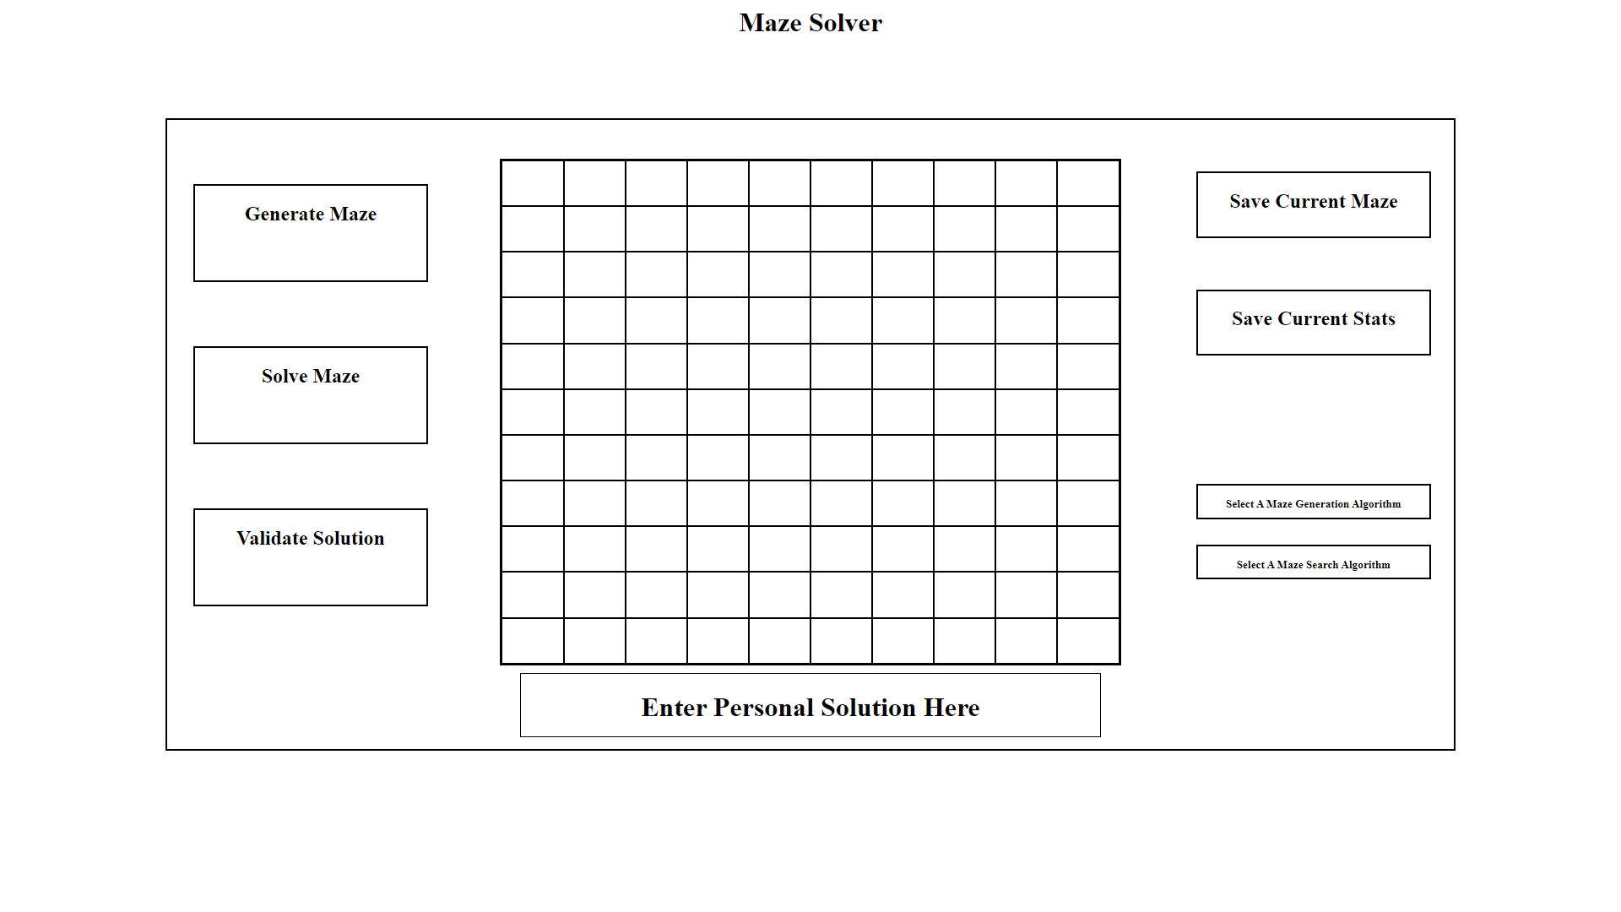

This is the initial design which I created with HTML and CSS for which I sent this to my client, Mr Rees. He said that the layout was fine, but the colour scheme could have included more colours. However, knowing the layout was okay, this meant I could begin on coding up the design of my solution using Java.

The initial design was said to be bland and could have included some additional colour:

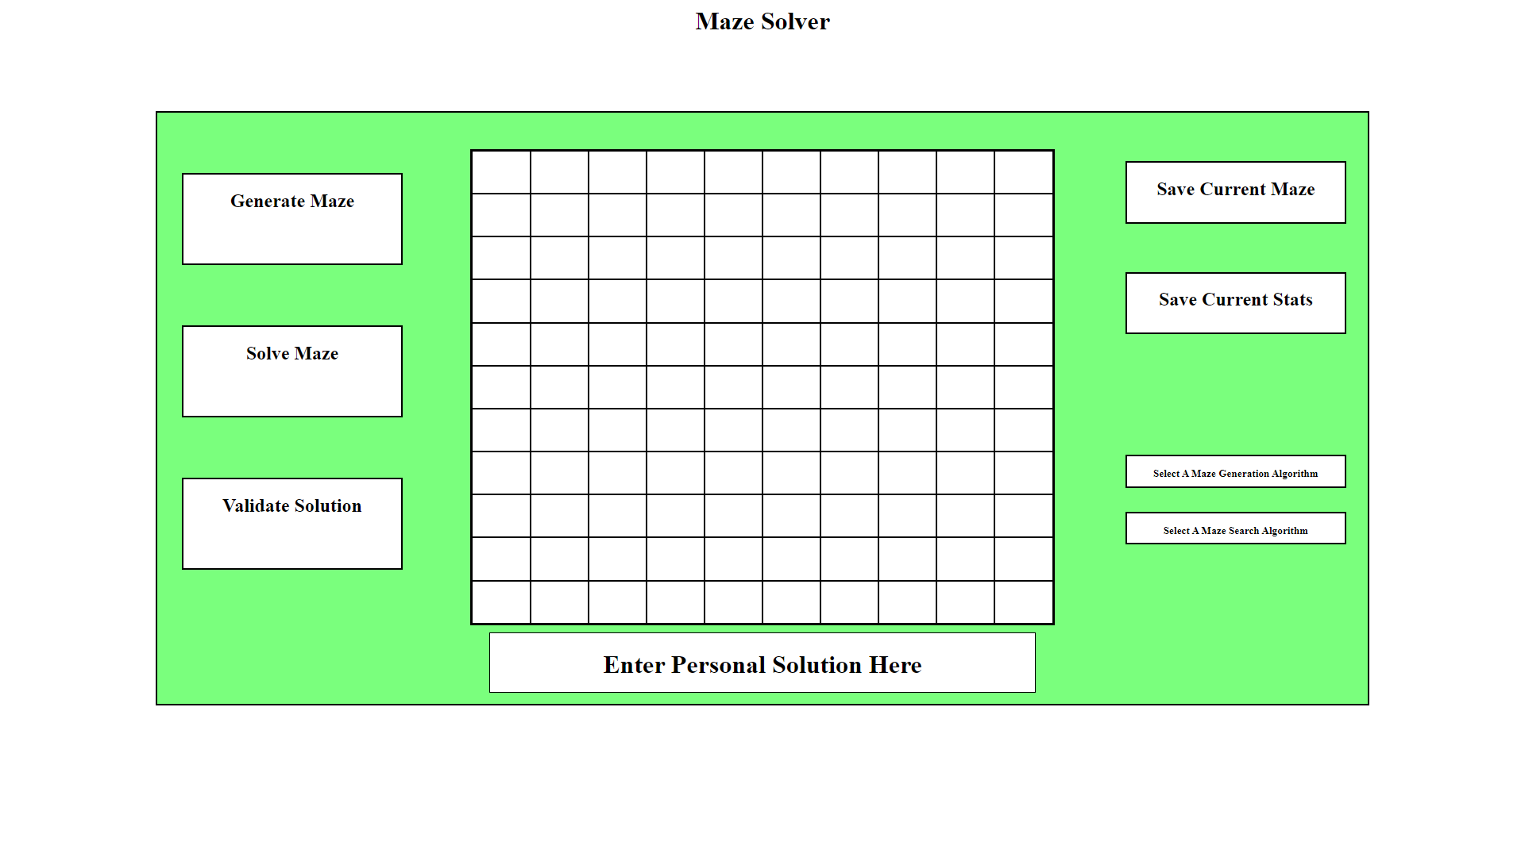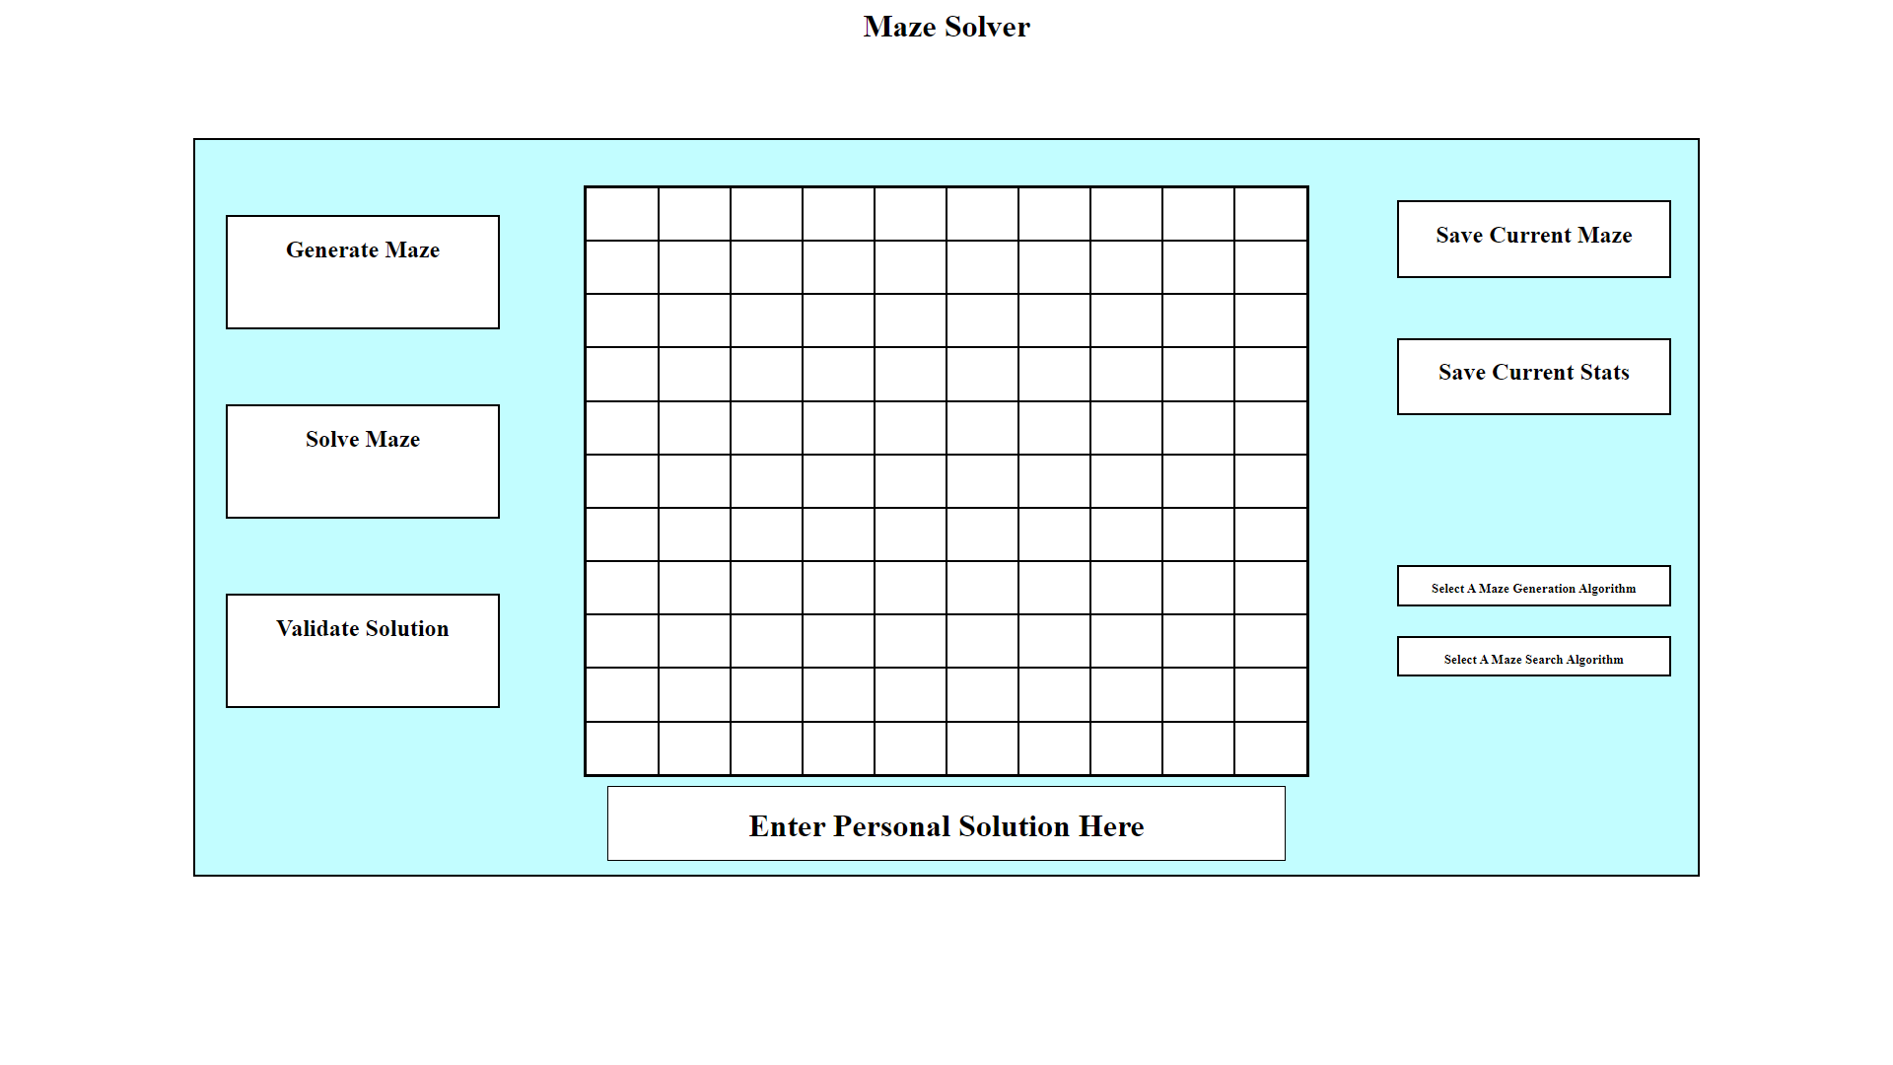

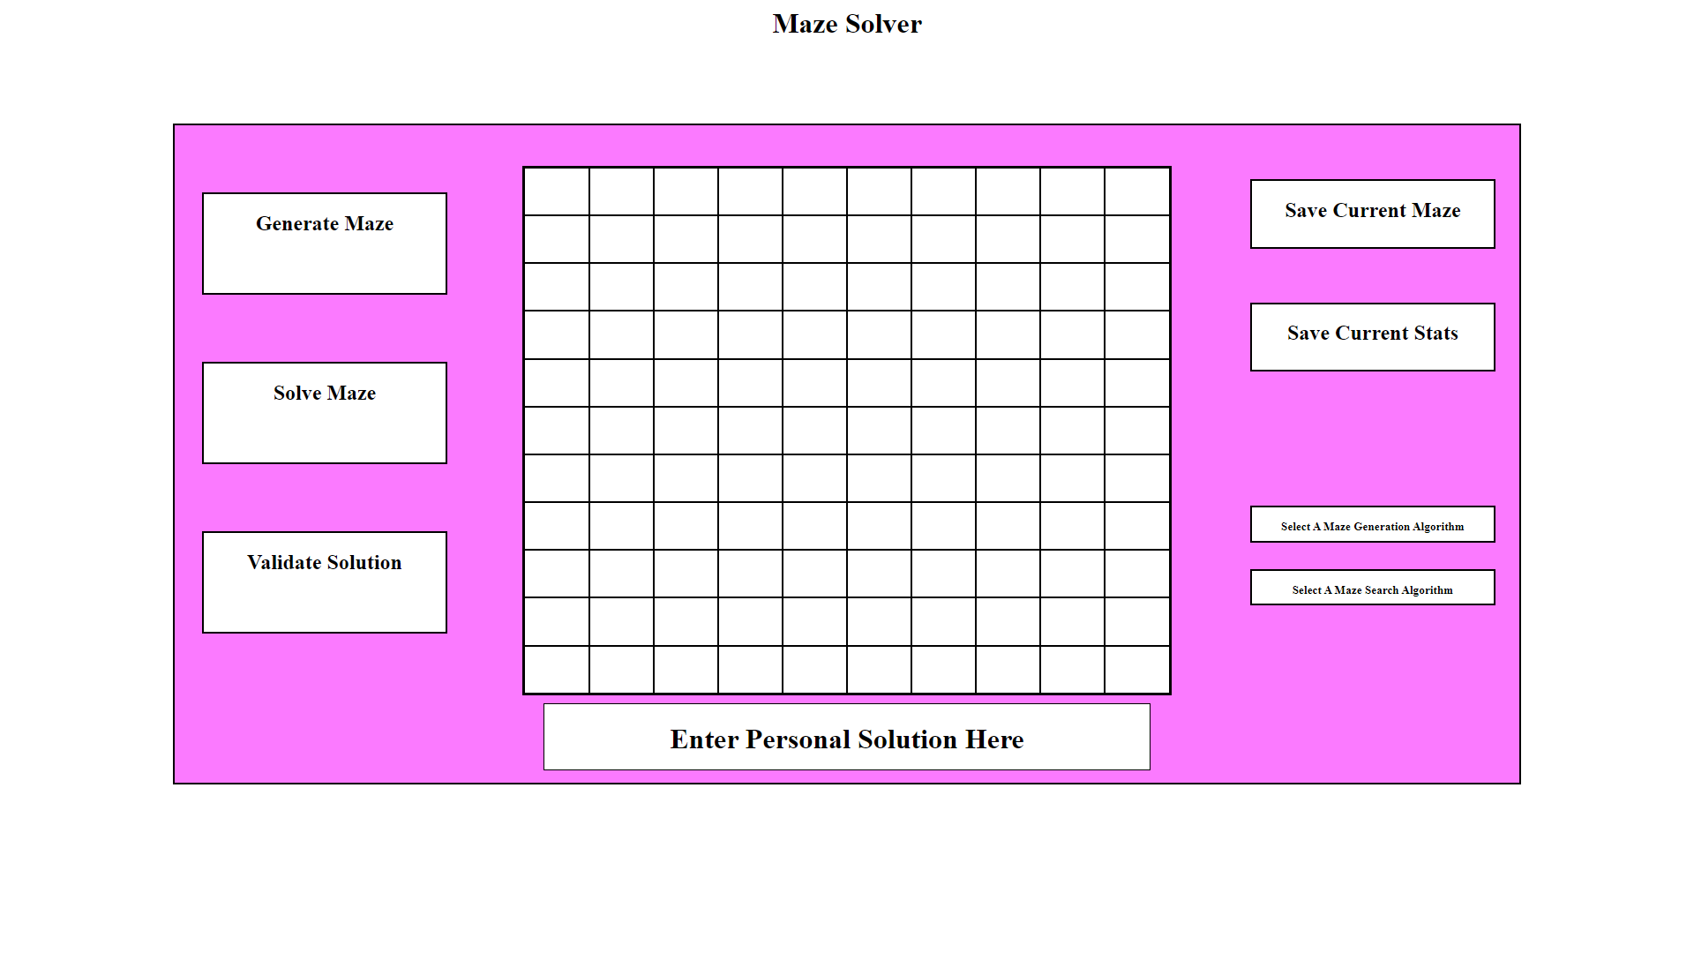

I have mocked up different background colours for the software, where the hex values of these colours are: Light Green = #7affa0, Light Blue = #7ae7ff and Light Pink = #ff7af4.

### Evaluation

This is the initial phase and outlines how my software should look, the design is structured to have minimal and clear elements which are related to the project solution. The maze is centred in the middle of the window, buttons related to manipulating the maze and positioned on the left and buttons and combo boxes related to data the maze is currently working with is positioned on the right. The user can enter their solution into the text field which states: ‘Enter Personal Solution Here’ where the solution will be used to attempt at solving the maze.

## Phase 2 (The GUI Implementation – Version 1.0)

### Design

This section will be based around my approach to the solution, designing required data structures and algorithms needed in order to fulfil this stage and the variables which are needed for those structures and algorithms.

#### variables tables

|  |  |  |
| --- | --- | --- |
| Name | Type | Justification |
| maze | Maze | The maze variable is used to define the maze within the program, containing an array of cells which are then to be traversed using the maze traversal algorithms. The Maze data structure will consist of a List of Cell data structures. |
| leftUtils | MazeUtils | The leftUtils structure is a very simple container which is used to contain all the buttons on the left-hand side of the window. |
| rightUtils | MazeUtils | The rightUtils structure is a very simple container which is used to contain all the buttons on the right-hand side of the window. |
| window | Window | The window variable inherits the attributes of a JFrame and will hold all the necessary content which is to be displayed within the window. This structure will setup all the components for the window, add them to the window, and finally present the window to the user. |

#### classes and data structures

The classes and data structures I am deciding the implement in this phase are as follows:

##### Cell

This structure will inherit the attributes of the JPanel class and have an integer attribute called flags, the flags attribute will contain the state of the cell, where the cell is based on the bits set within the 32-bit integer.

##### Maze

This structure will contain a List containing cells, this can then be traversed using the maze traversal methods and the cells’ state can be changed during the maze generation algorithm.

##### Window

The window structure will contain various amounts of attributes which compose the structure of the window, such as: w (the width of the window), h (the height of the window), leftUtils (the container of the components on the left side of the window), rightUtils (the container of the components on the right side of the window), createMazeBtn (a button which will generate the maze within the maze data structure), solveMazeBtn (a button which will solve the currently generated maze), validateSolnBtn (a button which will check for any code inside of the userSolnTxt variable, if so, the code will be read and translated into a solution to the maze), userSolnTxt (a text field where the user can enter their solution), saveStatsBtn (a button which allows the user to save statistical data to a file they specify), saveMazeBtn (a button which allows the user to save the current maze to a file they specify), selectSolveCombo ( a combo box which allows the user to select a maze solving algorithm to use), selectMazeCombo ( a combo box which allows the user to select the maze generation algorithm to use).

#### Validation

Validation will occur by checking the userSolnTxt variable for data, if data does not exist and the validateSolnBtn button is pressed, then the program will let the user know to enter a solution before trying to validate it. Also, the userSolnTxt variable will have its data extracted if data is entered, and the data will be checked to verify whether it is in the appropriate format which specifies a solution, meaning the solution must consist only of: directions from ‘U’, ‘L’, ‘D’, ‘R’ and magnitudes from 1 to N, where N is the width and height of the maze.

### Implementation

This section is where I take the aspects defined in the design phase are implemented and integrated using the java programming language.

#### source code

Firstly, I needed to define the Cell class, this was a class which is needed throughout the program in order to represent the maze.

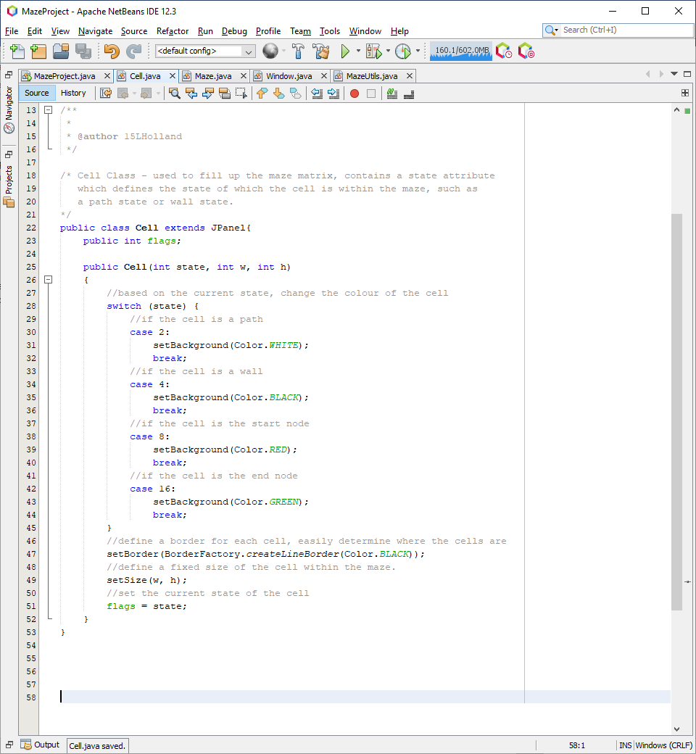

For the Cell I have defined a class which inherits the JPanel class. Then defined a constructor with parameters: state, w, h; which are used to define the state of the cell, which in this case are either a wall, path, start node or end node; based on the state, the background colour of the cell is set accordingly, w defines the width of the cell and h defines the height of the cell.

Next, I decided to implement the maze as I had created a core component of the maze, the maze was ready to be implemented:

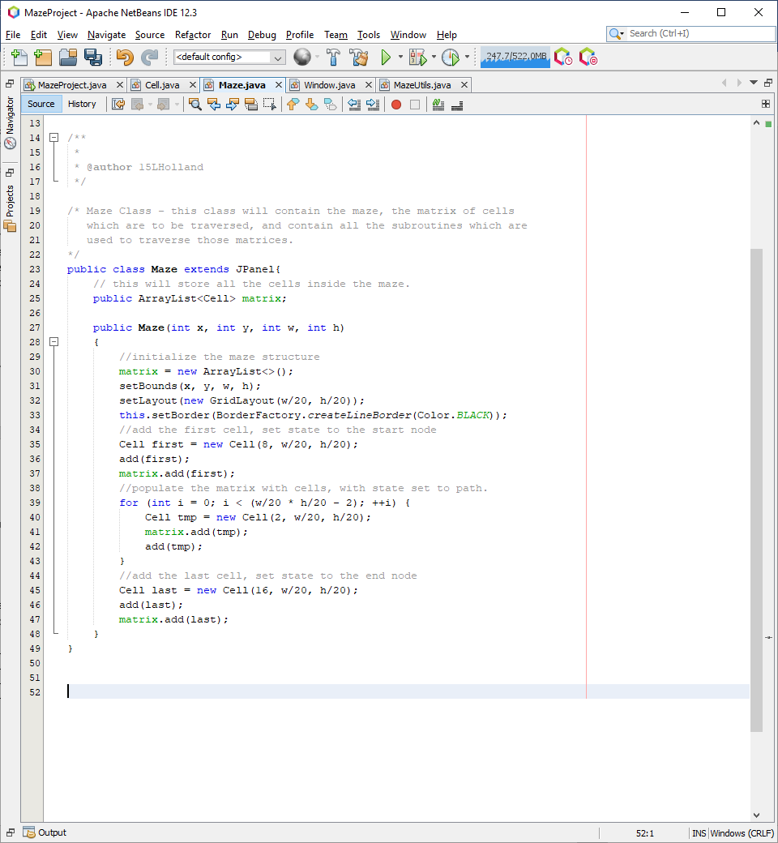

The maze also inherits the JPanel class, I have chosen to inherit the JPanel class because it is a blank slate which has a colour feature and can also act as a container, since the cells need to have their colours values changed, and the maze is to contain all these cells, inheriting a JPanel was essential for allowing the maze and the cell to be viewed from a swing context. The constructor for the maze initialises the matrix variable, sets the width, height and position of the maze. It then loops through the matrix, adding cells to the matrix Array List and the JPanel.

I then decided to work on the window, so I could test the previously defined structures are working as intended:

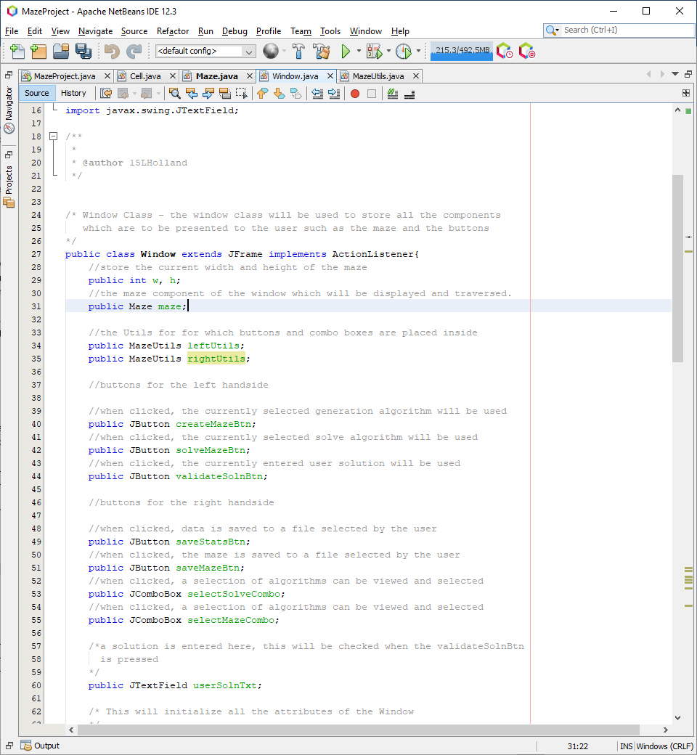

The window inherits the JFrame class so it can be used to store the components of the application. Components are added to the Window, which adds them to the JFrame so they are present when the JFrame is shown to the user.

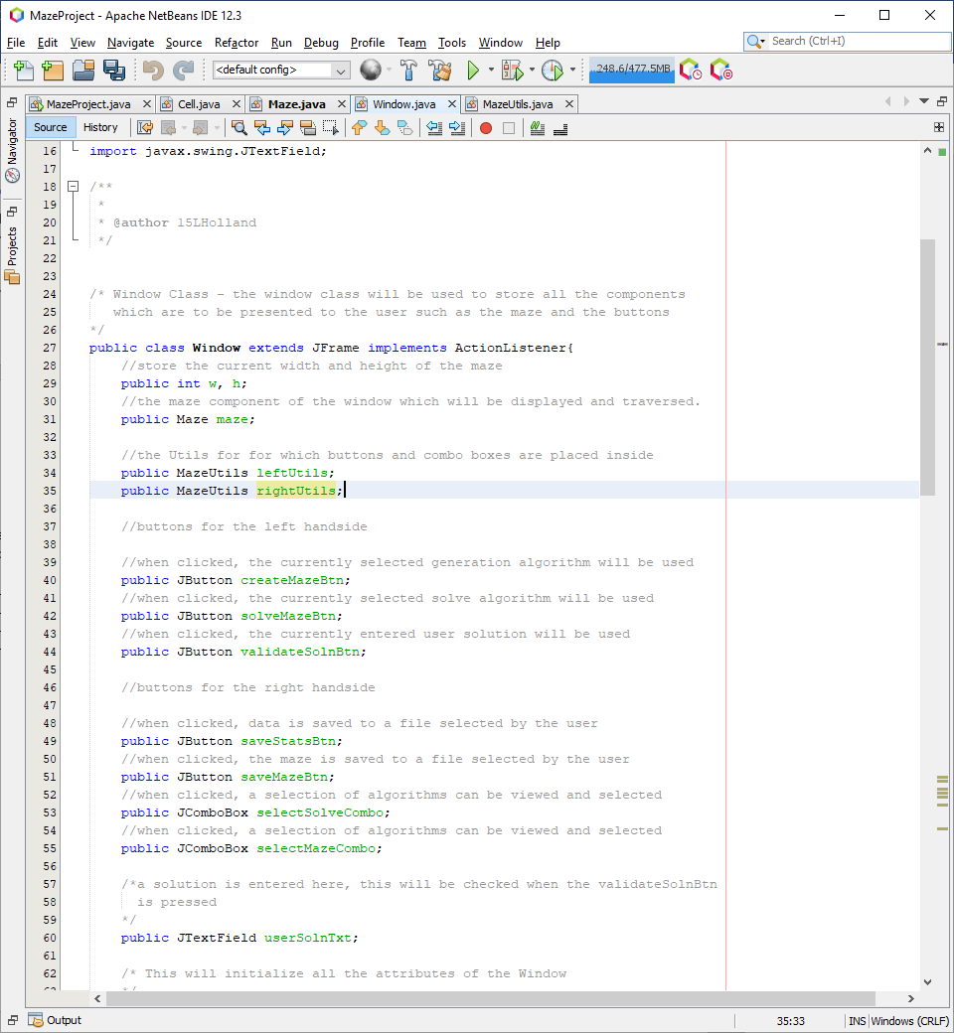

I then added the maze as an attribute of the window class, which would then be initialised within the constructor class.

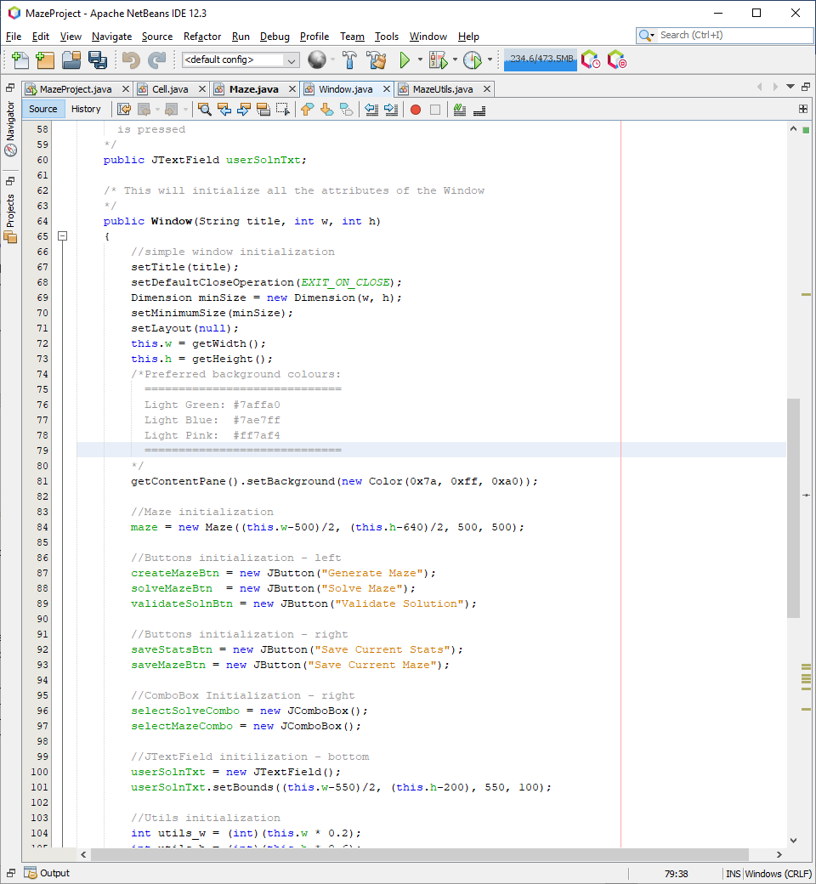

The constructor contains code to set the title, minimum size, layout and dimensions of the window as well as the background colour discussed in the previous phase. The maze is initialised with some pre-calculated constants which position the maze in the centre of the window.

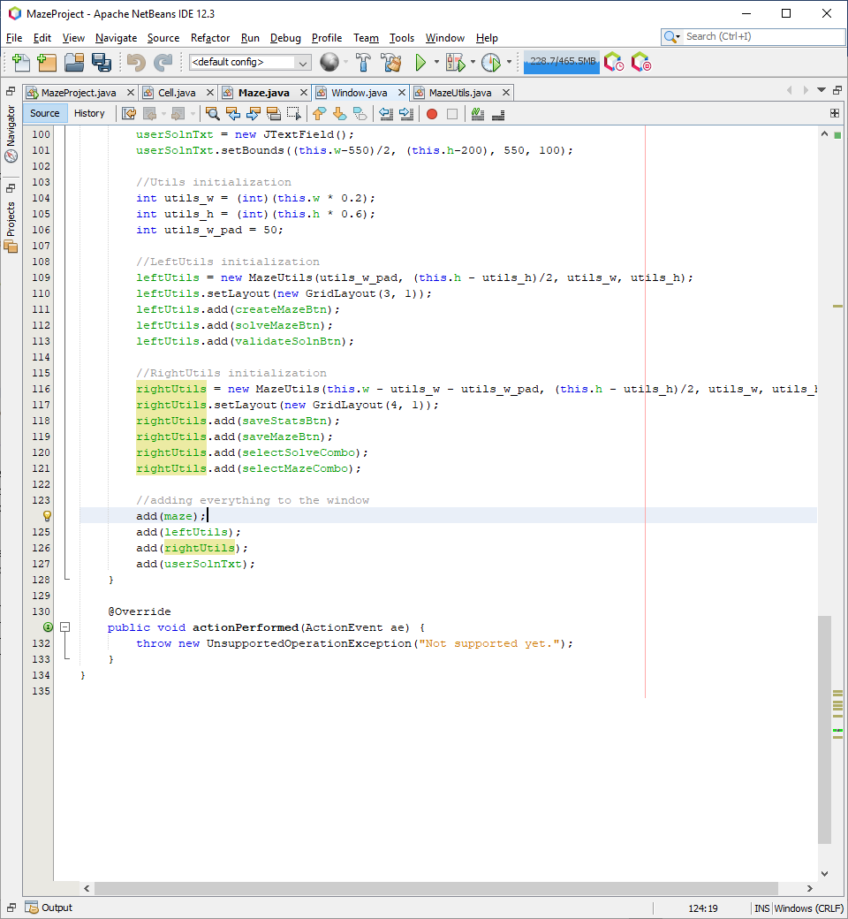

Then I add the maze to the window.

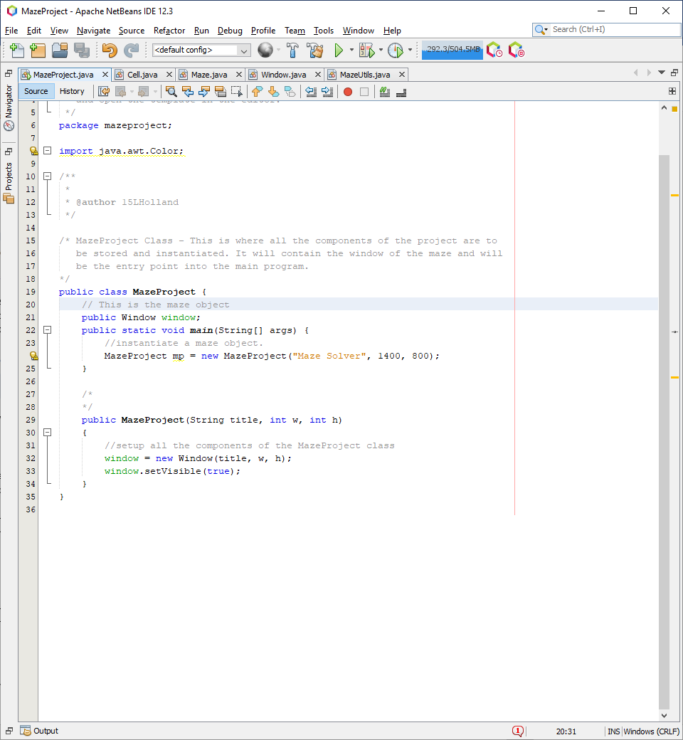

The MazeProject class is the entry point into the program, it contains the window as one of its attributes. The constructor initialises the window, and once window initialisation is done, it sets the window to visible. Creating a new MazeProject class in the main function, it should display a window with the maze centred in the middle of the screen:

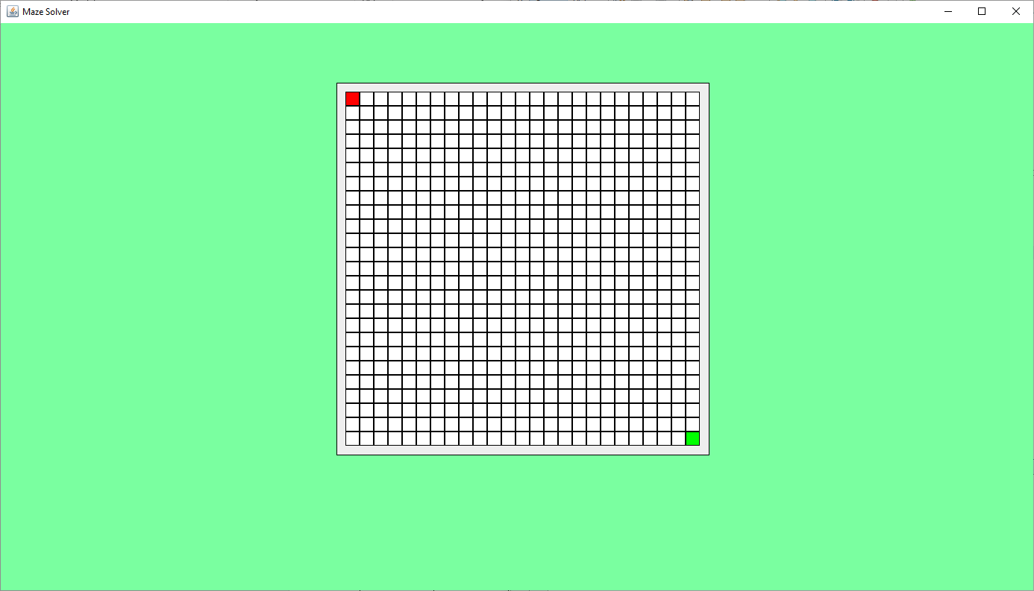

This is the output of running the program, the program shows the maze being centred in the middle of the window, therefore the test worked as intended. This is logged as success in the test table for test #1.

Next, I need to add the JTextField which allows the user to enter their custom solution:

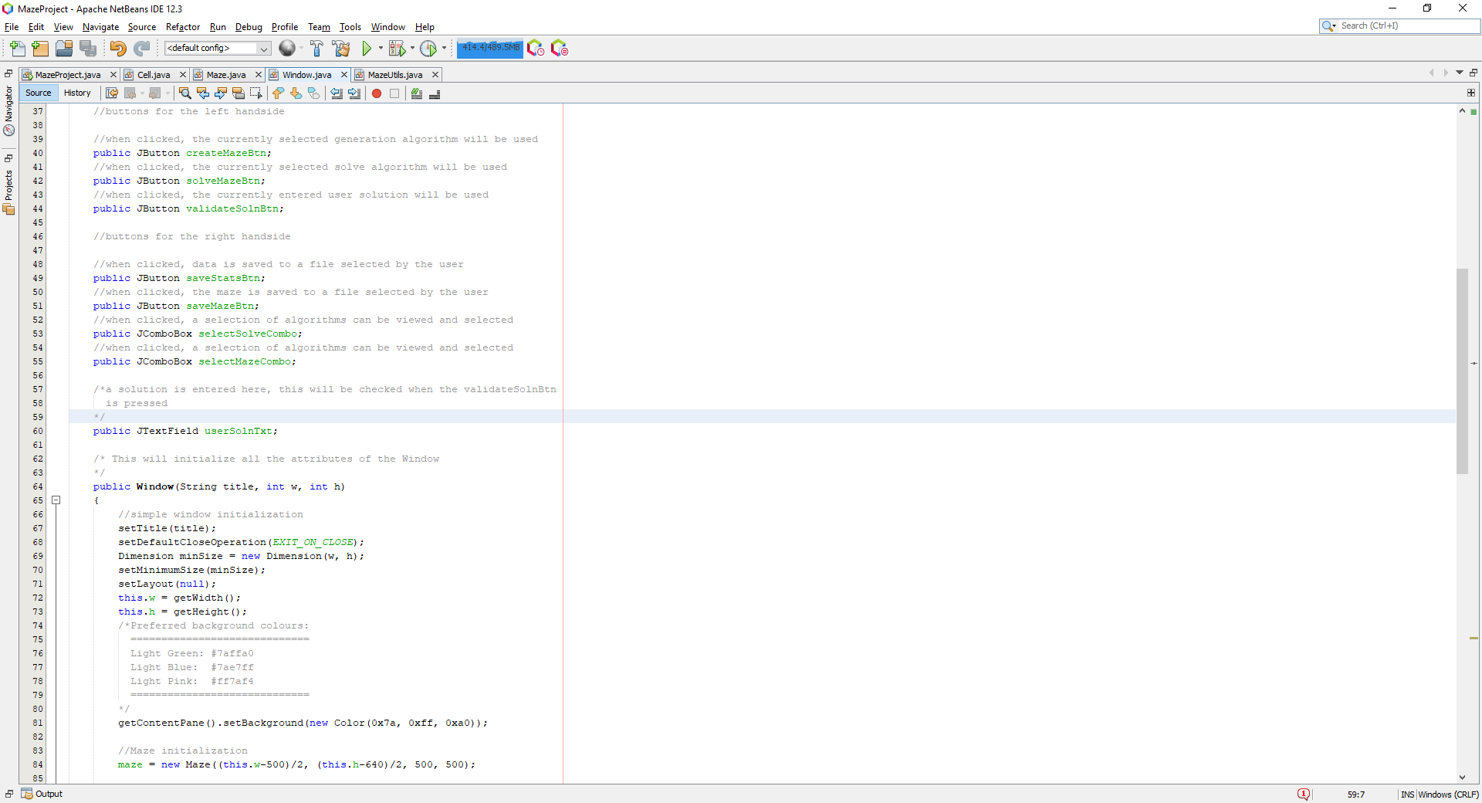

This is added to the window as another attribute.

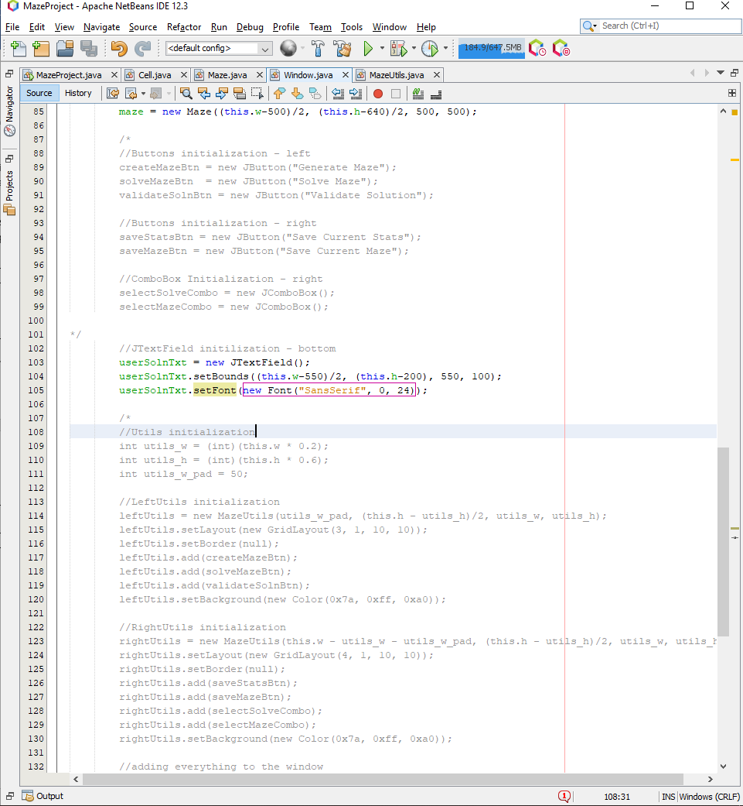

The userSolnTxt attribute is then initialised inside the constructor, also with pre-calculated constants which align the text box underneath the maze area.

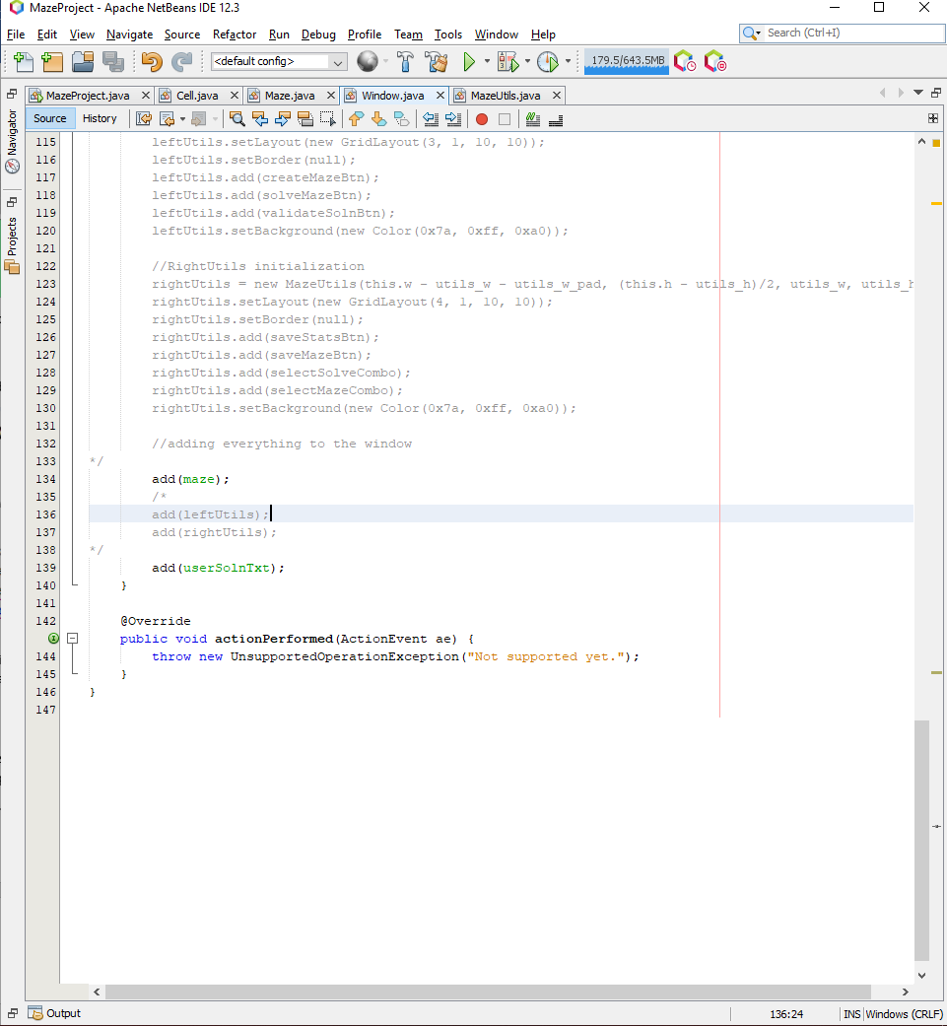

Then I add the userSolnTxt to the window. I then tested to see if the JTextField was present in the window and in the correct location:

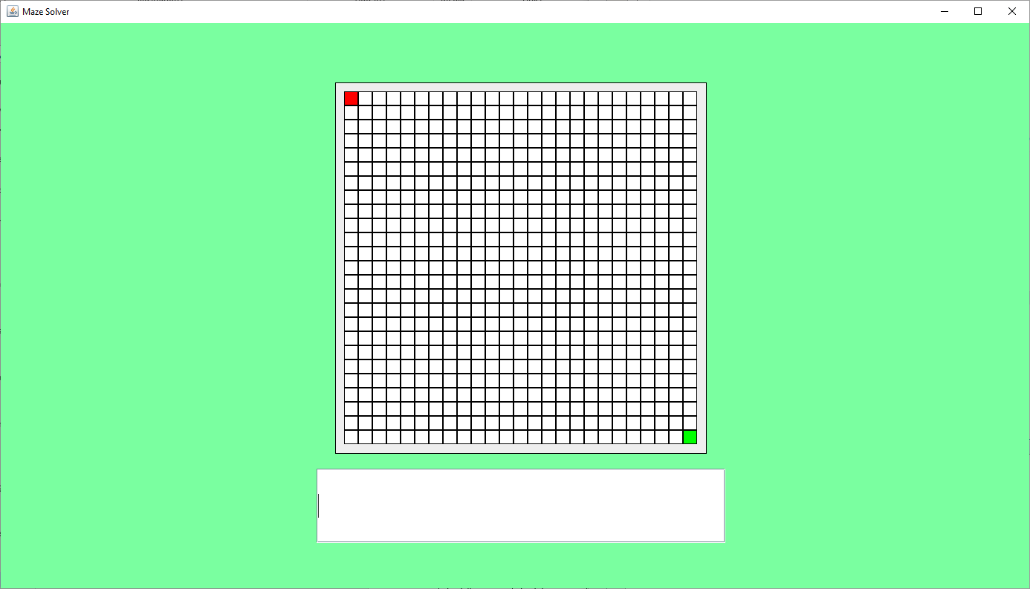

This was successful, the text area is set below the maze. This can be logged as another successful test, test #2.

Then, I want to add both the leftUtils and rightUtils to the window, which will contain a range of buttons which will control the maze, user input and the algorithms used to manipulate the data inside the application.

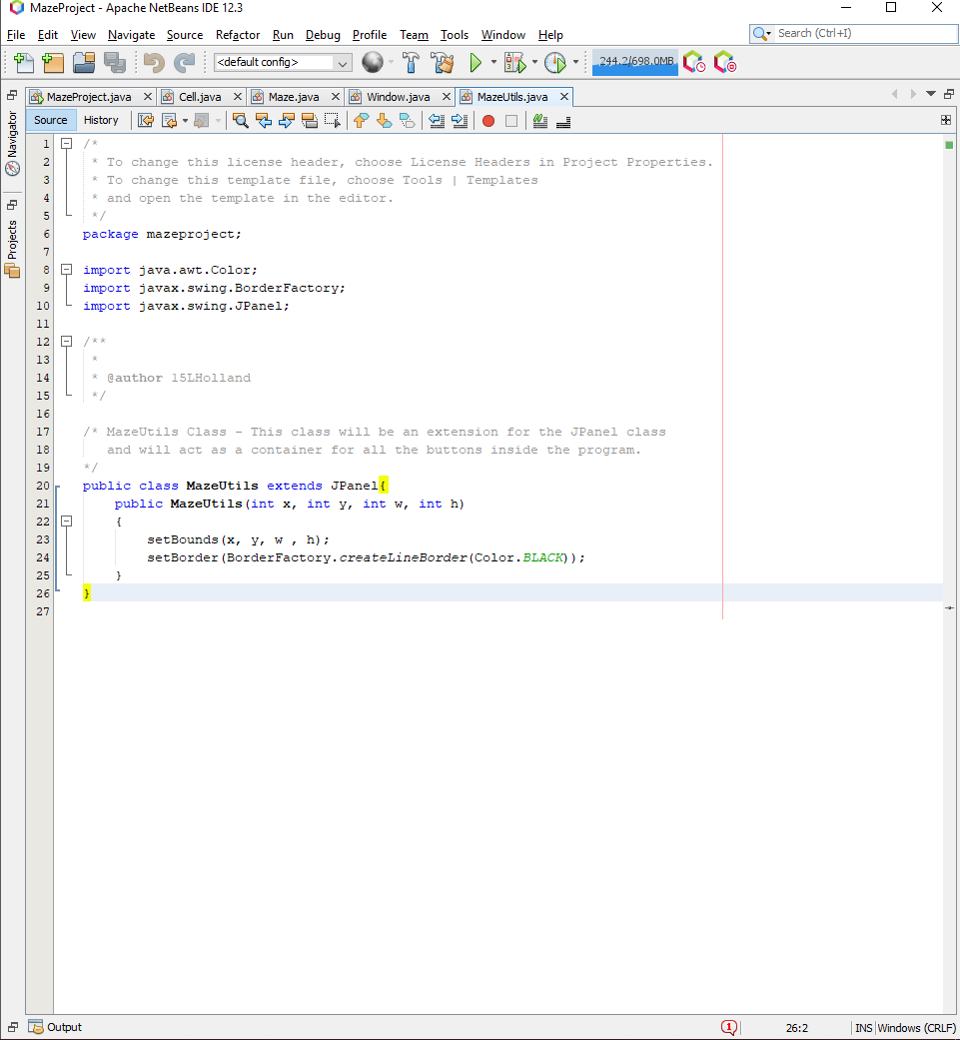

Firstly, I define the MazeUtils class which inherits the JPanel, this acts as a container for the buttons which are to be stored and viewed within the window. The constructor simply setups up the position and dimension of the container and gives it a black border.

I then added the respective buttons and MazeUtils as attributes to the window class:

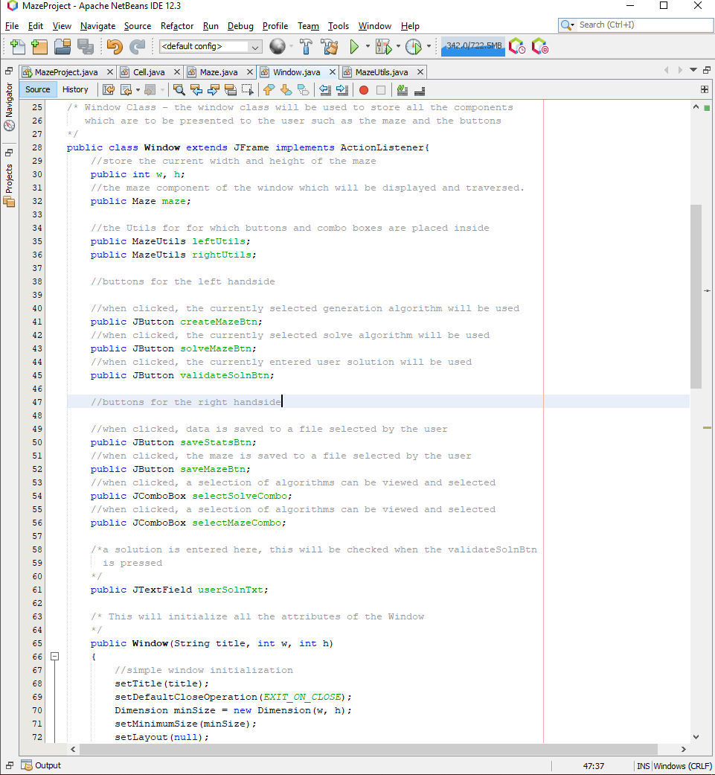

This is the leftUtils and rightUtils with the corresponding buttons which are to be inserted into either container.

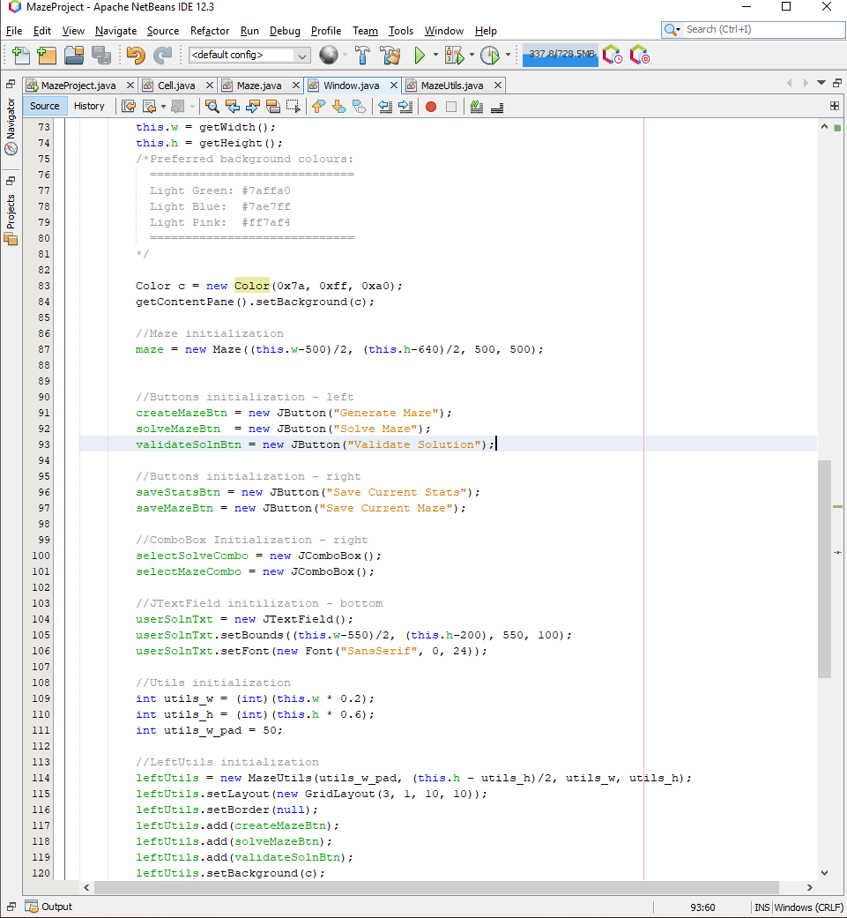

I initialise the components which are to be inserted into the MazeUtils containers.

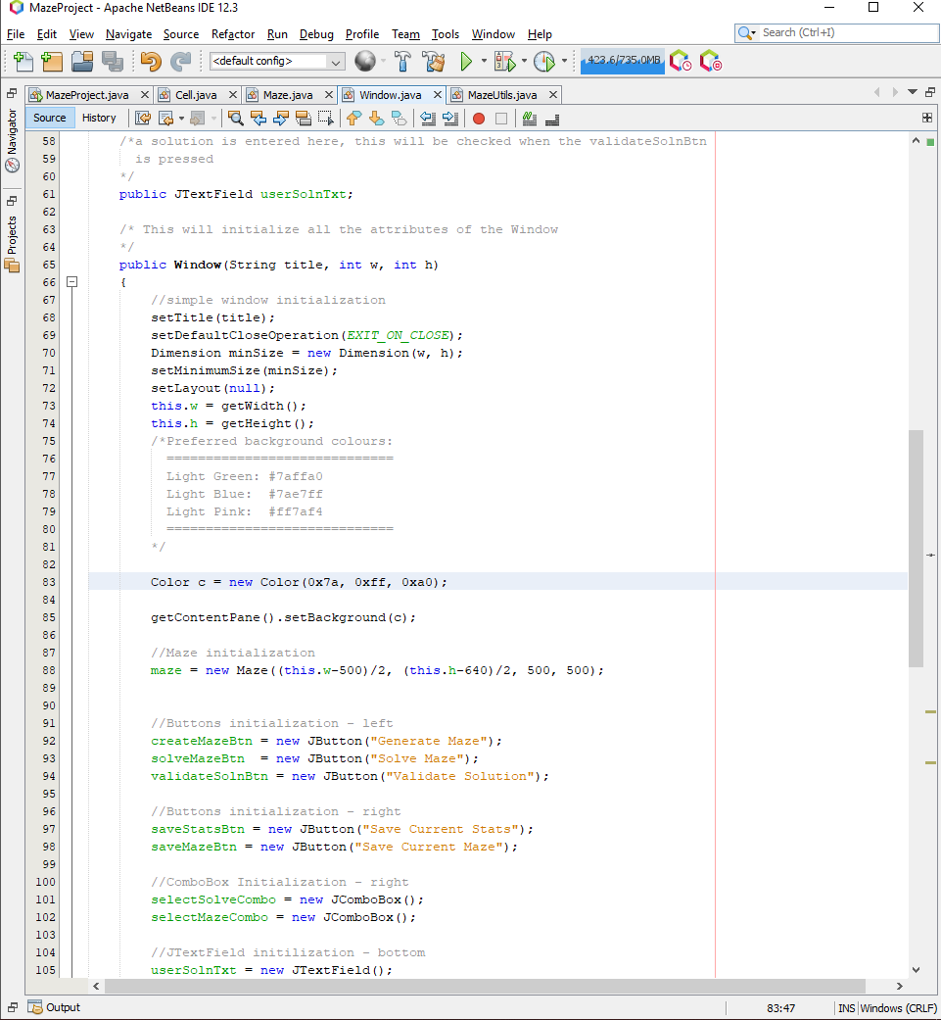

To prevent any redundant code repeats for the sake of the test, I defined a variable, c which stores the colour used for the background of the window and each container.

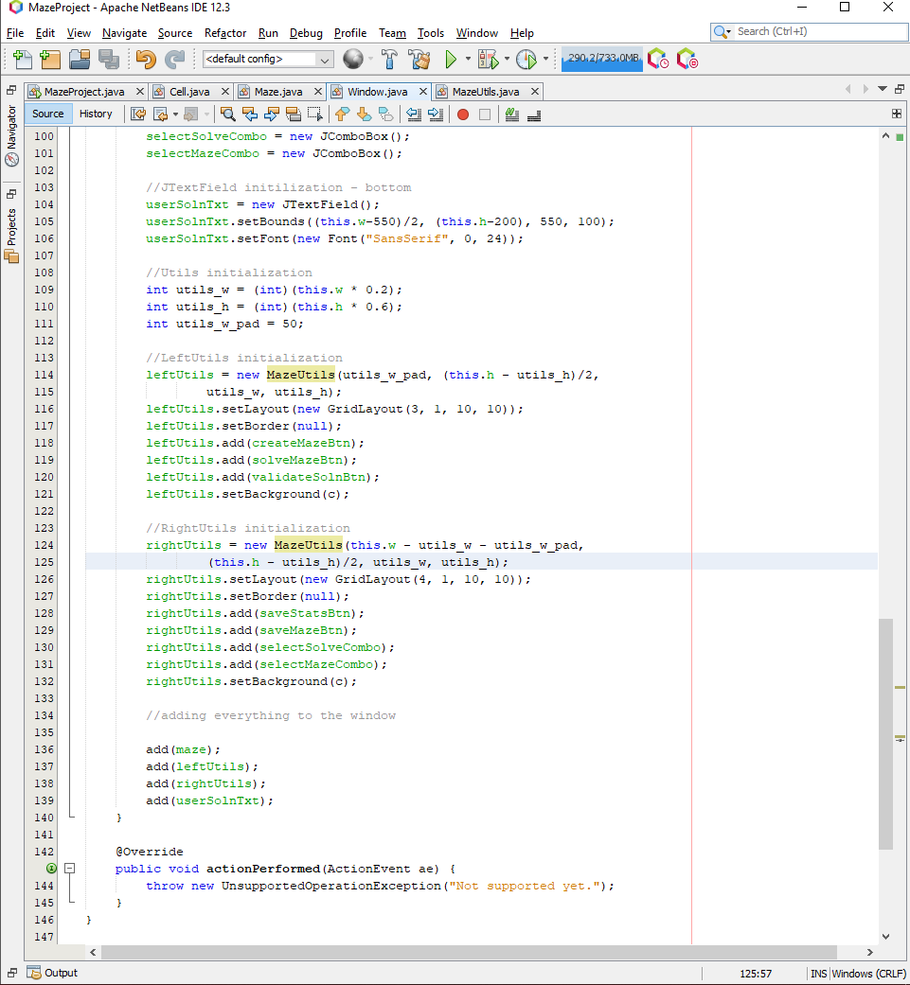

I define some variables which define the width and height of the leftUtils and rightUtils. These are then used to position the pairs of maze utils within the window. The leftUtils is positioned to the left of the screen with gridlayout and padding between each of the buttons. Each of the buttons previously initialised is added to the leftUtils container, the background is set to match the background of the window.

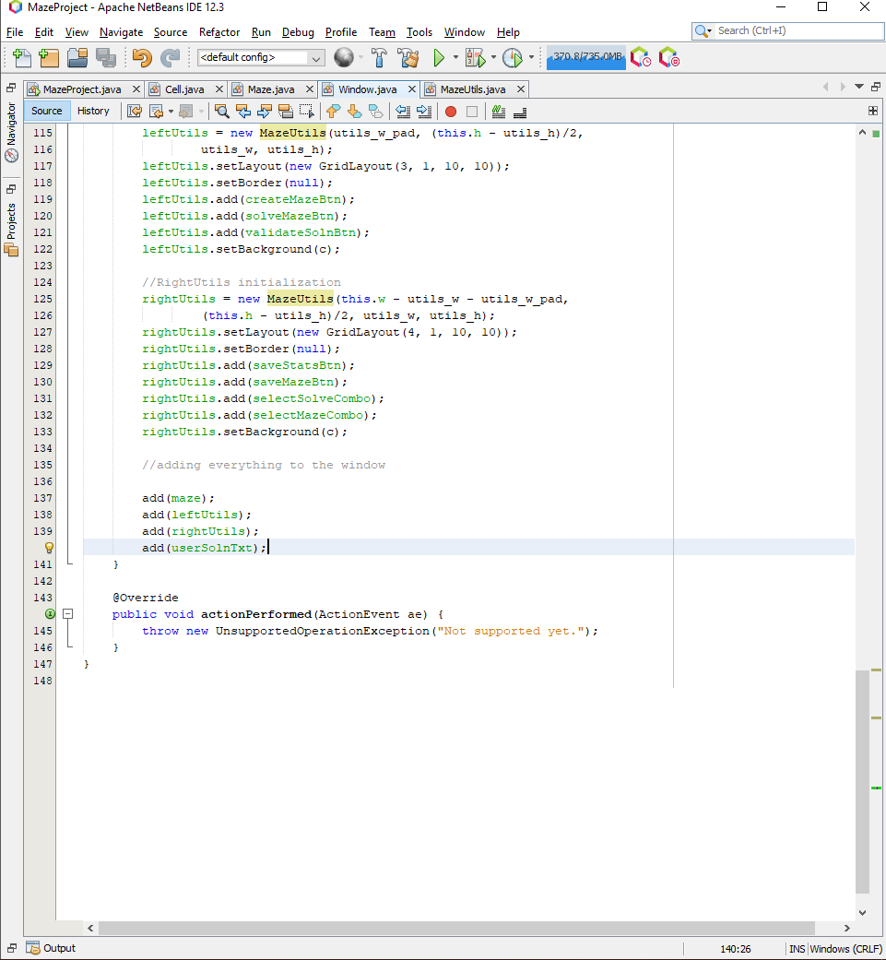

I then added the leftUtils and rightUtils container to the window.

Running the program with the newly added components provides this output:

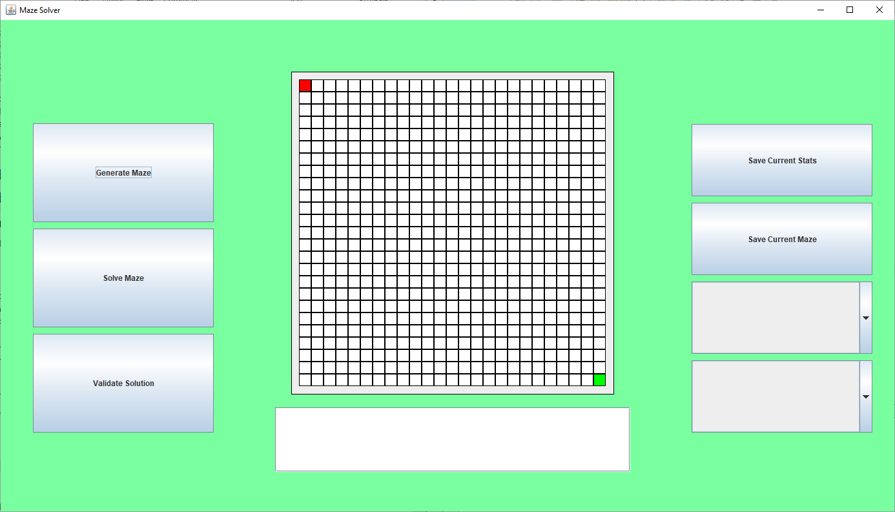

This is as intended, the leftUtils container contains the buttons added and presents them to the left of the screen with padding between the buttons, the rightUtils container contains the buttons and combo boxes added and presents them to the right of the screen with padding between them, the colours of the background of the containers matches the background of the window which makes the window look nicer and neater.

### Testing

This section is where I test each aspect of this development phase to check of any faults during the development process during this phase. The ‘Test #’ is referenced throughout the implementation phase and is used to reference each test throughout the implementation process.

#### test table

|  |  |  |  |  |  |
| --- | --- | --- | --- | --- | --- |
| Test # | Test Type | Test Data | Expected | Actual | Success (?) |
| 1 | Normal | Setup a window, just with a maze positioned in the centre of the screen | The maze should be presented in the centre of the screen | The maze was centred in the middle of the window, as intended | Success |
| 2 | Normal | Add the text field to the window, and see if it appears as intended, below the maze | The text field should be positioned just below the maze and should be visible when the window is visible | The text field is positioned below the maze and can be seen when the window is visible | Success |
| 3 | Normal | Setup the leftUtils and rightUtils containers, adding in the necessary components | Once added, the window should present the leftUtils buttons on the left and the rightUtils buttons and combo boxes on the right | The window presents the leftUtils and rightUtils on the left and right respectively | Success |

### Evaluation

During this phase, I implemented the solution based on the prototype presented in phase 1 of the GUI design. The implementation tests went through smoothly with little to no errors during the testing of each GUI arrangement and the addition of new components did not introduce any problems.

## Phase 3 (The Maze – Maze Generation)

This phase is to build on the functionality of manipulating the maze, specifically generating mazes within it.

### Design

Firstly, the design section is going to contain all the essential variables, classes, data structures and validation which is essential before deciding to implement the solution.

#### Variable tables

|  |  |  |
| --- | --- | --- |
| Name | Type | Justification |
| stack | Stack | This structure is essential for DFS because the stack is needed to hold currently traversed nodes, so they can be popped and their neighbours can then be traversed |
| queue | Queue | This structure is essential for BFS because the queue is needed to hold the next in queue, where the neighbours of a currently traversed node and queued up, then each a popped from the queue as they are traversed |

#### Classes and data structures

##### Stack

The stack data structure is used to hold data into a FILO type routine where the first element added to the stack is the last to exit the stack. This is useful when state is needed to be reserved and retrieved such as DFS, where once the traversal of one ‘branch’ has finished, one would need to return to the head of the tree, to traverse down its alternative paths.

##### Queue

The queue data structure is used to hold data into a FIFO type routine where the first element added to the queue is the first element to leave the queue. This structure is necessary when a routine of queuing up elements to be served where the first element queued is the first to be executed, such as BFS where a node is selected, the neighbouring nodes are pushed onto the queue and they are each traversed in turn as their neighbours are also placed into the queue, given that their neighbour is a path to be traversed that has not already been traversed.

#### Validation

Since the user must select an algorithm, they wish to be used to generate the maze, the validation will include the user selecting an algorithm using the combo box on the left, which will list a set of usable generation algorithms, where the user will be prompted otherwise to select an algorithm if one is not selected. This is yet to be developed in this phase, hence there is no validation during this phase of the development.

### Implementation

This section will include pseudocode for the procedures which are going to be used throughout the solution of this phase, and the source code for the implementation of the solution for this phase.

#### Pseudocode

These will be a member functions of the maze class and will therefore have access to the mazes’ attributes such as the matrix Array List.

##### get_neighbours

procedure get_neighbours(index)

neighbours = []

x = index MOD matrix_w

y = index DIV matrix_w

left = (x – 2) + (y * matrix_w)

right = (x + 2) + (y * matrix_w)

up = x + (y – 2) * matrix_w

down = x + (y + 2) * matrix_w

if (x – 2) >= 0 AND NOT matrix[left].check_state(VISITED) then

neighbours.append(left)

endif

if (x + 2) < matrix_w AND NOT matrix[right].check_state(VISITED) then

neighbours.append(right)

endif

if (y – 2) >= 0 AND NOT matrix[up].check_state(VISITED) then

neighbours.append(up)

endif

if (y + 2) < matrix_h AND NOT matrix.get(down).check_state(VISITED) then

neighbours.append(down)

endif

return neighbours

endprocedure

##### BFS

procedure BFS()

queue = new Queue()

index = end_pos

current_cell = matrix[index]

Current_cell.add_state(VISITED)

do

neighbours = get_neighbours(index)

if len(neighbours) != 0 then

neighbour_index = neighbours[randrange(len(neighbours))]

neighbour_cell = matrix[neighbour_index]

queue.add(neighbour_index)

index = neighbour_index

current_cell = neighbour_cell

current_cell.set_state(PATH)

current_cell.add_state(VISITED)

else

index = queue.remove()

current_cell = matrix[index]

endif

while !queue.empty()

endprocedure

##### DFS

procedure

stack = new Stack()

index = end_pos

current_cell = matrix[index]

current_cell.add_state(VISITED)

Do

neighbours = get_neighbours(index)

if len(neighbours) != 0 then

neighbour_index = neighbours[randrange(len(neighbours))]

neighbour_cell = matrix[neighbour_index]

stack.push(neighbour_index)

index = neighbour_index

current_cell = neighbour_cell

current_cell.set_state(PATH)

current_cell.add_state(VISITED)

else

index = stack.pop()

current_cell = matrix[index]

endif

while !stack.empty()

endprocedure

These are the most important algorithms which are going to be used in this part of the cycle, getting the maze generation for the program working, where further required algorithms will be developed in cycles soon to come.

#### Source code

Firstly, I needed to reinstate the methods for the Cell class so I can manipulate the state of the cells within the maze. So firstly, I implemented a few more member functions for the cell class which would allow for state manipulation:

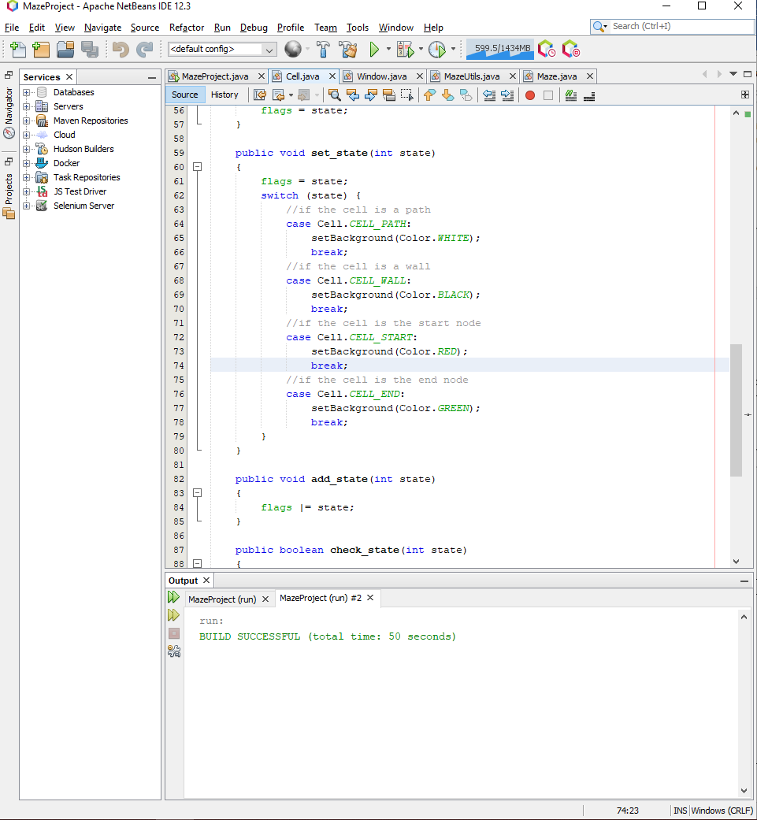

This procedure will take in a state and will assign the cell’s state to that new state, this will completely erase any saved state within the cell and is useful for removing any saved state such as being visited which no longer applies for that cell.

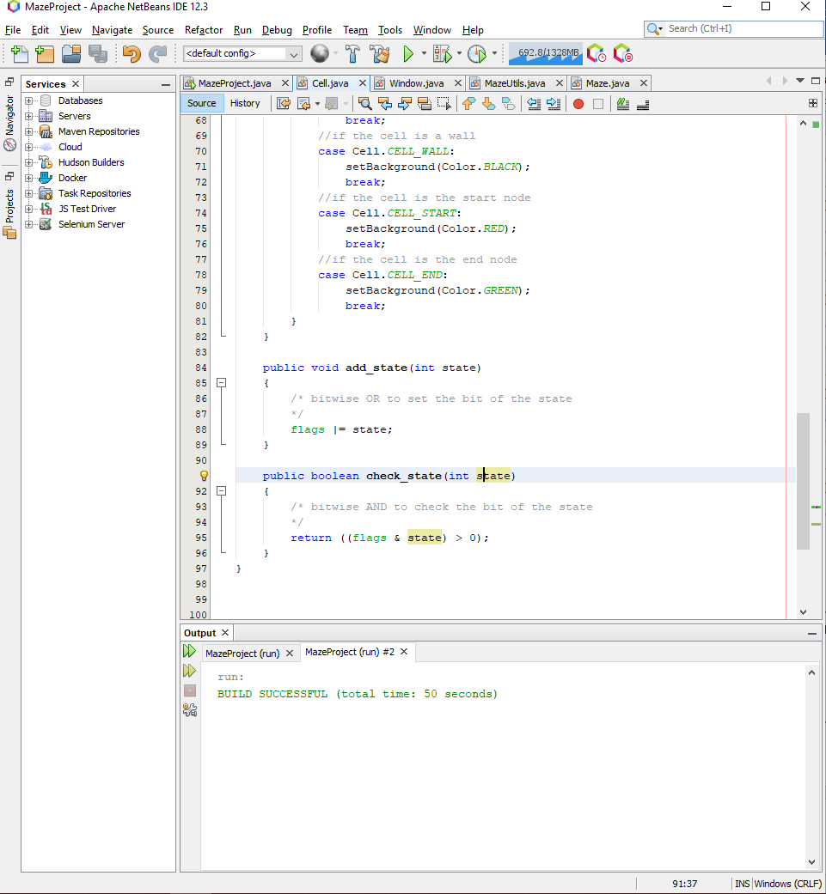

The first procedure can add states to the current state of the cell, this will be useful for maintaining state such as the state of the cell being a wall or a path, and saying that the cell is visited, this is done with OR bit-manipulation.

The second function returns a Boolean if the current state of the cell has the bit set for the entered state. This is useful for checking for whether the cell has been visited during a maze generation or solving algorithm.

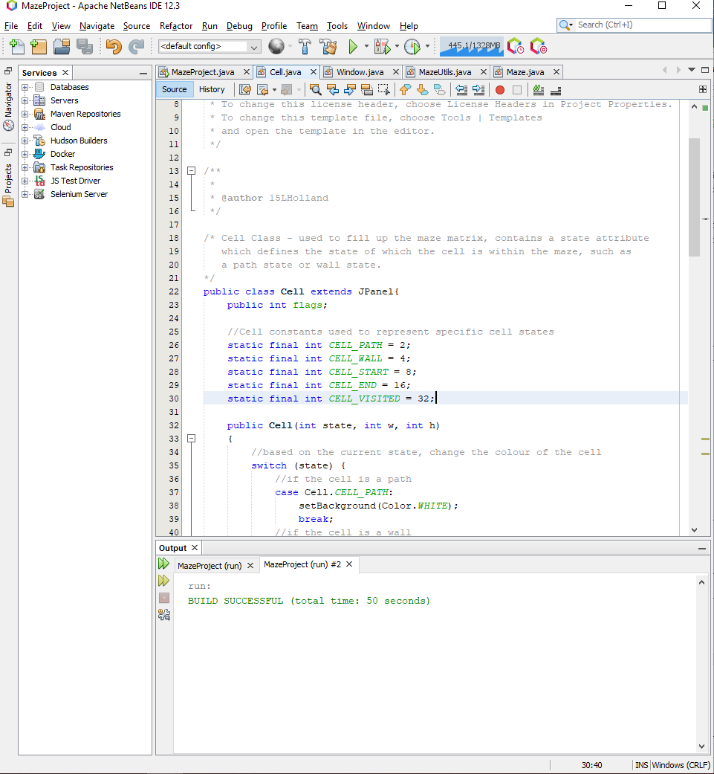

For convenience, I defined some constants which define the state of a cell, they represented powers of two which could be bitwise AND or bitwise OR to set and check cell state.

As the BFS and DFS algorithms are dependent on the get_neighbours function, I decided to implement it first:

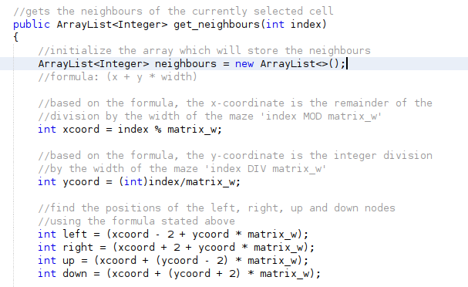

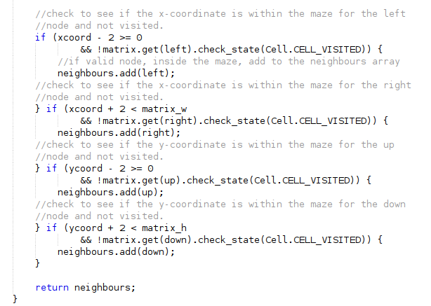

This function is used to get all the adjacent nodes of the currently selected node. This will aid the maze generation and search algorithms when they are searching for the available paths they can traverse.

I decided to test the function with the following:

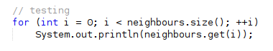

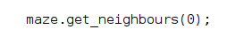

Running this line of code for an index of 0 should contain an array of two indexes, for the right and the bottom. The testing code presented above should therefore print 2 and 2 * matrix_w which in this case is 26, hence the two outputs should be 2 and 52:

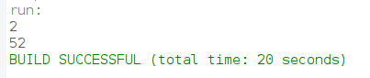

The expected result follows true; therefore, the test was successful for test #1.

Then, I decided to implement the BFS algorithm which would generate the maze:

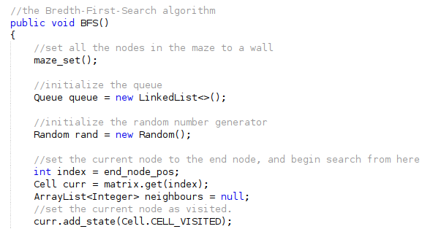

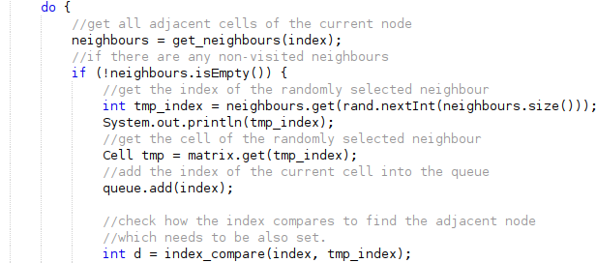

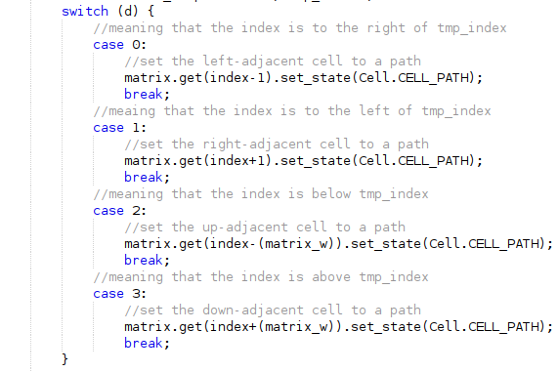

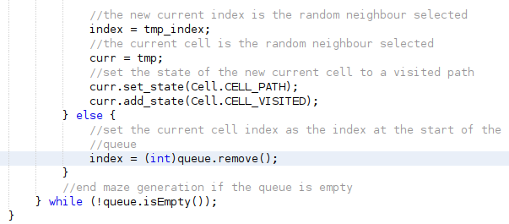

A few changes differ from the original pseudocode implementation, I have defined the end_node_pos as the start of the maze generation where its state is set to visited so it is not traversed and set to a path. The changes made are to check for the adjacent cell which is to be set as a path which is adjacent to the randomly selected neighbour.

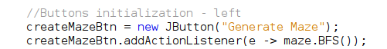

Setting the createMazeBtn’s function as BFS generation algorithm, I can test to see if the BFS algorithm works as intended:

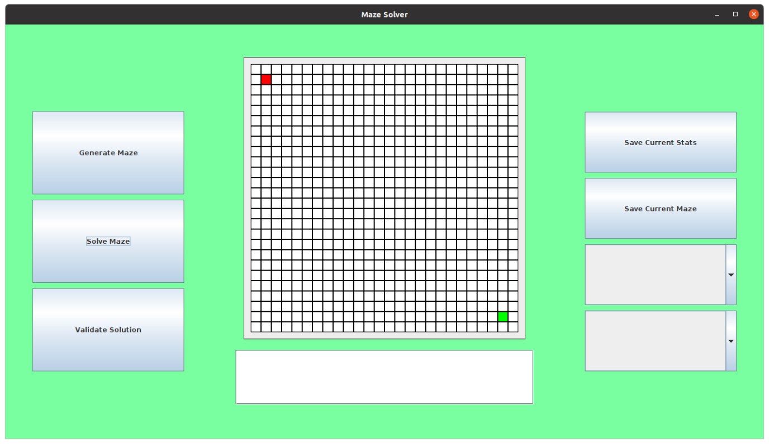

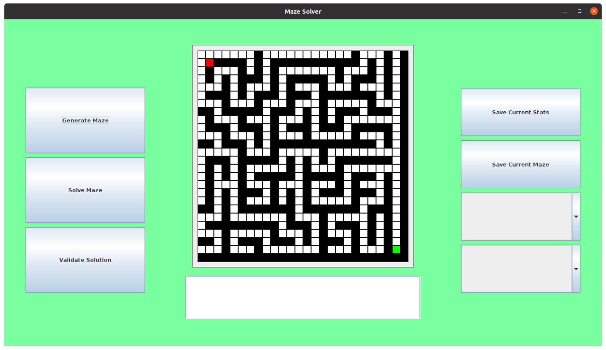

This is the response to pressing the button, obviously it seems clear that the maze is not big enough to support the algorithm because the maze is generated successfully but is incapable of generating the top and left border. In order to verify this, I decided to change the width and height of the maze to see if the algorithm would work for large dimensions:

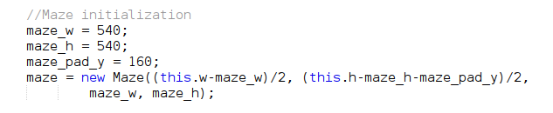

I have defined some variables for the width and height of the maze which is to be used through the initialization process as well as a padding from the bottom. Apart from this, I have changed the maze_w and maze_h from the original 520 by 520 to 540 by 540. The reason for this is because it seems the maze needs an odd number of cells in order to generate the extra walls around the maze and 520/20 = 26 which is even but 540/20 = 27 which is odd. With this new change I check the new output:

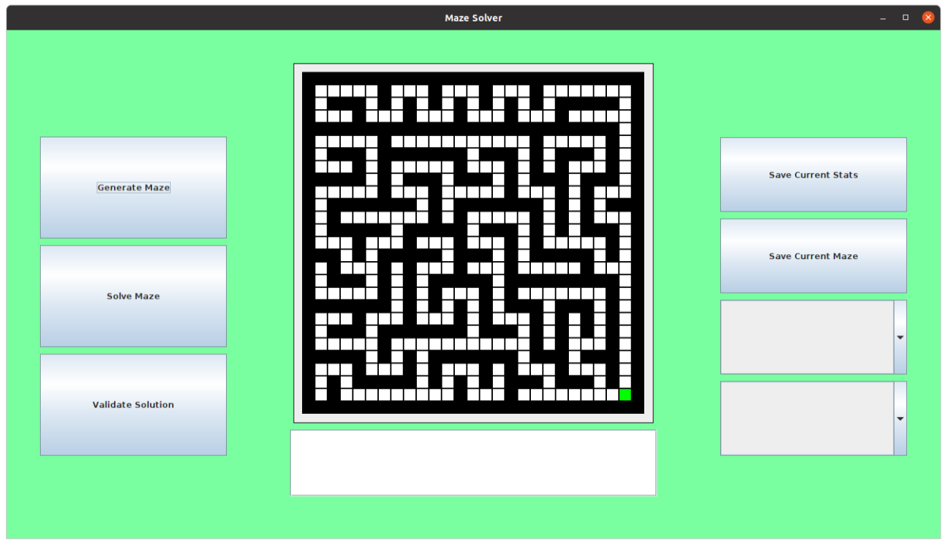

This shows that the issue was not the algorithm but the dimensions of the maze, hence the test failed for test #2, although it works now. However, it is noticed that the start node is erased, this can simply be returned to original state by setting the start node’s state back to the start node:



With this line of code, generating a maze now shows the following output:

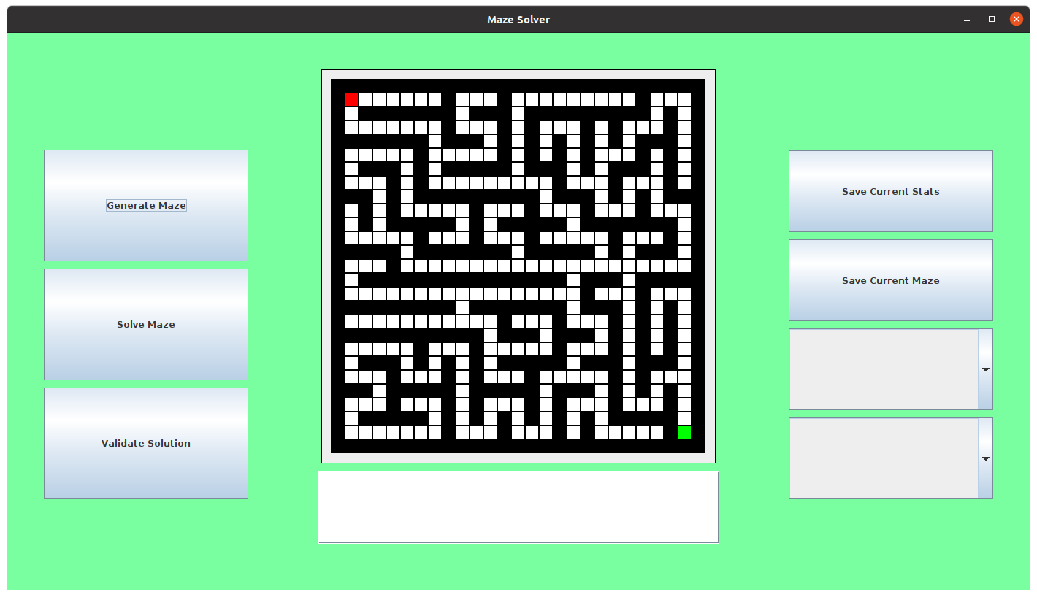

The start node is displayed after the maze is generated. Now I must write the DFS algorithm which shares the same characteristics, but the data structure used to back track is the stack instead of the queue:

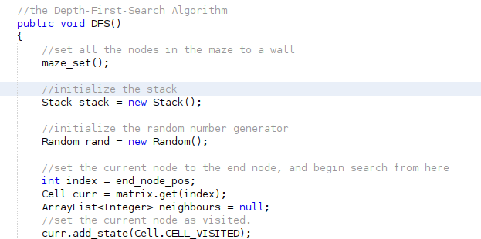

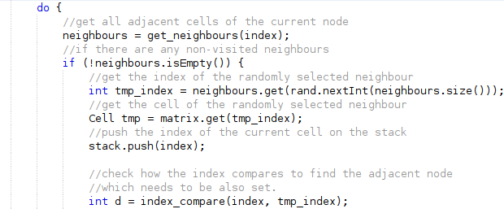

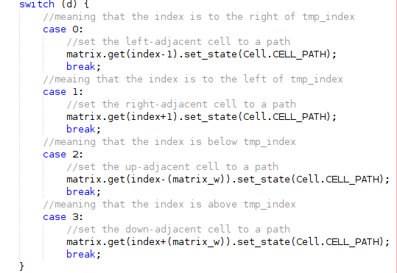

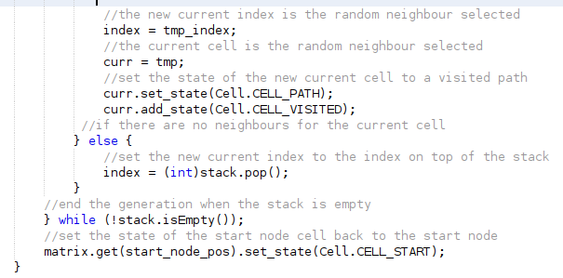

The implementation of the BFS algorithm looks like the DFS implementation, the only noticeable difference is the use of the stack instead of the queue data structure.

Testing the algorithm by setting the maze generation button to use the DFS algorithm:

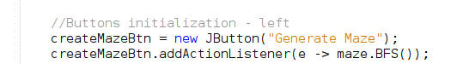

Then running the program and pressing the button shows the following:

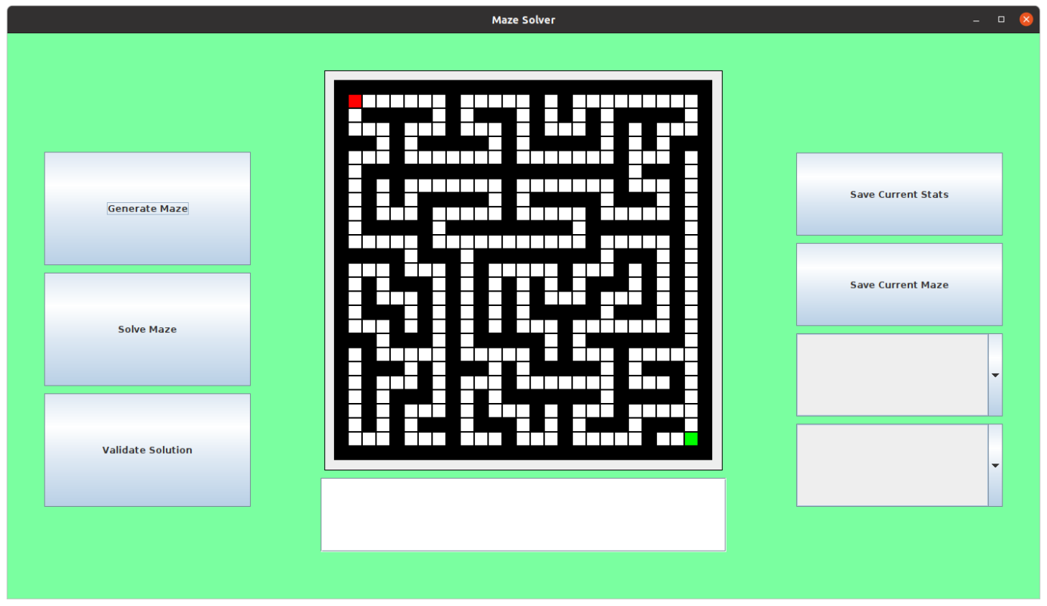

This works as intended and therefore is successful for test #3.

### Testing

#### Test table

|  |  |  |  |  |  |
| --- | --- | --- | --- | --- | --- |
| Test # | Test Type | Test Data | Expected | Actual | Success (?) |
| 1 | Normal | Check to see if the get_neighbours function returns an array which contains 2 and 52 for an input of 0. | The function should return an array containing all the available adjacent nodes for the given input. | The function returns an array containing indexes 2 and 52 for an input of 0 | Success |
| 2 | Normal | Check to see if the DFS maze algorithm works as intended. | The algorithm should display a carved series of paths which eventually connect the start and end node together, with long hallways and some dead ends. | The function presented unordinary output for even width and height dimensions but for odd width and heights. | Failed |
| 3 | Normal | Check to see if the BFS maze algorithm works as intended. | The algorithm should display a carved series of paths which eventually connect the start and end node together, with short hallways and many dead ends. | The algorithm presented the correct output and generated a maze successfully. | Success |

### Evaluation

Concluding the third phase, I have developed the core algorithms used for maze generation: DFS and BFS, in further phases to come, I will create more generation algorithms to be used. But the next phase will be maze solutions using BFS and DFS, getting the maze functionality working as intended.

## Phase 4 (The Maze – Maze Solving)

This phase is based solving the generated mazes with BFS and DFS algorithms. The aim is to create algorithms which can solve any given maze generated.

### Design

For the design, I am going to define the variable I will use for this section and the outline the specific classes and data structures I am going to use.

#### Variable Table

|  |  |  |
| --- | --- | --- |
| Name | Type | Justification |
| stack | Stack | It is needed for the DFS search algorithm. It is like the DFS maze generation algorithm as stated in the previous stage, it will be used to store the indexes of the cells. |
| queue | Queue | This is needed for the BFS search algorithm. It is similar to the BFS maze generation algorithm as stated in the previous stage, it will be used to store the indexes of the cells. |

#### Classes and Data structures

The data structures listed have already been covered in the previous phase but are useful in the development of the next phase.

##### Stack

The stack data structure has been covered previously. The stack data structure is a simple data structure, usually an array or linked list with methods to push on to the top of the stack and to pop off the top of the stack, it is a FILO type structure.

##### Queue

The queue data structure has also been covered previously. The queue data structure is a simple data structure, usually an array or linked list with methods to add to the end of the queue and to remove from the front of the queue, it is a FIFO type structure.

#### Validation

Validation is yet to come in a future phase in the development. The validation regarding this section would be to only let the user search the maze is when they have first selected an algorithm to use by using the combo box on the right, like the validation in the previous phase. However, this validation is yet to come in the next phase of maze search development.

### Implementation

In this section I will write the pseudocode necessary for the algorithms which are going to be used to solve the specified maze.

#### Pseudocode

I later realised that my implementation of BFS in the previous phase is incorrect and that BFS is not suitable for maze generation, DFS is the most suitable for maze generation, hence my pseudocode differs from the previous pseudocode. The BFS pseudocode only has a small difference which is clear in the pseudocode, in the BFS algorithm all the neighbours which are found, which are adjacent to the current cell, are to be added to the queue. In order to trace back the path I need to keep an array which stores a clear link between cells. Once the path has been generated I can loop through the found path and highlight it.

##### BFS

procedure BFS()

queue = new Queue()

queue.add(start_node_pos)

current_cell = matrix[start_node_pos]

current_cell.add_state(VISITED)

path = [0 for i in range(len(matrix))]

while !queue.empty() then

index = queue.remove()

neighbours = get_neighbours(index)

for neighbour in neighbours

neighbour_cell = matrix[neighbour]

queue.add(neighbour)

neighbour_cell.add_state(VISITED)

path[neighbour] = index

next neighbour

endwhile

for index in path:

cell = matrix[index]

cell.set_state(SEARCHED)

next i

endprocedure

#### Source code

Now, I decided to implement the BFS algorithm but came to realisation that the algorithm would not work with the current state of the get_neighbours function. The get_neighbours function returns neighbours which are of distance 2 from the current node by default, where for the search algorithm I would need neighbours which are perfectly adjacent, only 1 distance away. Therefore, I decided to add some additional functionality to the get_neighbours function to adapt it to anything I needed to use the function for:

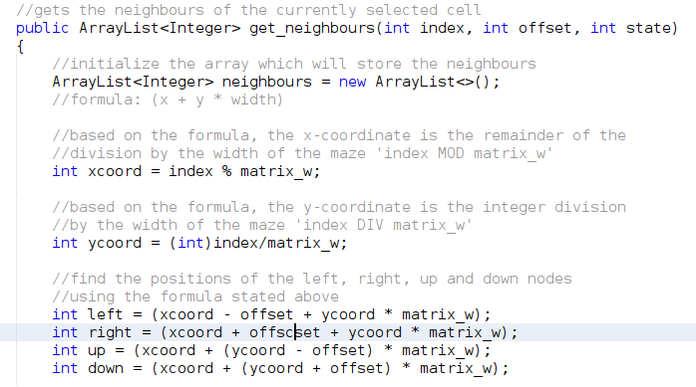

As you can see the function header as changed, the function header now consists 3 arguments instead of just 1. The offset argument is the number of nodes I want to search from relative to the current node. The state argument is the state of the cell which I don’t want the neighbours to have set, this is useful in checking if the neighbours are not walls and are not visited which tends to be useful in the implementation of the BFS algorithm, with this change, it has been updated where necessary.

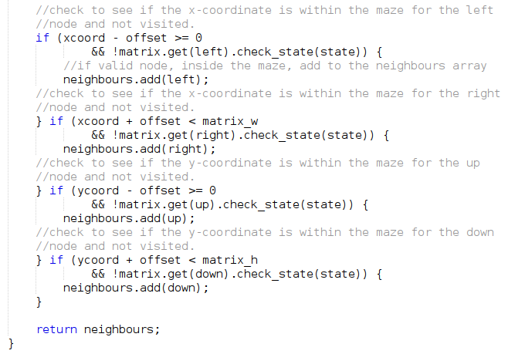

The rest of the function remains the same with the variables replacing the previous constant states and offsets.

I checked to see if the function worked as intended:

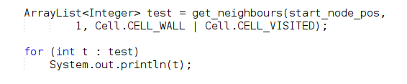

This should return the indexes of the top, left, right and bottom as the integers in the array list. Which in this case should be: 1, 27, 29 and 55 where start_node_pos = 28:

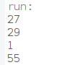

Which works as intended, showing it is a success for test #1.

Then I decided I would need an extra state to represent the highlighted path and an extra function to provide full control over the cells in the maze:



I added the CELL_SEARCHED state to represent the state of a cell which has been traversed during a maze traversal.

I further updated the cell’s constructor function and set_state function to work alongside the extra added state:

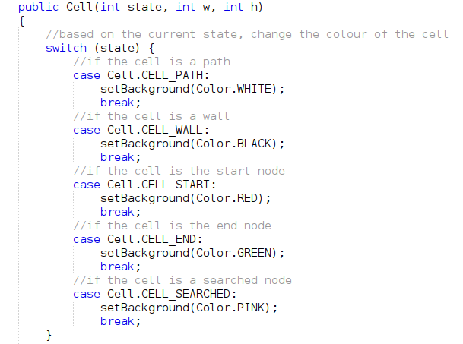

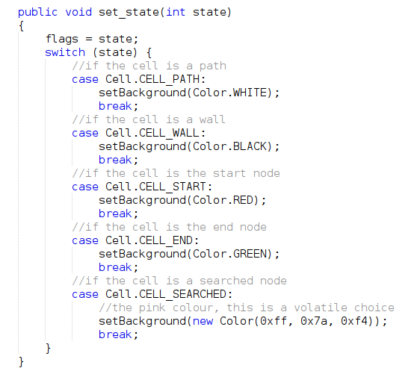

The colour I decided to choose is the colour I presented previously in the first phase showing the designs of the application and the different background colours I was going to use. I also added a remove_state to the cell class which is useful for removing states from the cell, such as declaring a cell as no longer visited before another call to the maze generation or another call to a maze search:

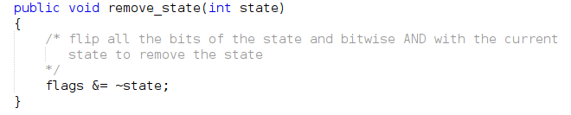

This simply uses ~ operand to flip the bits of the state number and bitwise AND with the current state of the cell, this is a way of removing a bit from a number.

I checked to see if the remove_state function works as intended:

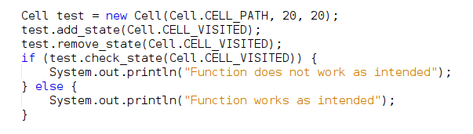

And after running this code, the following is printed:



Therefore, test #2 is successful.

Now, with those extra features added I decided to finally implement the BFS search algorithm:

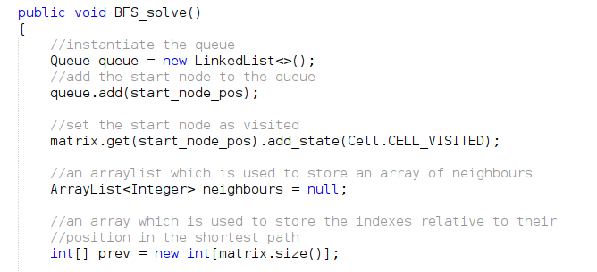

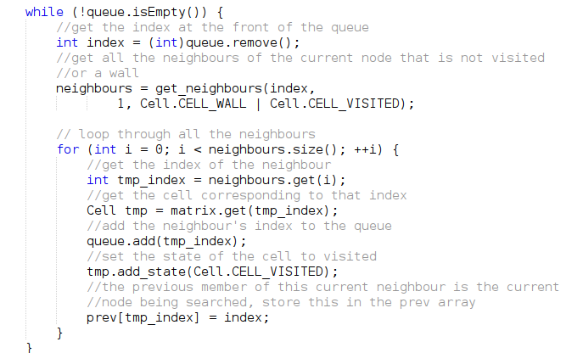

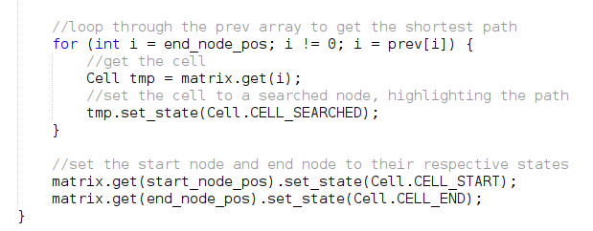

This is the BFS algorithm, it makes use of the queue data structure, pushing all the neighbours onto the queue of the currently selected index, and searching all the neighbours and their neighbours until there are no more nodes to search, storing the indexes and their previously searched nodes into an array called prev. This prev array is used to then backtrack from the end node back to the start node to trace the shortest path. When running this algorithm on any maze it will present the shortest path:

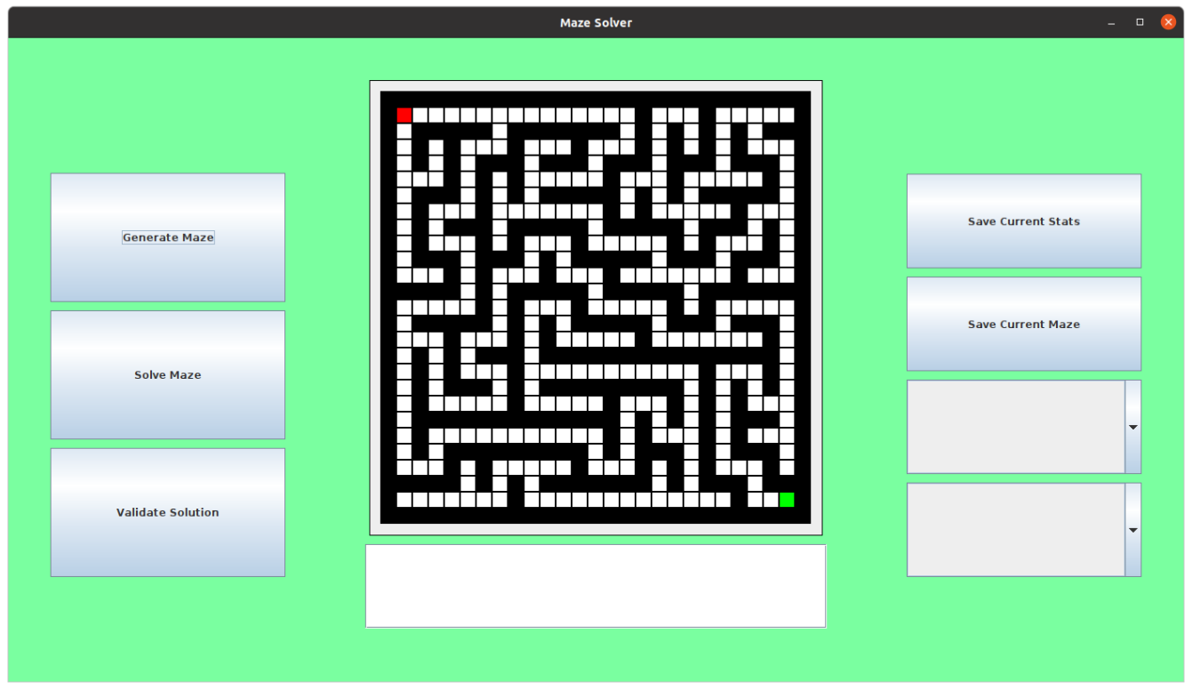

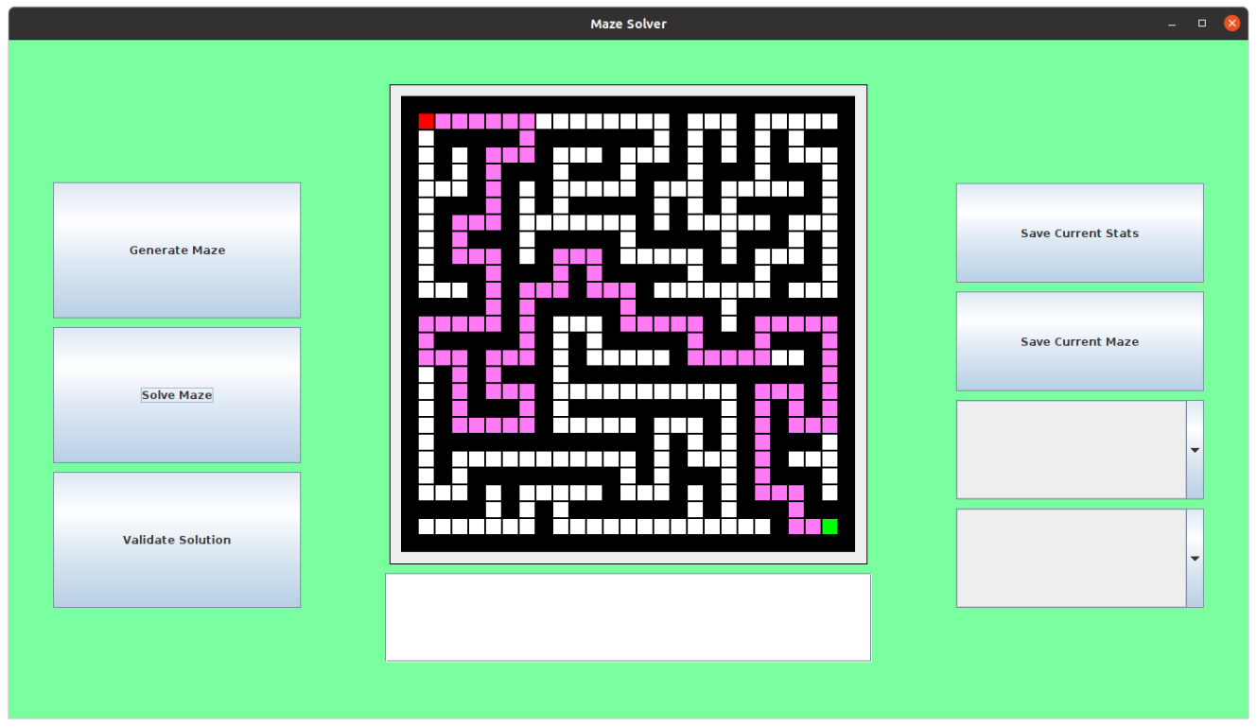

This shows that test #3 works as intended.

### Testing

#### Test Table

|  |  |  |  |  |  |
| --- | --- | --- | --- | --- | --- |
| Test # | Test Type | Test Data | Expected | Actual | Success (?) |
| 1 | Normal | Check the new version of get_neighbours to see if gets the correct neighbours for the index 0 | It should return 1 and 27 | It returned 1 and 27 | Success |
| 2 | Normal | Check if the remove_state function works as intended by creating a cell with a path state with an additional visited state, and remove the visited state | The visited state should be removed and check_state should return false when checking for the visited state | The visited state was removed as the check_state returned false causing “Function works as intended” to be printed | Success |
| 3 | Normal | Check the BFS algorithm for the generated maze, see if the shortest path is generated | The shortest path is generated, highlighted in a pink-like colour | The shortest path is generated as expected and the path is highlighted in the pink-colour | Success |

### Evaluation

In this section, I added additional features to the cell class, and improved the get_neighbours function, finally implementing one of the maze solving algorithms, BFS. I had come to the realisation that the BFS algorithm was only suitable for solving mazes and not generating them. A DFS algorithm would also not be suitable for solving mazes as it would not get the shortest path all the time and would therefore not be an efficient solution. Other algorithms for this purpose will be implemented in future phases, but currently it is obvious that solving mazes with the current design is possible.

## Phase 5 (The Maze – User Solution Verification)

In this phase, I will be creating the method of validating a user solution. The user can enter in a string of moves with magnitudes next to them, which will traverse the maze, and notify the user if the solution was successful.

### Design

#### Variable Table

|  |  |  |
| --- | --- | --- |
| Name | Type | Justification |
| user_solution | String | This will contain the user’s entered solution and will contain a series of ‘L’, ‘R’, ‘U’, ‘D’ characters with their respective magnitudes and will be parsed into a series of moves which are translated into a solution for the given maze. |
| userSolnTxt | JTextField | This is where the user can enter their solution for the given maze, this is needed to allow the user to enter their solution through the application. |
| validateSolnBtn | JButton | This is the button which is pressed in order to validate the entered solution, it will invoke a procedure which will parse the entered solution and check if it solves the maze. |
| soln_parser | SolnParser | This will parse the data that the user enters |

#### Classes and Data structures

##### SolnParser

This data structure will act as a queue like structure which contains the string entered, it will parse the string into a series of codes which represent a direction and magnitude which can then be translated into moves within the maze.

#### Validation

The text entered by the user will need to be validated and checked whether the user entered a solution which includes characters which belong to the set of characters which are allowed. If they do not fit in the set of characters defined by the parser, the user will be prompted to enter a valid solution.

### Implementation

#### Pseudocode

##### SolnParser

class SolnParser

PARSER_SUCCESS = 1

PARSER_ERROR = 2

PARSER_EOF = ‘\0’

ptr = 0

procedure parse(soln)

if ptr >= len(soln) then

return PARSER_EOF

buffer = “”

flag = 0

for i = 0 to len(soln) – 1 then

curr = soln[i]

if curr == ‘R’ OR curr == ‘L’ OR curr == ‘U’ OR curr == ‘D’ then

flag = flag + 1

endif

if flag >= 2 then

break

endif

buffer = buffer + curr

next i

ptr = i

return buffer

endprocedure

endclass

##### Validate

procedure validate(soln)

parser = new SolnParser()

buffer = “”

x = start_node_pos MOD matrix_w

y = start_node_pos DIV matrix_w

while (buffer = parser.parse(soln)) != PARSER_EOF then

direction = buffer[0]

mag = int(buffer[1:len(buffer)])

switch (dir)

case ‘D’

for i = 0 to mag – 1

y = y + 1

index = (x + y * matrix_w)

tmp = matrix[index]

tmp.set_state(CELL_SEARCHED)

next i

break

case ‘U’

for i = 0 to mag – 1

y = y - 1

index = (x + y * matrix_w)

tmp = matrix[index]

tmp.set_state(CELL_SEARCHED)

next i

break

case ‘L’

for i = 0 to mag – 1

x = x – 1

index = (x + y * matrix_w)

tmp = matrix[index]

tmp.set_state(CELL_SEARCHED)

next i

break

case ‘R’

for i = 0 to mag – 1

x = x + 1

index = (x + y * matrix_w)

tmp = matrix[index]

tmp.set_state(CELL_SEARCHED)

next i

break

endswitch

endprocedure

The validate procedure is a member function to the maze class and will use the SolnParser to parse the solution, once the solution is entered the solution will then be parsed into a buffer, the buffer will contain each individual ‘instruction’ entered in by the user, these instructions will be translated into movements within the maze.

#### Source code

Firstly, I decided to implement the new SolnParser class and test the features when it came to parsing an entered solution:

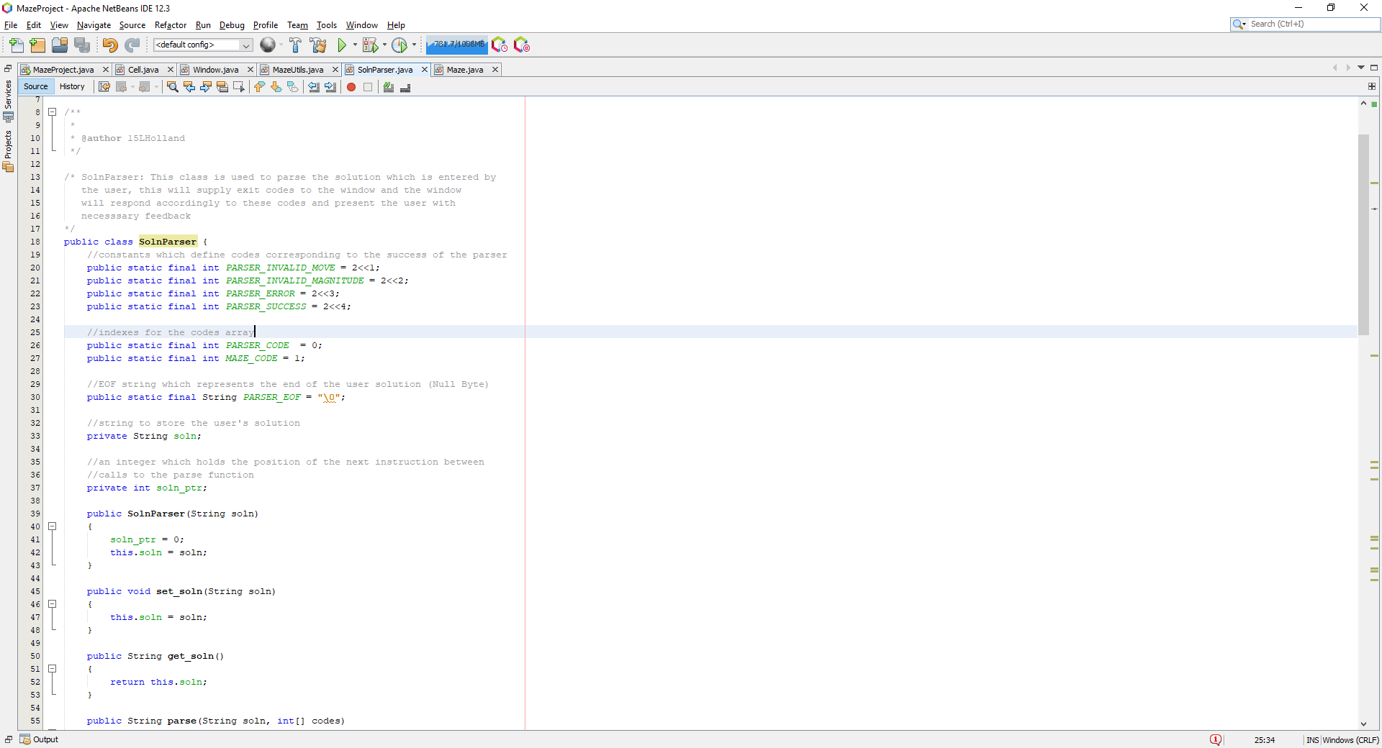

I decided to define some constants which define codes related to the success of the parser, these would be returned and sent to the window for which the window can respond accordingly such as showing the user a window which tells the user they have made an error. Furthermore, I wanted a way to handle errors which arise from the parser, so I have a codes array which stores error codes corresponding to the error of the parser and error of the maze itself. This is what differs from the original source code because the validate procedure is now a function which returns an array containing the codes raised by the parser and the maze:

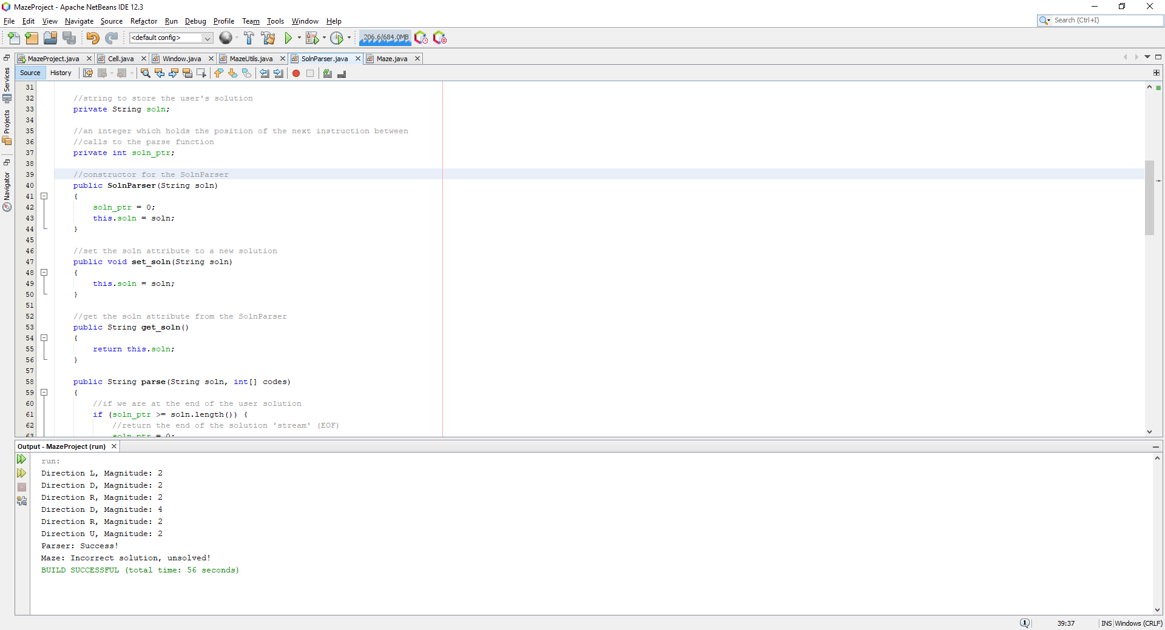

I have two private variables which are used to store the solution which is what the variable ‘soln’ is for, and a pointer to the first letter of the next instruction to be parsed. It contains a constructor which initializes the pointer to zero and assigns a new solution to the soln attribute, it also has a getter to get the solution from the SolnParser and a setter to set the soln attribute.

I then decided to implement the parser function for the SolnParser class:

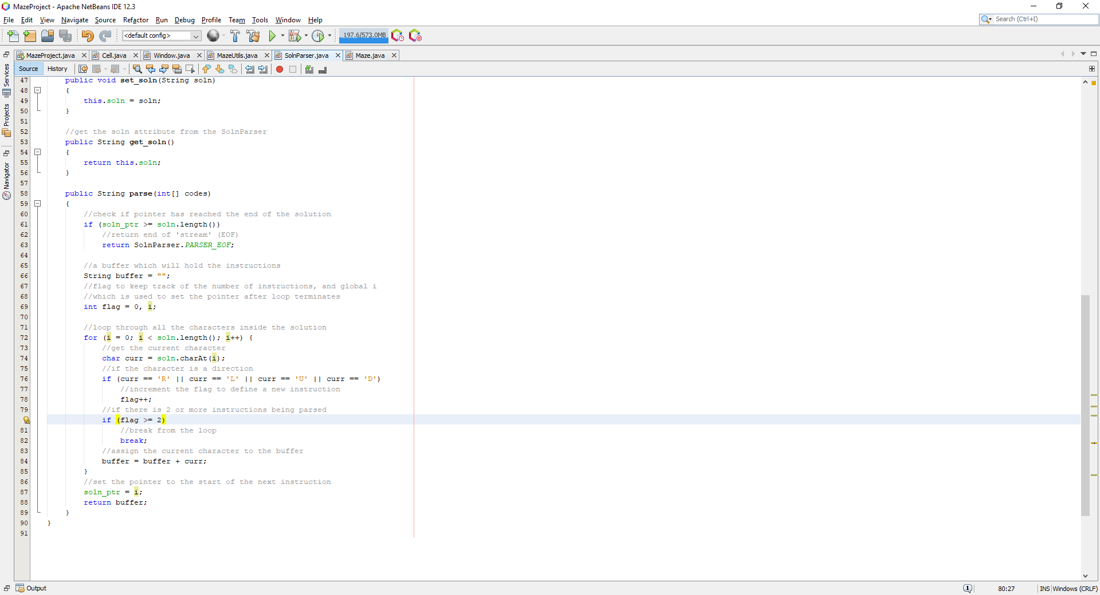

This is the same as the pseudocode created. It will check to see if the end of the solution has been reached, if the end of the solution has not been reached, continue, else return the end of the stream which will terminate the parsing process. A buffer will hold the current instruction and a pointer will be updated to hold an index to the next instruction. The buffer is finally returned and processed by the validate function.

I wanted to test to see if the function worked as intended by checking to see if the function would return all the individual instructions which are present in multiple types of solutions:

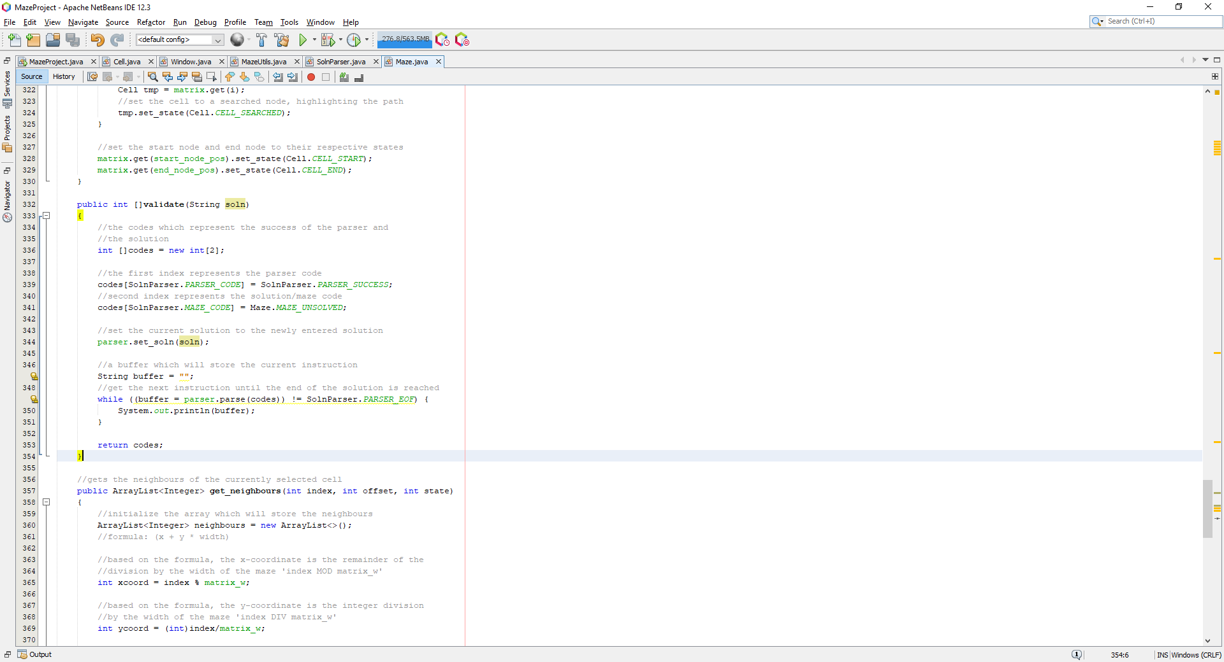

To do so I had to create a simple test which would occur inside the validate member function in the maze class. The maze class now has another attribute called parser of type SolnParser which is used to parse the solution:

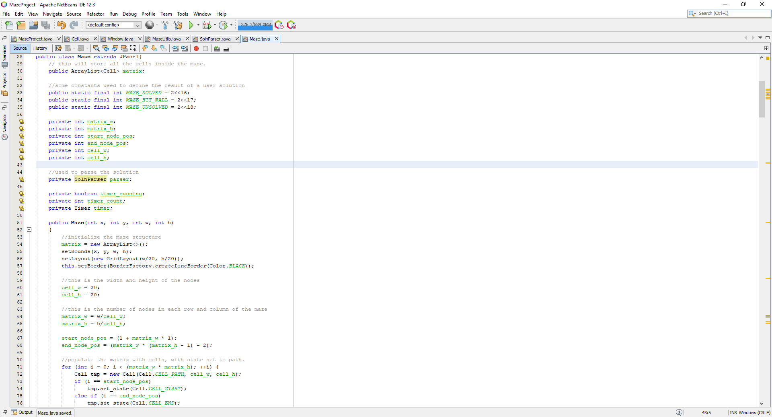

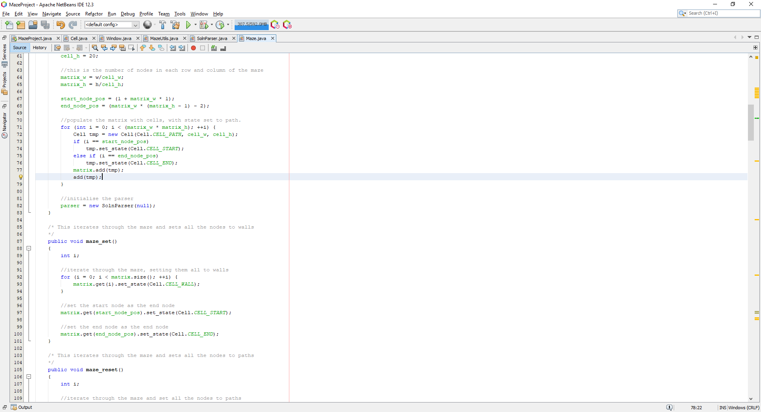

Then I needed a way to get the solution entered into the text box into the parser, so I defined a procedure in the Window class which would be called when the validate solution button is pressed:

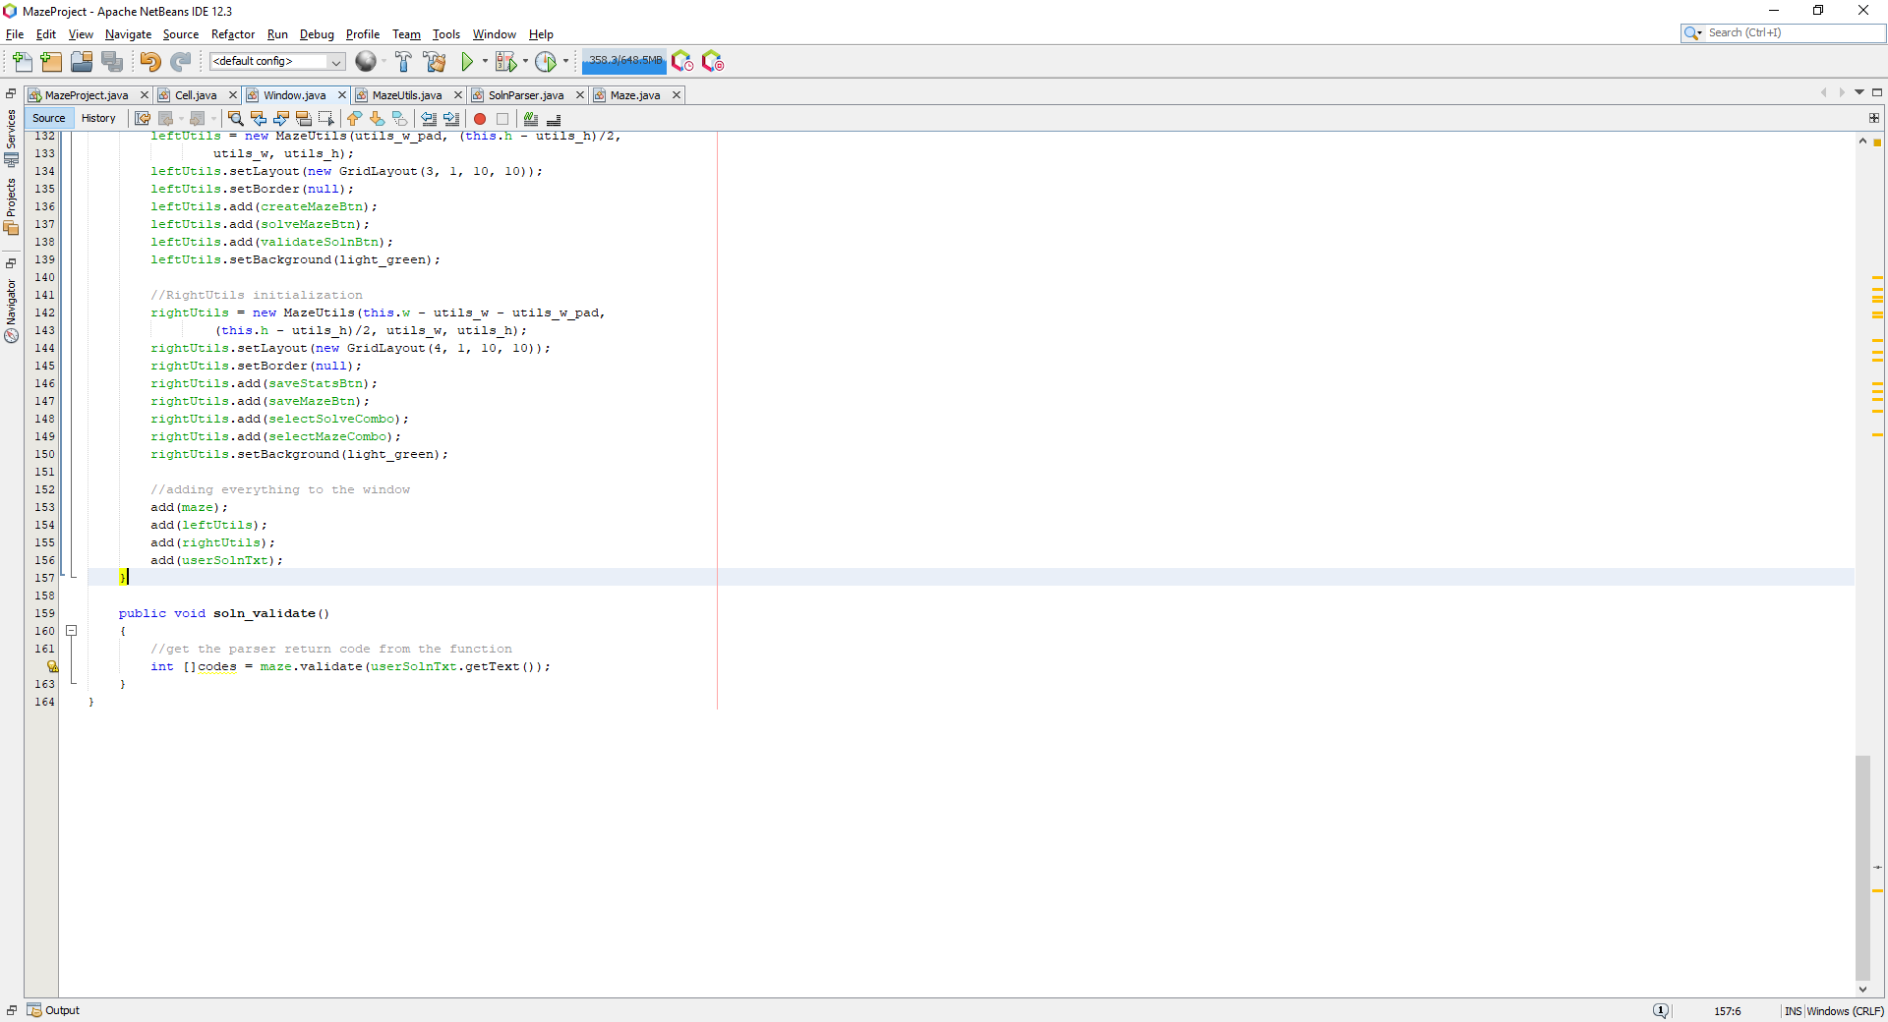

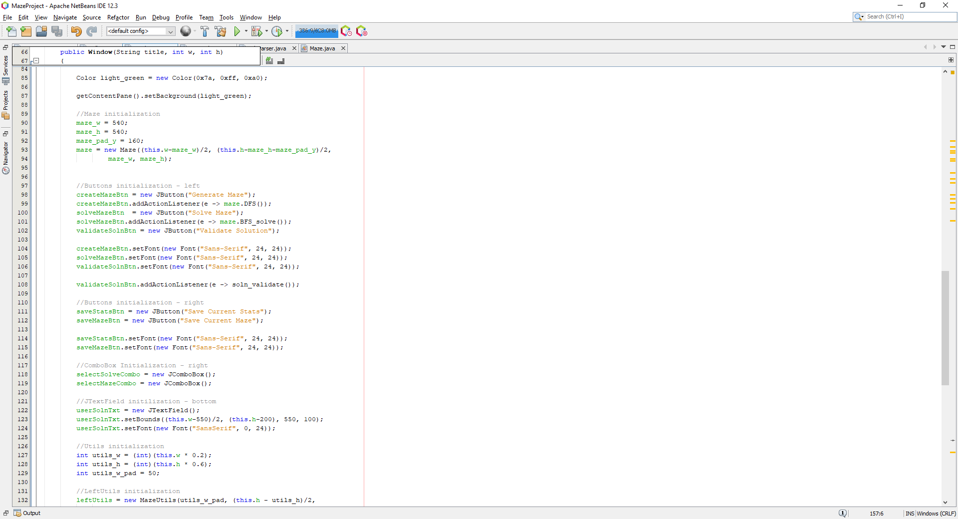

Now to test to see if the program works I entered a simple string of characters which would in theory when implemented, move the node 2 to the left and 2 down:

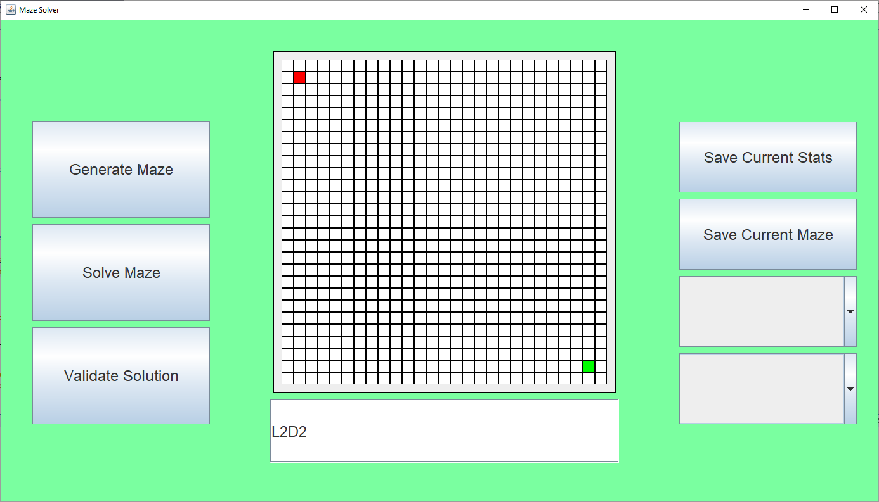

And then pressing validate solution produces the following:

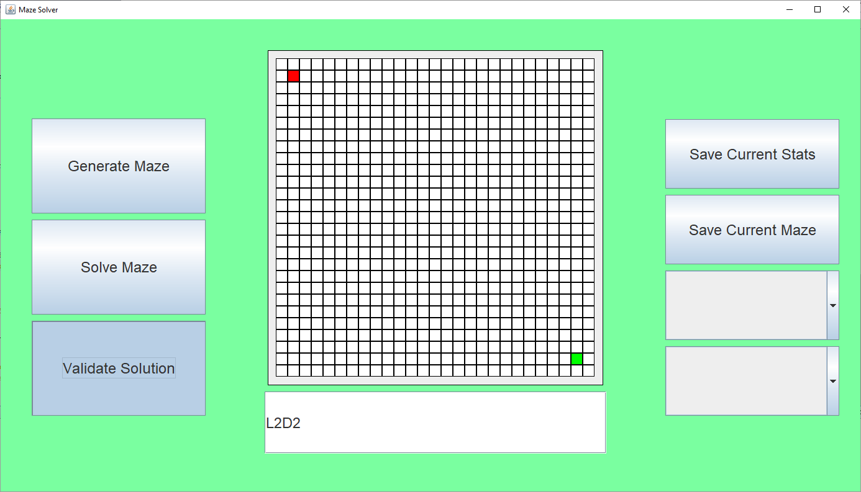

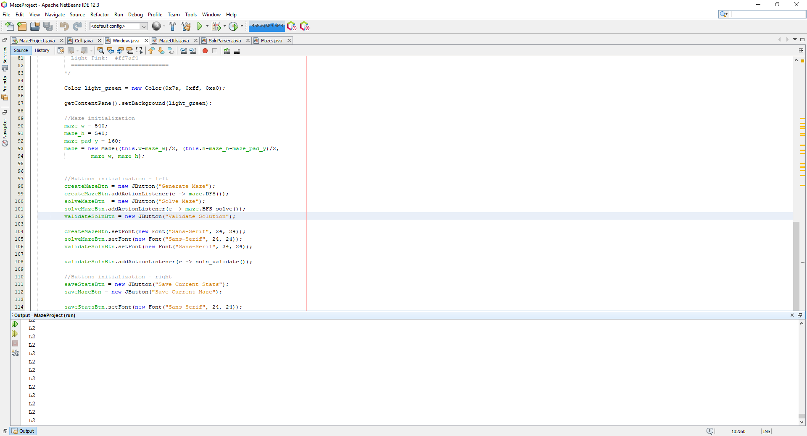

From this it seems the code reached an infinite loop and could not escape from the first instruction. This turns to be a failed test for test #1. Looking at the source code I realised that I was not setting the new value of ‘i’ to be the value stored in the pointer to the next instruction:

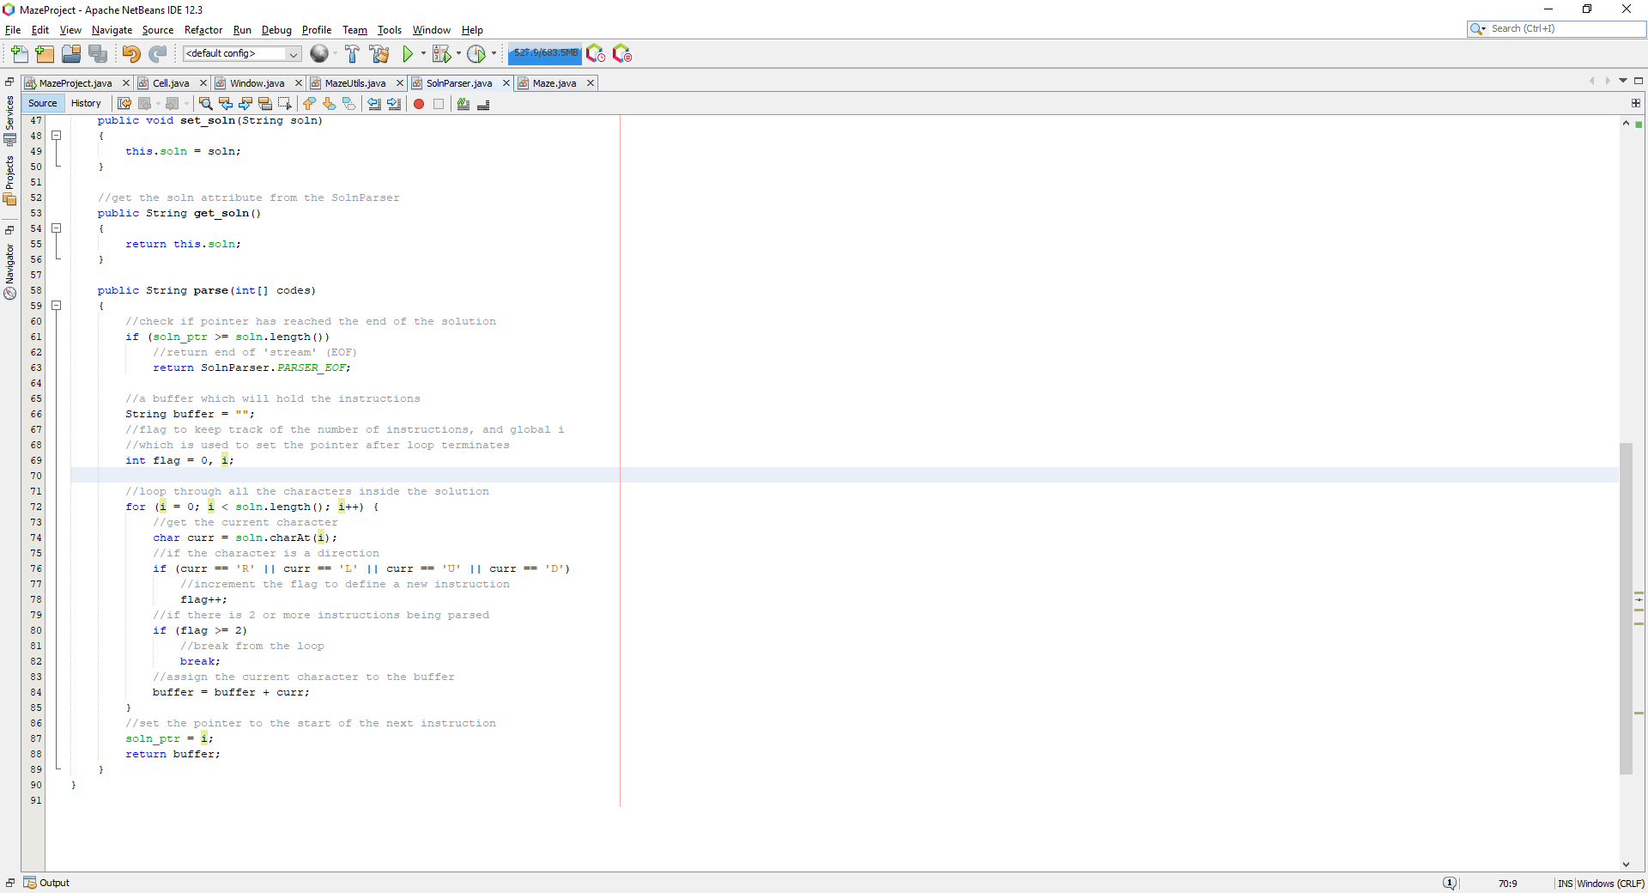

I should have set ‘i’ to soln_ptr, which when I do that produces the following:

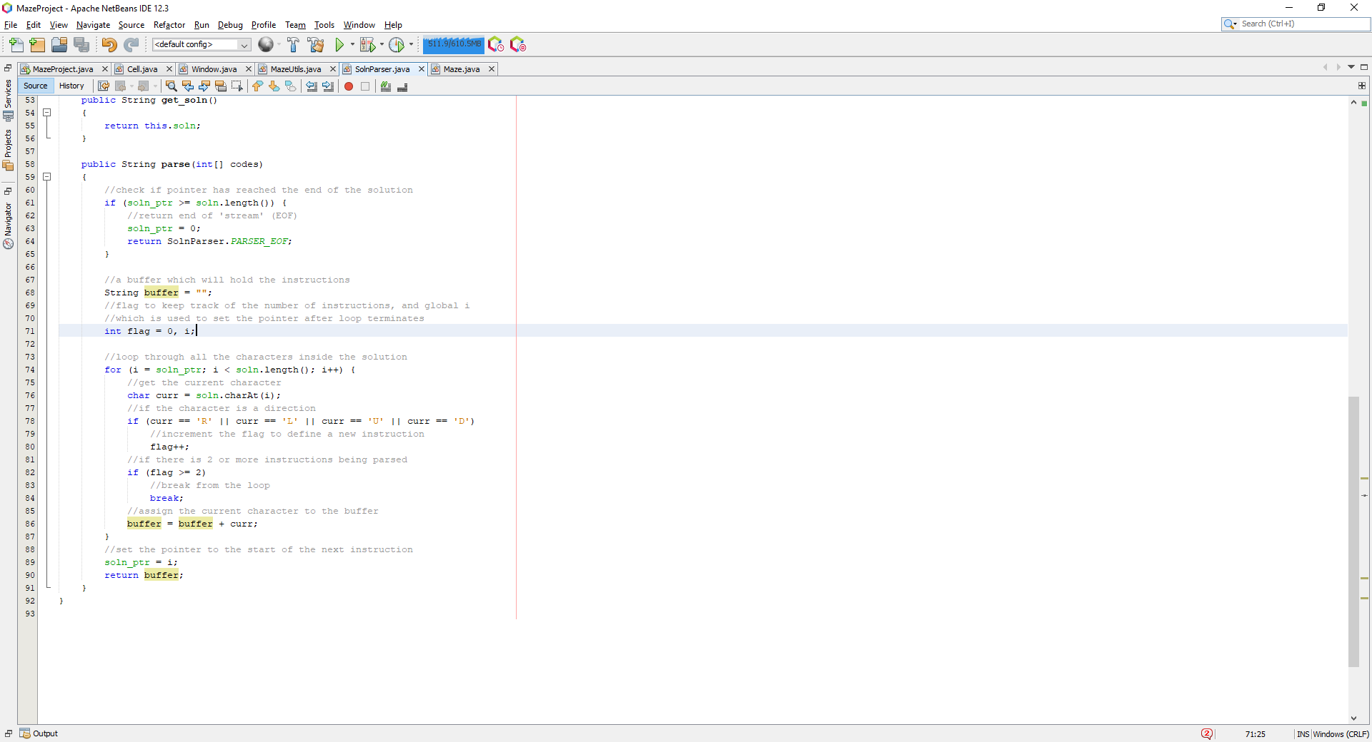

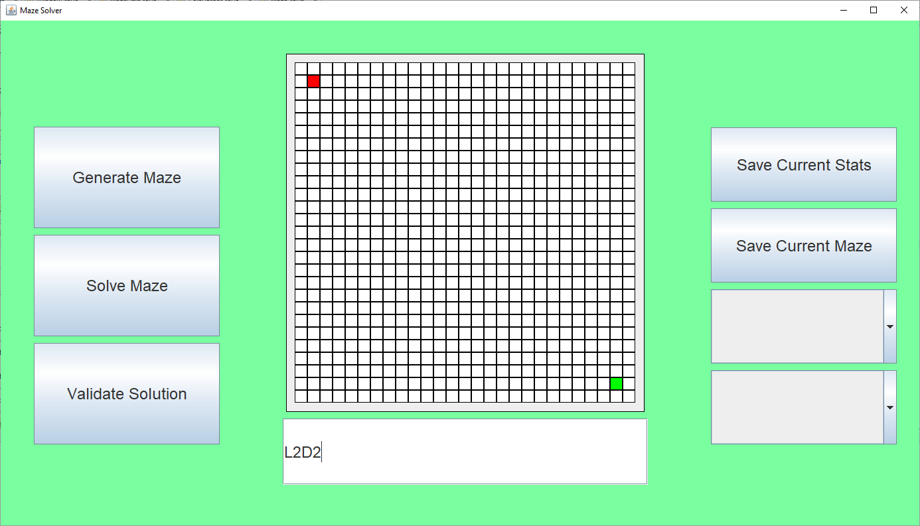

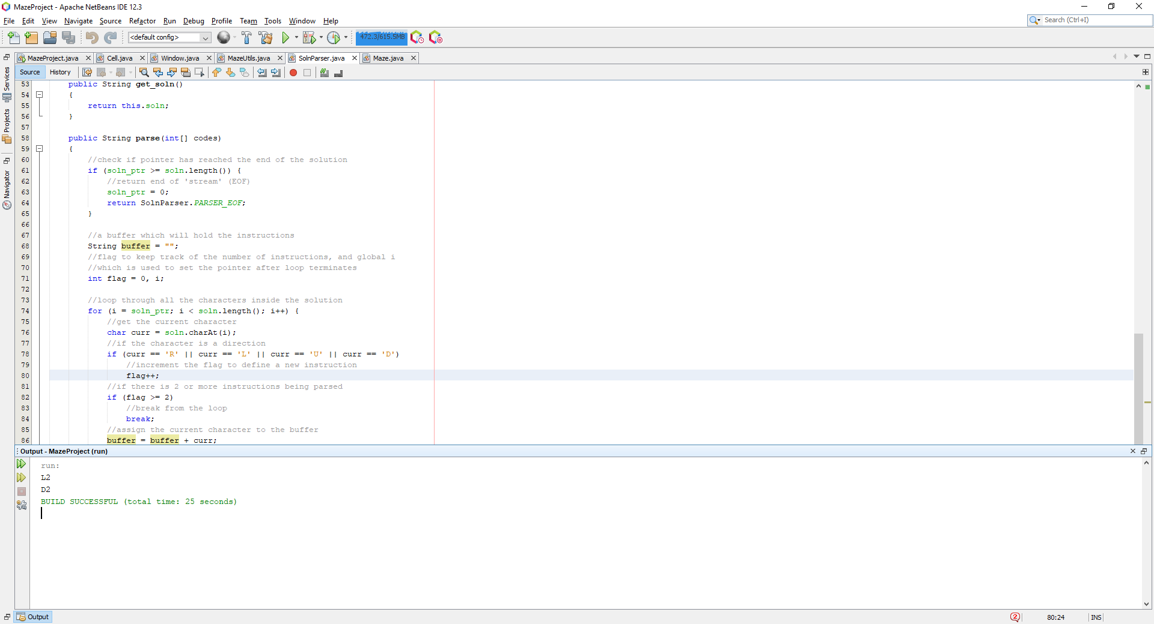

This is a success for test #2. Now I want to test whether any solutions entered are going to have all their instructions printed sequentially:

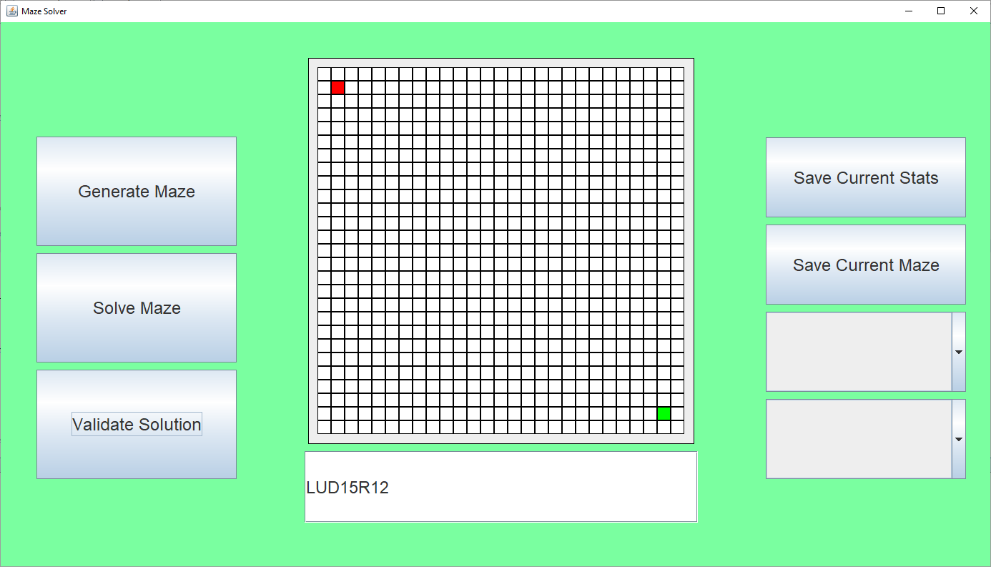

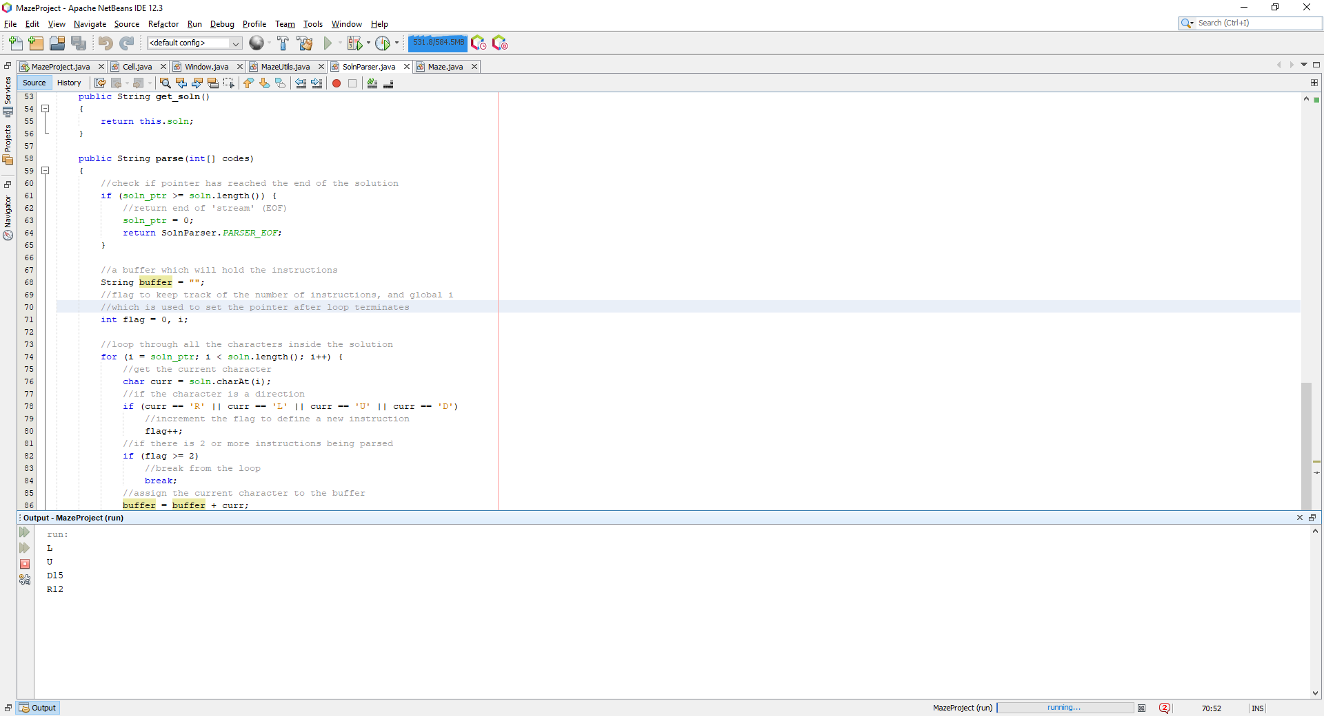

Which works as intended, a simple direction will have a default magnitude of 1. Hence L = L1, R = R1 etc. This was successful for test #3. Now I wanted to check what if the user didn’t enter any directions and only numbers:

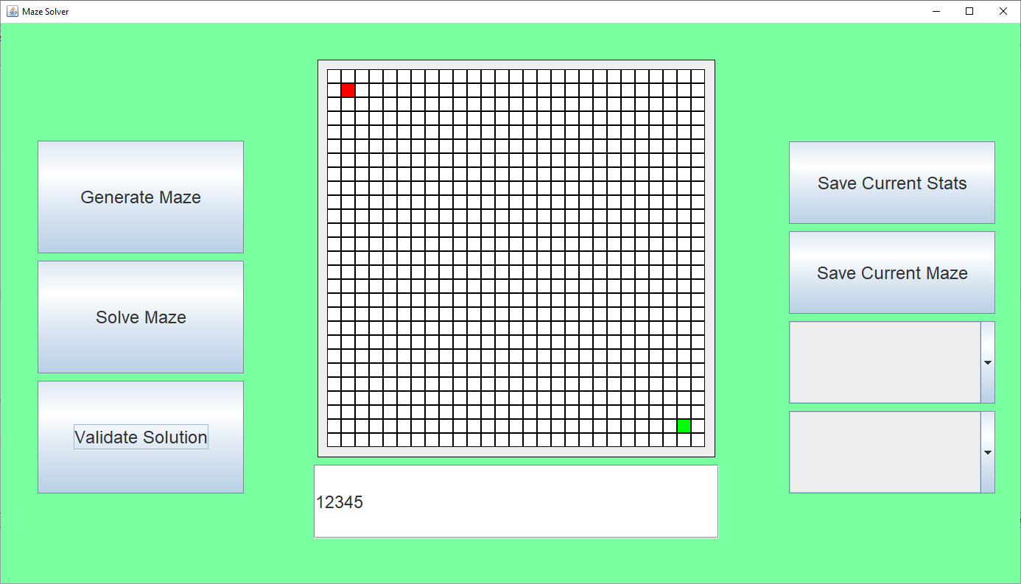

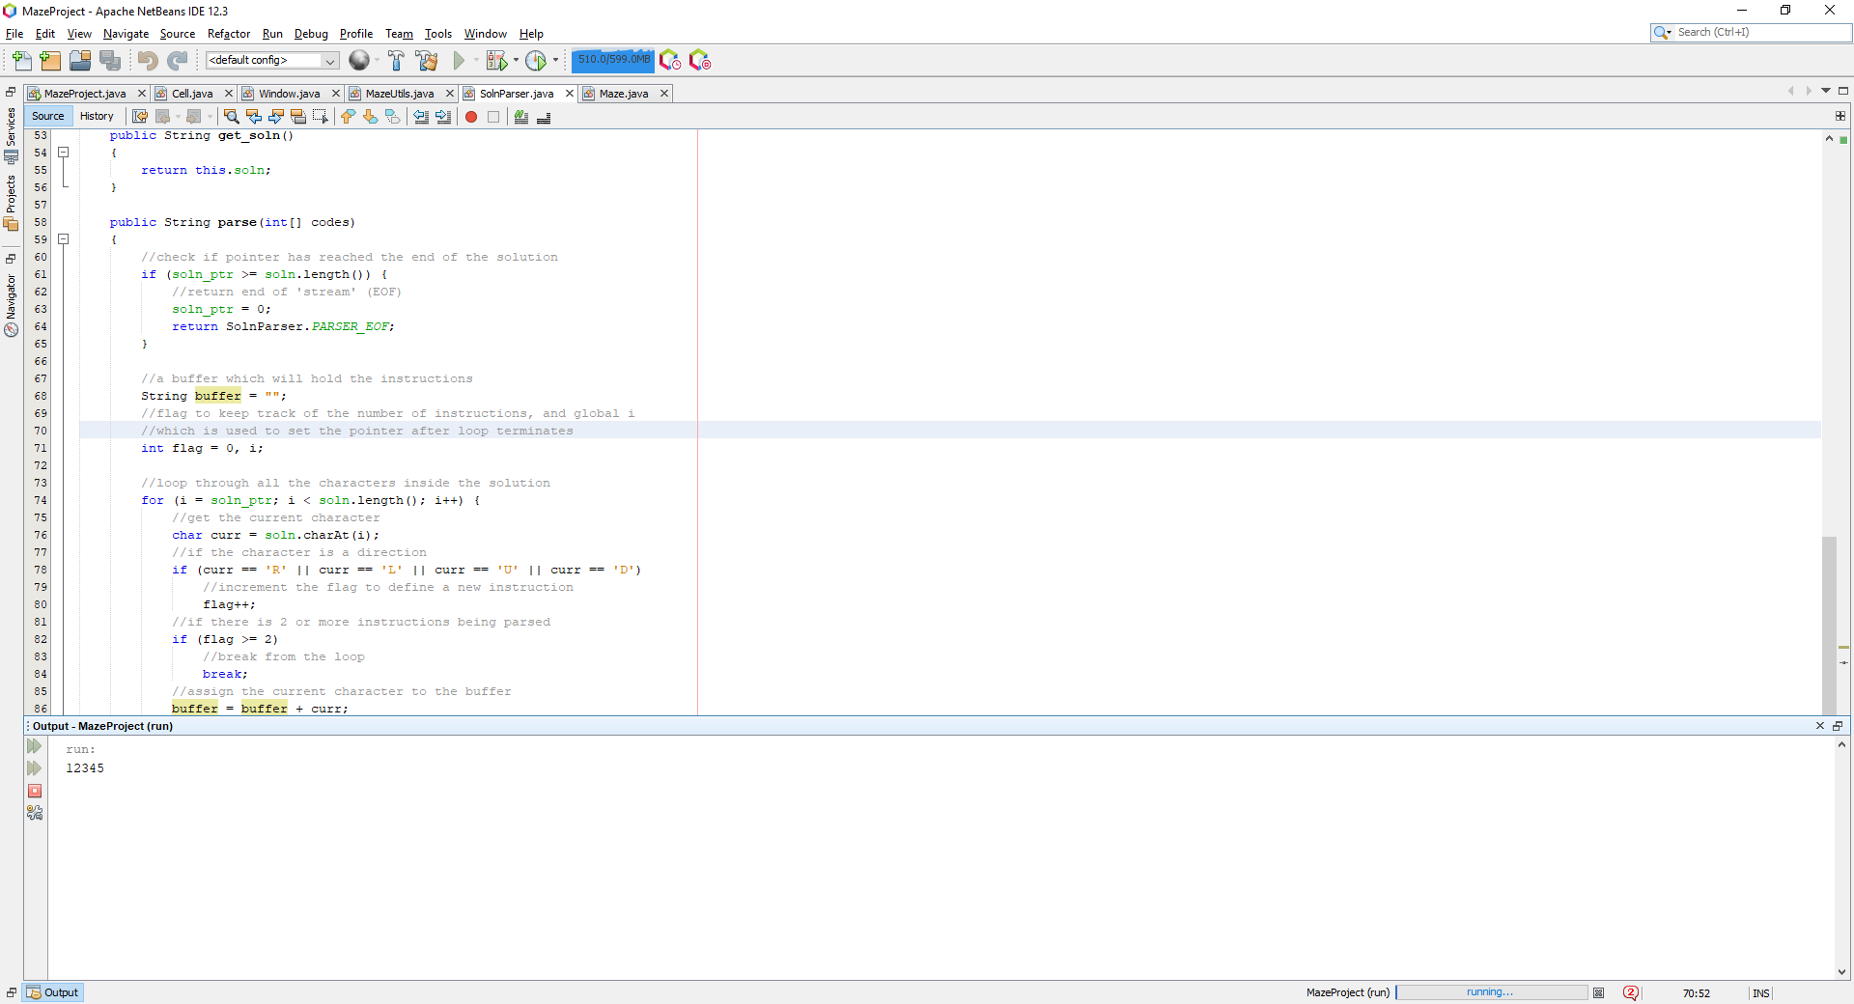

Which simply prints the numbers, which is expected and what I would want, if the buffer is composed of only integers, an error should be returned and should let the user know that this is invalid. Then I checked to see what would happen if there were spaces in the solution:

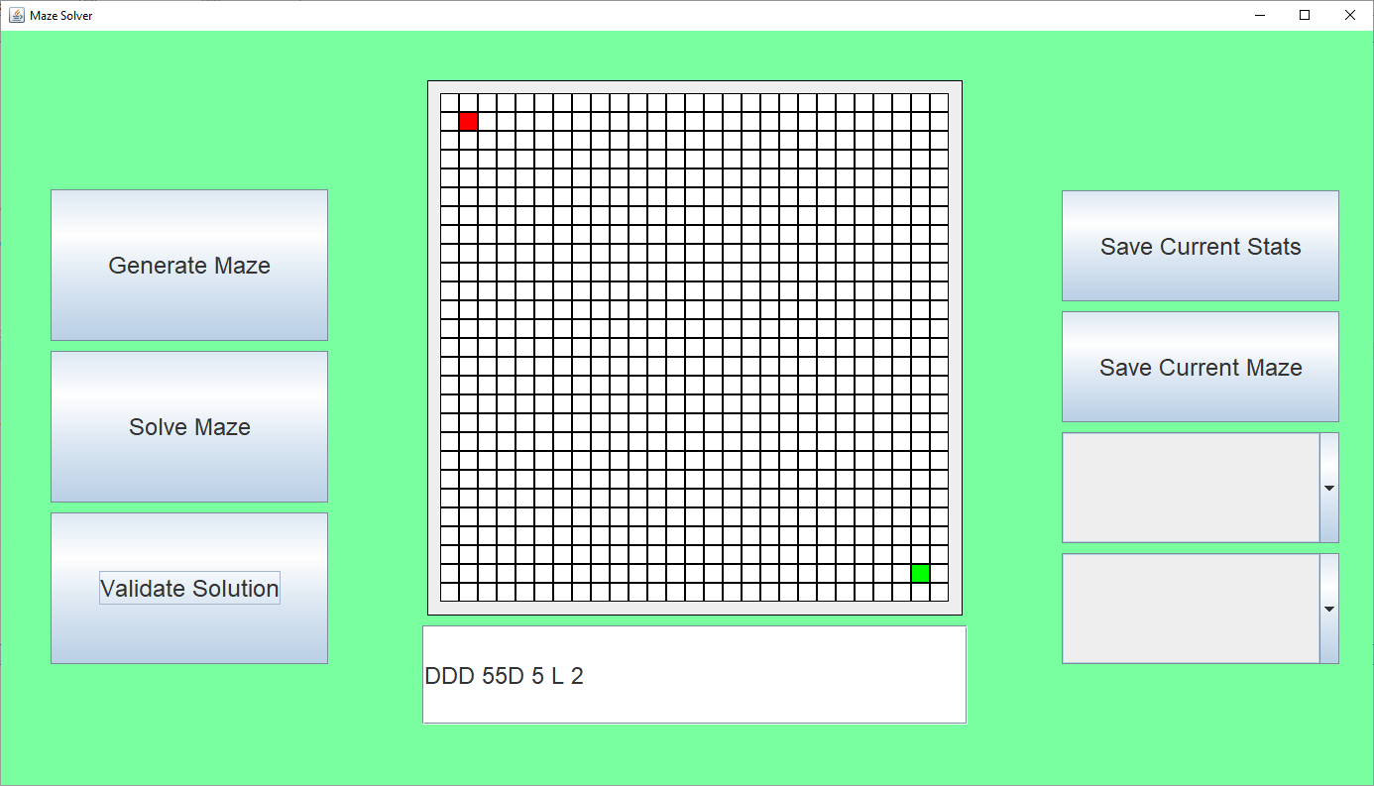

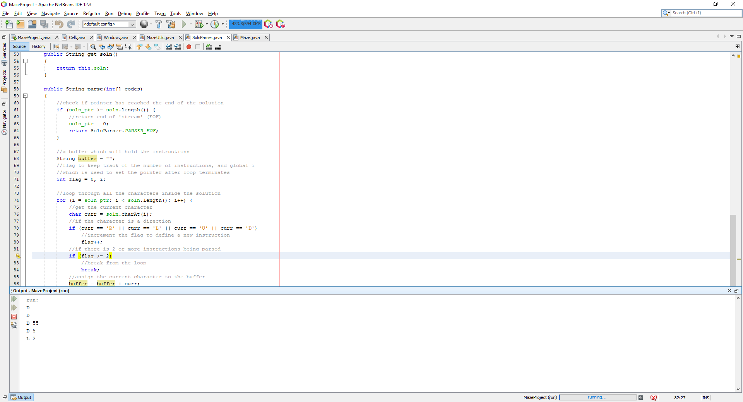

The buffers are still separated with a direction and magnitude but with spaces in between them, this is expected and can be fixed by simply removing any spaces which are present in the string, transferring all the non-spaces into a new buffer or use a function to remove the white space automatically.

Now I wanted to implement the fixes to these problems such as numbers present before a direction, numbers present on their own and spaces between directions and magnitudes:

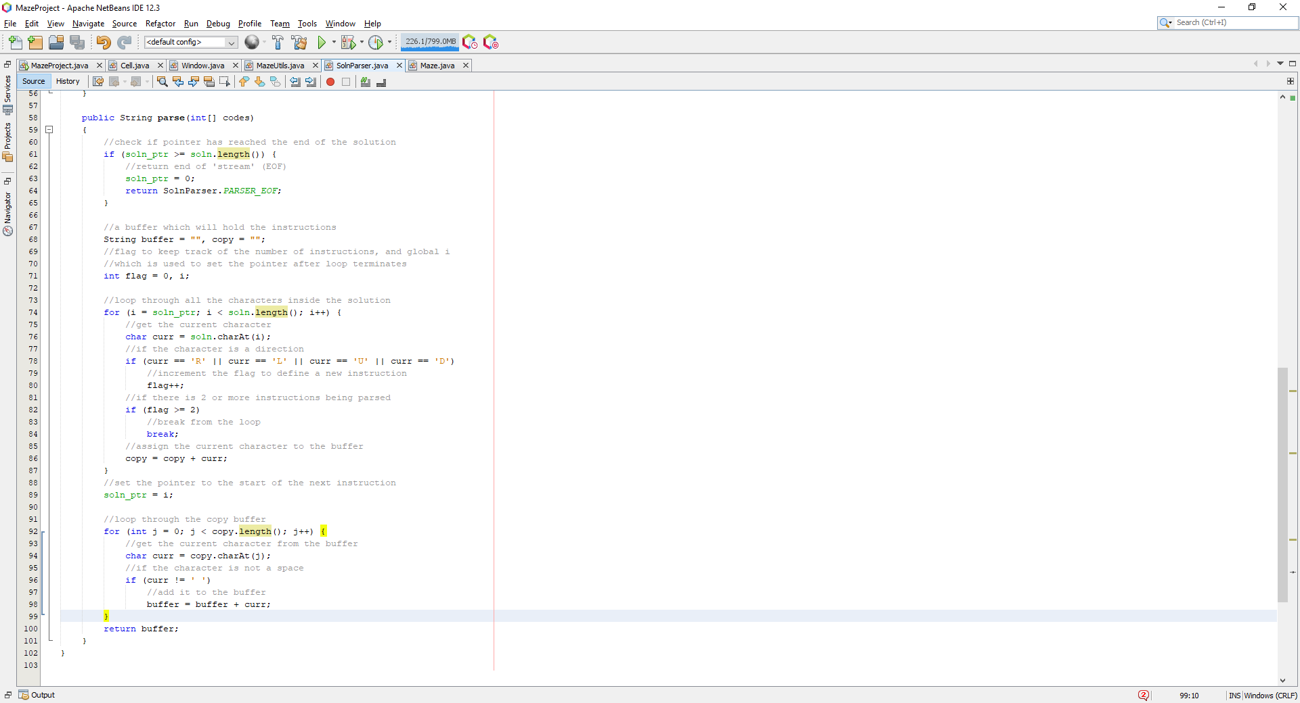

In the new implementation of the parse function, I added a new buffer called copy, this is the buffer which will now contain the instruction, and will be copied over to the buffer which will be returned as the current instruction. After the current instruction has been loaded into the copy buffer, it is looped through to check for any spaces, if the character is not a space, it is added to the buffer, which is then returned, the new buffer contains no spaces.

In order to avoid any instructions which contain only numbers, I added a final check before returning the instruction as valid:

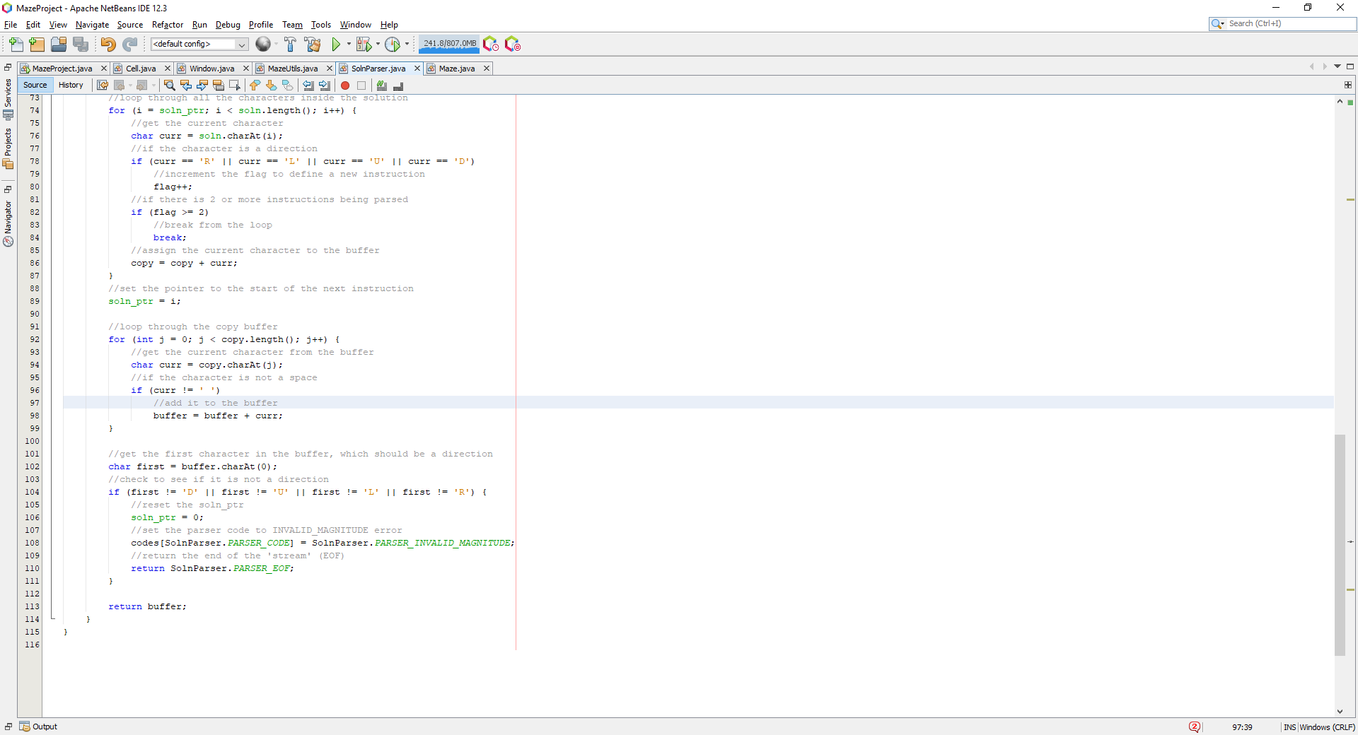

We check the first character of the instruction, if the first character is not a direction, this would be invalid syntax, hence we set the parser error code to define the error at hand which is an invalid magnitude error, the soln_ptr is reset and the end of the ‘stream’ is returned to the user to end of the loop through the string. Finally, I added one more check to prevent any buffer overflows for any large integers which could be entered:

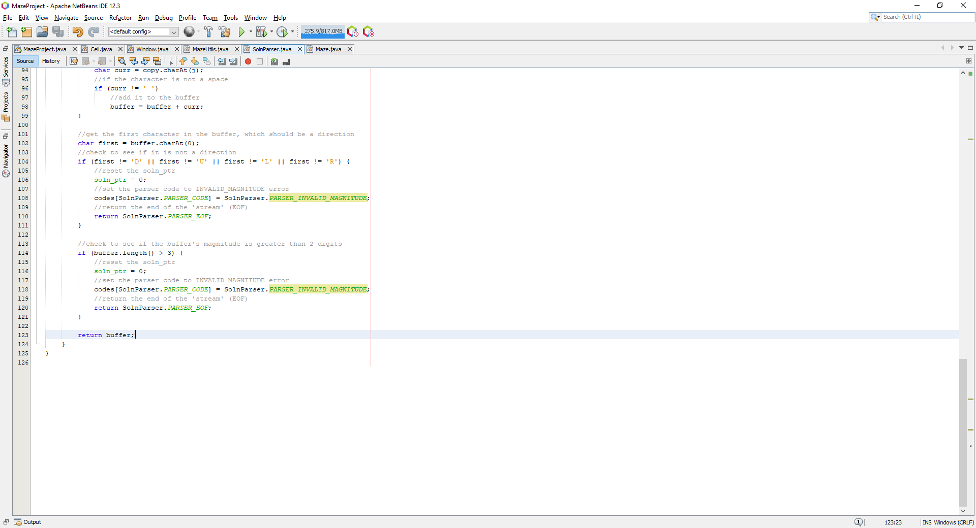

This simply checks to see if the buffer is greater than 3, meaning there is an integer greater than 100 which exists, which is too big to be valid for a magnitude. Next, I decided to finally implement the colouring of cells for each of the instruction:

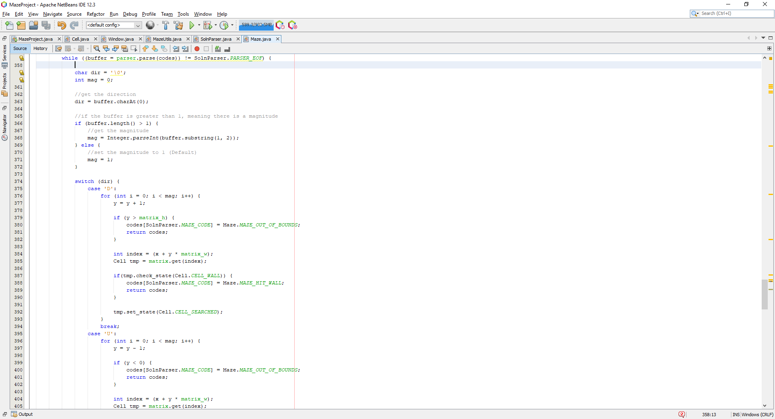

Here I am checking to see if the given buffer contains a magnitude or not, if there is no magnitude within the buffer, the default magnitude is set to 1, else the magnitude is extracted from the last 2 characters in the buffer and converted to an integer.

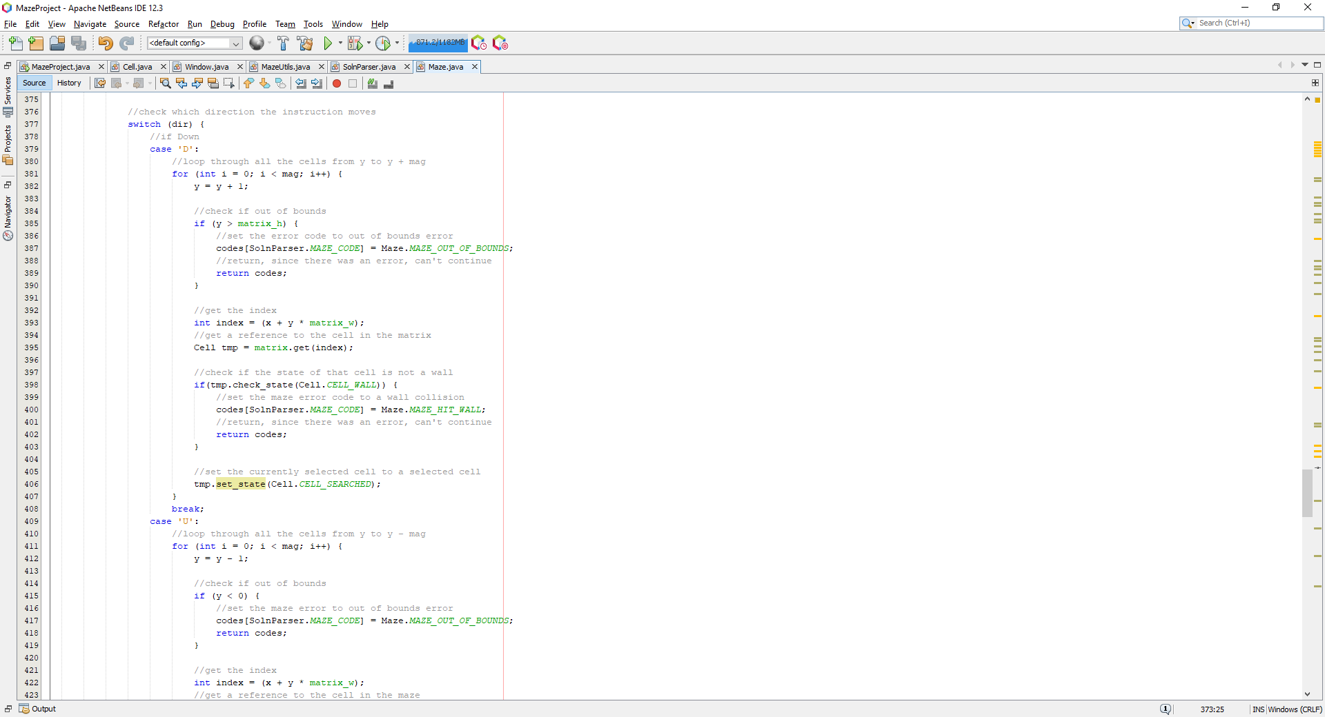

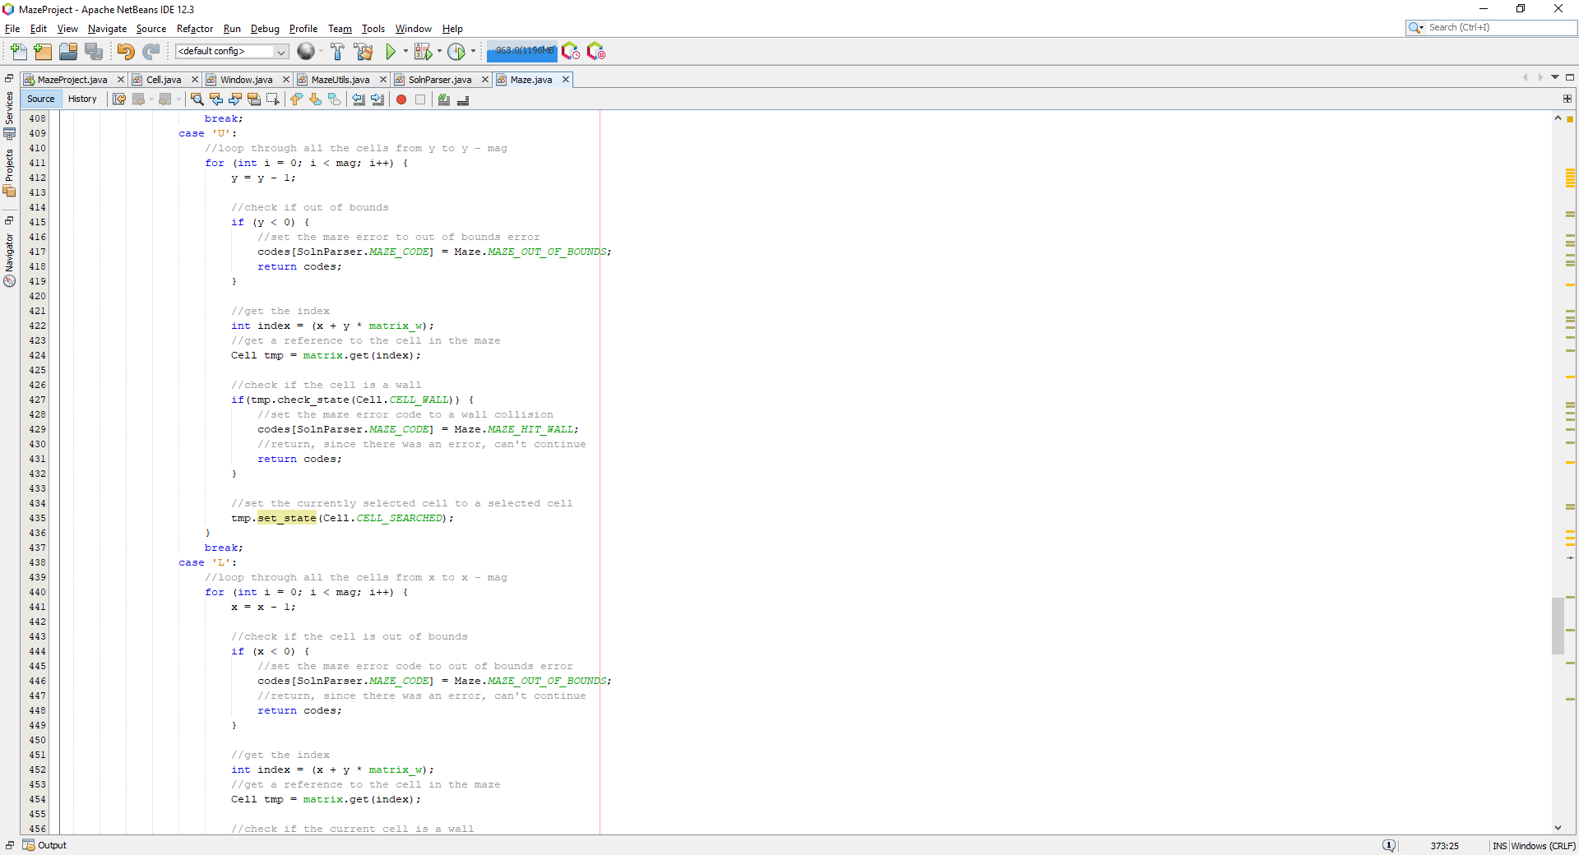

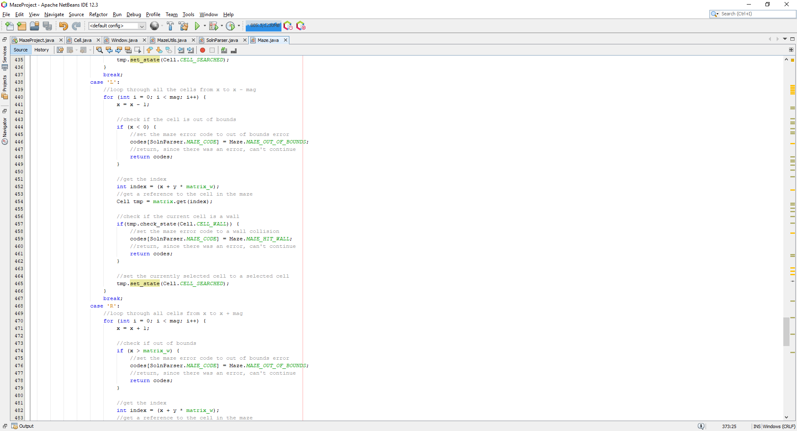

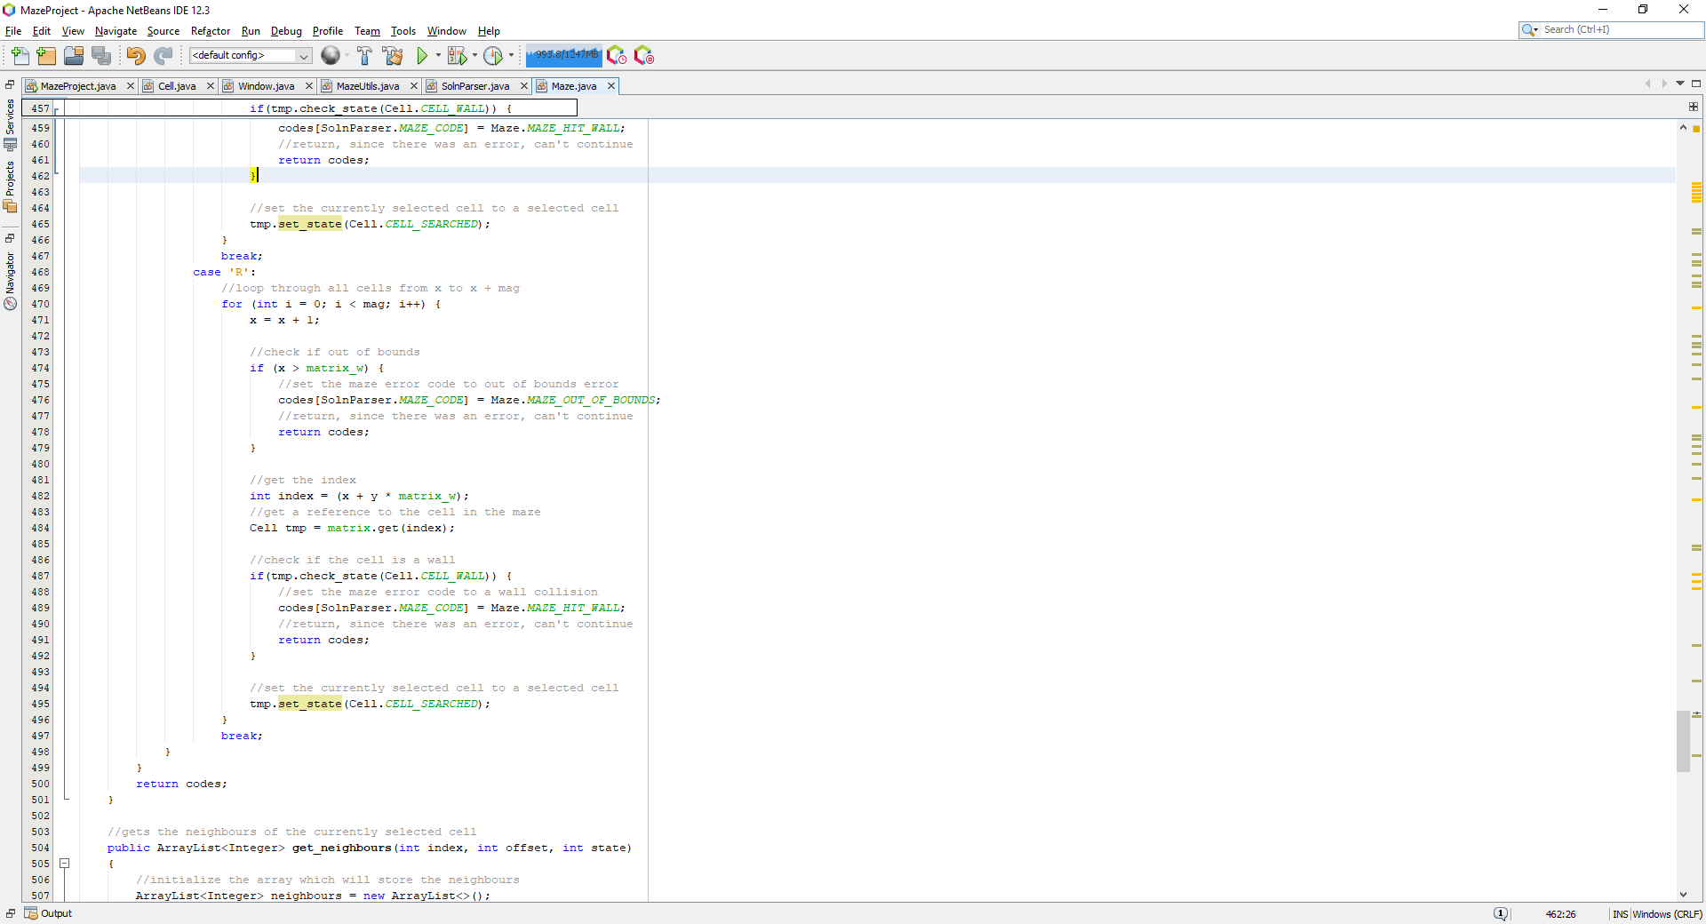

This long switch statement checks the direction and based on the direction, will move the coordinates in the following direction, where each step it will set the cell to a searched cell, whilst checking for bounding errors or collisions with walls.

Running this code with ‘L2D2’ presents the following:

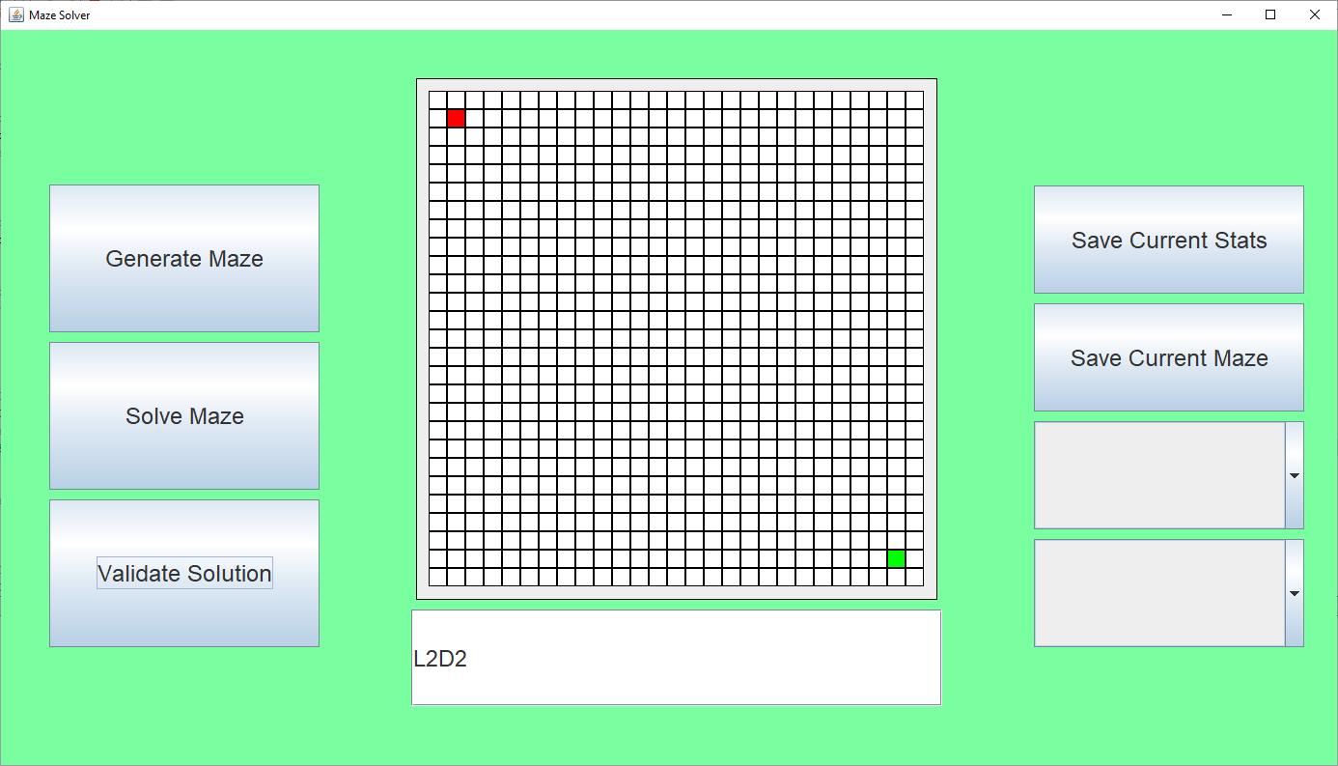

Nothing. The function failed. Looking over the source code I noticed this:



If the first character was ‘D’, it would still return false for the entire expression, hence I need to change it to:



And:



Now running the program with ‘L2D2’ produces:

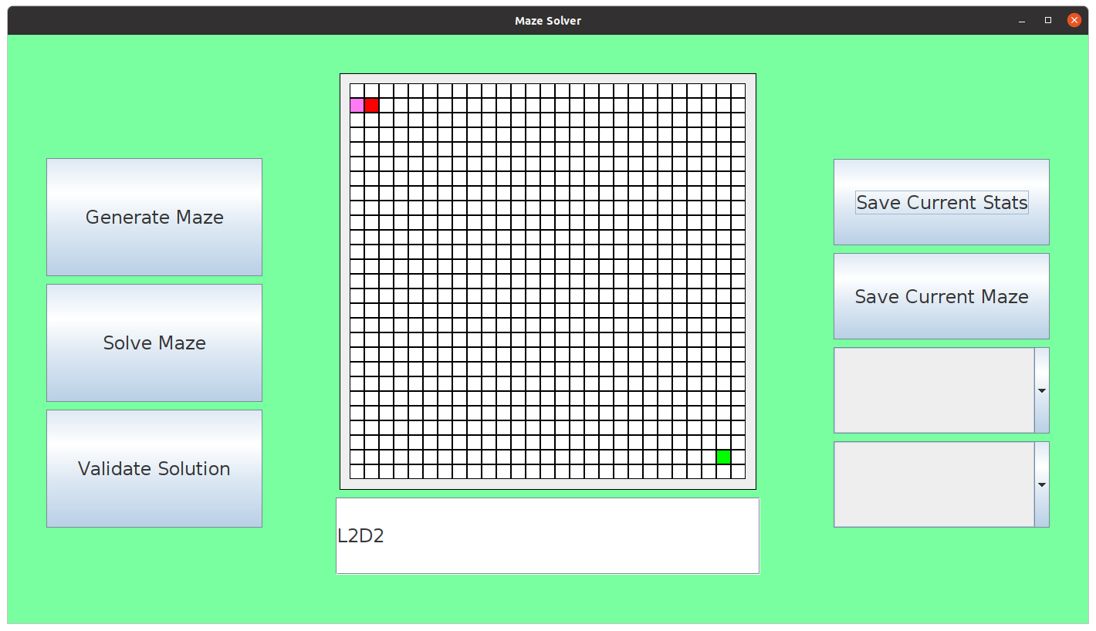

Now the program works as intended, this was an erroneous input, which goes out of bounds by 1 to the left, the output is as follows:

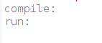

Empty. Which is expected, no error is flagged up as out of bounds indexing from the IDE. Hence test #5 was successful for testing user solution validation. Now to test a valid solution, we can easily solve the maze with ‘R24D24’ which produces the following:

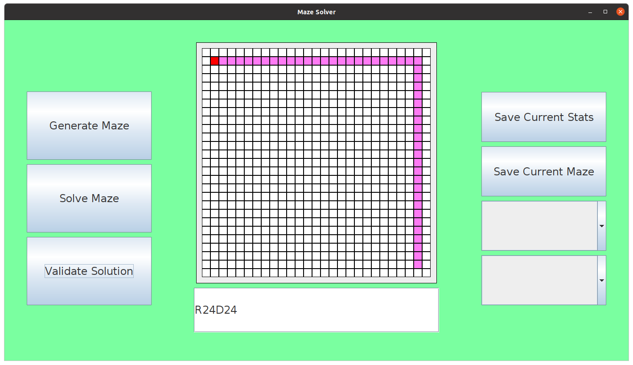

Now, I need to add a check to identify if the end of the maze has been reached successfully:

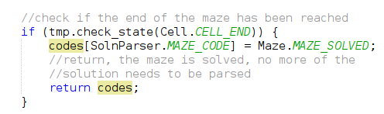

This is added into each section of the switch statement, if the end of the maze has been found, I set the maze code to be the MAZE_SOLVED flag. All these set codes are to be checked by the window, where the window will display a message corresponding to the code present.

I then decided to implement the interpretations of the error messages flagged up by the maze and the parser within the window:

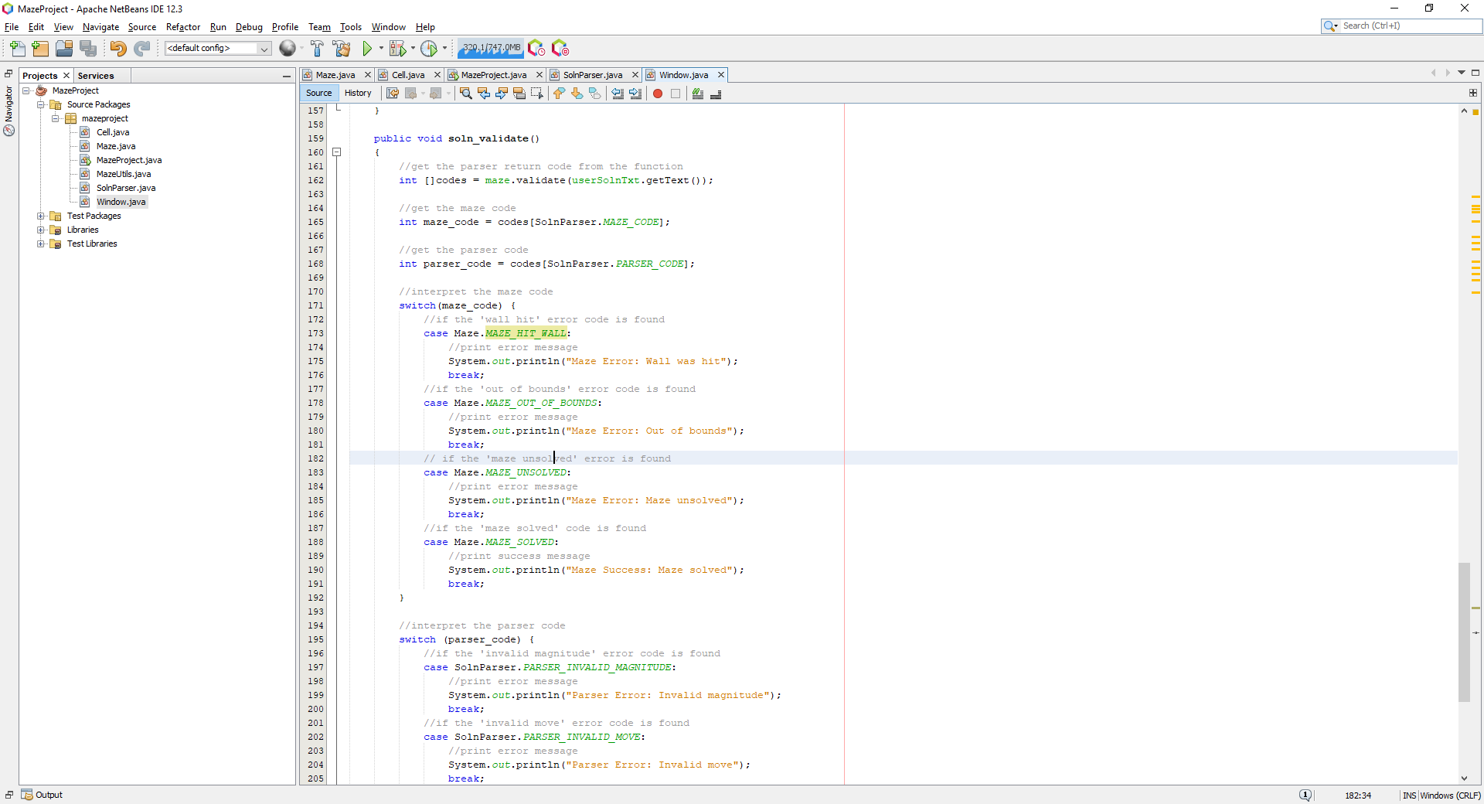

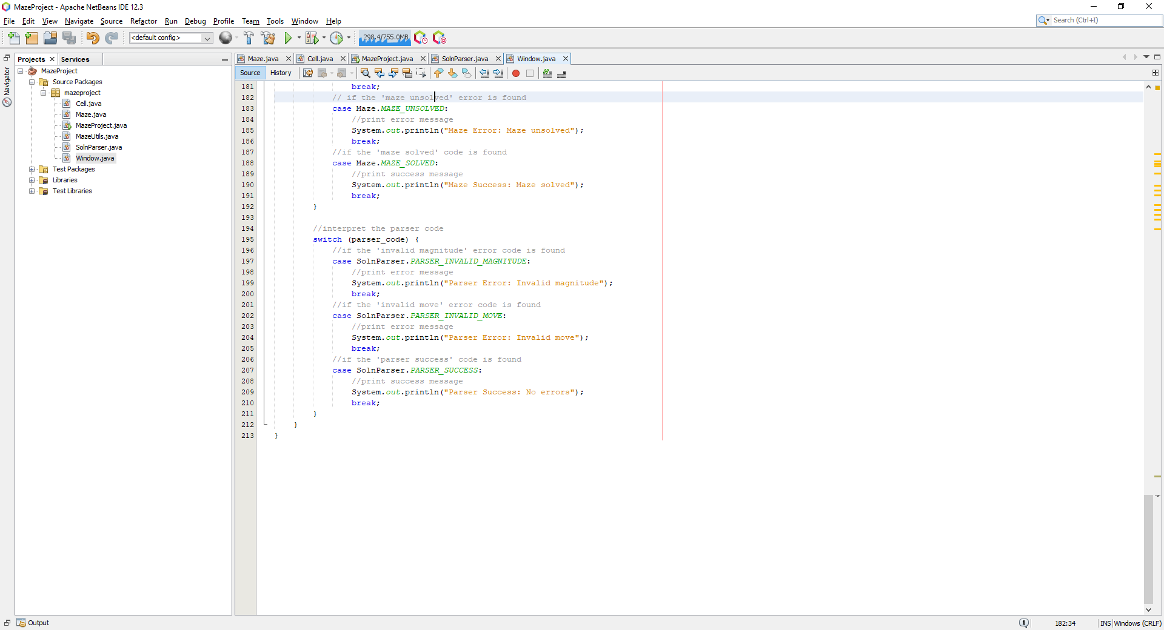

This reads from the codes array which stores the maze and parser codes, these are then checked through switch statements to identify which code exists, and responds accordingly with a simple console message. For example, if I enter ‘R24D24’, which solves the maze, it shows the following:

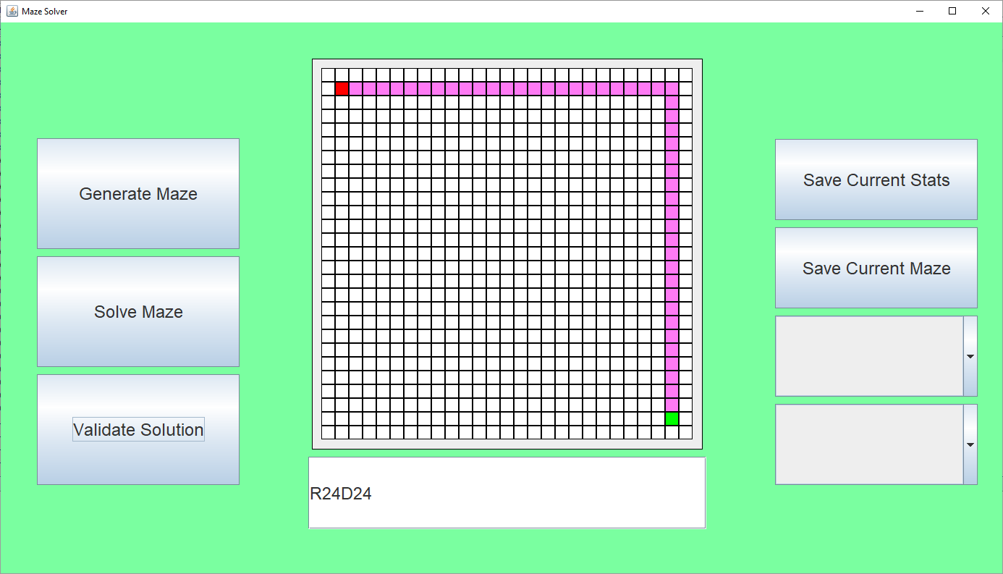

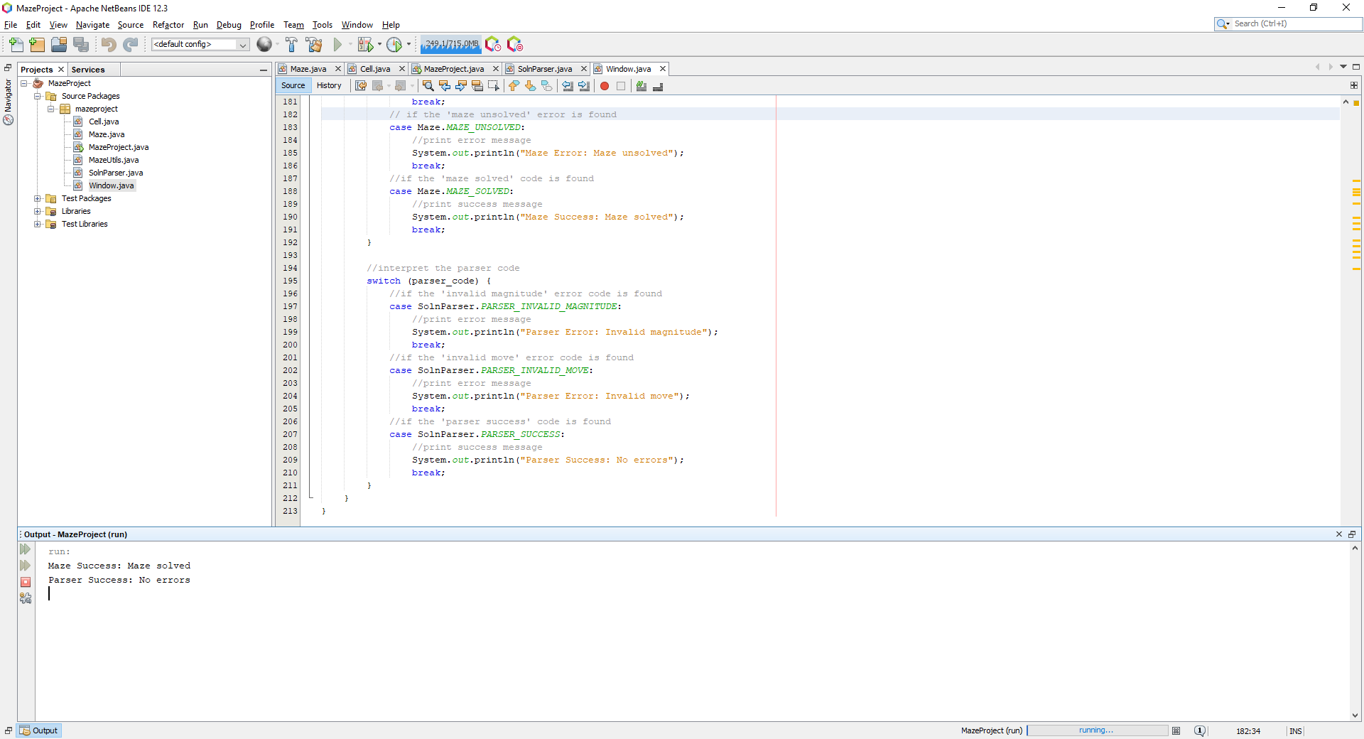

Maze success is produced because the maze was solved, and parser succeeds because there were no syntax errors which resulted in a successful parse of the solution string. However, I tried to then follow up with another ‘solution’ which simply moved the node by ‘D5’ which shows the following:

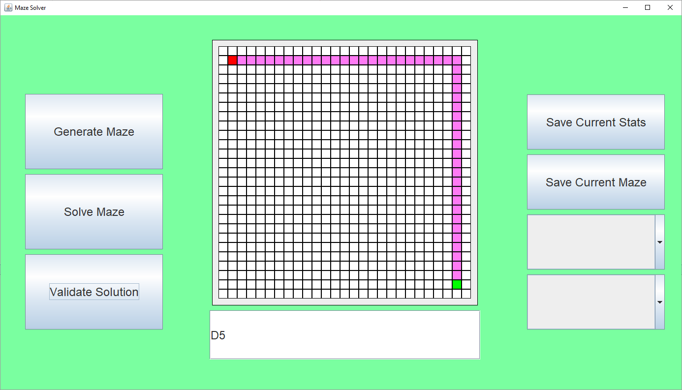

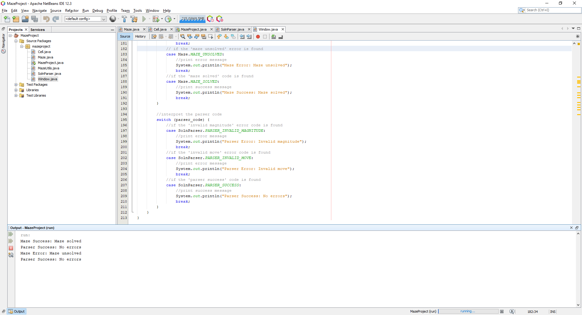

Which is correct, but it doesn’t highlight the maze, and validating the solution again produces the following:

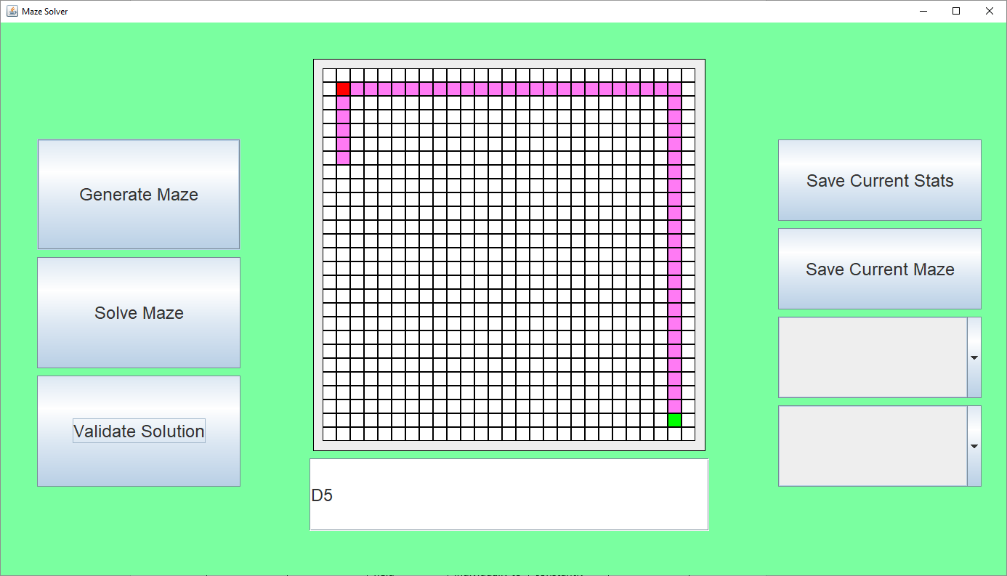

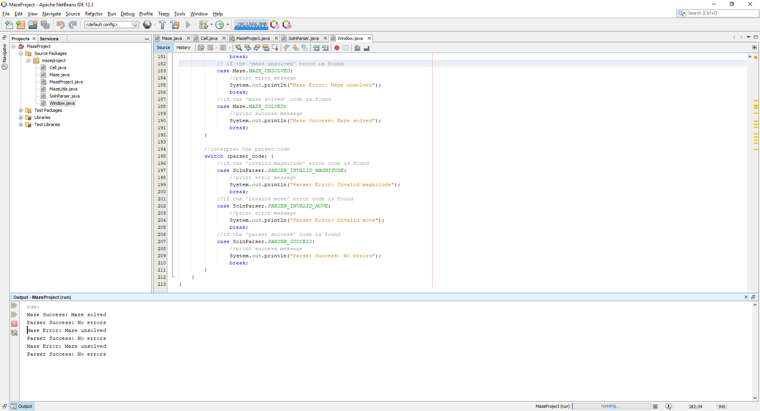

Which is what was expected, I realized that the reason for this is that the previously executed statement left its old pointer for the next call to use, instead of erasing the saved pointer once the parser was finished. I fixed this by changing the setter of the SolnParser to reset the soln_ptr when a new string was loaded:

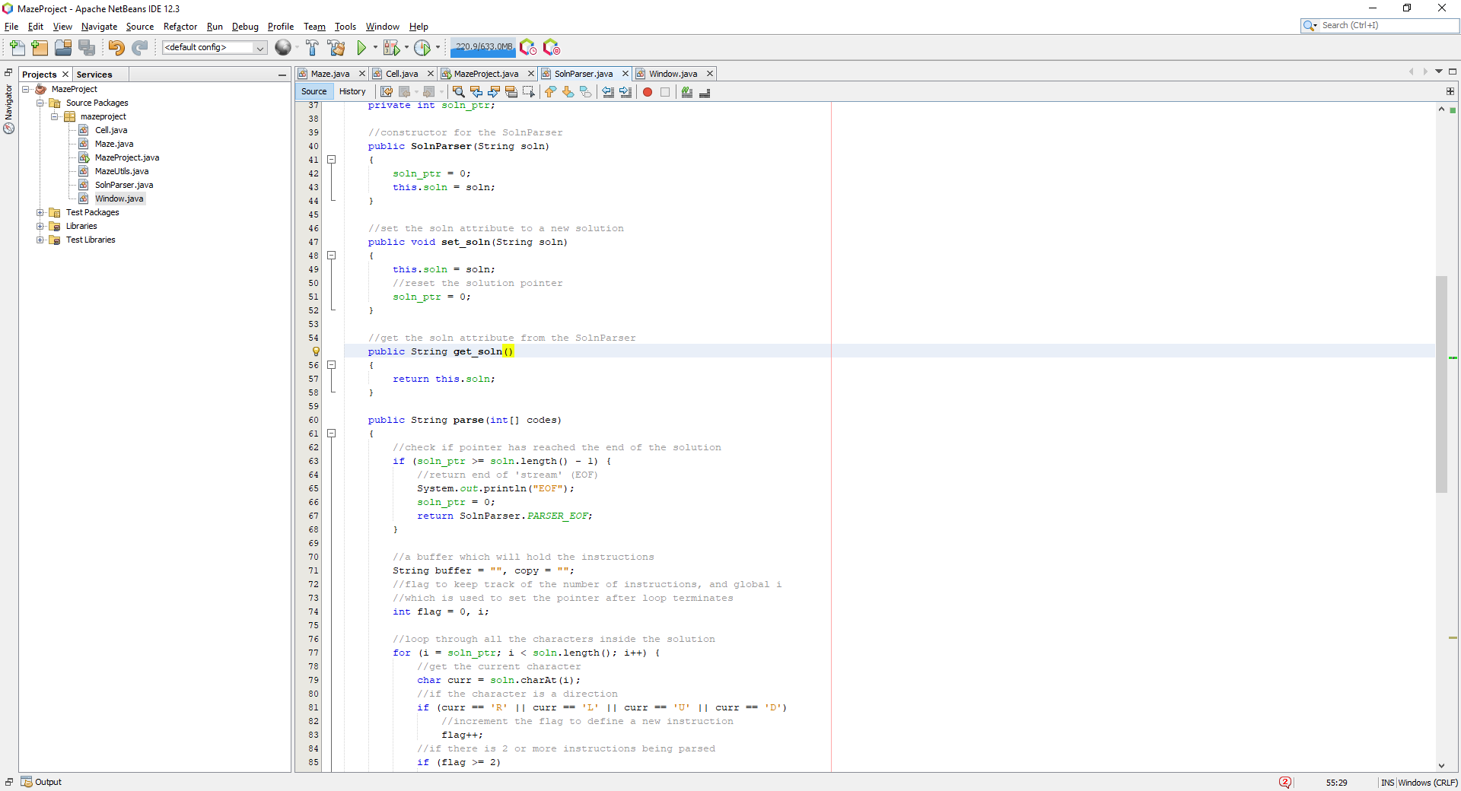

Now this works as intended, where running ‘R24D24’ followed by ‘D5’ it shows:

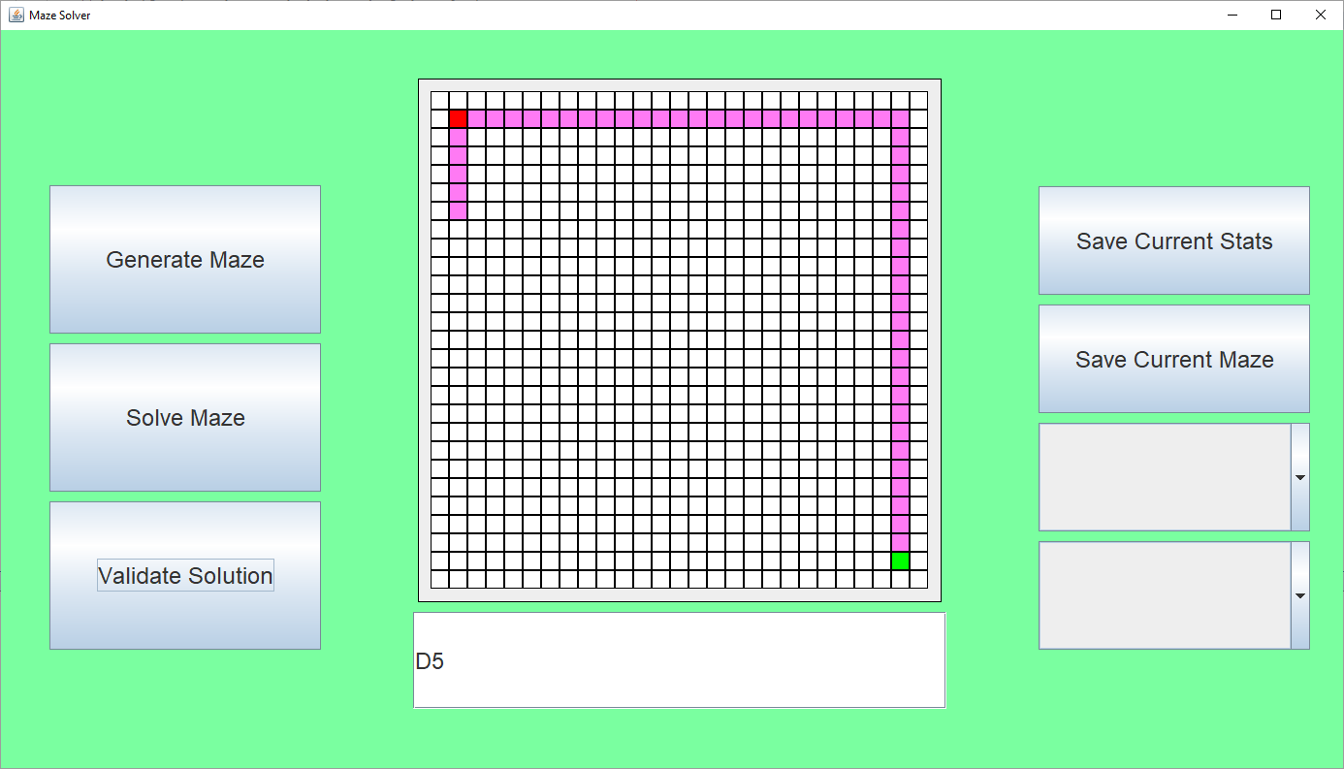

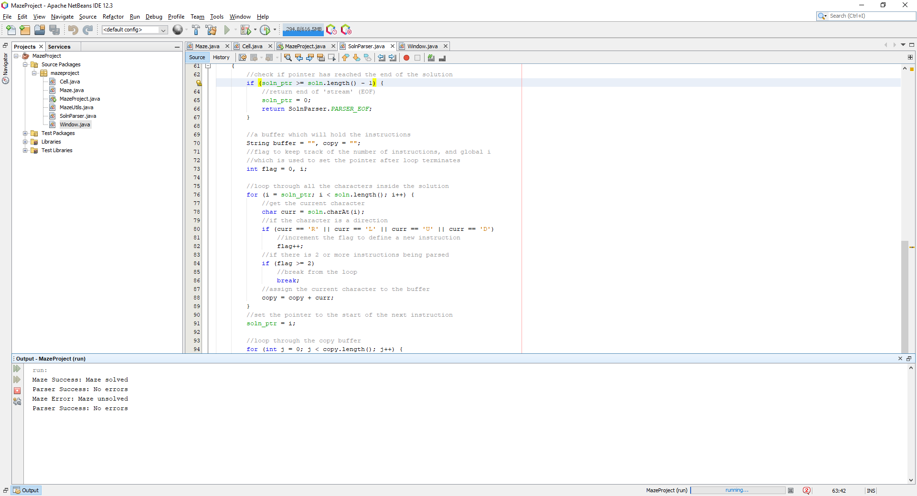

This was expected. Now I wanted to make it so instead of printing content to the console, which the user of this application is not going to see, I wanted to display small windows which contained the messages. I searched for how to create message boxes in swing and found from Stack Overflow: ‘swing – how to present a simple alert message in java’[12]. Using this information, I implemented this:

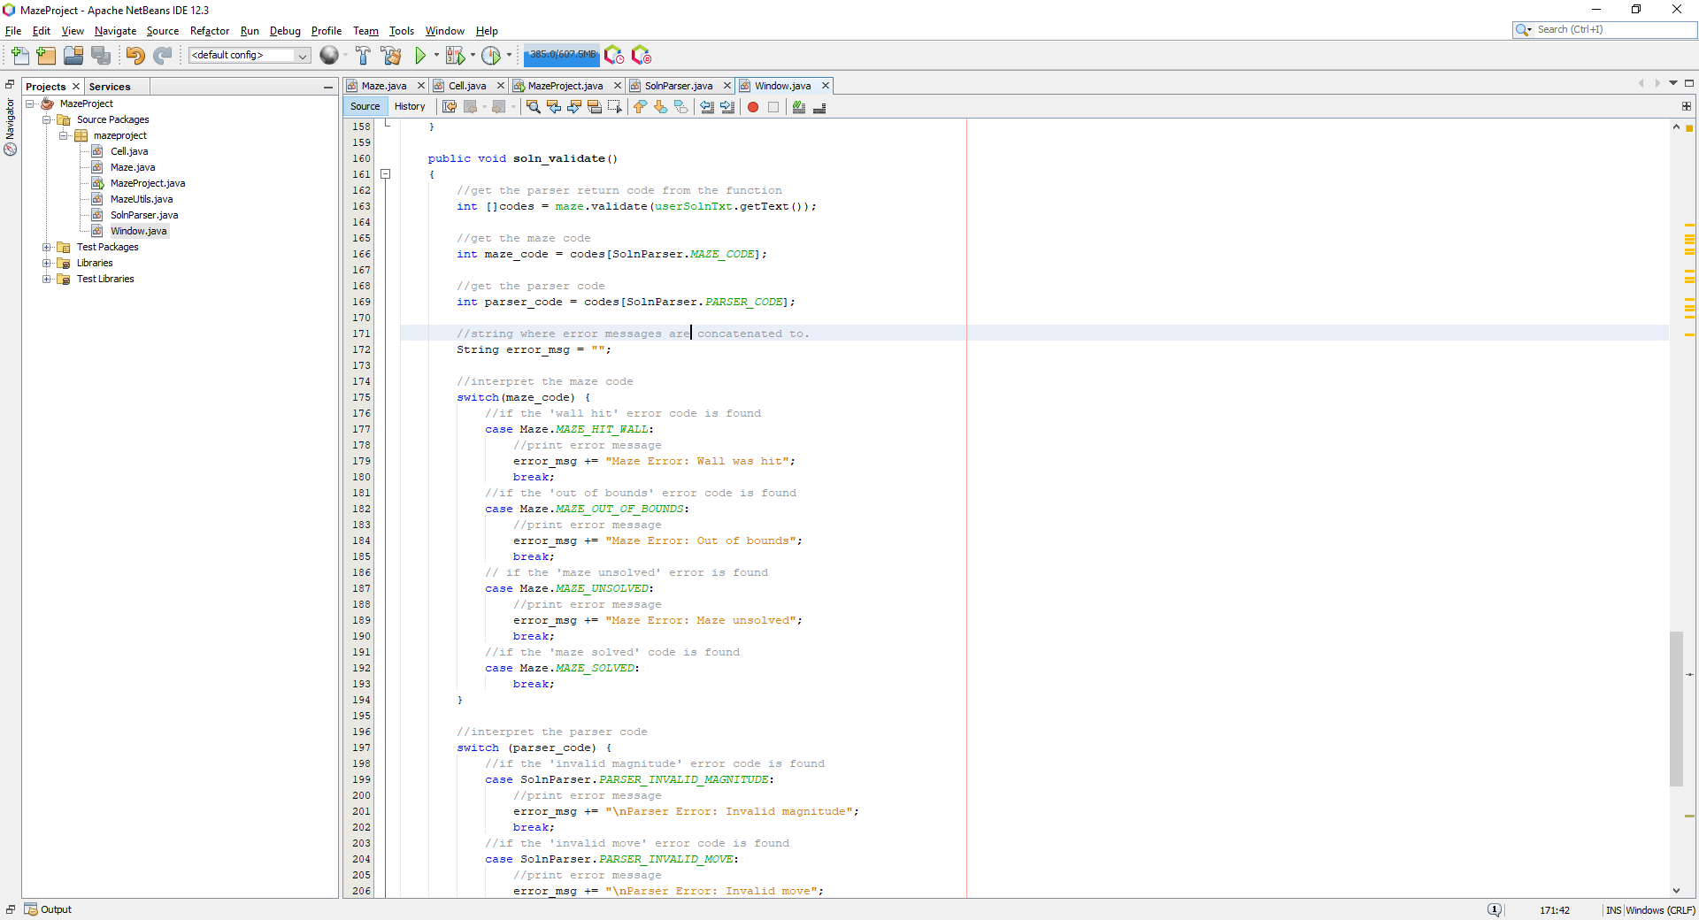

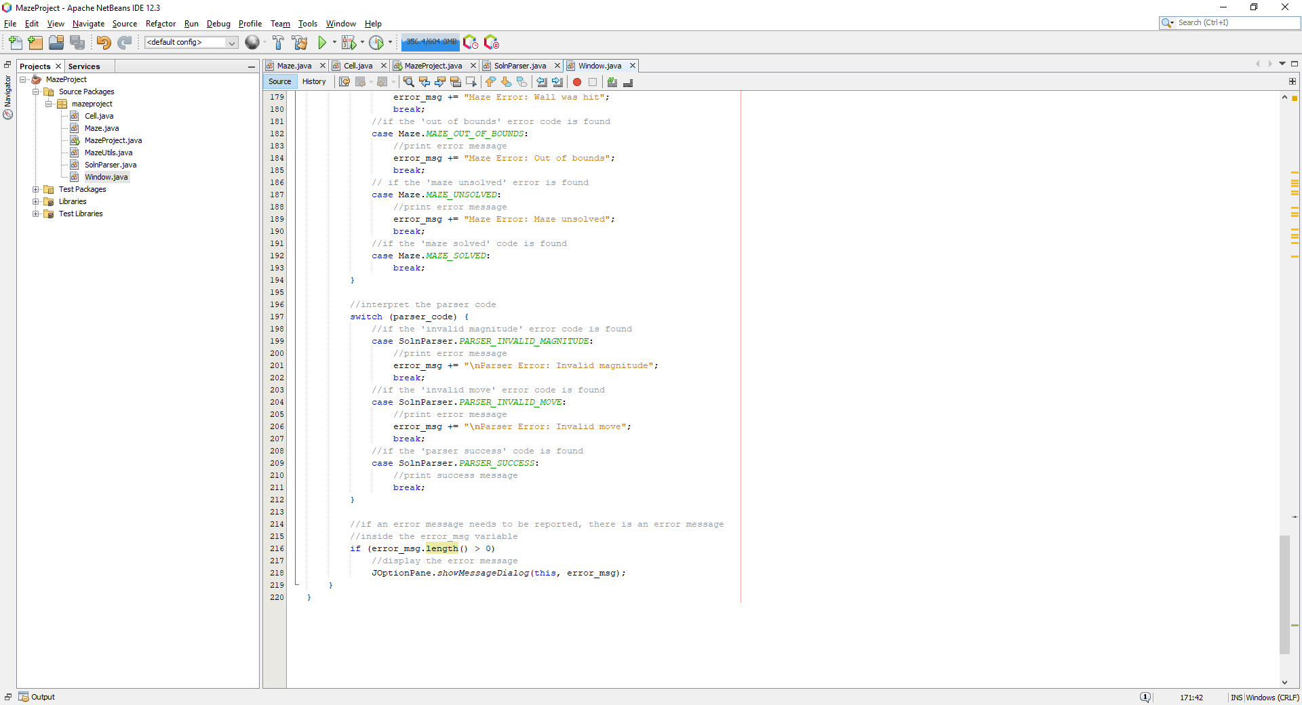

Now, for each of the codes presented, an error message is concatenated if an error exists, if an error exists then the user is presented with a dialog box which outlines what error occurred. Testing the code with sample inputs such as ‘D24R24’ and ‘L5’ displays the following:

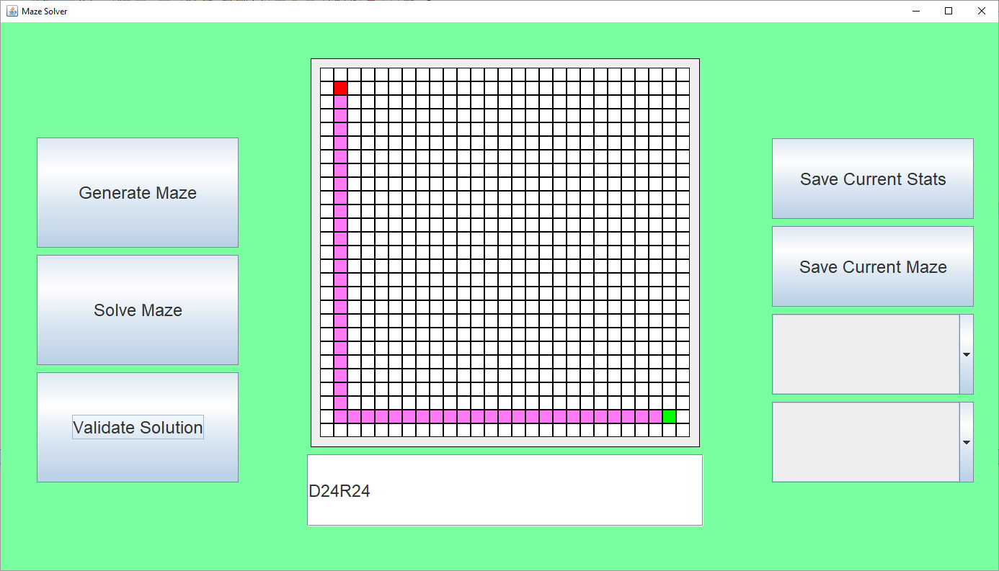

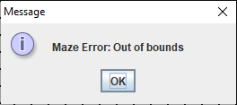

The second input displays this message, which is what is expected because ‘L5’ goes to the left 5 times which is too far out of the maze. Hence this test was a success for test #6 and test #7.

### Testing

#### Test Table

|  |  |  |  |  |  |
| --- | --- | --- | --- | --- | --- |
| Test # | Test Type | Test Data | Expected | Actual | Success (?) |
| 1 | Normal | Enter ‘L2D2’ into the solution text field | ‘L2’ and ‘D2’ should be printed individually to represent the two different instructions. | It went into an infinite loop constantly stuck on the first instruction. | Failed |
| 2 | Normal | Enter ‘L2D2’ into the solution text field with update | ‘L2’ and ‘D2’ should be printed individually to represent the two different instructions. | ‘L2’ and ‘D2’ are successfully printed individually representing the two different instructions | Success |
| 3 | Normal | Enter ‘LUD15R12’ into the solution text field | ‘L’, ‘U’, ‘D15’ and ‘R12’ should be printed individually to represent the multiple of instructions which compose the solution | ‘L’, ‘U’, ‘D15’ and ‘R12’ are successfully printed individually representing the two different instructions | Success |
| 4 | Erroneous | Enter ‘L2D2’ into the solution text field | 1 cell to the left and nothing after that, no error should be flagged up due to the out of bounds as it is dealt with during the parse stage | Nothing happens. Not even a cell was filled in to the left of the start node | Failed |
| 5 | Erroneous | Enter ‘L2D2’  Into the solution text field | 1 cell to the left and nothing after that, no error should be flagged up due to the out of bounds as it is dealt with during the parse stage | 1 cell to the left of the start node was filled in purple successfully | Success |
| 6 | Normal | Enter ‘D24L24’ into the input | The maze should be solved highlighting a path coloured in purple, and should not display an error message | The maze is solved and not error message is displayed | Success |
| 7 | Erroneous | Enter ‘L5’ in to the input | The maze should not be solved and should highlight 1 cell to the left before stopping and displaying the error: ‘Out of bounds’ | The maze is displayed as unsolved and displays an error message ‘Out of bounds’. | Success |

### Evaluation

In this section, I finalized the capabilities of user entered and validated solutions, the user can enter any string and their input is parsed, checking for the syntax required to traverse the maze, it validates that the syntax matches the required, if it does not match, the errors are handled accordingly and presented to the user so they can fix their mistakes. However, after looking over this stage I attempted to actually solve a generated maze with the solution syntax: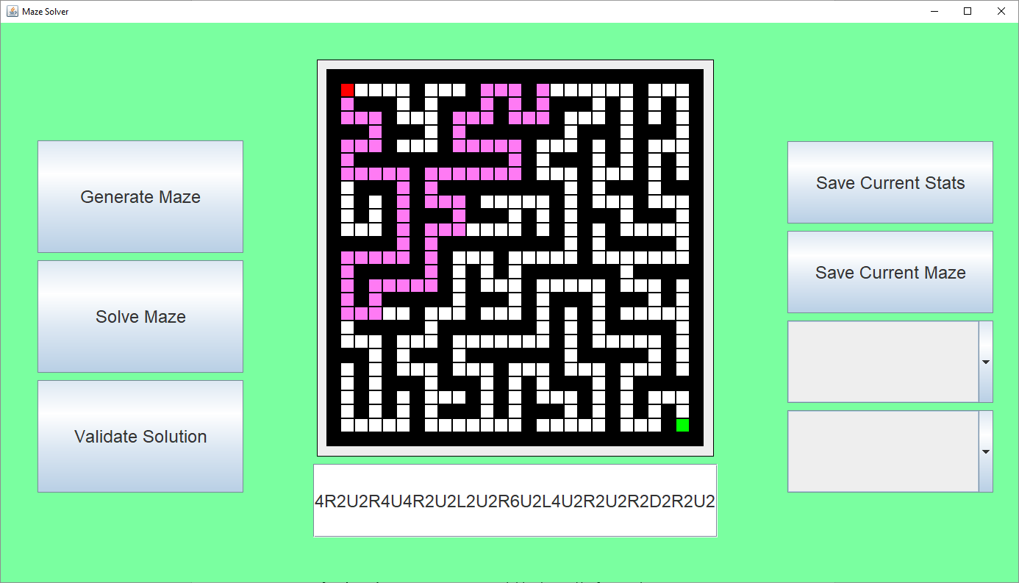

Which corresponds to ‘D2R2D2L2D2R4D6L4D4R2U2R4U4R2U2L2U2R6U2L4U2R2U2R2D2R2U2’ which is 54 characters wide and is yet to solve the maze, hence my approach to this proves a bit of a tedious solution to the problem of allowing the user to enter a custom solution.

## Phase 6 (Data – Processing and Saving Maze Data)

In this phase, it focused on how the maze generated can be saved to a file, and how statistics generated after solving the maze can also be saved in a format to be expressed and interpreted in other pieces of software such as Excel.

### Design

I am going to declare statistical variables which are going to be used to hold the relevant data, which can then be saved into a file in the CSV format.

#### Variable Table

|  |  |  |
| --- | --- | --- |
| Name | Type | Justification |
| stat_time | float | This will hold the time taken to solve the maze using the given algorithm, when more algorithms are used this could be used to compare algorithm efficiency. |
| stat_cell_count | int | This will hold the number of cells traversed before the solution was found, which can be used to compare the efficiency |
| stat_path_size | int | This will hold the number of cells which compose the found path |
| stat_path_count | Int | This will hold the number of paths which have been found for the given maze. |
| stat_solve | String | This will contain the algorithm which was used to solve the maze, which would be useful for identifying what algorithm the data corresponds to. |
| stat_generate | String | This will contain the algorithm which was used to generate the maze, which would be useful for identifying what algorithm the data corresponds to. |
| maker_solution | String | This will come with saving the given maze, when the maze is saved, a solution will be saved along side with it, this solution will be verified with the BFS algorithm meaning it is the shortest solution to the maze. |
| maker_maze | String | This will come with saving the given maze, when the maze is saved, it will be compressed using ‘My Compression Method’ found in the analysis phase. |

#### Classes and Data structures

There will be two classes which are going to be made: StatMaker which will write the statistical data to a file specified by the user in the CSV format, and a MazeMaker which will compress and write the maze to a file, as well as parse the maze from the file back into a format which can be presented back onto the maze.

#### Validation

There will be validation for whether a solution has been generated for the maze using one of the given algorithms, this is required to generate the data to be saved, if the user has not yet generated and solved a maze, the user cannot save data to a file as there exists no data to be saved. The MazeMaker will contain a parser which will require the maze to be in a specific format, if the user edits the file and/or is corrupted, the maze cannot be loaded, it will also require the ‘. maze’ file extension to make it obvious that the file entered is expected.

### Implementation

#### Pseudocode

##### StatMaker

class StatMaker

stat_time

stat_cell_count

stat_path_size

stat_path_count

stat_solve

stat_generate

procedure new()

stat_time = 0.0

stat_cell_count = 0

stat_path_size = 0

stat_path_count = 0

stat_solve = “”

stat_generate = “”

endprocedure

procedure write(filename)

filp = open(filename, “w”)

filp.write("Solve Algorithm, " + stat_solve + "\n");

filp.write("Generation Algorithm, " + stat_generate + "\n");

filp.write("Time, " + str(stat_time) + "\n");

filp.write("Cell Count, " + str(stat_cell_count) + "\n");

filp.write("Path Size, " + str(stat_path_size) + "\n");

filp.write("Path Count, " + str(stat_path_count) + "\n");

filp.close(); endprocedure

endclass

##### MazeMaker

class MazeMaker

maker_maze

maker_solution

procedure new()

maker_maze = “”

maker_solution = “”

endprocedure

procedure get_maze()

maker_solution = shortest_path_str()

maker_maze = maze_str()

endprocedure

endclass

##### shortest_path_str

procedure shortest_path_str()

maze_solution = “”

queue = new Queue()

queue.add(start_node_pos)

matrix[start_node_pos].add_state(VISITED)

prev = []

while NOT queue.Empty() then

index = queue.remove()

neighbours = get_neighbours(index, 1, WALL | VISITED)

for i = 0 to len(neighbours) then

neighbour_index = neighbours[i]

neighbour_cell = matrix[neighbour_index]

queue.add(neighbour_index)

neighbour_cell.add_state(VISITED)

prev[neighbour_index] = index

next i

endwhile

prev_cell = prev[end_node_pos]

for i = prev[end_node_pos] to 0 then

cell = prev[i]

maze_solution += get_dir(cell, prev_cell)

cell.set_state(SEARCHED)

next i = prev[i]

soln_simplify()

endprocedure

##### get_dir

procedure get_dir(curr, prev)

curr_x = curr MOD matrix_w

curr_y = curr DIV matrix_w

prev_x = prev MOD matrix_w

prev_y = prev DIV matrix_w

if (curr_x > prev_x) then

return ‘R’

else if (curr_x < prev_x) then

return ‘L’

else if (curr_y > prev_y) then

return ‘D’

else

return ‘U’

endprocedure

##### soln_simplify

procedure soln_simplify()

copy = “”

ptr = 0

while ptr < len(maze_solution) - 1 then

curr_dir = maze_solution[ptr]

mag = 1;

i = 0

for i = ptr to len(maze_solution) – 1 then

if maze_solution[i] == curr_dir

mag = mag + 1

else

break

next i

copy += curr_dir + chr(mag)

ptr = i

endwhile

maze_solution = copy

endprocedure

##### maze_str

procedure maze_str()

maze_str = “”

for i = 0 to len(matrix) then

if i MOD matrix_w == 0 then

maze_str += ‘\n’

endif

cell = matrix[i]

if cell.check_state(PATH) then

maze_str += ‘1’

else

maze_str += ‘0’

next i

endprocedure

shortest_path_str and maze_str are member functions of the maze class which are used to get the find the shortest path and commute the path into a series of commands which can be expressed in terms of the user validation syntax. This is presented in the get_dir and soln_simplify sub-procedures which help compose a simplified solution which can be entered to solve the given maze. The maze_str procedure simply loops through the maze and checking the state of each cell, if the cell is a wall a ‘0’ is written else a ‘1’ is written to represent a path.

#### Source code

Now I went onto first implementing the StatMaker class and testing to see whether it works based on the pseudocode created:

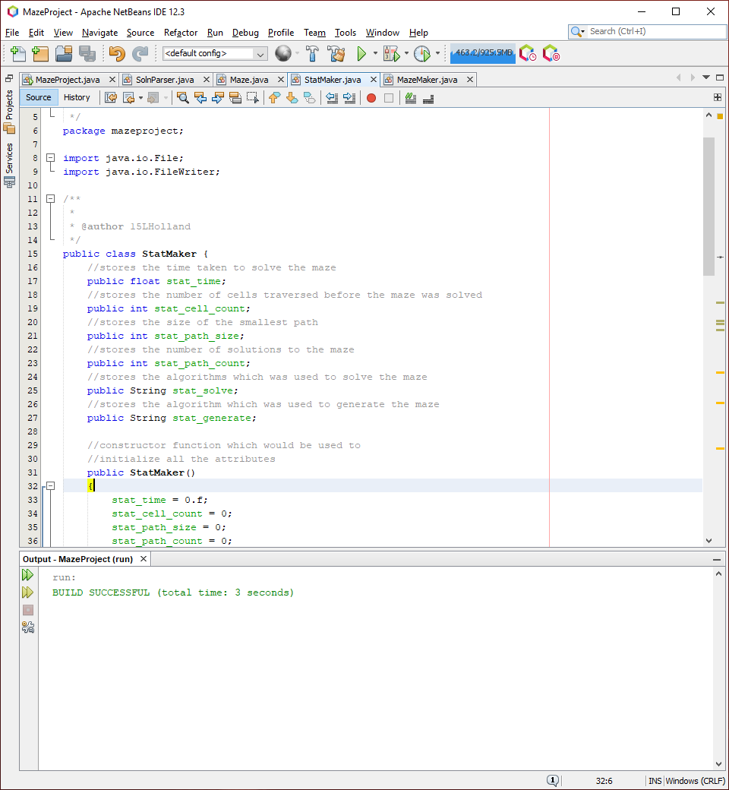

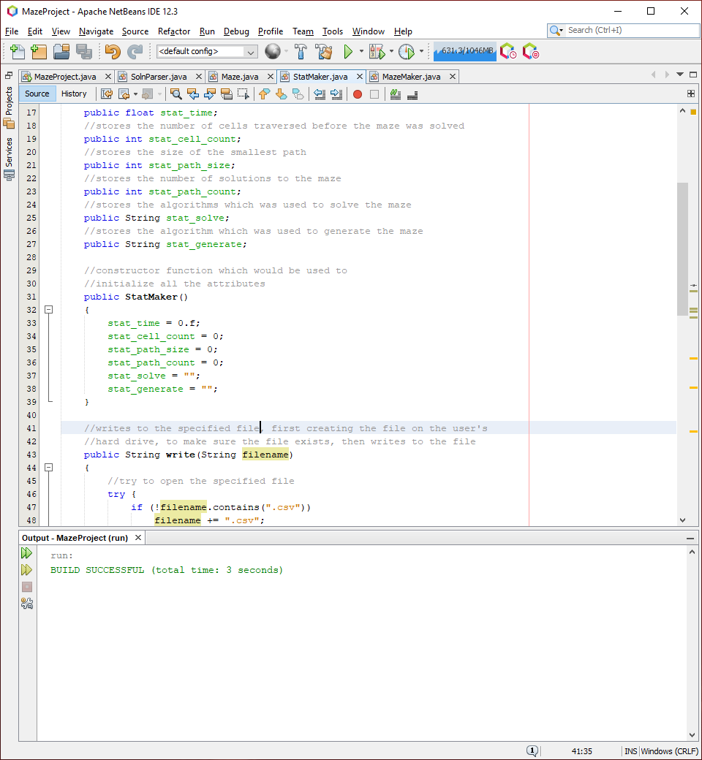

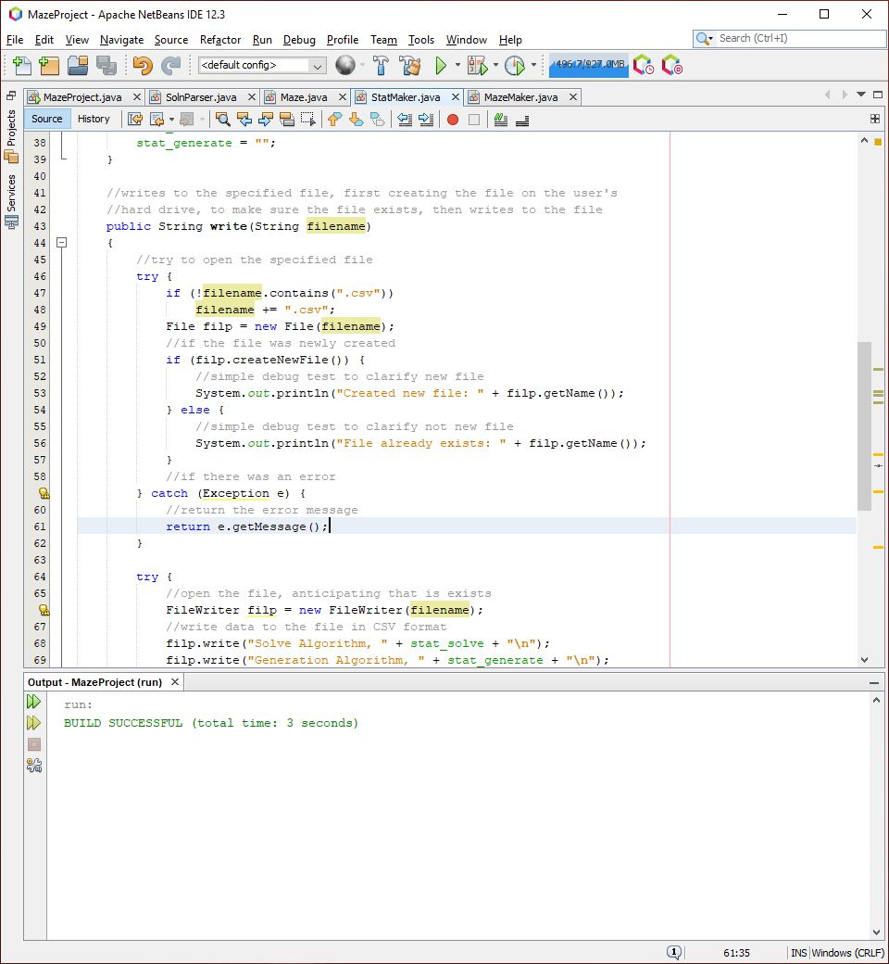

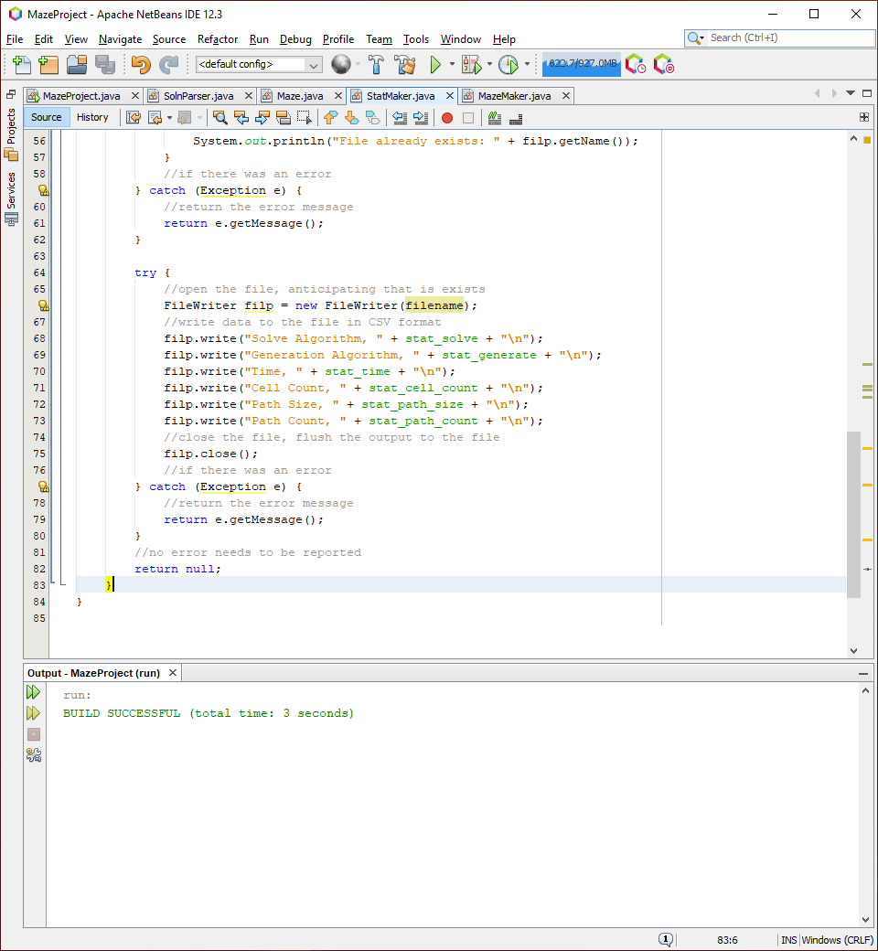

This is the implementation of the StatMaker class. I added the StatMaker class as an attribute of the window, where it’s procedures can be used as accessed into the files:

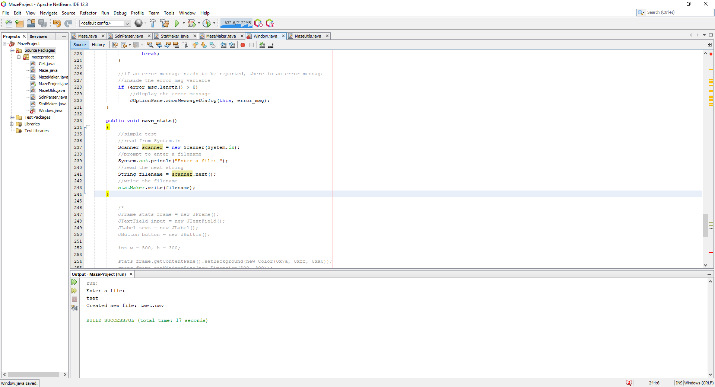

I then set the action listener of the saveStatsBtn to this function so when it is pressed, this function is called:

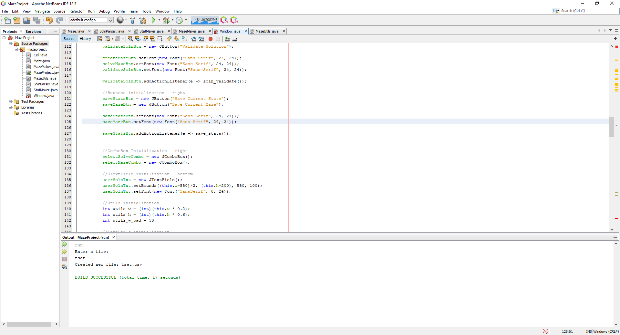

When the program runs with the input of ‘testfile’ to System.in, it produces the following:

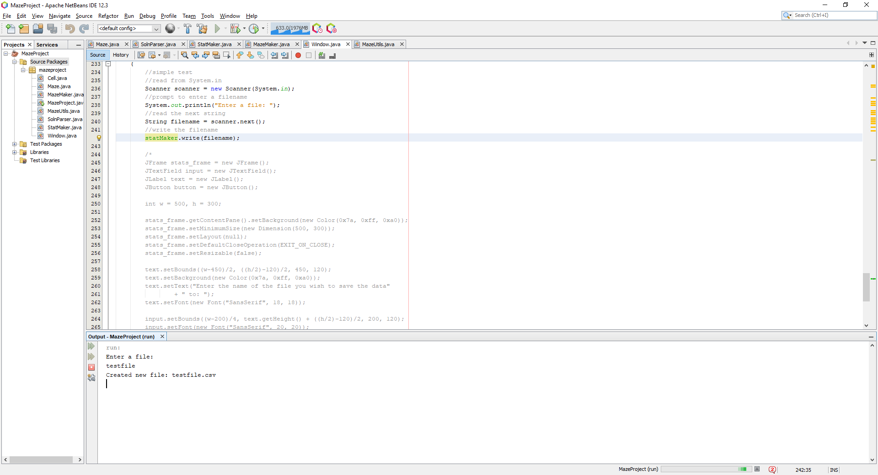

This is what is expected, and if I look into the project folder, I can find the folder has been created and is detected as a .csv file and requests to be opened with Excel:

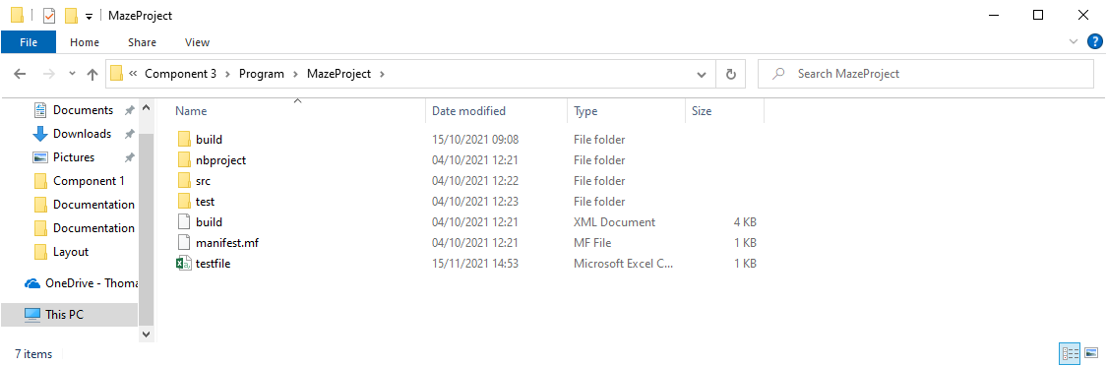

This was successful for test #1 where I wanted to check if the function would successfully create a file on the hard drive with the name specified.

Next, I wanted to create a window which would take in the input from the user, reading from a text box where once the user has entered a file the file is then passed and the data is written, since the user is not going to have access to a console when the application is given:

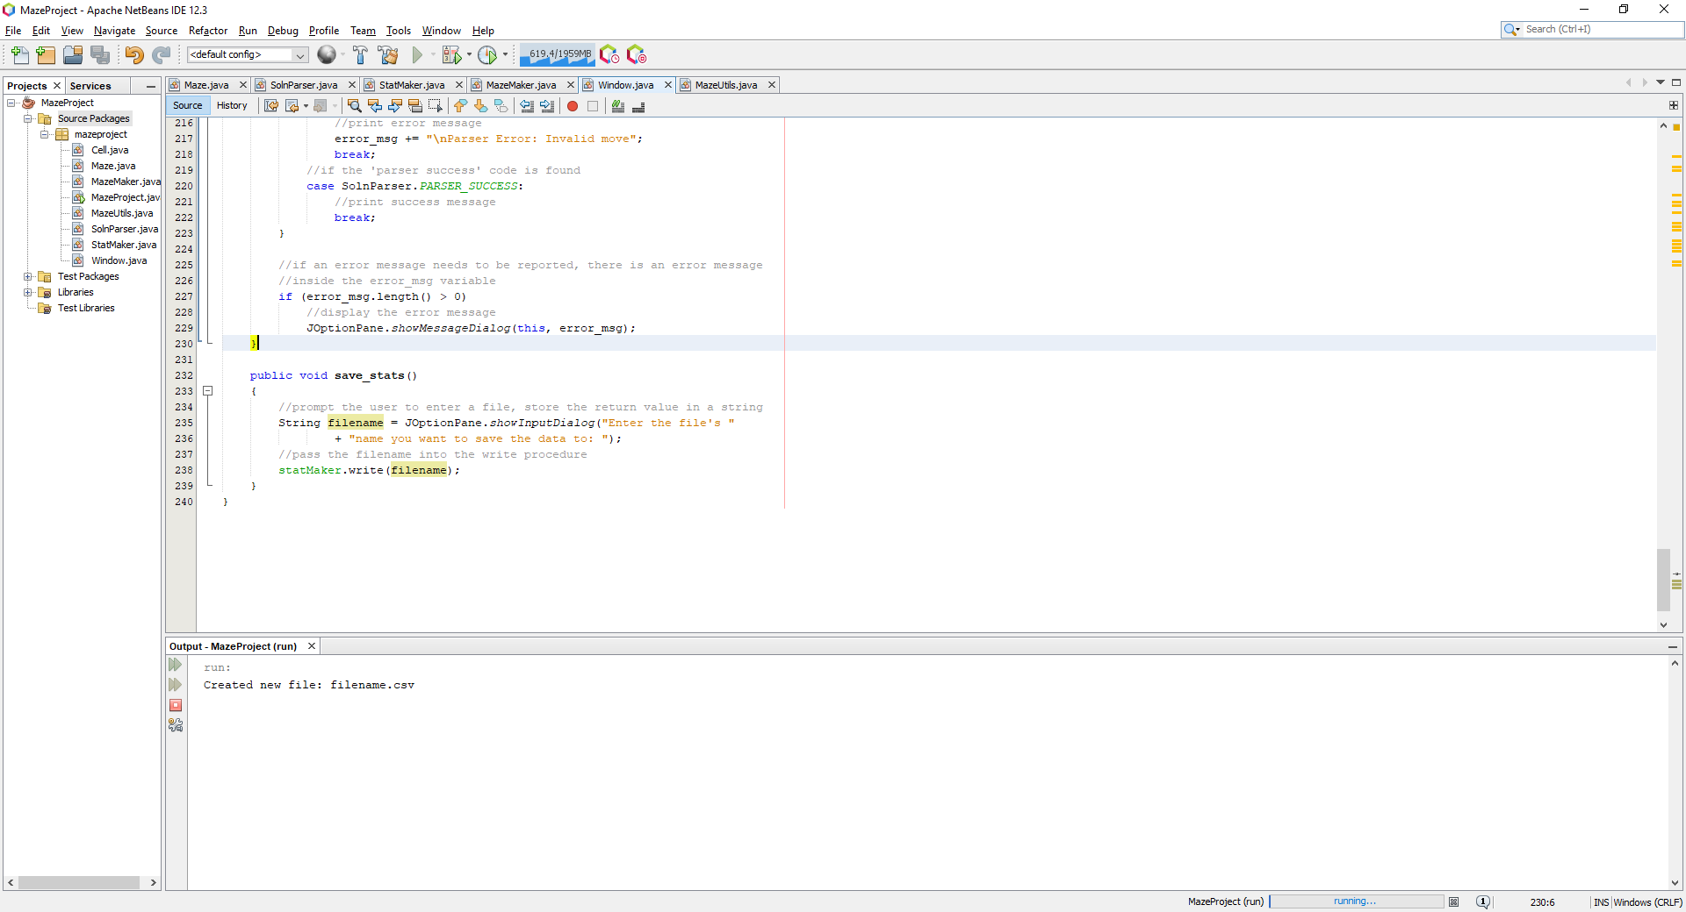

This does the following:

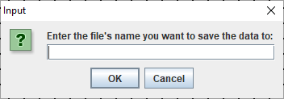

Where the user can enter the file name they want to enter, I chose to write ‘test’:

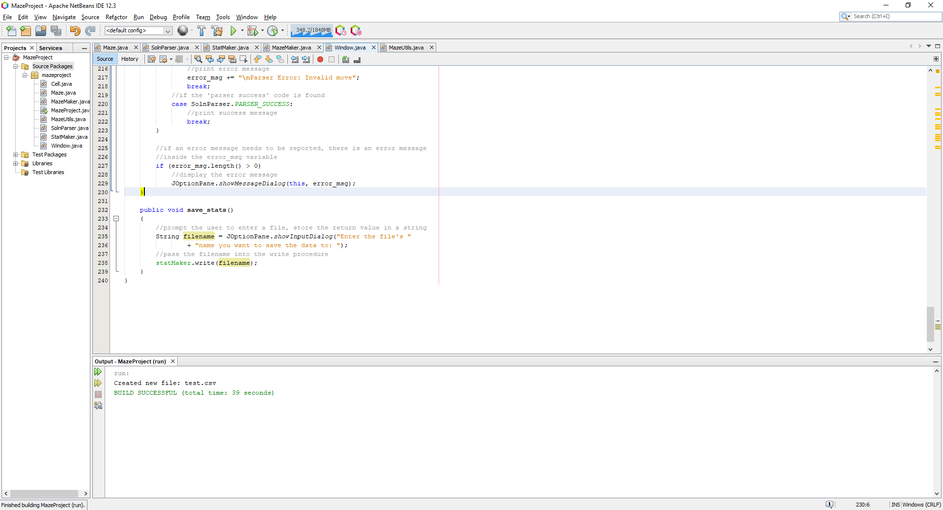

Where the file is created successfully.

Now it is clear that for every search algorithm that runs, it should have to write to each variable present in the statMaker so that when a save is requested, the data is present in the variables to be saved appropriately, so I decided to pass a reference to the statMaker to every generation and solving algorithm so they can edit the contents of the structure:

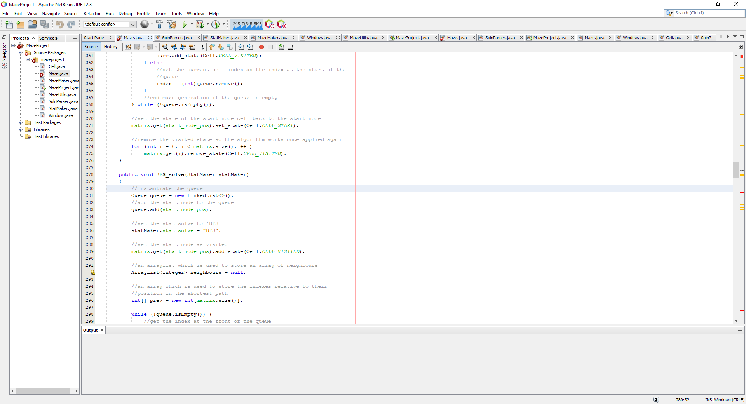

Where the algorithm will set the attributes related to the function being called:

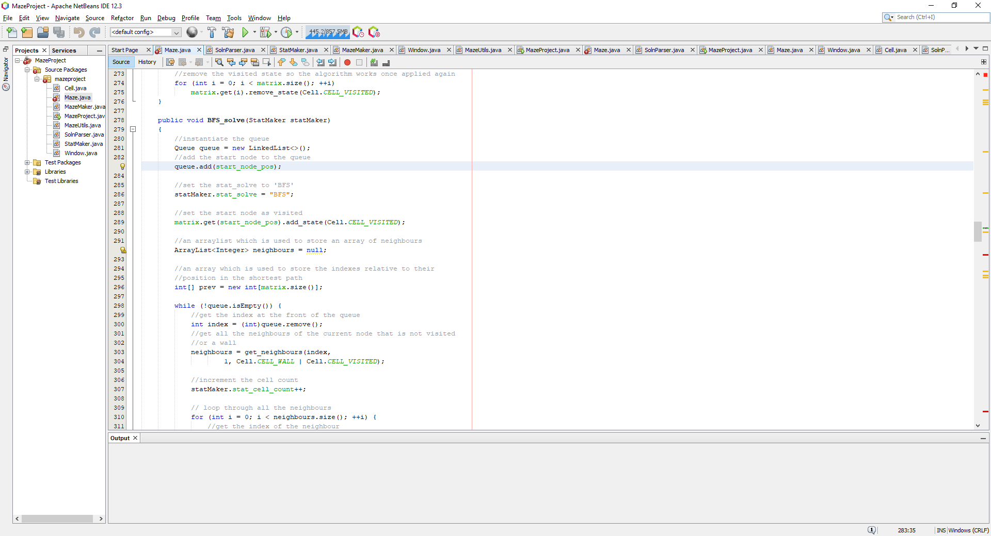

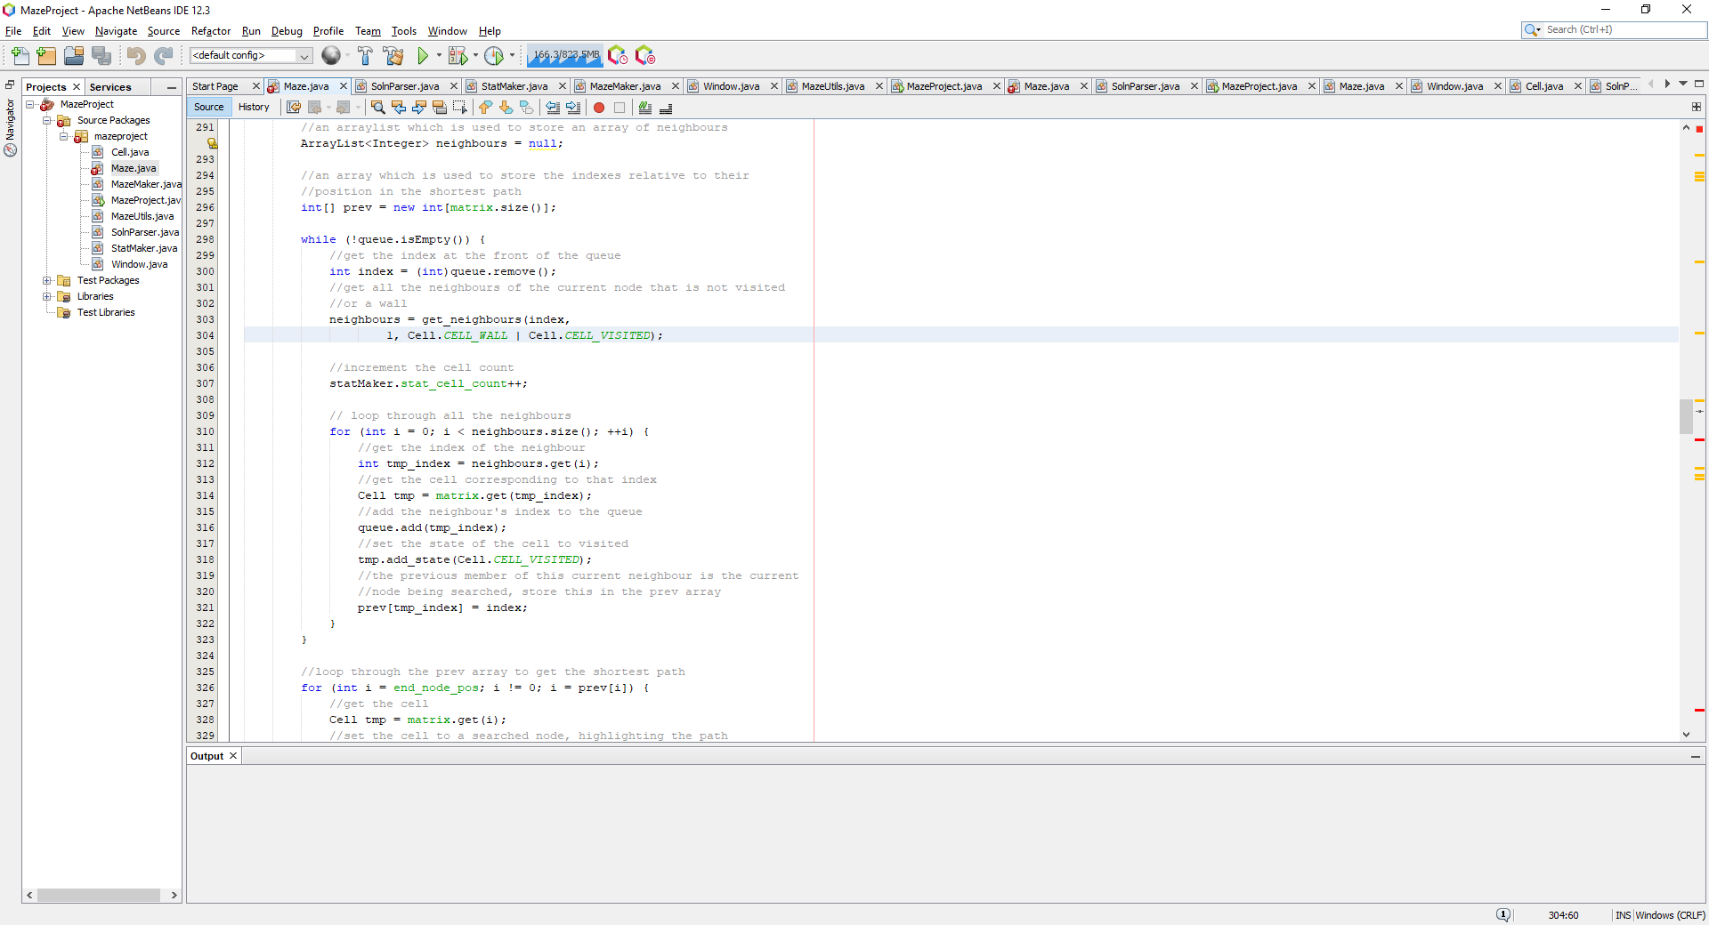

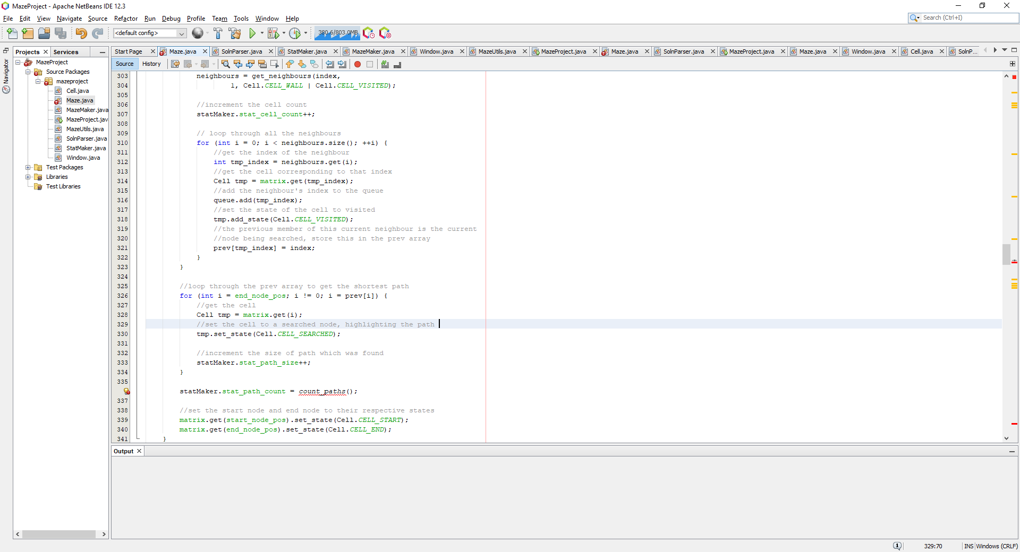

These are the first statMaker attributes which I have desired to edit in the BFS_solve procedure, another attribute which needs to be edited is the timer attribute where a timer will need to be created to time the procedure to see how long it takes to find the path, as well as a function which will provide the number of paths for the given maze generated. Furthermore, I have also passed a reference of the statMaker to the DFS procedure which will generate the algorithm:  
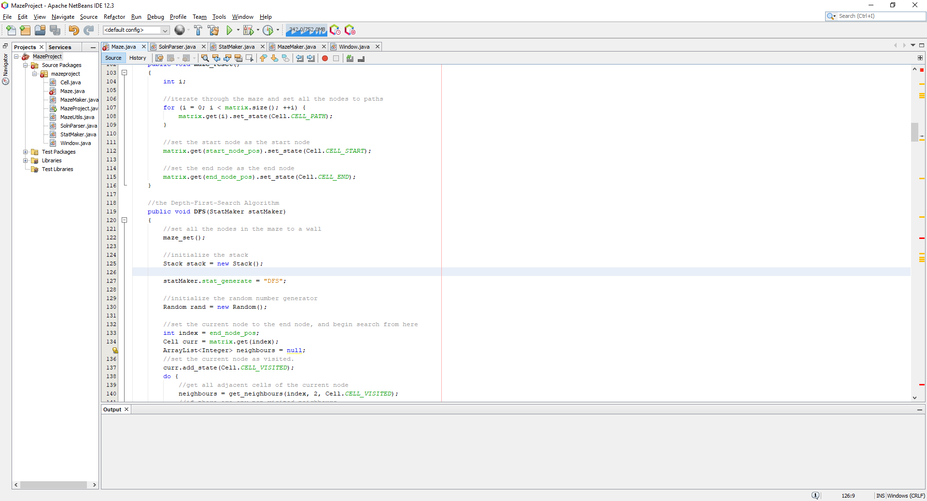

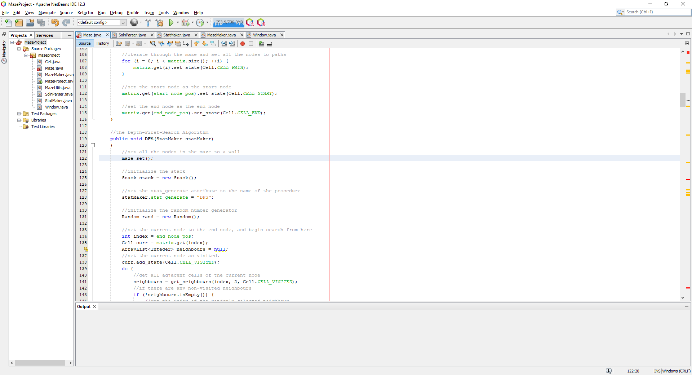

Next, I wanted to implement a function which would return the number of possible paths for a given maze called count_paths. I read ‘Count number of ways to reach destination in a maze using BFS’[13] where it explains how to use BFS to find the number of solutions to a given maze. The explained principle is to use a similar approach to the general solution of BFS where instead every time a neighbour is reached and a neighbour is the end cell, then we increment the path counter, because that path is responsible for a new path, we do not terminate once the end is reached, we can wait for more and more paths to be found, until no more optimal paths are found, more paths will exist, but some are entirely redundant and not necessary to count:

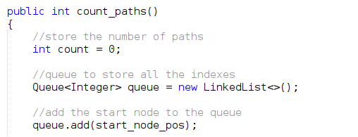

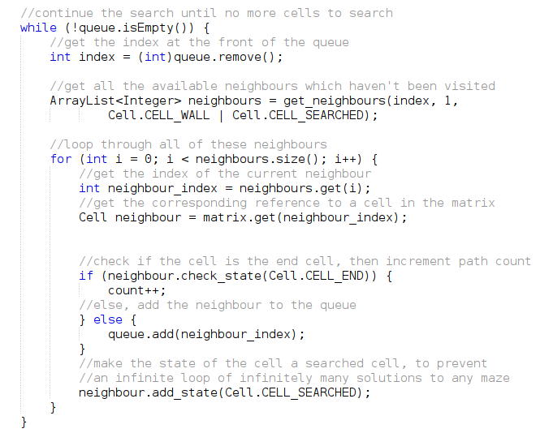

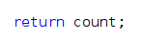

This is the function which defines the way to identify all the possible paths within a given maze, using the BFS algorithm to do so. It is hard to verify if this function implementation works but from the tests I have conducted, it works as intended and shows that there is only one solution for the mazes which are currently generated, which is expected. Using the following code to display the number of solutions to a given maze I can verify this:

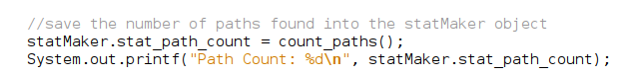

Where generating a maze will produce the following output:

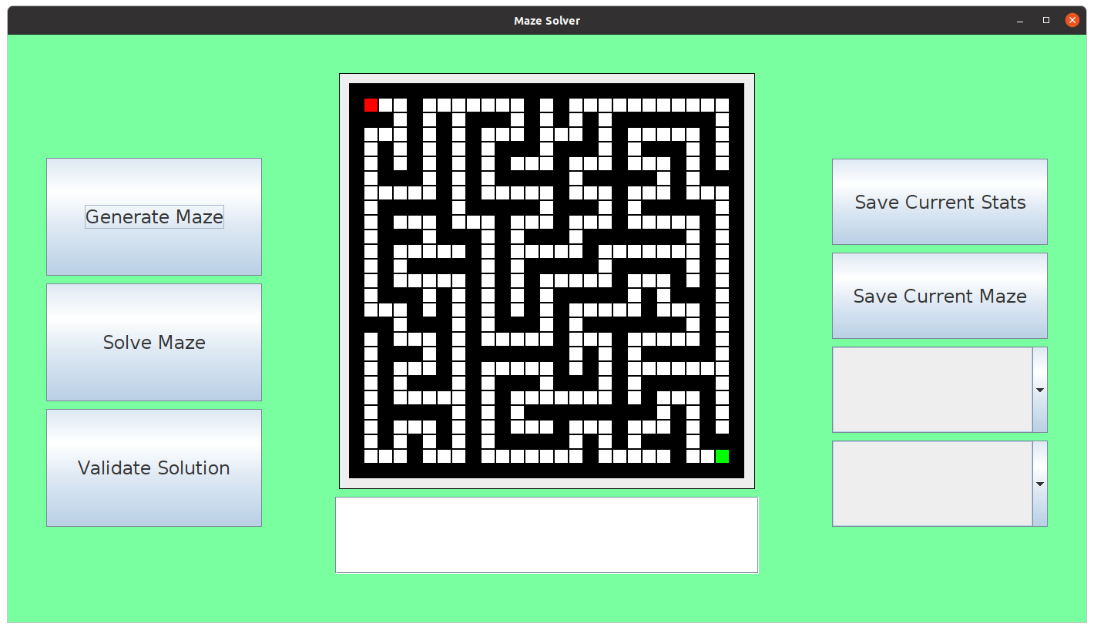

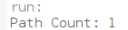

Hence, this was successful for test #2, as recorded in the test table below. Finally, I need to add the timer to time how long it takes for the algorithm to solve the given maze. This can be done by adding a simple timer which starts before the start of the solve and stops at the end of the solve:

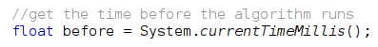

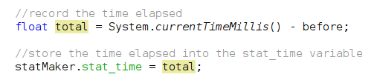

Where when we run the algorithm and save the statistics to a file, we can see the time it took to solve the maze:

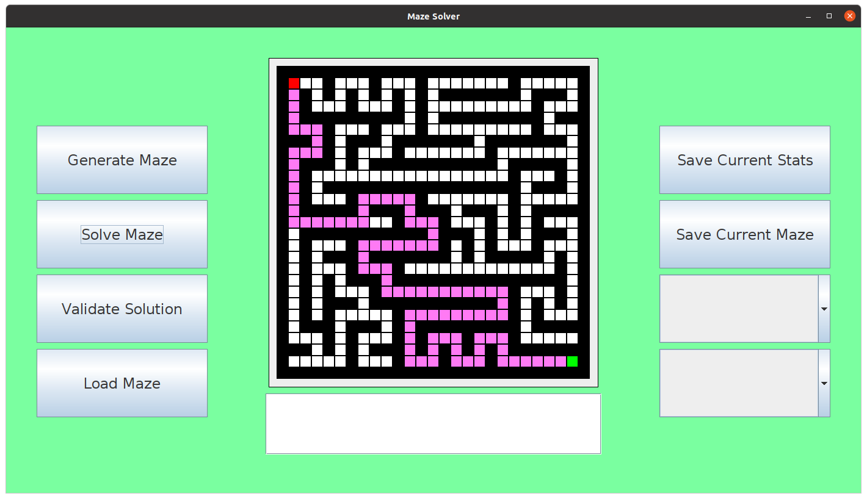

And saving the data for this solve, gives the following:



And opening stats:

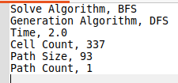

Which does not provide a great enough precision, only 1.sf which is not exactly what was expected. I printed out the value of the total time before it was written to a file, and this produces the following:

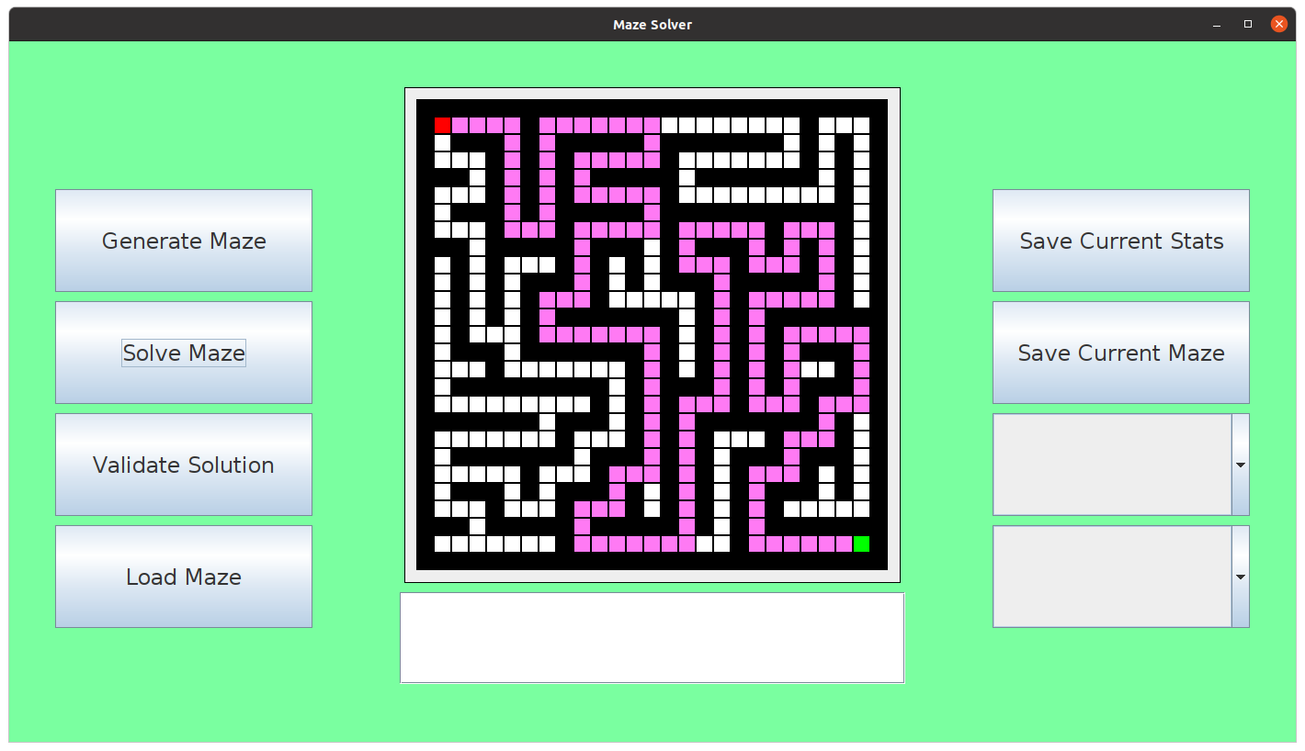



Which is up to 6.dp, not 1.dp but I assume that the precision is lost or coerced before being written to a file and hence the precision is not that important, if the times can be compared well enough, it will suffice.

Next, now I wanted to work on the saving of the actual maze, where the maze will also be saved to a file specified by the user, this can follow the similar functionality of the save current stats button functionality, but first, I need to create the function to process the maze and interpret it into a format which can be saved into a file, then I need to compress the file, to save space on the user’s computer. Considering the maze is pretty small and not going to be dynamic based on the client requirements, I am going to use ‘My Compression Method’ which was defined in the analysis of the solution when performing research on the Huffman coding compression method, details on ‘My Compression Method’ will briefly be re-explained: Scanning the maze and treating each wall as a ‘0’ and path as a ‘1’, this will eventually compose a w-bit integer, where w is the width of the maze and generate h of them, where h is the height of the maze. These w-bit integers are then converted into their hexadecimal form. This will reduce the size consumed on the hard drive and will save space when saving mazes from w*h bytes to log16(w)*h which for example for a maze with dimensions of 24 by 24 making up 576 cells would be compressed to roughly 144 bytes compared to 576 bytes. In order to do this, I wanted to first create the function to turn the maze into a string of ‘1’s and ‘0’s:

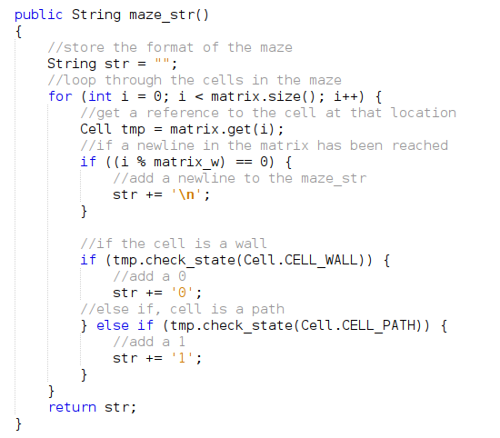

Then I add a save_maze function to the window class which will call this function and print the resulting string, for testing purposes:

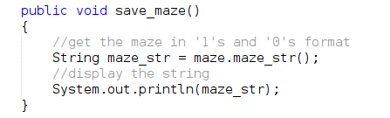

Then I add this function as the action listener for the saveMazeBtn:



Now, running the program, produces the following:

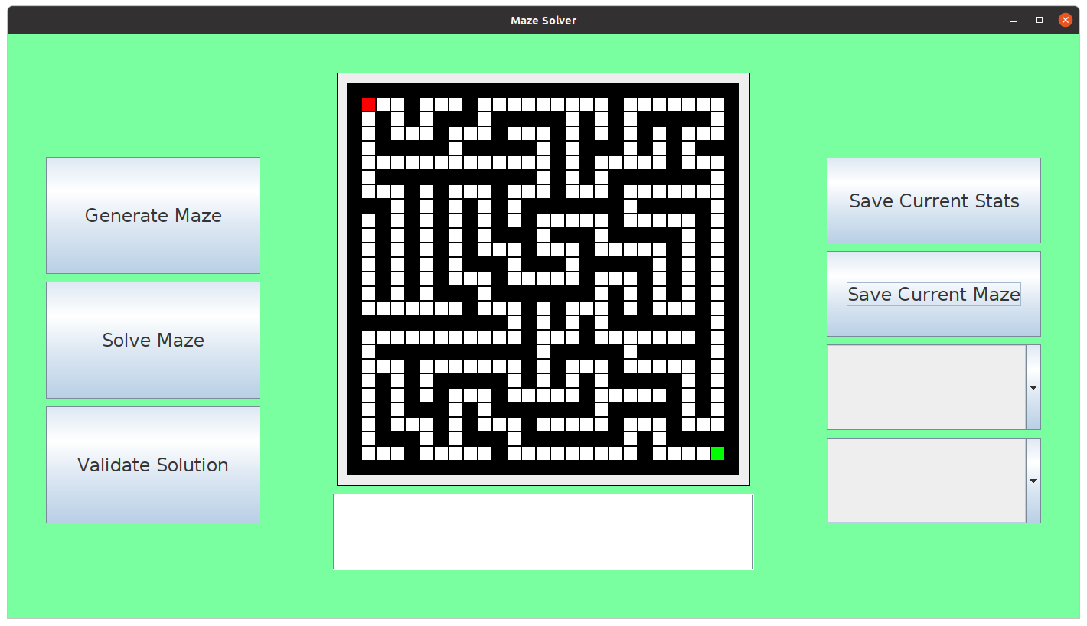

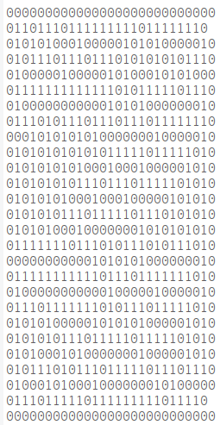

Which is what is expected, apart from the 2nd line and 2nd from last line, where the start node and end nodes are present in the maze, I need to make sure the function knows how to represent those in the string too. This was unsuccessful for the first test for this function as test #3. To fix this, I just added an extra test before adding a ‘1’ to the string:  
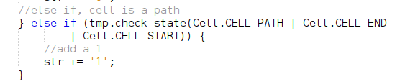

Where I do a bitwise OR to create a single state which contains the path state, start state and end state, which will return true if any of those states is encountered for the check_state function. Running the program now shows the following:

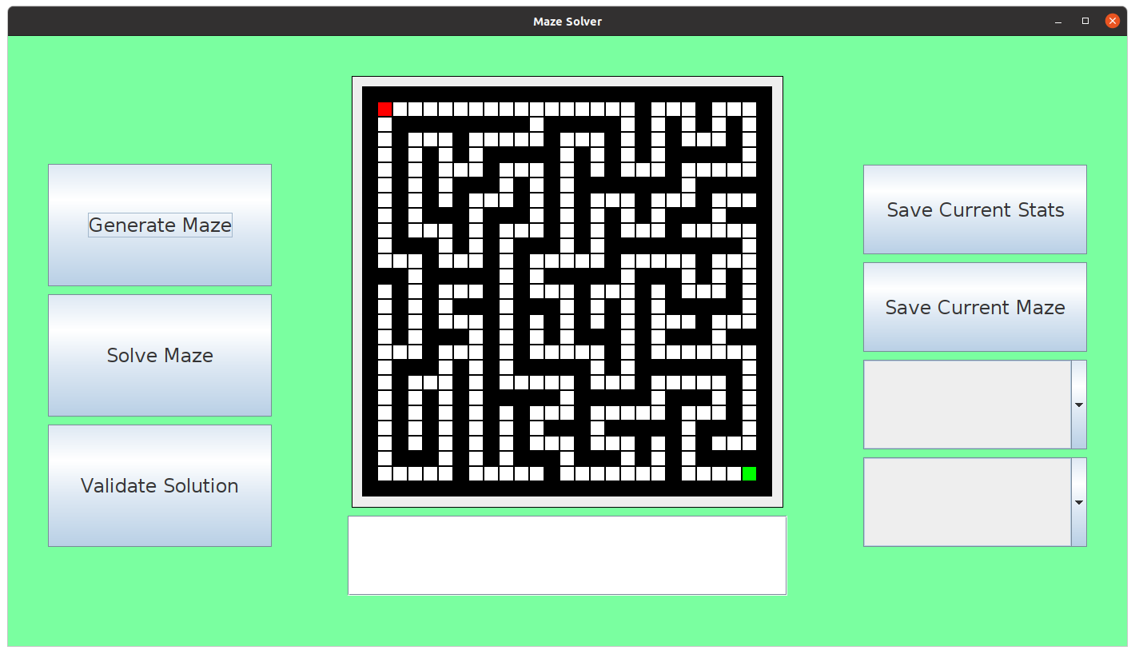

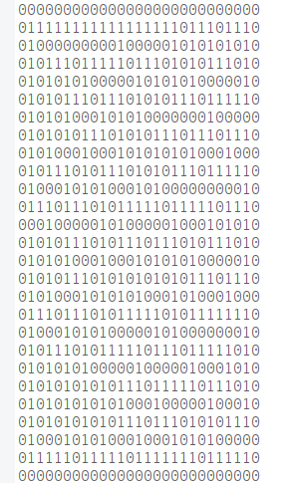

Where now in place of the start and end node, there exists a ‘1’ in the string. Which is successful for test #4.

Now I need to convert each binary number into its hexadecimal equivalent, which can be done by creating a separate function called bin_to_hex, checking each nibble of the binary number and converting that way:

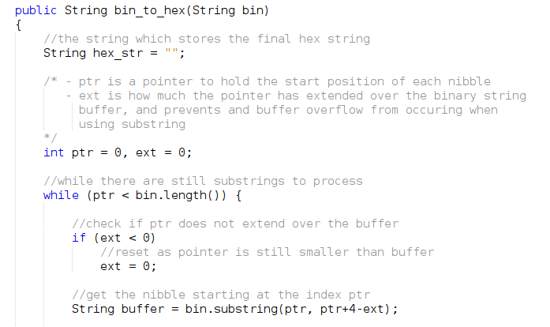

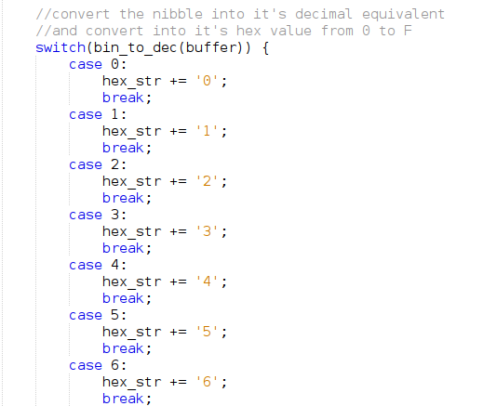

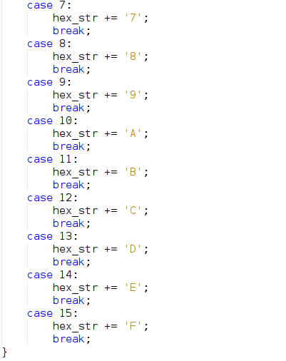

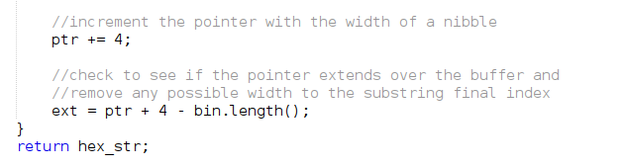

Where the bin_to_dec function is also as follows:

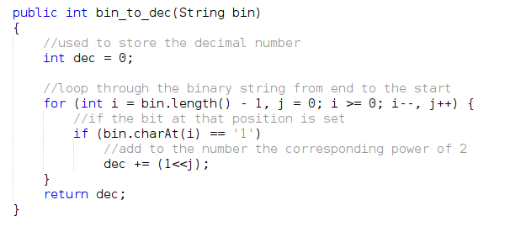

This is the function which translates the binary string into a hexadecimal string, using this to compress the binary strings in maze_str as follows:

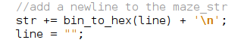

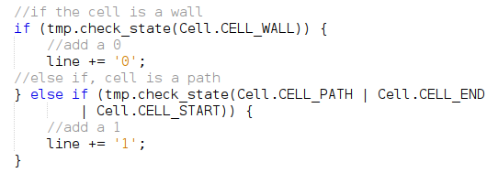

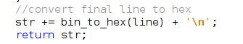

Where to fix the processing of individual lines of the maze, I created a line variable which simply contains each line of the maze before adding it to the final str.

Now calling the maze_str function produces the following output when printed:

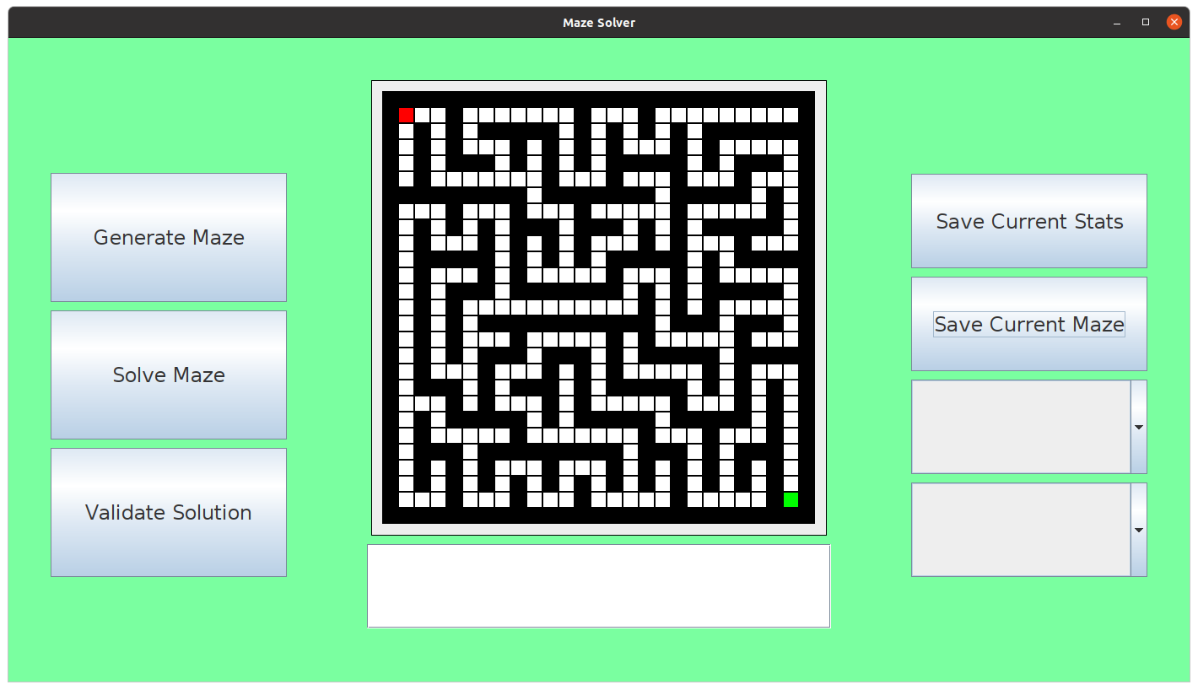

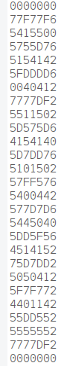

Where it can be observed that the width the output has decreased from 27 to 7, and the test was successful for test #5. Going from consuming 729 bytes to 189 bytes. Which is 189/729 x 100 = 26% the original size. Now I wanted to make sure that I could recover the original maze from after this compression, which I created a hex_to_bin function which would do so, which works in the following way:

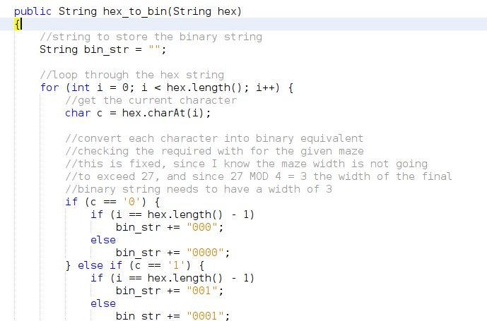

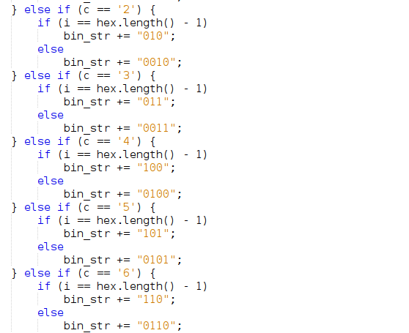

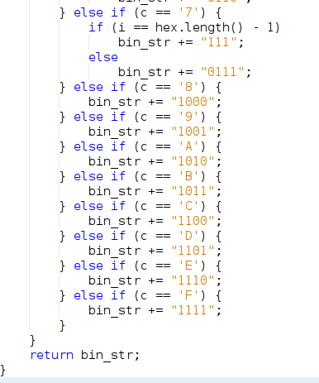

Which works for only a single special case, the special case being that the width of the maze MOD 4 is equal to 3. If the width of the maze has different remainders the function will not work, but since the width of the maze has been agreed to not be dynamic and it has been set to 27, which 27 MOD 4 = 3, it works for the current state of the program. And testing this in the maze_str function as follows:  
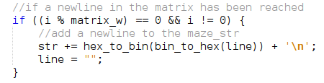

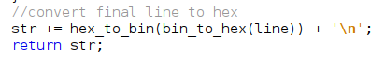

Which simply converts to hex, then back to binary again, so it should produce a similar looking binary maze, similar to the screenshot of a binary maze previously, and testing this presents the following:

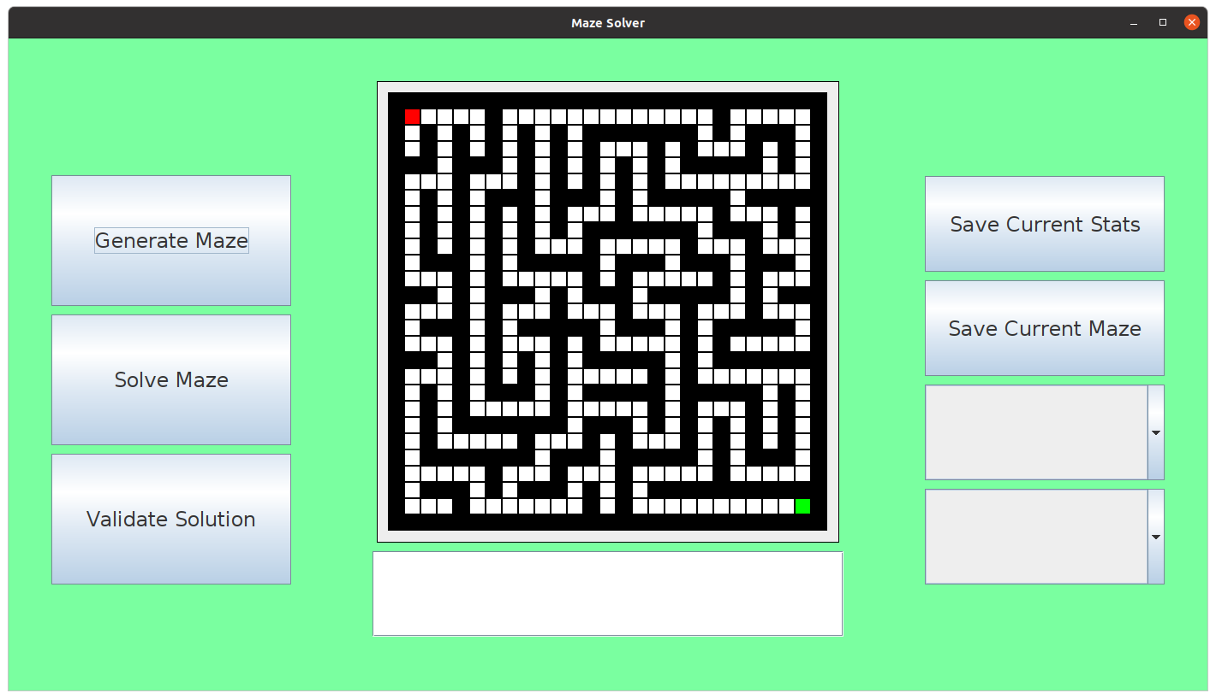

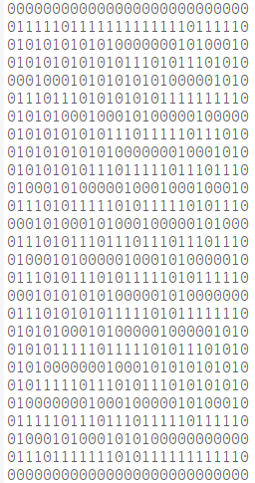

Which is as intended, the compression works and can also be decompressed back into its original, interpretable binary format. Next, I wanted to work on the string solution which is saved along-side the maze, this can be done by looking at the pseudocode created define above, which simply outlines the BFS algorithm but when the BFS algorithm is taking place, it creates a string which represents the solution, this is implemented as follows:  
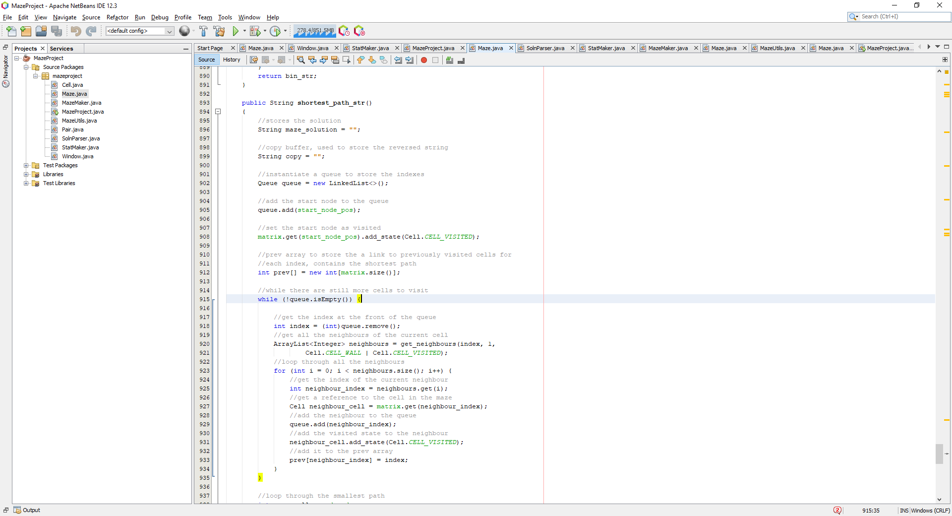

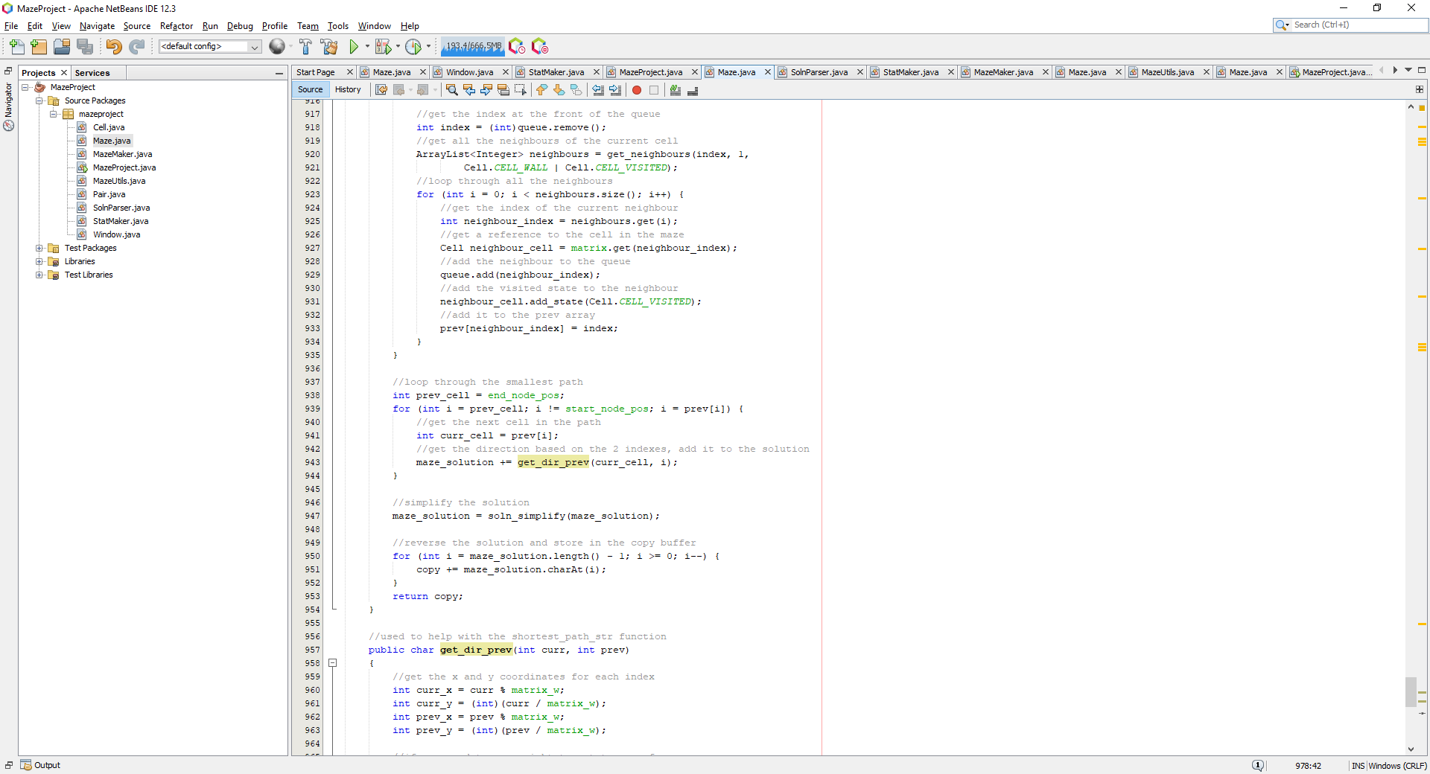

Where this function is used to create the solution to the currently saved maze which is then saved alongside the compressed maze. This algorithm uses other functions such as get_dir_rev and soln_simplify to help improve the way the solution is presented inside the file and make it more presentable. These functions were made as follows:

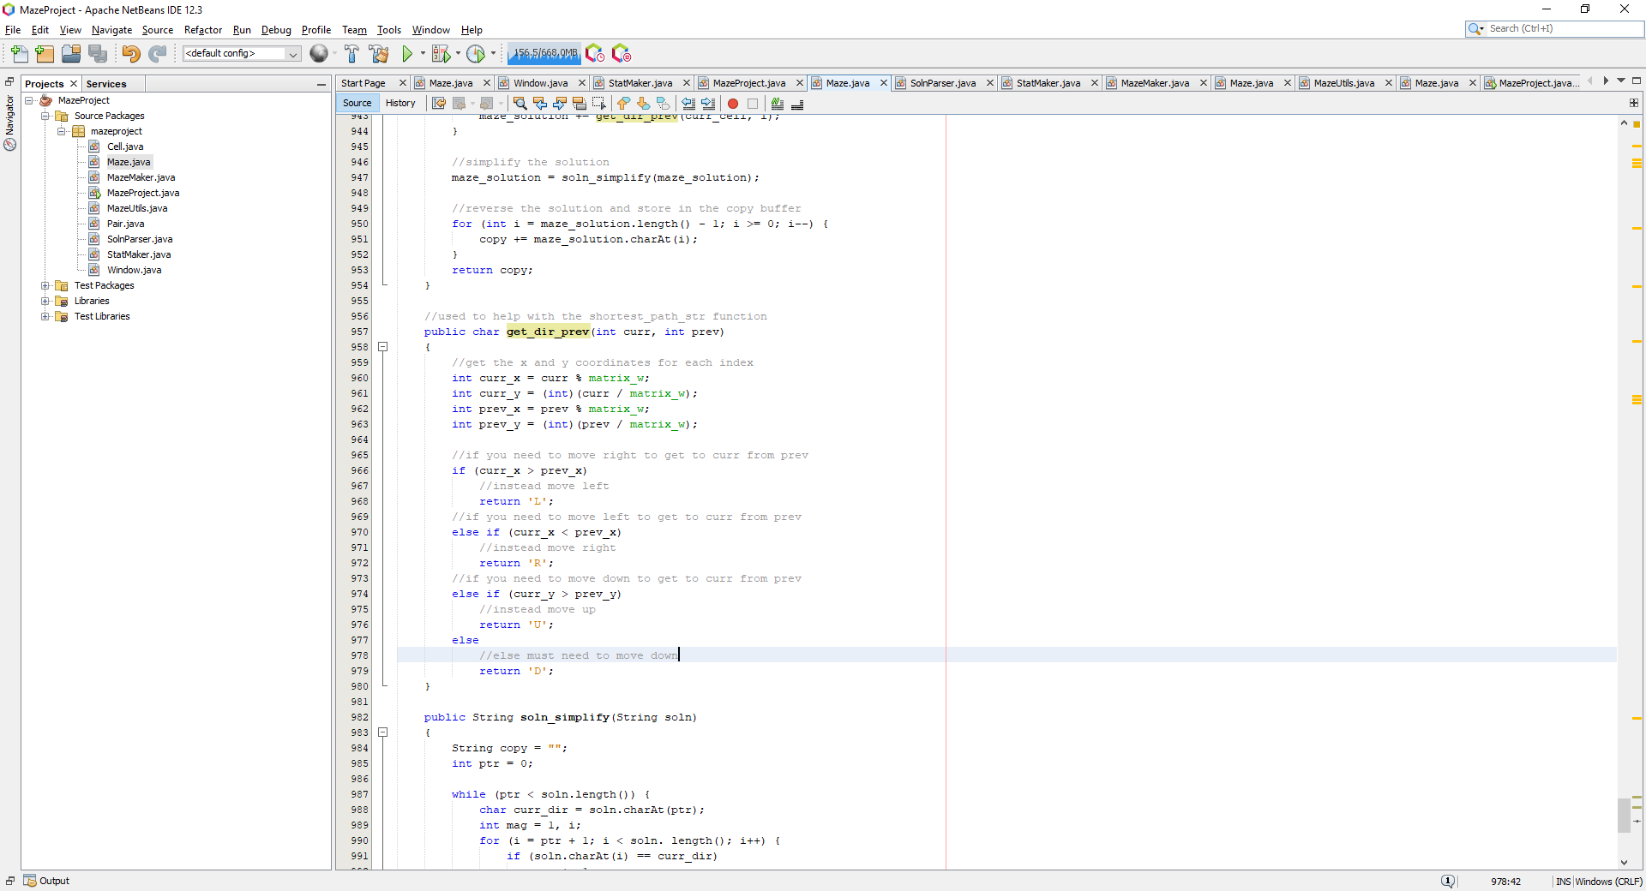

The get_dir_rev function will take in 2 indexes from the maze and translate them into a direction based on how to get to the curr index from the prev index, and reverses based on the path taken since the prev array which is being traversed is going to contain the path to get from the end node to the start node and we need to the path to the start node to the end node. This is the reverse of the get_dir function which was designed in pseudocode, hence the rev in the function header. The next function is the soln_simplify function which simply turns something like ‘LLLL’ into ‘L4’ to simplify the solution into its direction magnitude form:

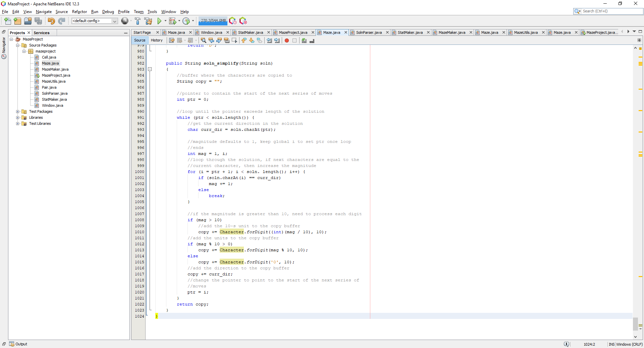

Now, to test if the shortest_path_str function works as intended, I decided to generate the string when the maze button was pressed, and print the string returned from the function:

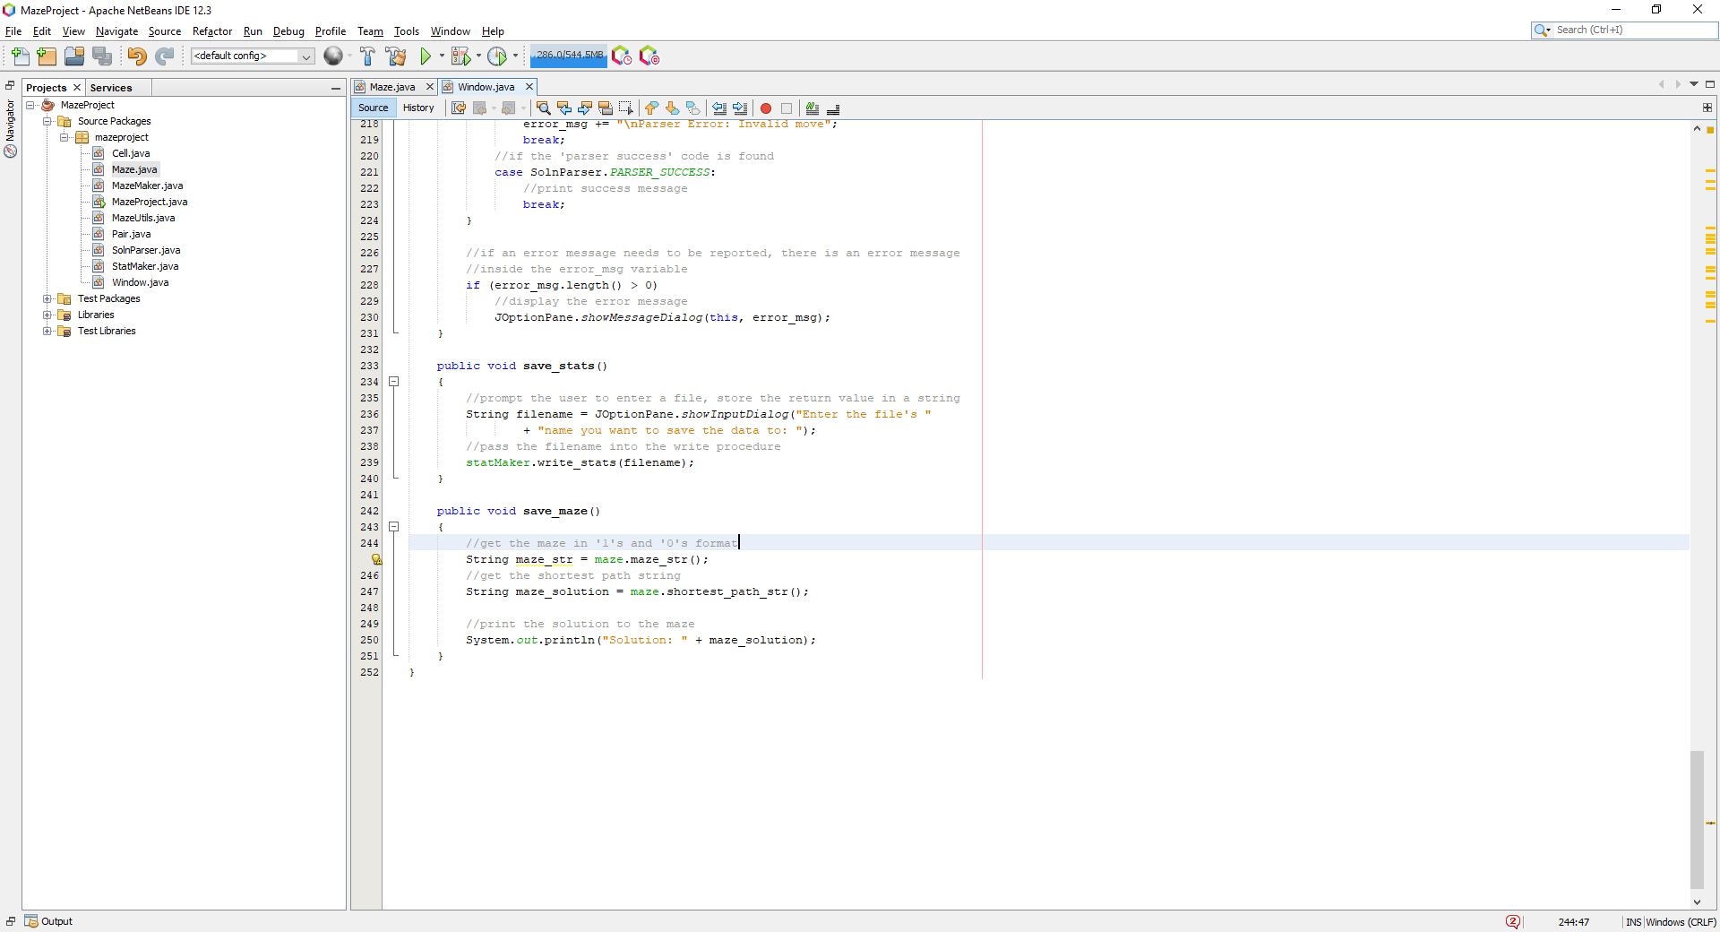

Now running the program, generating a maze and pressing the maze button should generate a valid solution in the console, which when verified should solve the maze and display no error:

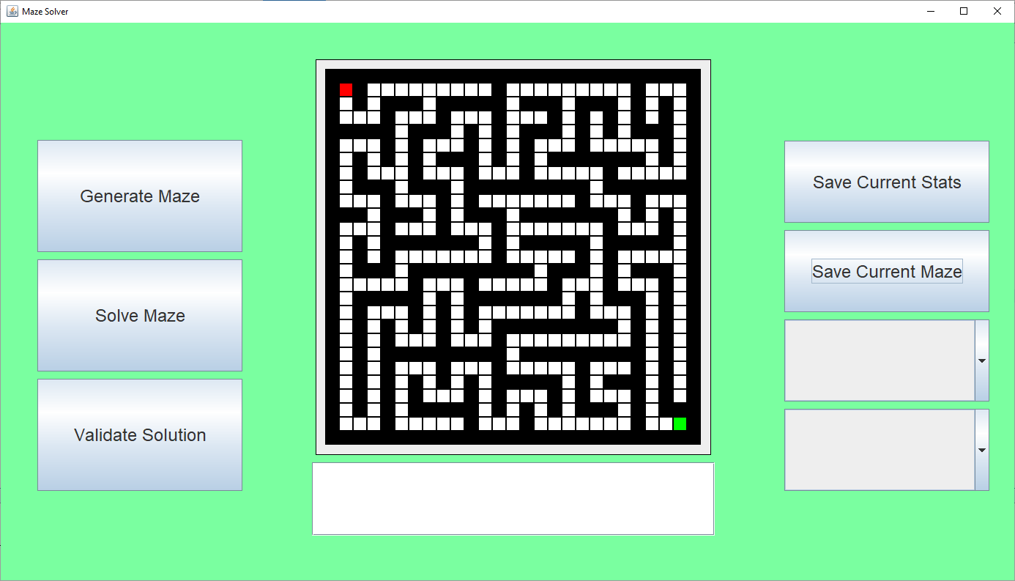

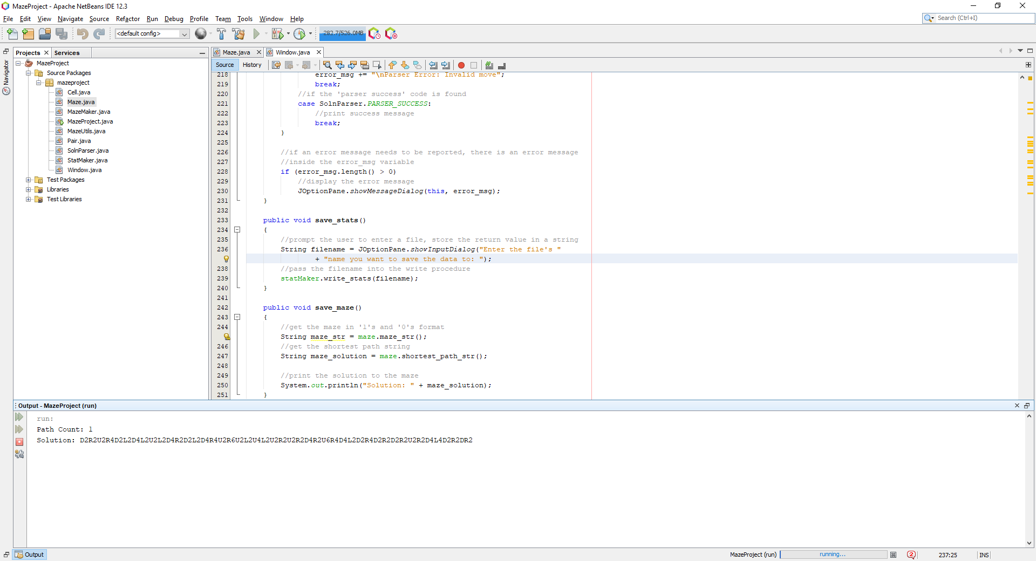

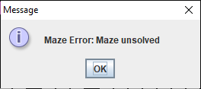

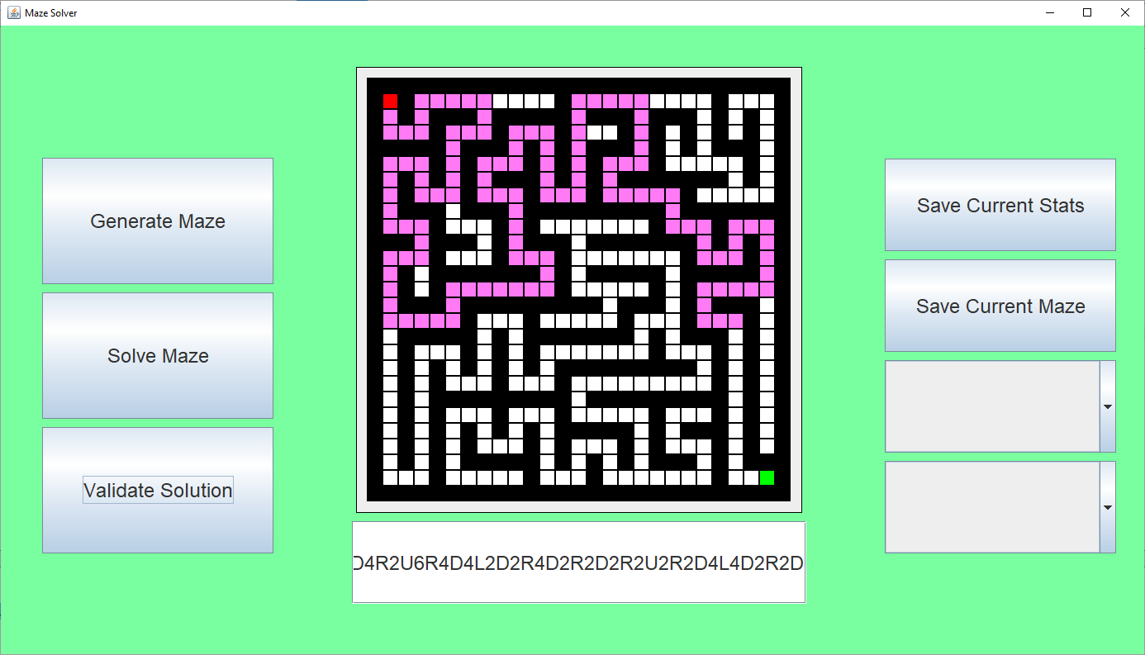

Looking at the solution the magnitude next to the ‘D’ should have been 10 to move down 10. This was an unsuccessful test for test #7. I realised the issue was dealing with magnitudes greater than 10, which is handled in the soln_simplify function:

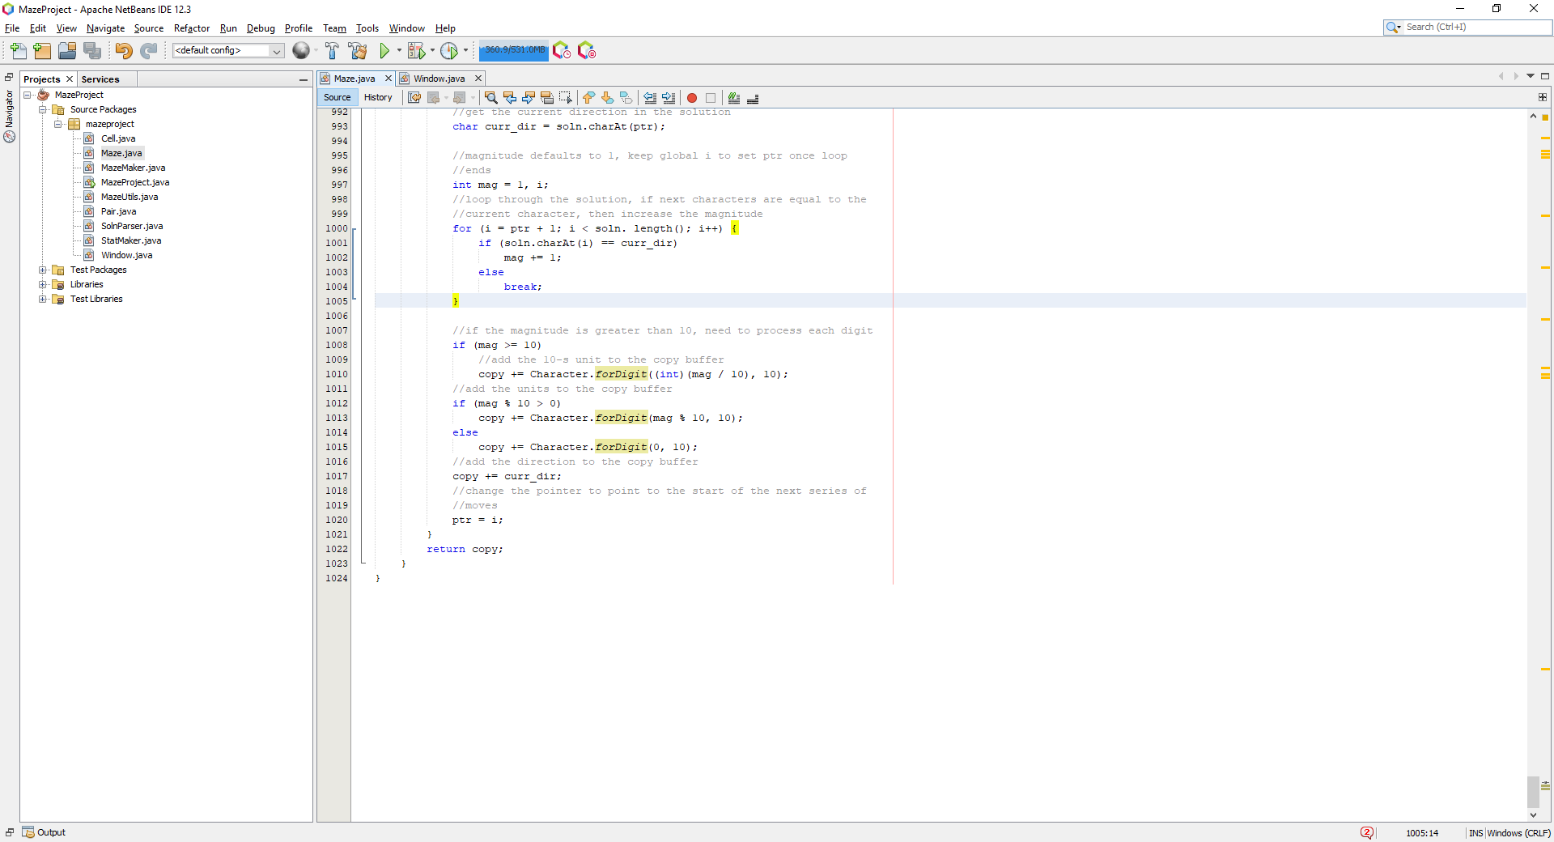

This isn’t great and could be better, I created a separate function to deal with the magnitudes and turn them into strings, this function was called int_to_str:

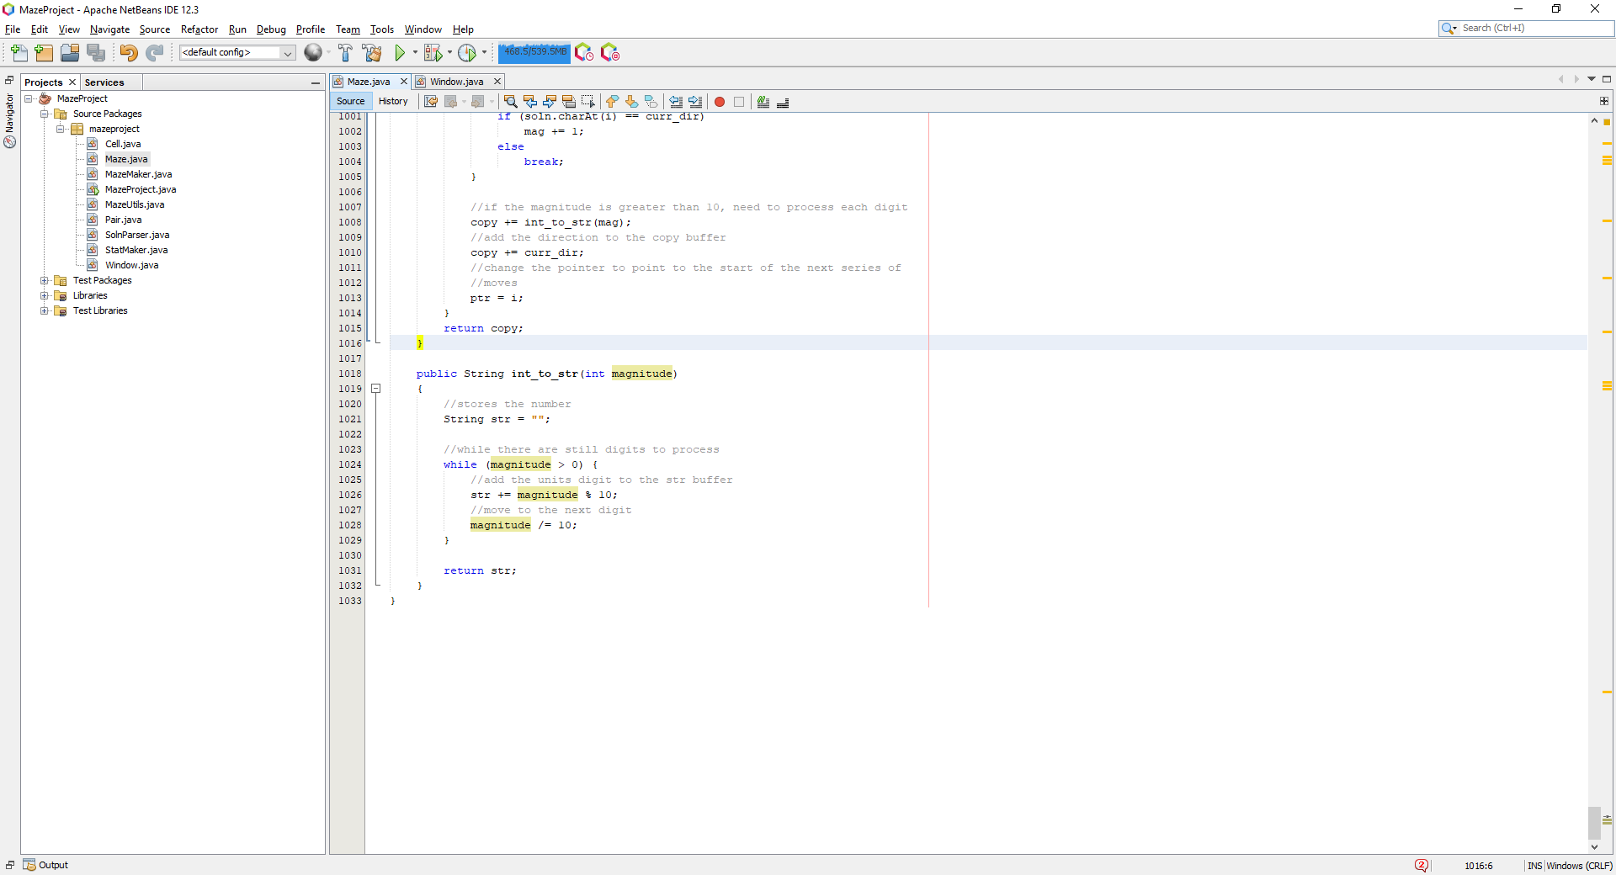

And now inserting this function into the soln_simplify function here:

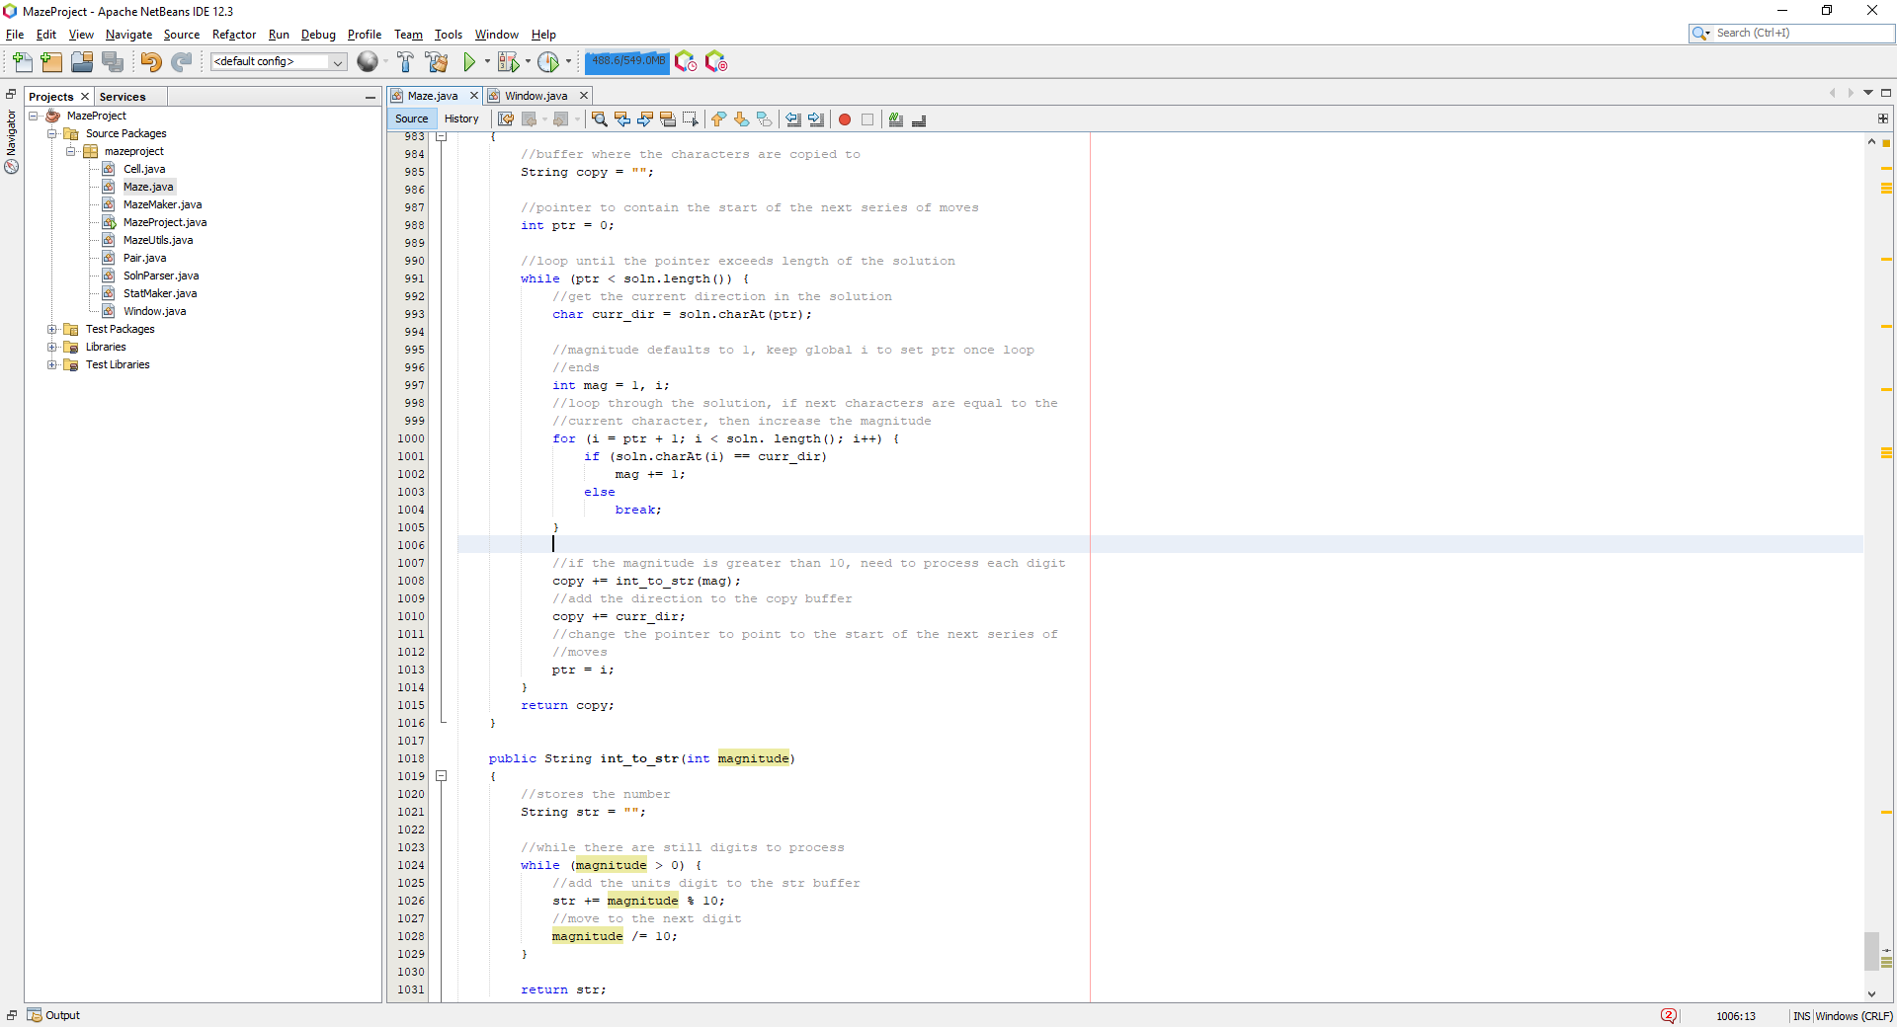

Running the program now, produces the following:

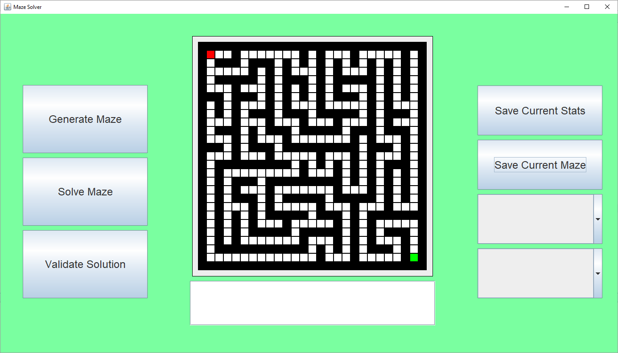

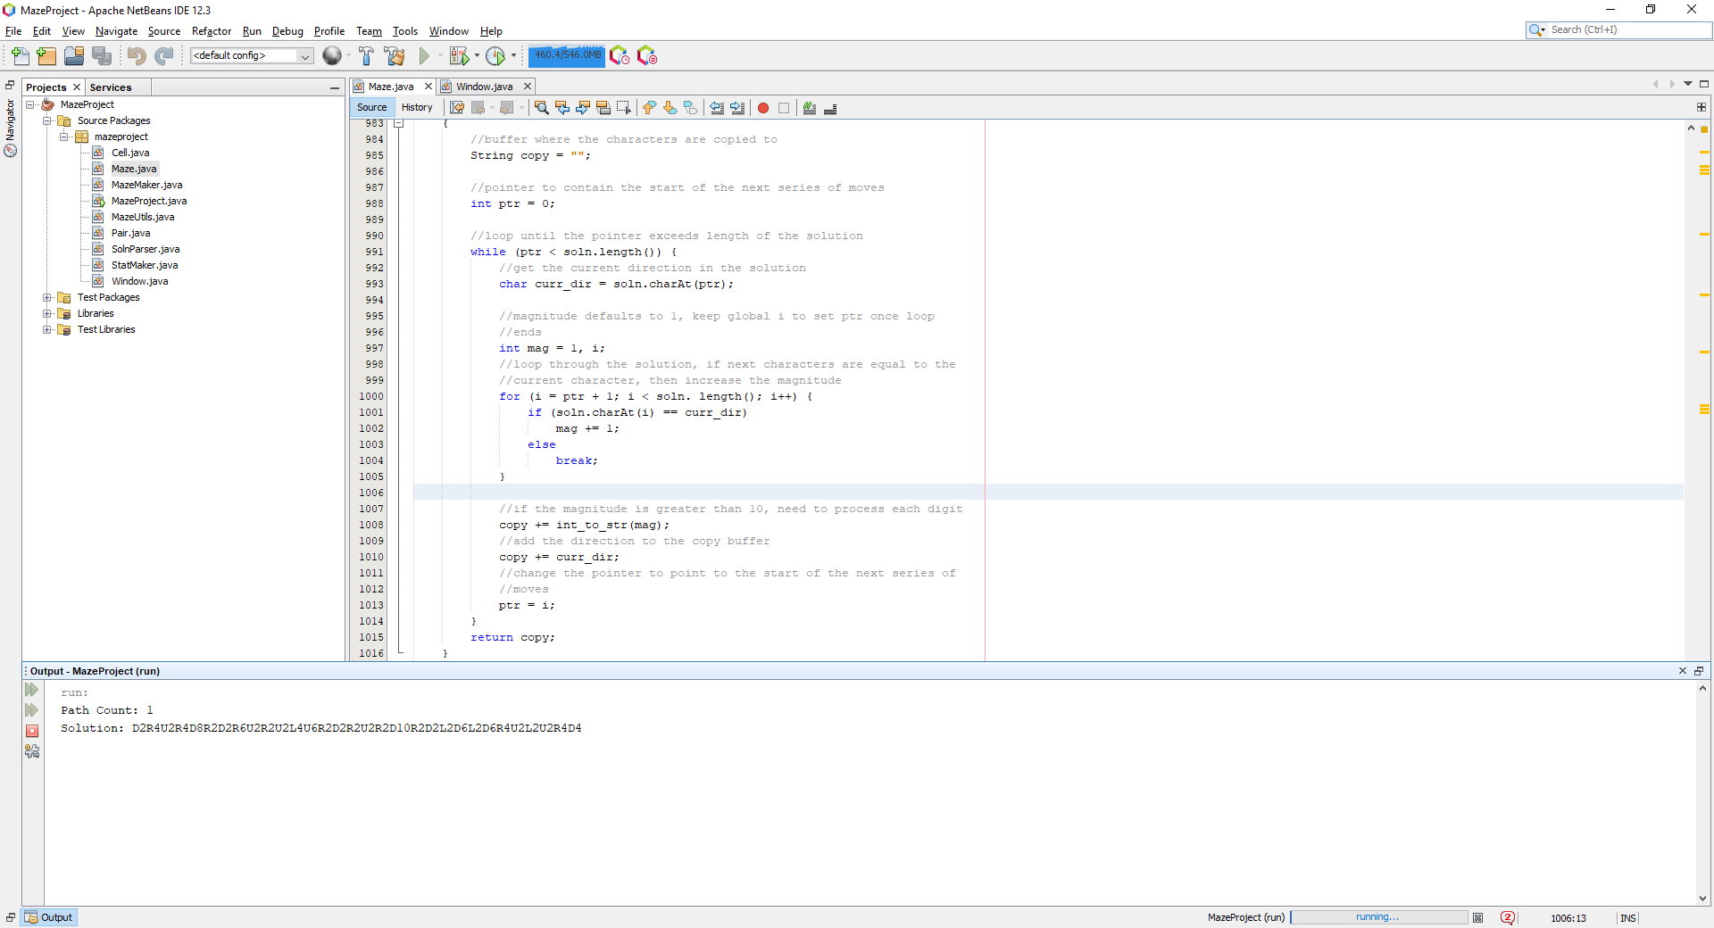

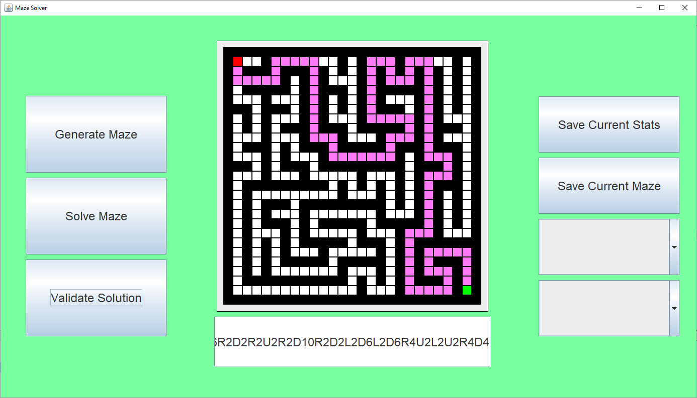

Showing it produces a valid solution, which happens to be shortest possible path due to the algorithm used to be BFS. Hence, this test was successful for test #8.

Next, I need to save the maze and solution to a file which can be specified by the user, also I realised that I must provide the user with a method to actually reload the maze back into the software, so I needed to add another button to the interface to allow for that. First, I wanted to add the new button to the display:

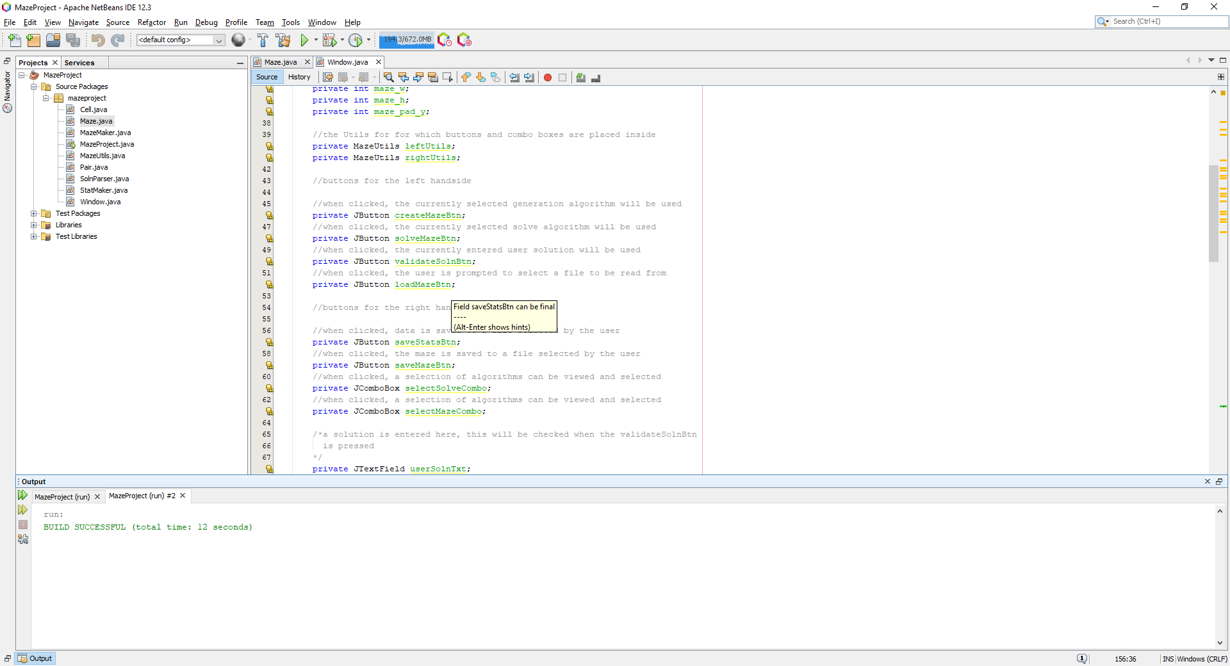

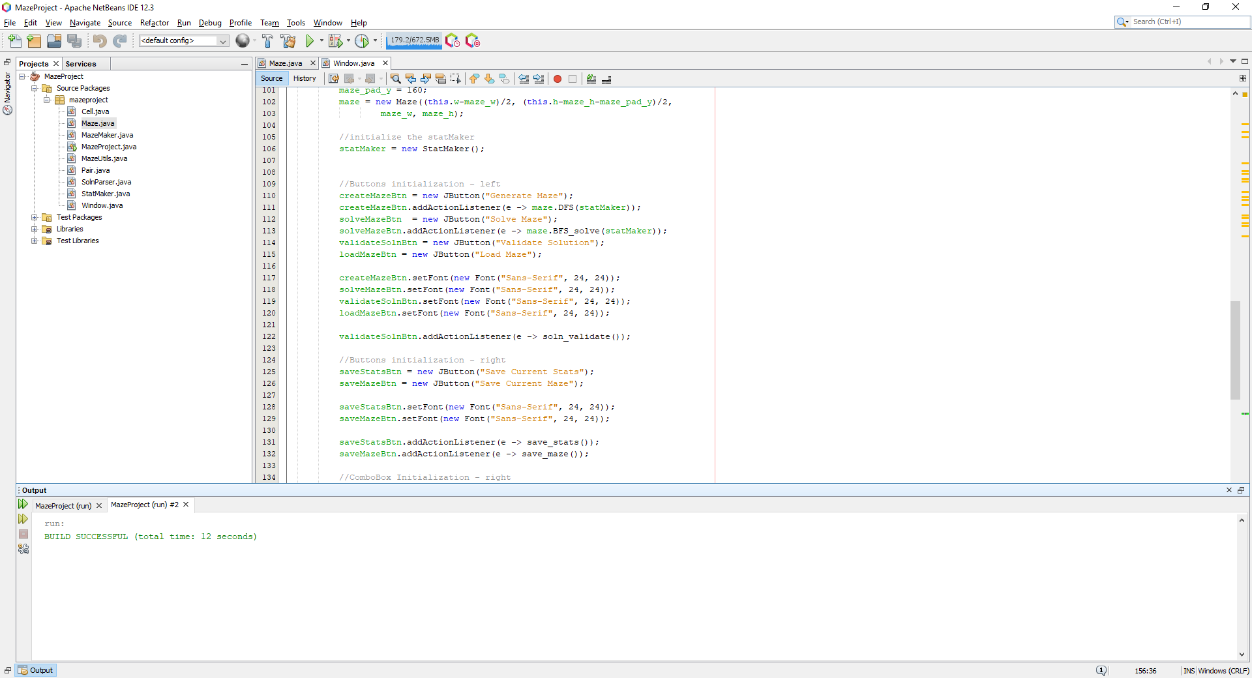

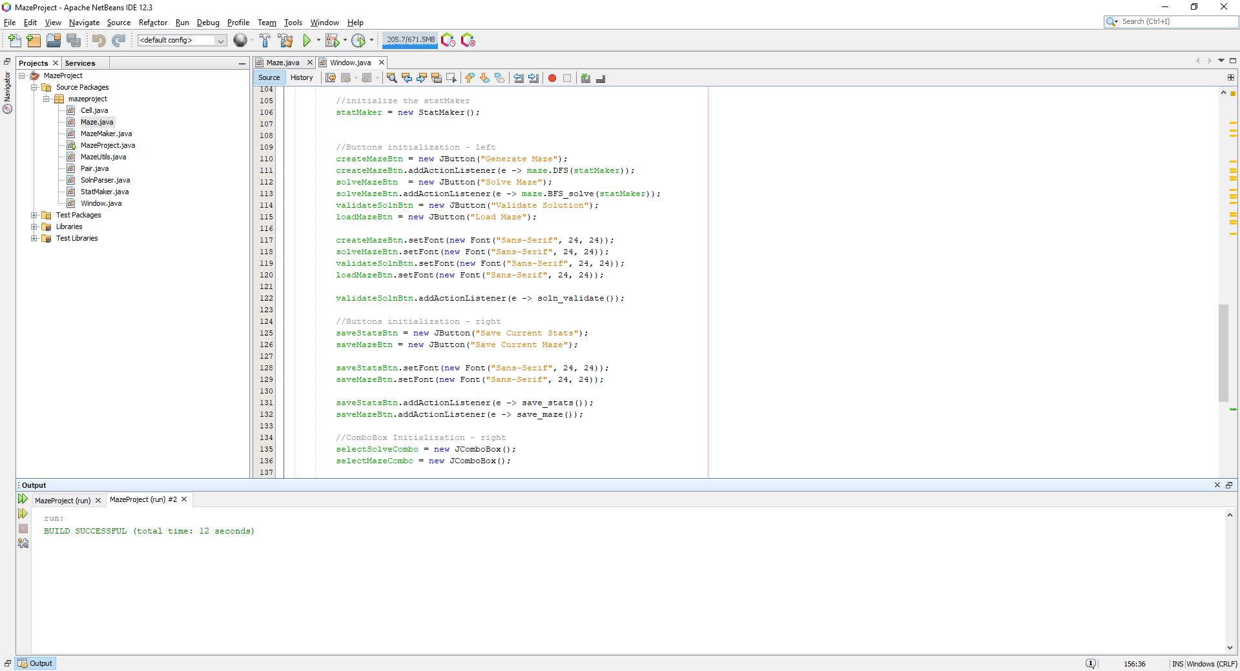

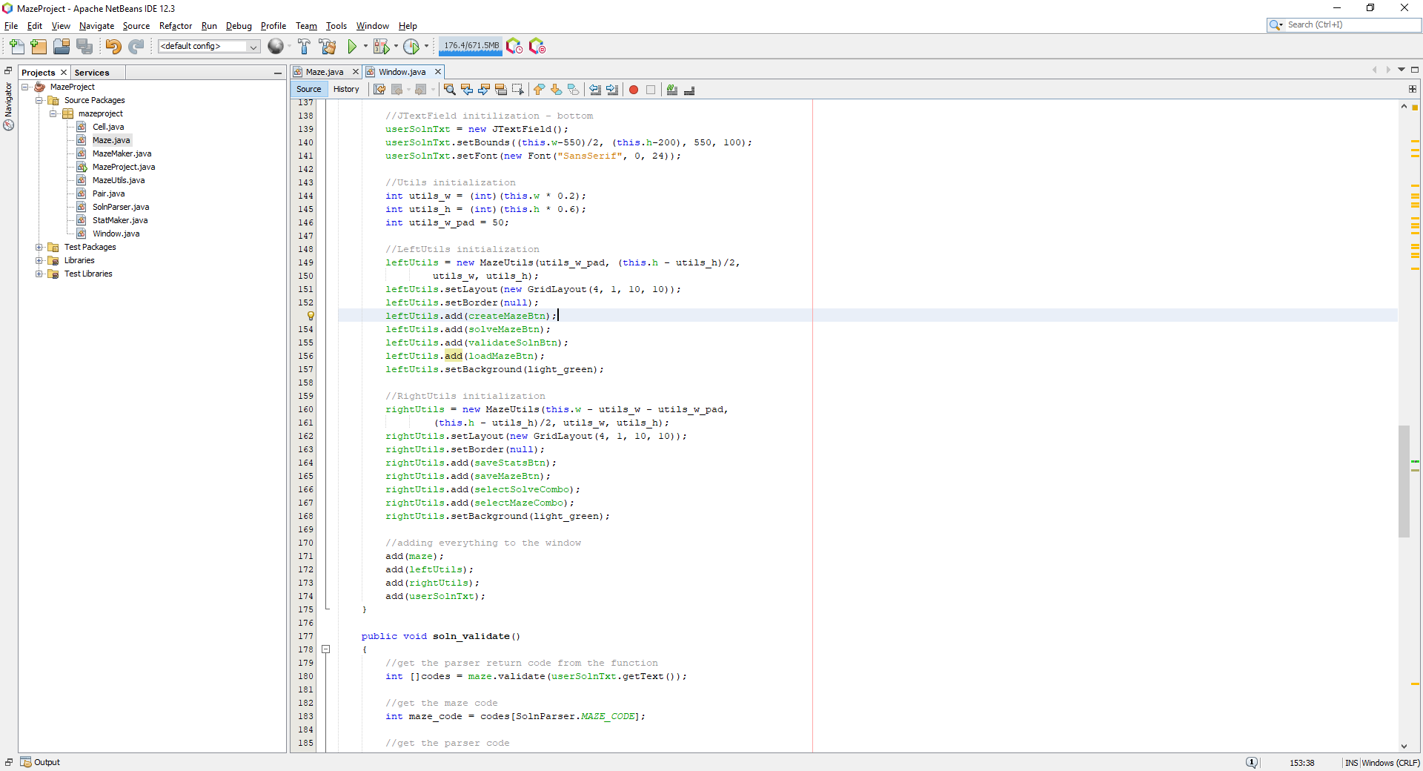

Which produces the following:

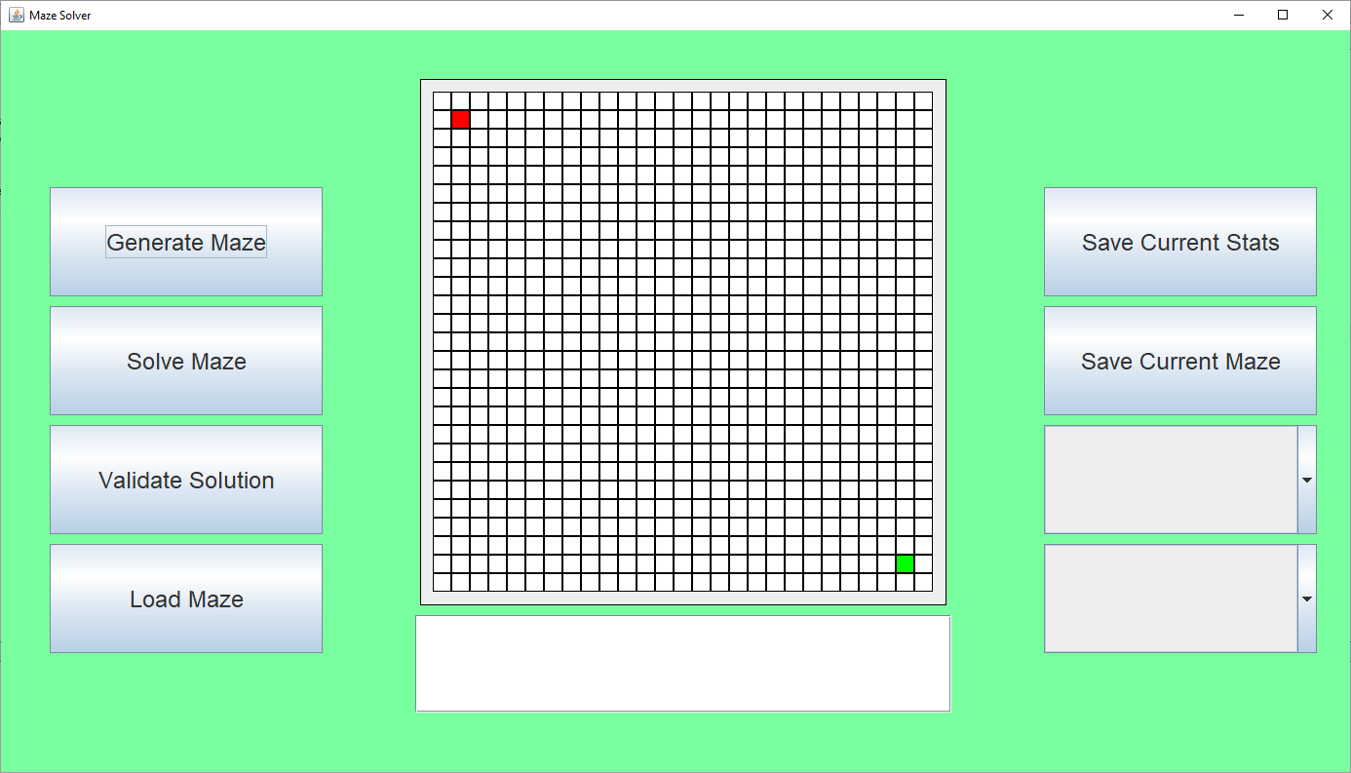

Where the button can be located at the bottom left, called ‘Load Maze’. Now I wanted to save the maze and the solution to a file, when the user presses the save maze button, where they are first prompted to enter a file name:

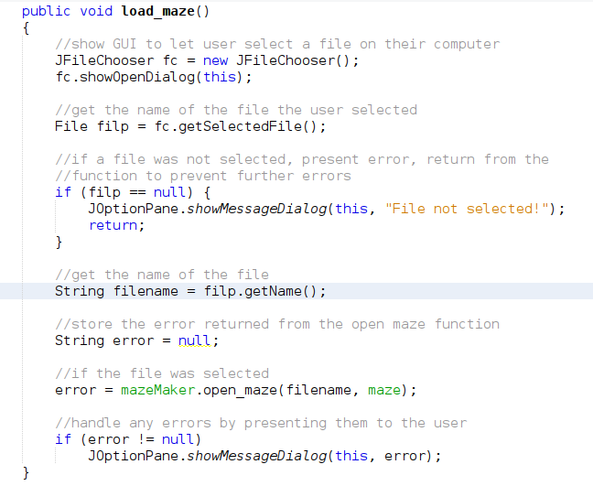

Where this function will be called when the user presses the load maze button:



The load_maze function opens up a file selection GUI where the user can select a file from their file system, checking if the user has selected a file before trying to access the name of the file, reading upon the JFileChooser from the oracle docs[14] , it says that the getSelectedFile function returns null when the user does not select a file, so I check before getting the name. Once, the file has been chosen, a call to the function open_maze is called from the mazeMaker object which is responsible for writing maze data to files, taking the filename and a reference to the maze object, returing an error which is to be reported if an error exists.

Now, the open_maze function is defined as follows:

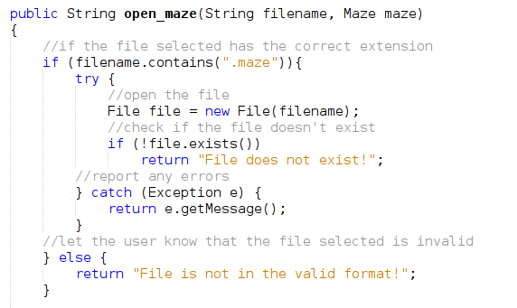

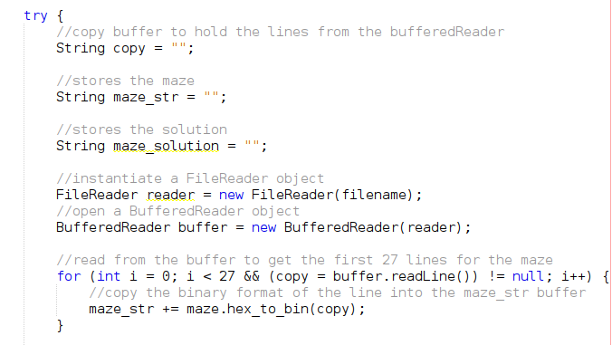



This function checks to see if the filename contains the expected and valid extension ‘.maze’ which will provide an error if it does not, then it checks if the file exists, presenting any errors to the user if the files does not exist. Then I start reading each line of the file, storing the first 27 lines, corresponding to the maze, and storing that in the maze_str buffer, converting each line from hex to binary, then the final line into the maze_solution buffer. Then we call maze_load on the maze_str buffer, which loads the maze_str into the physical maze.

Where maze_load is defined as the following:  
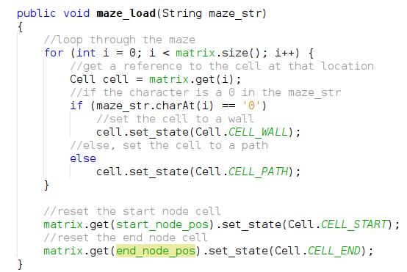

All this function does is read each character from the string and sets the corresponding cell in the maze based on the state of the character in the string.

Now loading the maze is possible, I need to implement the actual writing to the file, this can be done with the following function:

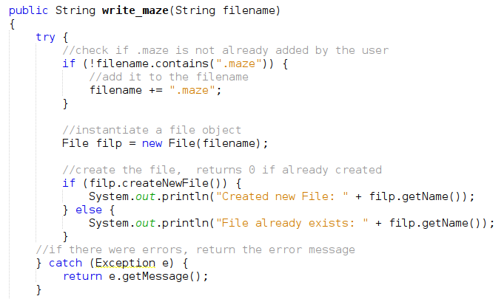

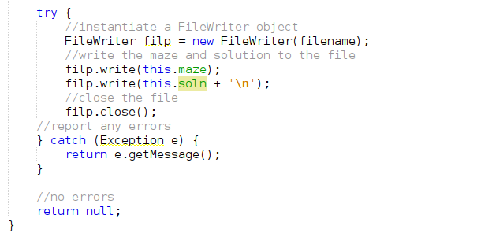

This function is then called in the window’s save_maze function:

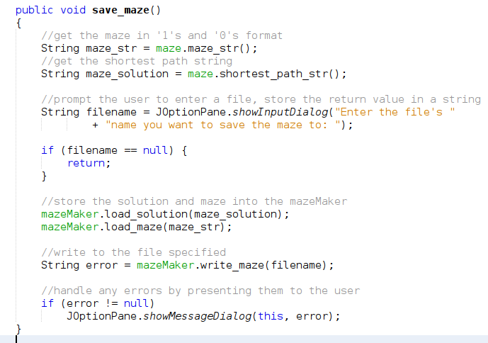



Now, I wanted to test to see if all this code can work together, by first generating a maze, saving that maze, generating a few mazes, then trying to reload the previous maze:

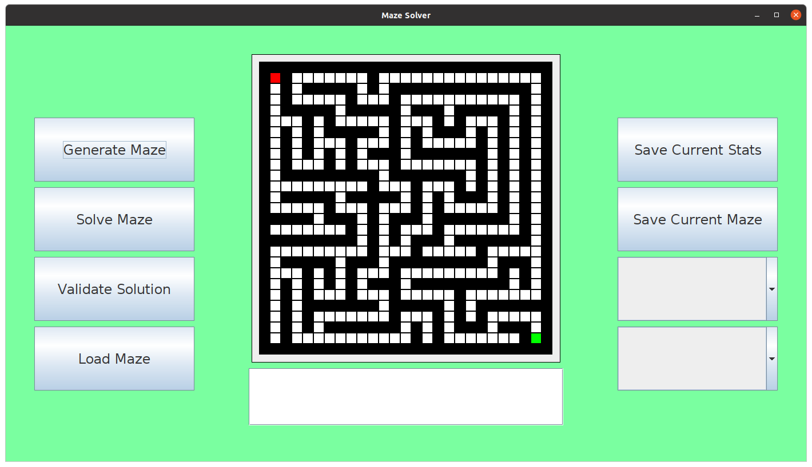

Here is the current maze which we are going to save, this will be saved to a file called ‘testmaze.maze’:

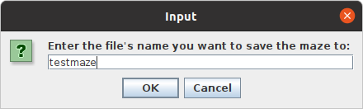

Here a prompt is presented to take in the name of the file for which the maze is going to be saved to.

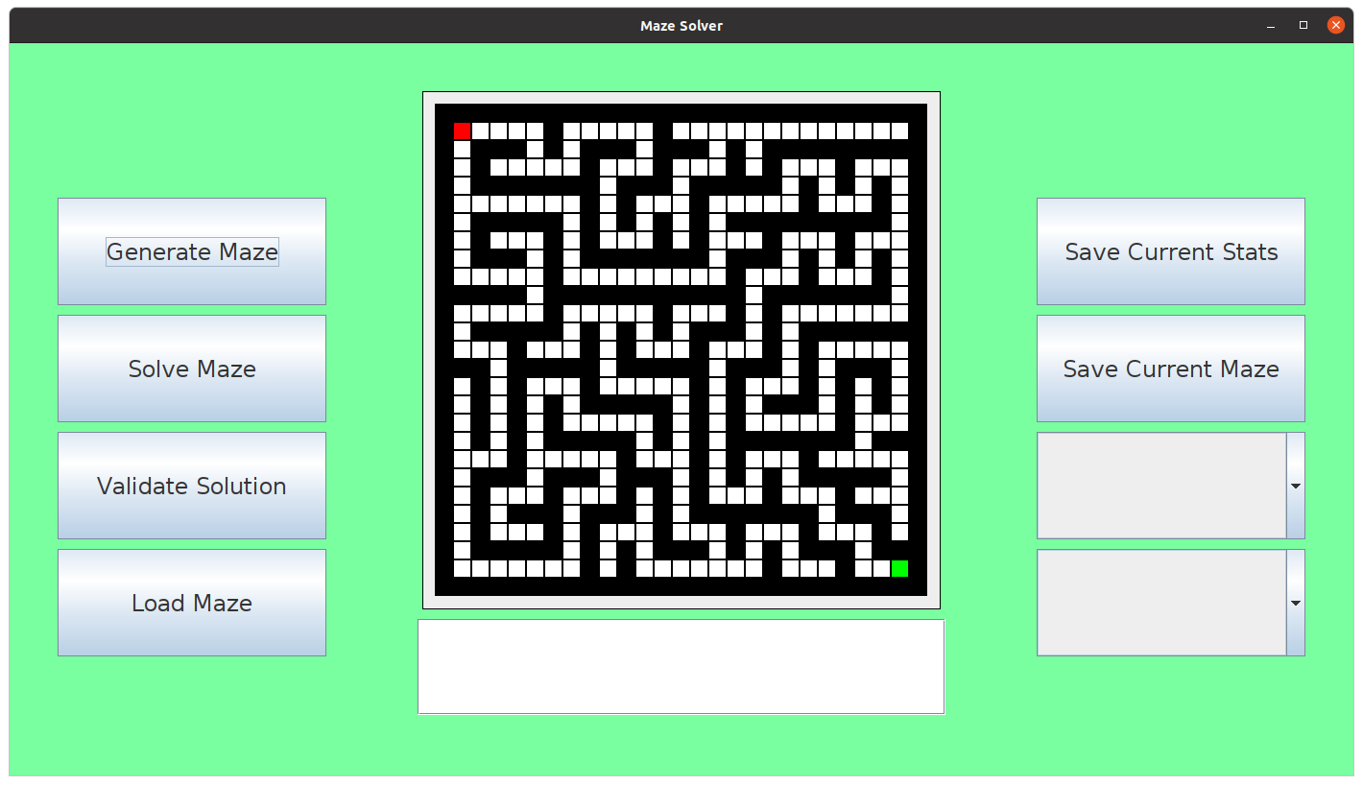

Here is the newly generated maze, now going to override this maze, by reloading a new maze:

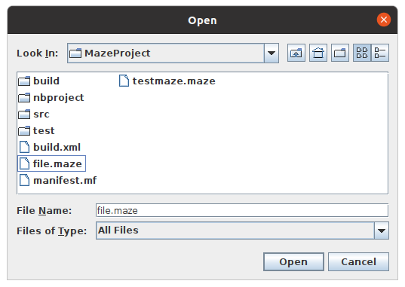

Which is located in the filesystem GUI, and when opened:

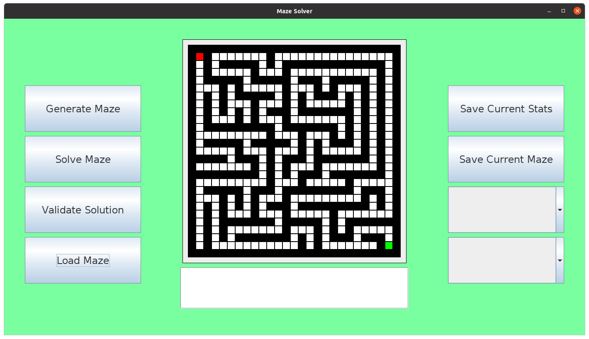

Successfully reloads the maze from the file. Hence, this was a successful test for test #9.

The maze is saved in the file ‘testmaze.maze’ which can be viewed in a text editor and shows that the maze is compressed and below is the solution to the maze:

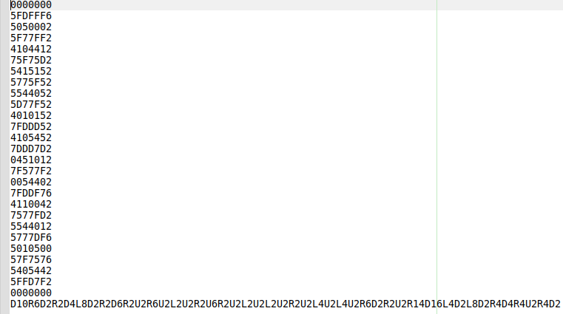

### Testing

#### Test Table

|  |  |  |  |  |  |
| --- | --- | --- | --- | --- | --- |
| Test # | Test Type | Test Data | Expected | Actual | Success (?) |
| 1 | Normal | Enter ‘testfile’ into System.in and check if the file is created | The file should be located in the project folder and should have the .csv extension so it is recognized to be opened with Excel | The file is created in the project folder and is recognized to be opened by Excel | Success |
| 2 | Normal | Generate a maze using DFS | The output of the test should be 1 since all DFS generated mazes produce a maze with a single solution | The output is as expected and prints 1 to the terminal | Success |
| 3 | Normal | Generate a maze, press the save maze button and see the output | The output should be a series of ‘1’s and ‘0’s which represent the maze generated | It is close the what is expected apart from the 2nd and 2nd last are missing an extra 1 in place of the start and end node | Unsuccessful |
| 4 | Normal | Generate a maze, press the save maze button and see the output | The output should be a series of ‘1’s and ‘0’s which represent the maze generated | The output represents the maze as a series of ‘1’s and ‘0’s now for each cell in the maze | Success |
| 5 | Normal | Generate a maze and press the save maze button, see the output | The output consists of characters from the hexadecimal character set from ‘0’ to ‘F’ | The output consists of hexadecimal characters and looks as intended | Success |
| 6 | Normal | Generate a maze and press the save maze button, see the output | The output should be a series of ‘0’s and ‘1’s which represent the maze generated | The output represents the maze as a series of ‘1’s and ‘0’s and proves the compression algorithm can be reversed | Success |
| 7 | Normal | Generate a maze and press the save maze button, use the solution generated and pass into the validate solution text box | The output should be a solved maze, with no error produced | There was an unsolved maze error produced where the string produced lacked a magnitude of 10 to successfully solve the maze | Unsuccessful |
| 8 | Normal | Generate a maze and press the save maze button, use the solution generate and pass into the validate solution text box | The output should be solved maze, with no error produced | There was no error produced and the maze presented showed a clear solution to the given maze | Success |
| 9 | Normal | Generate a maze, press the save maze button and try to reload the maze | The maze should be successfully loaded into the physical maze | The maze successfully overrides current mazes and loads successfully into the physical maze | Success |

### Evaluation

This phase included saving statistical data based on the mazes performance to a file and saving and loading a saved maze back into the physical maze space. There were a few issues with dealing with the files and handling the data within the maze, such as the compression of the binary maze itself from binary to hexadecimal.

The next phase will finally be creating more maze generation and maze solving algorithms which can be used by the user.

## Phase 7 (Maze Solving and Maze Generation and the Manual - Finale)

This section will contain many new maze generation and maze solving algorithms. This will be the final phase on the project and will clean up the maze lack of maze generation and maze solving variety by adding more algorithms to pick from, utilising the combo boxes to the right of the window.

### Design

The new algorithms are going to be recursive based, a recursive solver and prim’s algorithm. No unique variables are going to be needed for these algorithms, internal variables will be used.

#### Variable Table

|  |  |  |
| --- | --- | --- |
| Name | Type | Justification |
| x | int | Stores the x-coordinate of the current cell and is going to be passed to recursive calls of the solving algorithm |
| y | int | Stores the y-coordinate of the current cell and is going to be passed to recursive calls of the solving algorithm |
| walls | array | Used to store the walls which prim’s algorithm will use to generate the maze, storing the walls of each cells and randomly selecting walls from the array to generate the next cell in the maze. |

#### Classes and data structures

##### ManPages

This class will inherit the attributes of a JFrame and will be a newly designed window which presents the user with the features of the entire application, telling them how to use everything with description of how everything works.

#### Validation

The only user validation for this phase is that the user is aware that they need to select an algorithm before they decide to use the algorithm, this will default to the BFS and DFS algorithms otherwise.

### Implementation

Firstly, I am not going to outline the structure of the ManPages class since it consists of Swing API elements and contains buttons and other UI related features. However, I am going to outline the structure of the recursive generation and solving algorithms.

#### Pseudocode

##### Recursive_solve

procedure recursive_solve()

recursive_solve_helper(start_pos)

Endprocedure

Procedure recursive_solve_helper(index)

x = index MOD matrix_w

y = index DIV matrix_w

cell = matrix[index]

if cell.check_state(VISITED) or cell.check_state(WALL) then

return false

Endif

cell.add_state(VISITED)

if index == end_pos then

return true

Endif

if x > 0 then

if recursive_solve_helper(index-1) == true then

cell.set_state(SEARCHED)

return true

endif

endif

if x < matrix_w – 1 then

if recursive_solve_helper(index+1)

cell.set_state(SEARCHED)

return true

endif

endif

if y > 0 then

if recursive_solve_helper(index-matrix_w) then

cell.set_state(SEARCHED)

return true

endif

Endif

if y > matrix_h – 1

if recursive_solve_helper(index+matrix_w) then

cell.set_state(SEARCHED)

return true

endif

endif

return false

Endprocedure

##### Prim’s algorithm

procedure prim()

index = start_pos

walls = []

insert_walls(index, walls)

while len(walls) > 0 then

wall_index = randrange(0, len(walls))

if check_cells(wall_index) == 1 then

rand_wall = walls[wall_index]

cell = matrix[rand_wall]

cell.set_state(PATH)

cell.add_state(VISITED)

insert_walls(rand_Wall, walls)

endif

walls.remove(wall_index)

endwhile

Endprocedure

##### Insert Walls

procedure insert_walls(index, walls)

x = index MOD matrix_w

y = index DIV matrix_w

if x > 0 then

if matrix[index-1].check_state(WALL)

walls.append(index-1)

endif

endif

if x < matrix_w – 1 then

if matrix[index+1].check_state(WALL)

walls.append(index+1)

endif

endif

if y > 0 then

if matrix[index-matrix_w].check_state(WALL)

walls.append(index-matrix_w)

endif

endif

if y < matrix_h – 1 then

if matrix[index+matrix_w].check_state(WALL)

walls.append(index+matrix_w)

endif

endif

endprocedure

##### check_cell

procedure check_cells(index)

count = 0

x = index MOD matrix_w

y = index DIV matrix_w

if x > 0 then

cell = matrix[index-1]

if cell.check_state(VISITED)

count = count + 1

endif

endif

if x < matrix_w – 1 then

cell = matrix[index+1]

if cell.check_state(VISITED)

count = count + 1

endif

endif

if y > 0 then

cell = matrix[index-matrix_w]

if cell.check_state(VISITED)

count = count + 1

endif

endif

if y < matrix_h - 1 then

cell = matrix[index+matrix_w]

if cell.check_state(VISITED)

count = count + 1

endif

endif

return count

endprocedure

#### Source code

Now I wanted to implement the algorithm and quickly test to see if they worked, firstly I implemented the recursive solving algorithm:

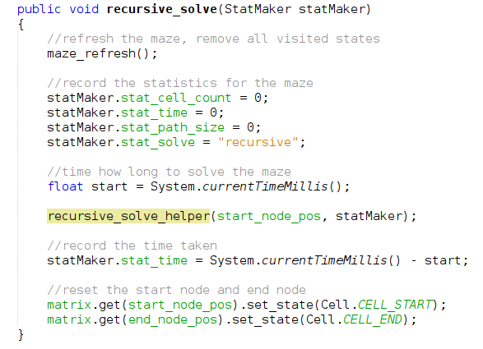

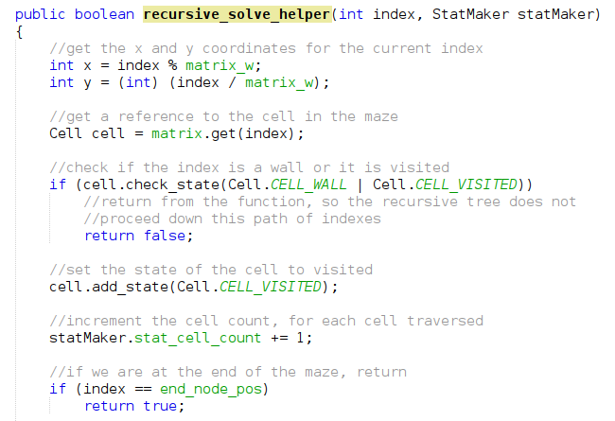

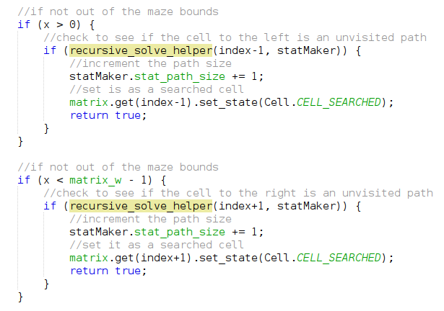

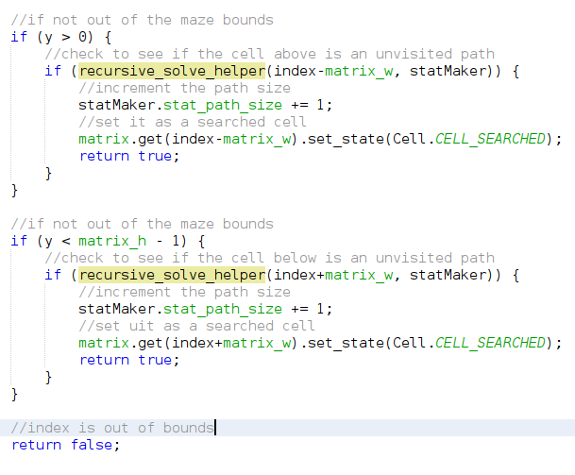

This algorithm calls a recursive helper which performs the cell by cell path search. Each call, increment the cell count, and for each return of a boolean true value, increment the path size. Now I want to test to see if it can solve the mazes currently generated, first I need to set the current algorithm to the recursive_solve function:



Now, with it set, I decided to test the algorithm to see if it can solve the mazes:

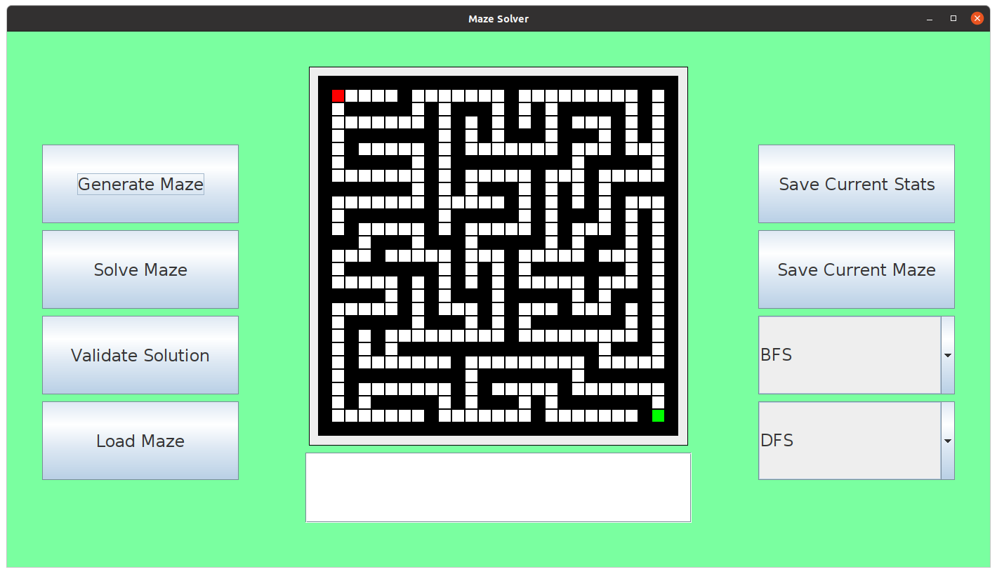

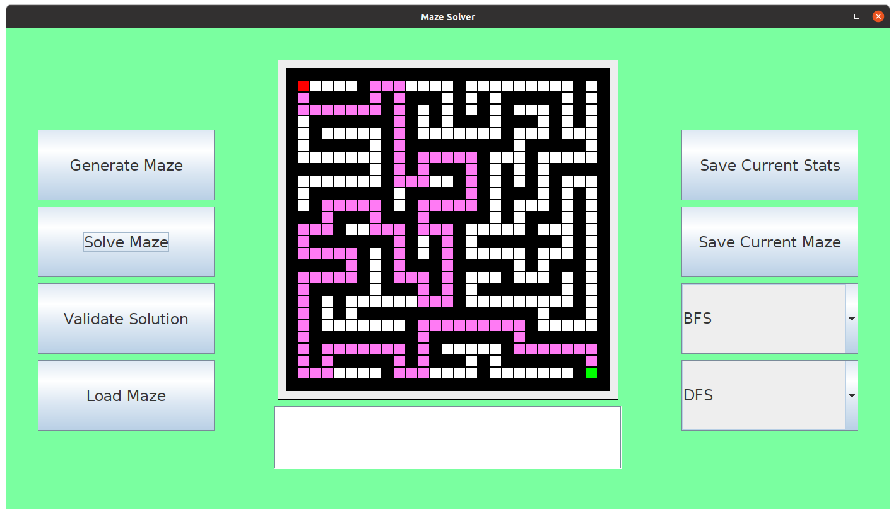

Therefore, this was successful for test #1, as it solves the maze successfully. Next, I wanted to implement the pseudocode for Prim’s algorithm, which I did as follows:

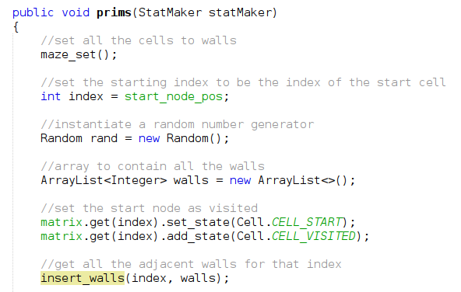

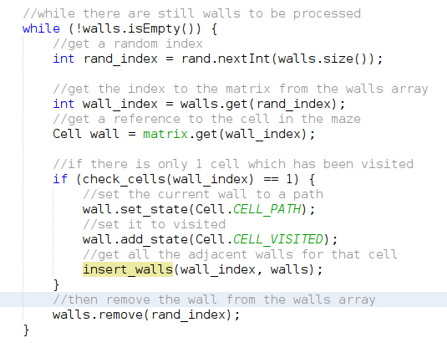

This algorithm will store all the adjacent walls for each cell, choosing whether to set the randomly selected wall to a cell or not, depending on whether the number of visited cells is equal to 1, until all the walls have been searched and all the walls are removed from the array list. The algorithm uses other procedures such as insert_walls and check_cells which are used to insert all the adjacent walls into the array, and to check if the adjacent cells to the current index are already visited.

The insert_walls procedure like the pseudocode above and implemented as follows:

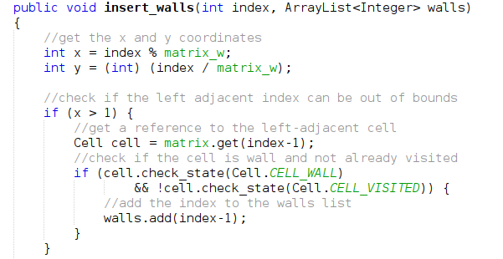

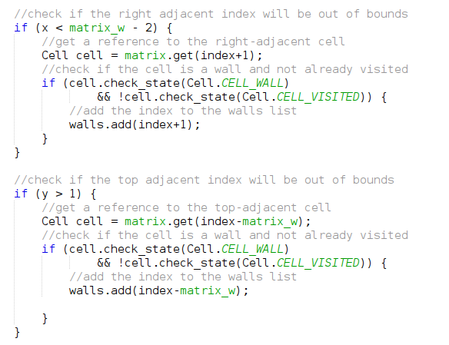

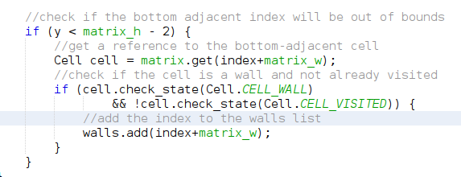

This is the definition for the insert_walls procedure and it checks to see if the adjacent cells to the current cell are either not visited and the cell is a wall in the matrix, if these conditions are met, they are added to the list of walls.

Next, is the check_cells function which simply returns the number of adjacent cells which are visited:

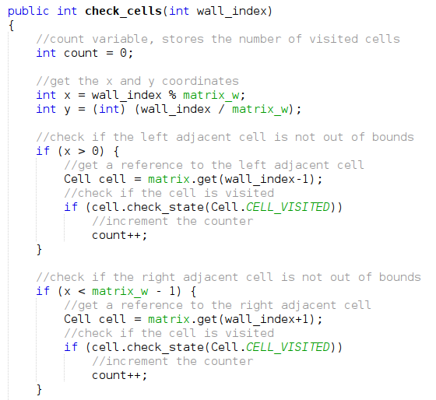

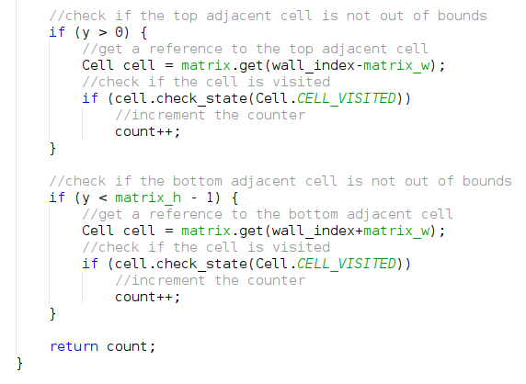

Now with those two functions defined. I wanted to test to see if the prim’s algorithm would generate a maze successfully, but first I needed to set the current generation algorithm to the algorithm:



Now, I ran the program to see how the algorithm would generate a maze:

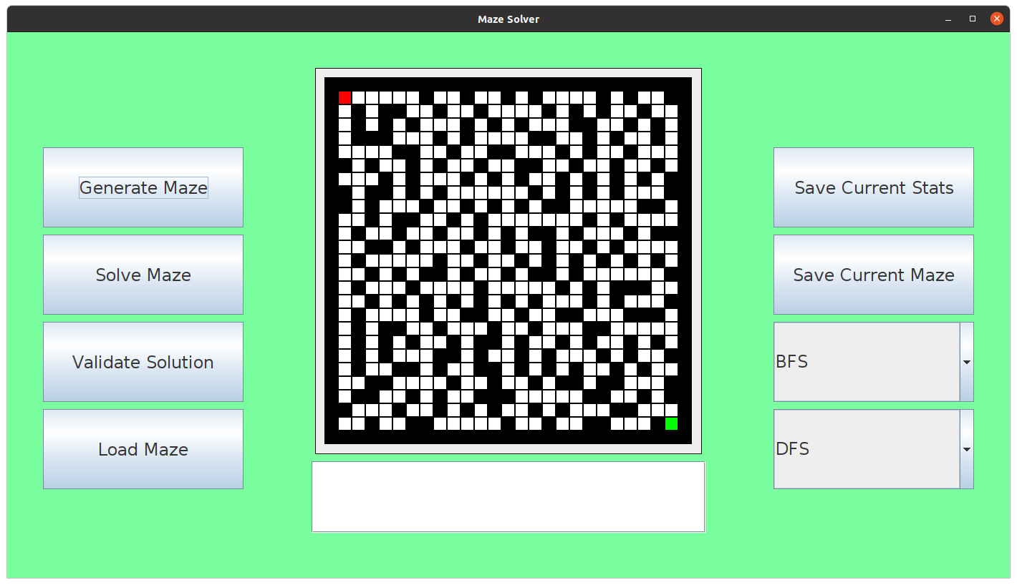

Which does not look like a maze at all. Hence, this was unsuccessful for test #2. It should generate a maze like DFS, but it should contain more dead ends, this maze has multiple solutions and has a possibility to not have any solutions at all. This can be seen in the following screenshot:

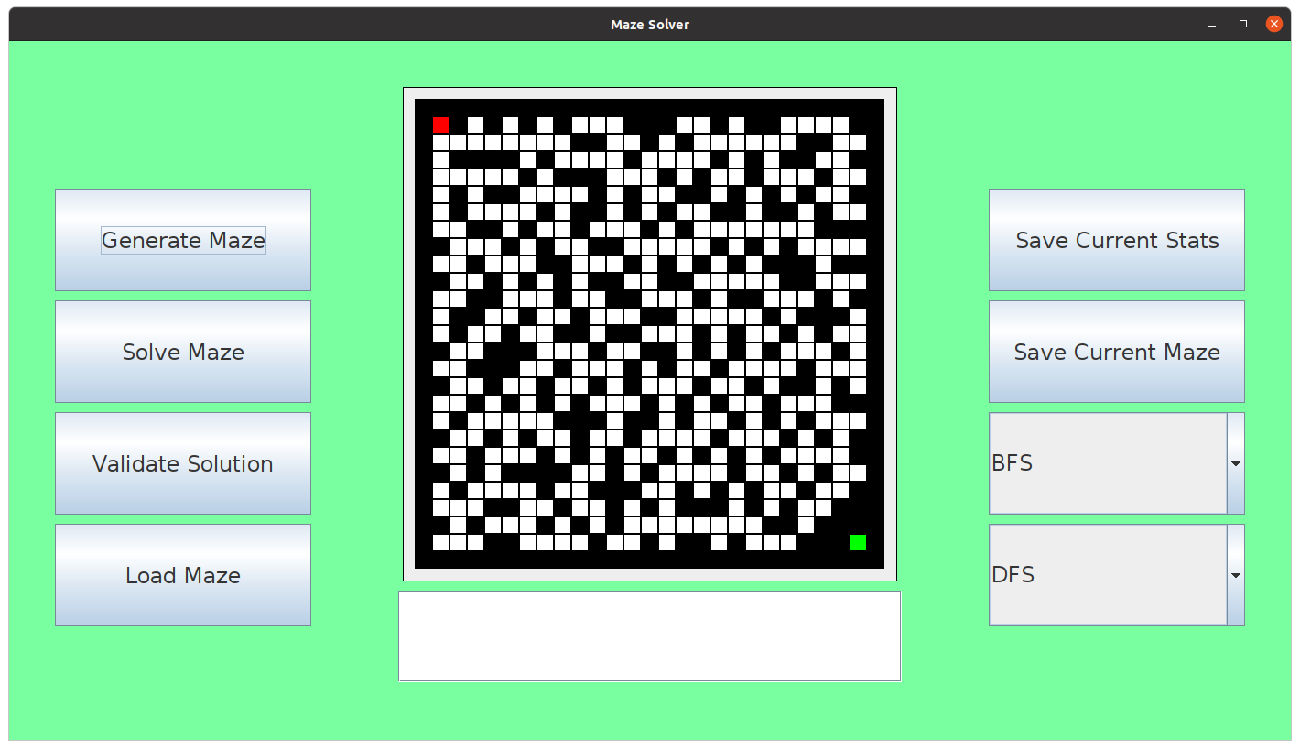

Where the end node is covered with walls, where there is no possible way to get to the end node. But it is possible to find a solution, here is a solution obtained from using the recursive search method:

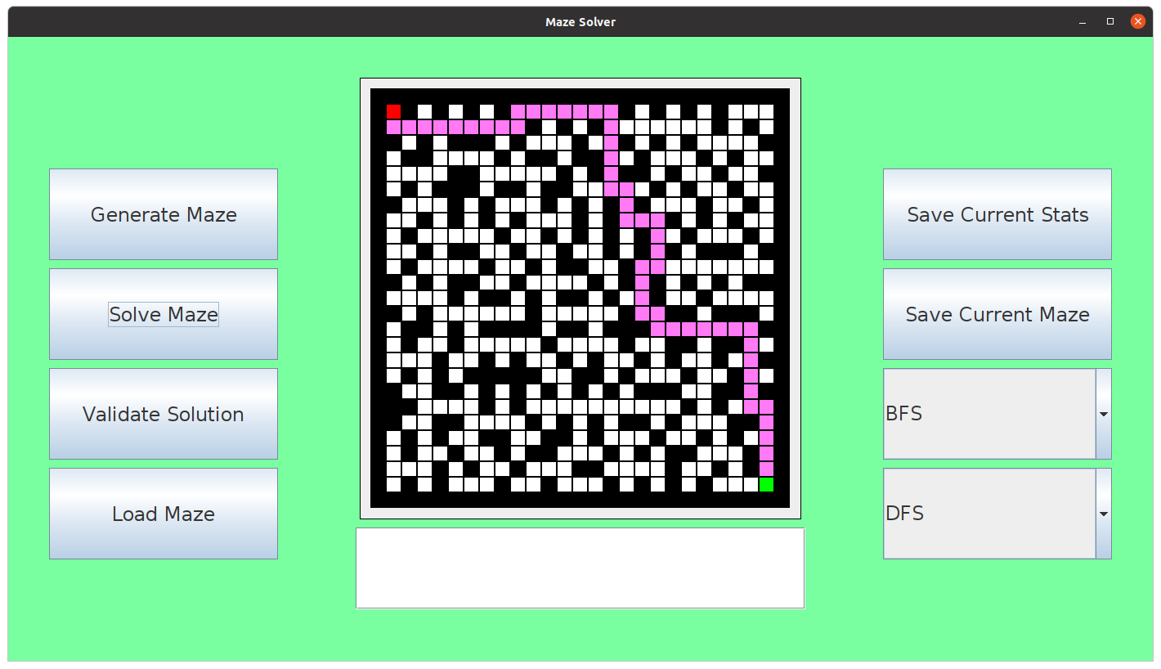

I wanted to reimplement the algorithms used for the prims algorithm, the issues I believe which are causing this incorrect maze generation is that the walls gathered are perfectly adjacent which was a cause for error in the DFS maze generation too, the solution was to search an extra distance and instead of adding 1 path, instead to add 2 paths to prevent any build-up of paths which would cause clusters of paths within the maze. Using this approach, I reimplemented as follows:

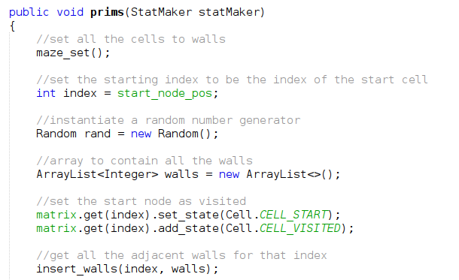

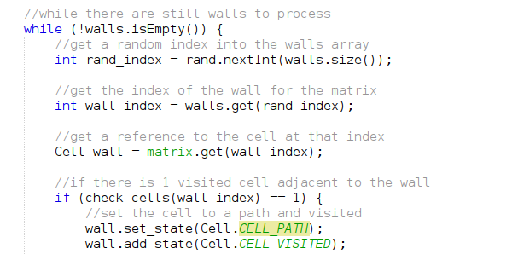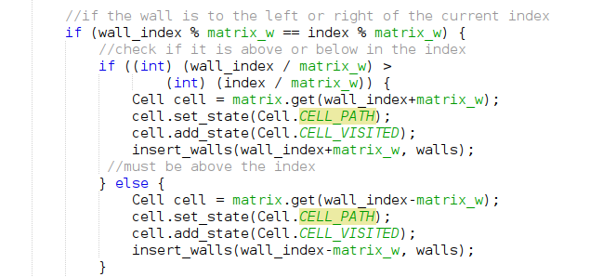

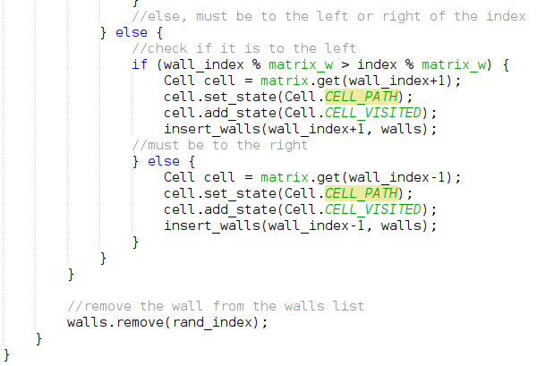

Which this new version now further extends each wall, by checking the direction from the current index to the new wall index, and then setting the adjacent cell to the wall, also to a path. The other functions remain unchanged. Hence, I decided to test to see if the function would now work as intended and generate a maze:

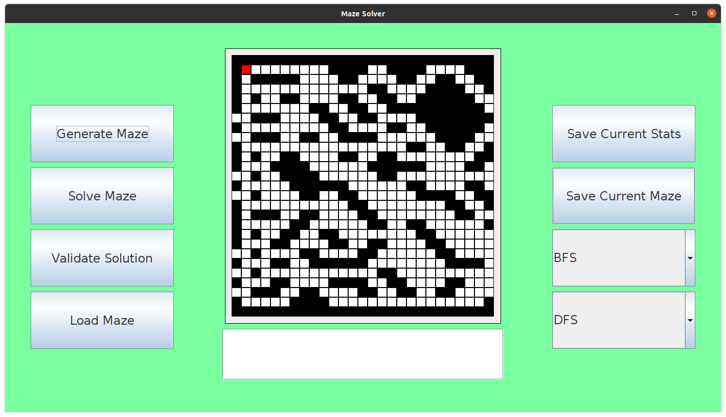

And this is obviously not a maze, As a result of this, I decided not to implement prim’s algorithm because I was having no luck and was unsure of how else to go about the implementation. However, I decided to proceed with other useful features such as the selection of the algorithms used where in this case there are 2 solving algorithms and 1 generation algorithm for which can be selected. The drop boxes would define which algorithms were being used and which could be used when they were selected. Based on the selection, it would determine which algorithm is going to be used. This can be done by creating 2 functions which get the value of the combo box, based on the combo box’s value, it will select which algorithm to call. This is done as follows:

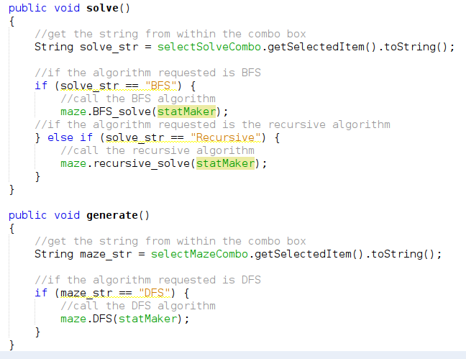

Where these replace the functions for the ActionListener's for the generate and solve buttons. A simple test is to check to see how the solve algorithms work for a plain maze, with no walls:

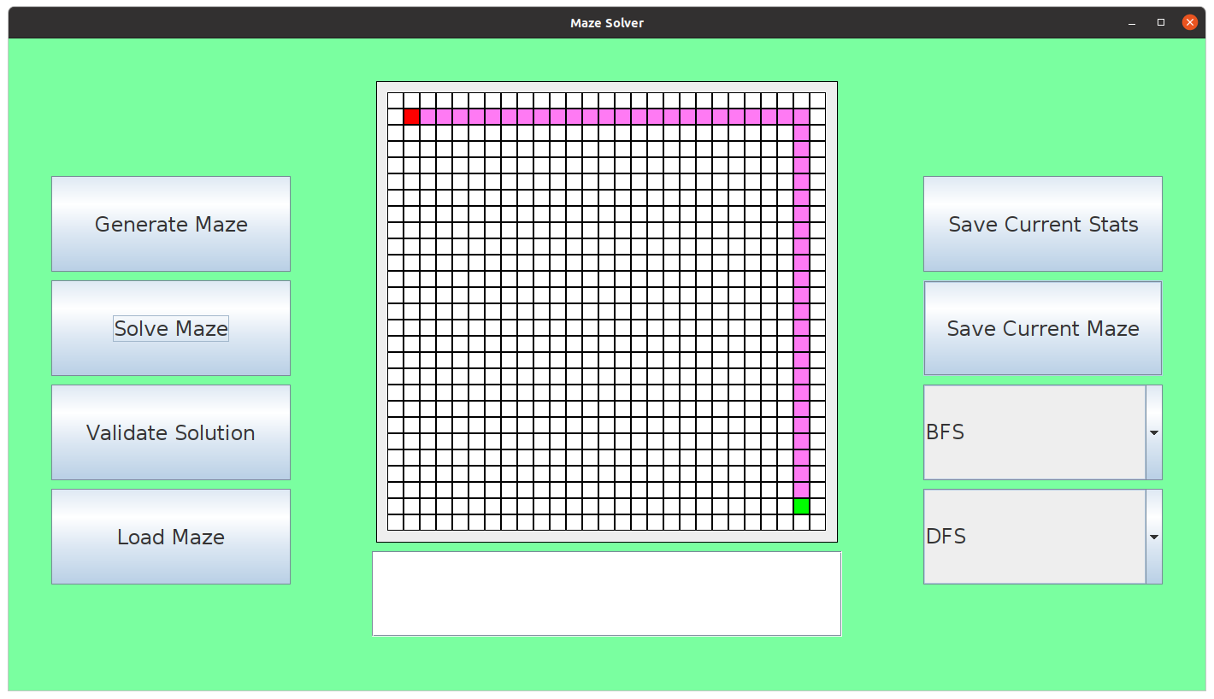

This is BFS and is how it should look. And for the recursive algorithm:

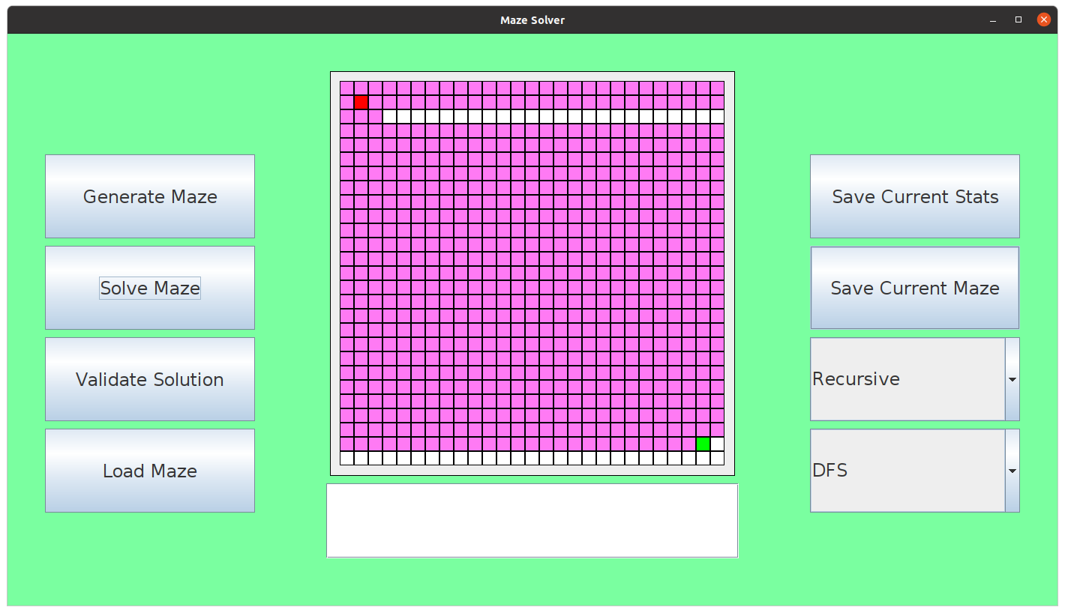

This is the recursive algorithm and is how it should look, as it is simply searching all possible cells until it reaches the end node.

Next, I wanted to implement the manual to help explain how the things work, and how to use the software, this will be a window which will have pages, this was explained as the ManPages for the Maze Solver and will be implemented as a simple window which when opened will contain information about how to use each button and how to use anything within the maze.

I created a new class called ManPages and it inherits the JFrame object so it can create a graphical window in the swing context:

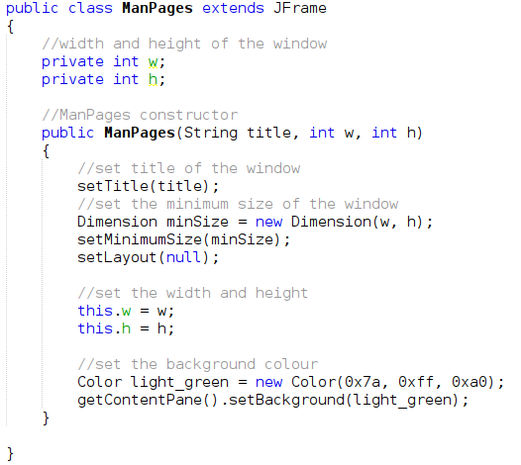

Next, is to create a button which can then open the manual when pressed:

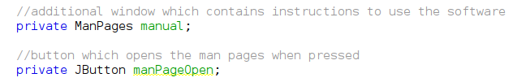

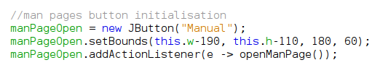

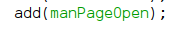

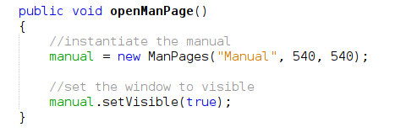

Where this will now open the manual page window when the window is clicked:

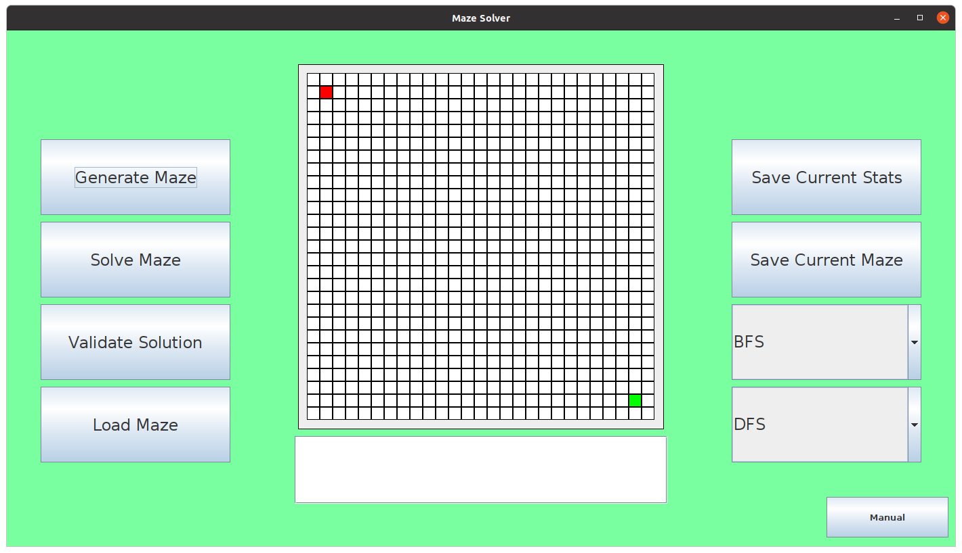

Where as you can see, the manual page button is located at the bottom right, which when pressed produces the following:

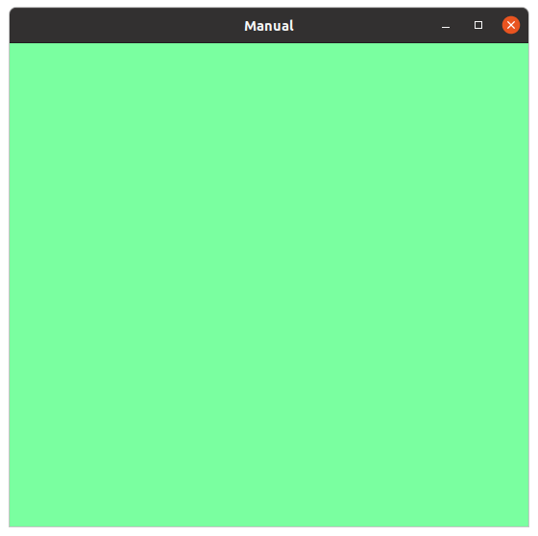

This is the manual window where it will contain details, those details I am going to add now, each page will contain details on the set of buttons within the window and how to use specific functionality such as the user solution maze grammar.

Next, I wanted to add the buttons which will be used to traverse from page to page:

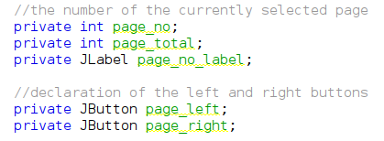

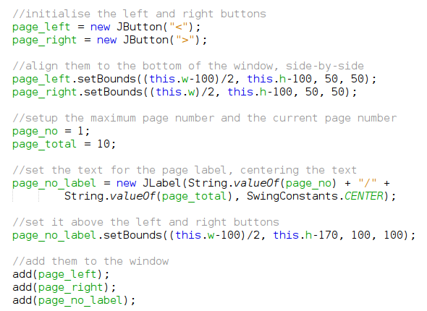

And when I run this:

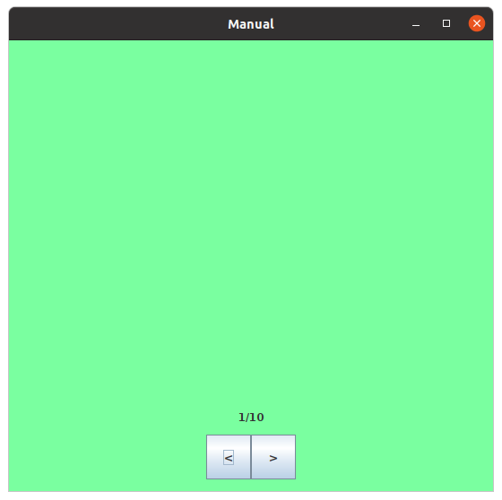

Which displays the left and right buttons with the current page number out of the total page numbers above them.

For each page, it would need to remove all the contents of the page and then add all the new contents to the window to be rendered. This can be done by making functions for each page which will remove all the contents of the previous page and then render everything which needs to be rendered for that page.

I wanted each page to contain clear and obvious sections which are based around the different parts of the software, so the first page would be based around the left set of buttons, next buttons would be based around the right buttons, 3rd page would be based around the maze syntax and how to provide a solution to the maze. Meaning there really only needs to be 3 pages to explain how to the software works. This will include a resize of the window to fit everything onto it.

Implementing the first page would require a preview of each button and a description next to, to explain what that button does:

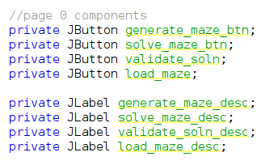

Here are the buttons and the corresponding labels which will contain the description for what each button does. The buttons are going to be placed into a container and the descriptions are going to be placed into another container to help organise the manual:

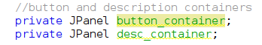

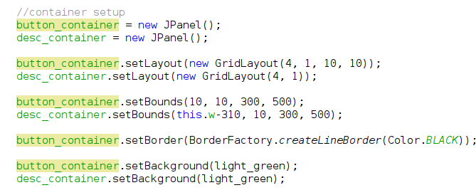

Where this is the setup for the containers, now I wanted to setup all the components for page 0 and to then add the components to their respective containers:

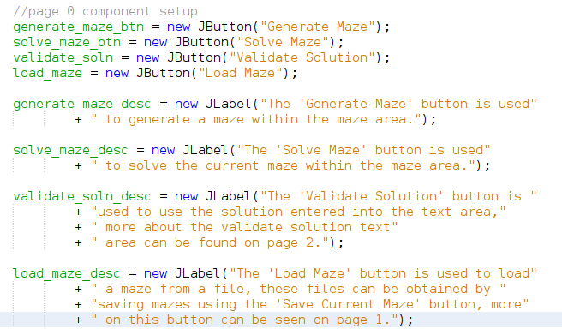

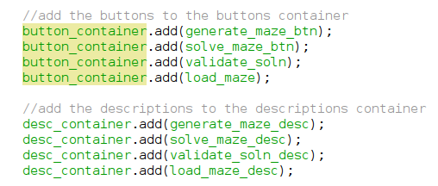

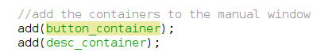

Where running the code shows the following:

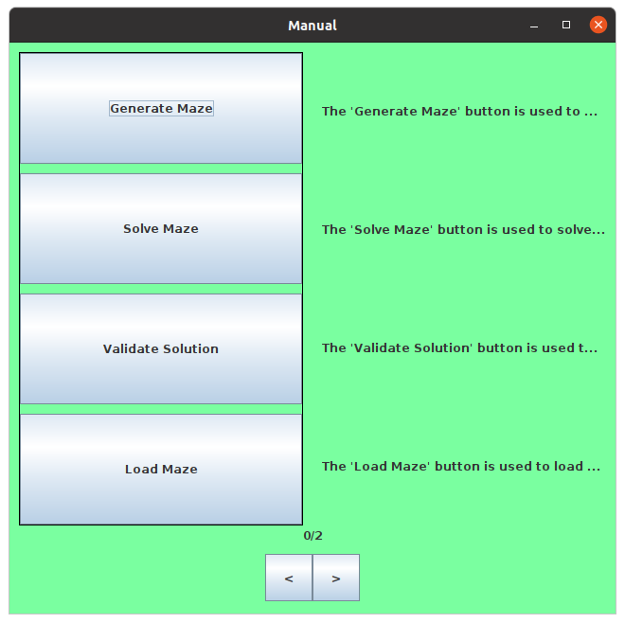

It is clear that the text on the right is being cut off, doing some research on this subject proved that surrounding the text with the html tag: ‘<html>’ would solve this issue, this was found from this website [15] where it simply stated this was the solution:

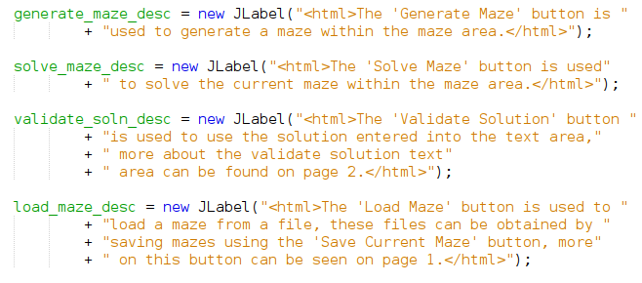

Running this now, produces the following:

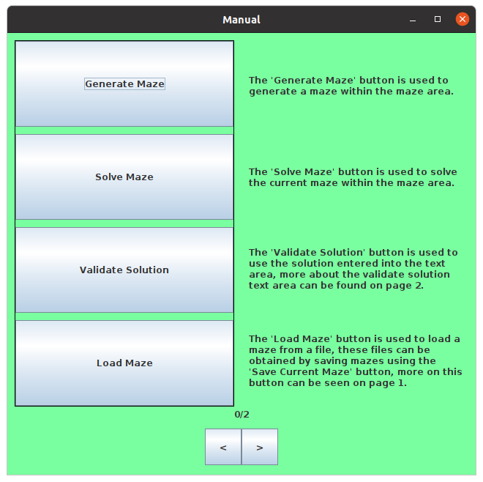

Which is what was intended, now it is easy to implement the other pages in a similar way and once the components are setup, add them to the containers are add the containers to the window to see how the page looks. This was a successful test for test #3. Now, on to page 1:

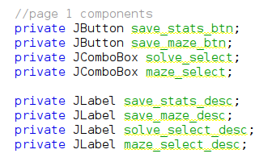

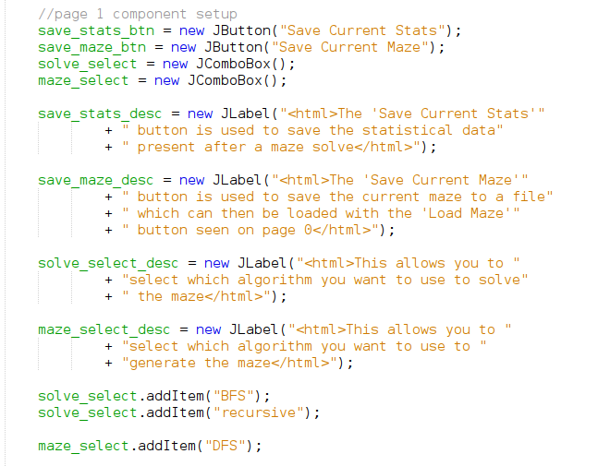

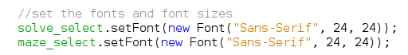

With the components setup, finally add them to their respective contains to test the page:

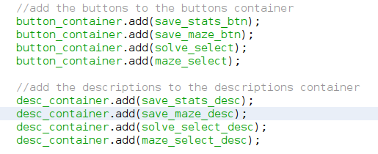

Where running the code shows the following:

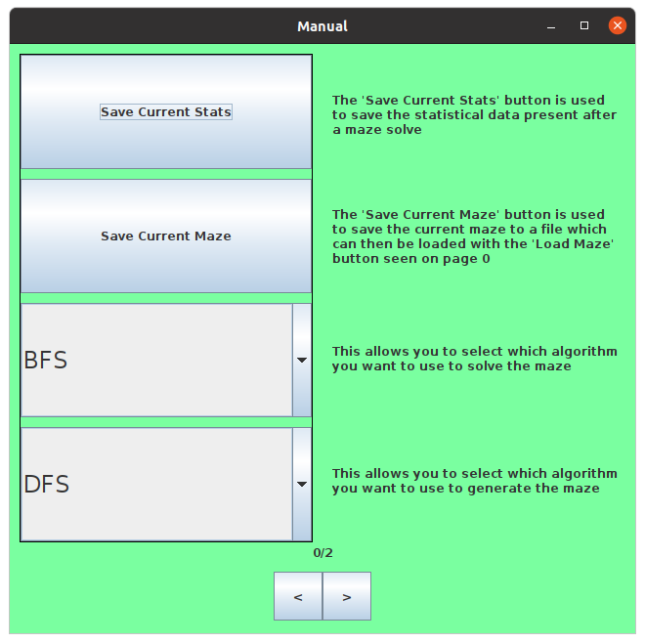

Finally, the last page which is the simplest of them all:

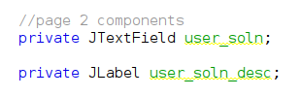

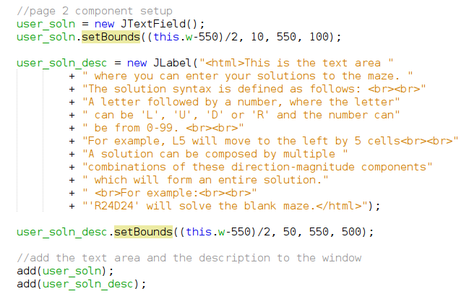

Where running this produces the following:

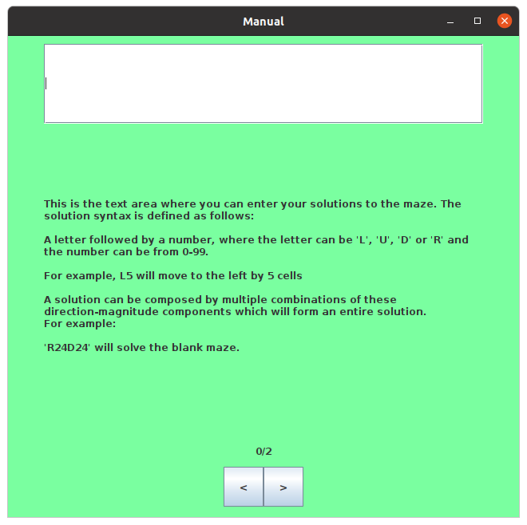

Which although it doesn’t look very tidy, it is what was expected and it conveys the information about the text area and what is it meant to be used for. I decided to add a background to this, adding a simple panel which is set to white:



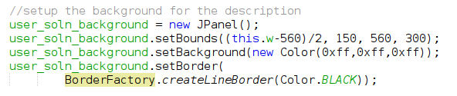

And now running this will produce:

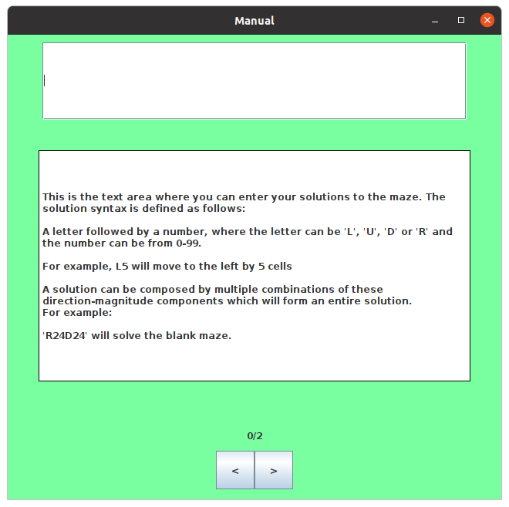

The final thing to implement is the functions to toggle what is viewed for each page:

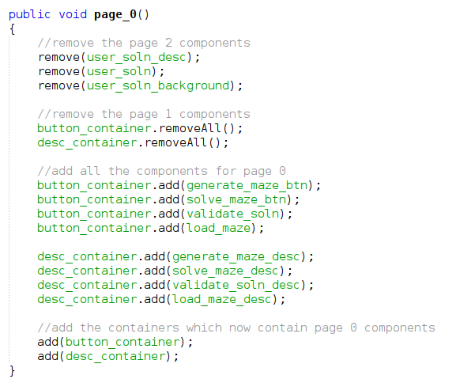

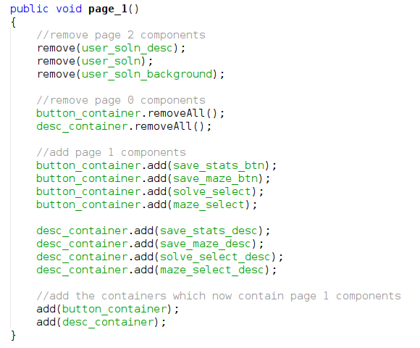

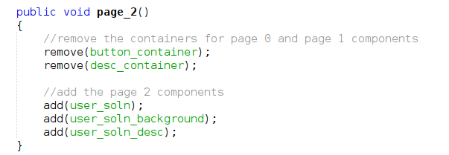

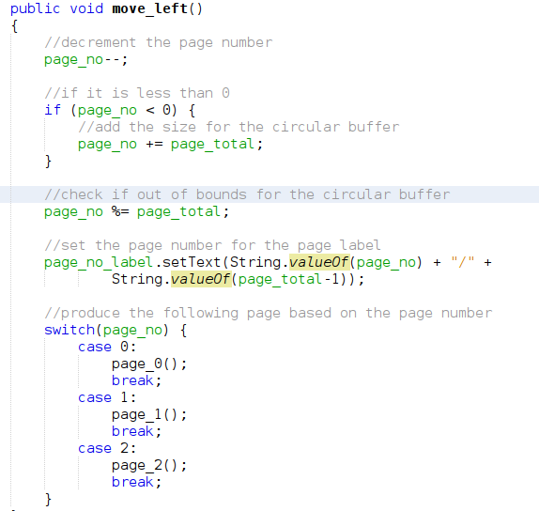

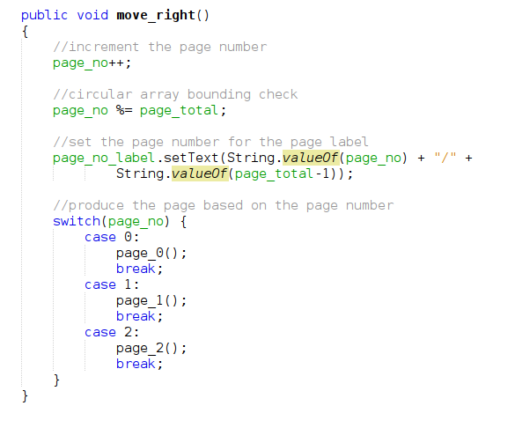

The first three functions simply add the correct components to the window for rendering. The final two will simply increment or decrement the page number and based on the new value of the page number, will generate the new page. Running this produces the following:



For page 0, then for page 1:

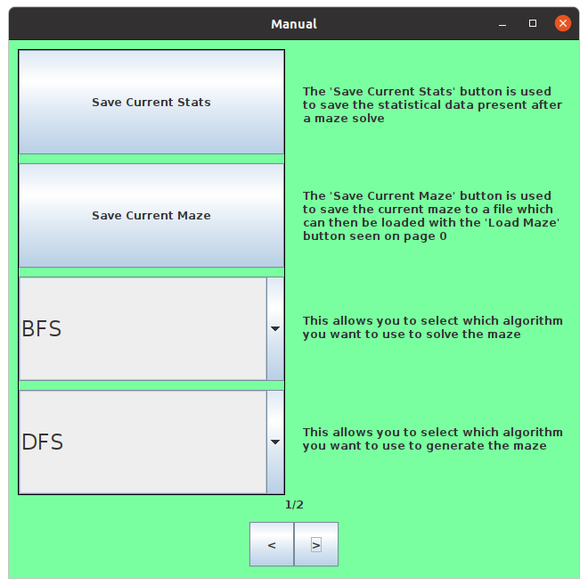

For page 1, then for page 2:

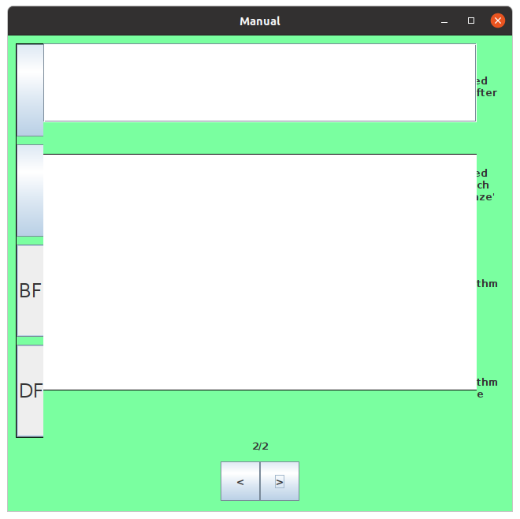

Which clearly shows some error, this was unsuccessful for test #4.

I checked over the available methods to see if there was a method which would refresh the renderer to re-render the window and I found a method called repaint which I call at the end of each of the page functions, this produces the following:





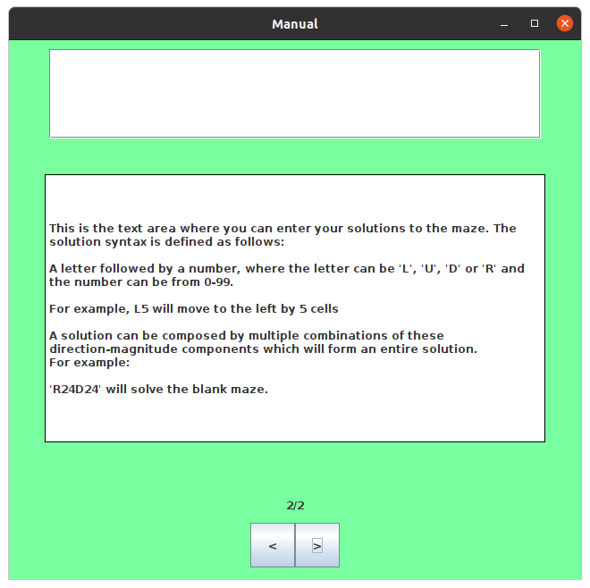

This is successful for test #5. I wanted to resume back to attempting prim’s algorithm and getting it working. The reimplementation uses the previous functions: get_neighours and index_compare to help support the algorithm since those functions worked for the DFS algorithm created previously, the new design of prim’s algorithm is now as follows:

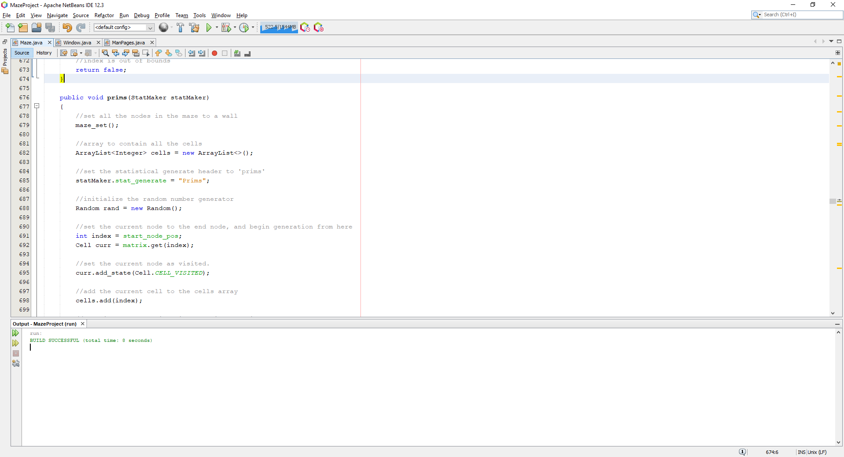

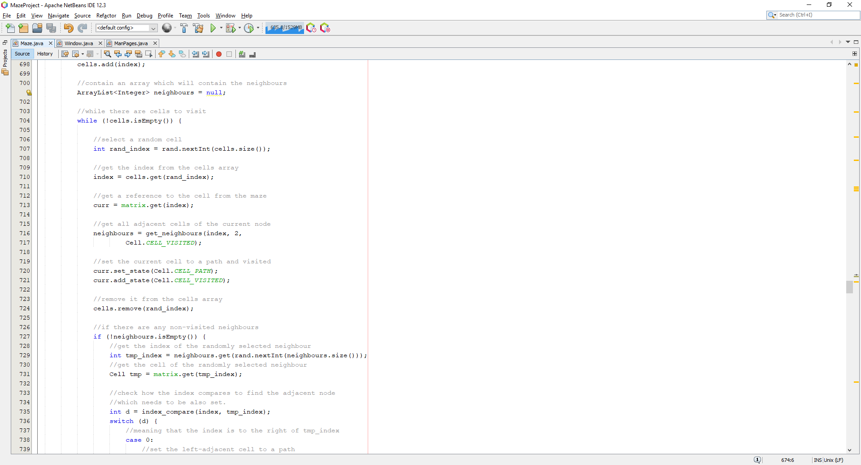

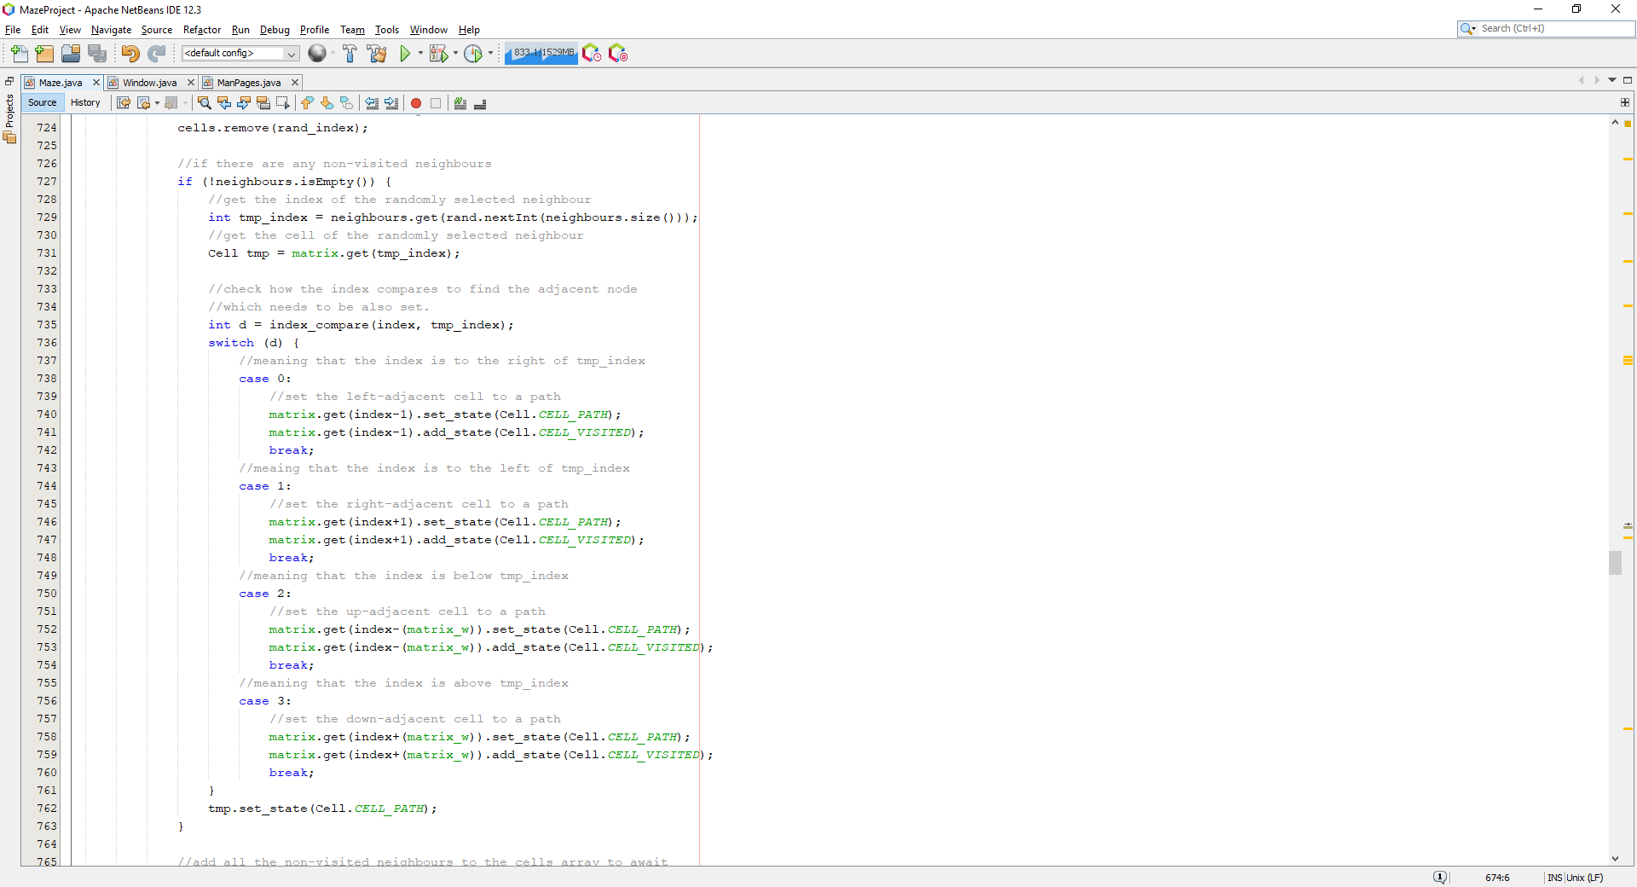

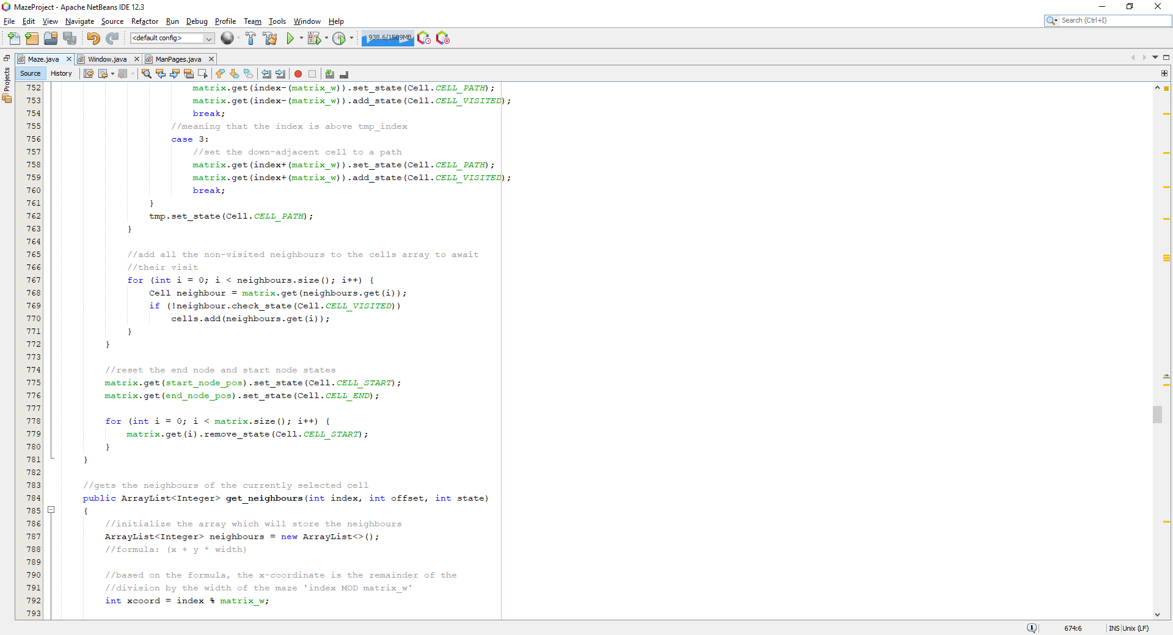

Where this code is the new attempt at the prim’s algorithm implementation where instead it uses get_neighbours and index_compare to get the adjacent unvisited cells and index_compare is used to determine which cell also needs to be set to a path.

I added code to allow the algorithm to be selected via the combo box here:

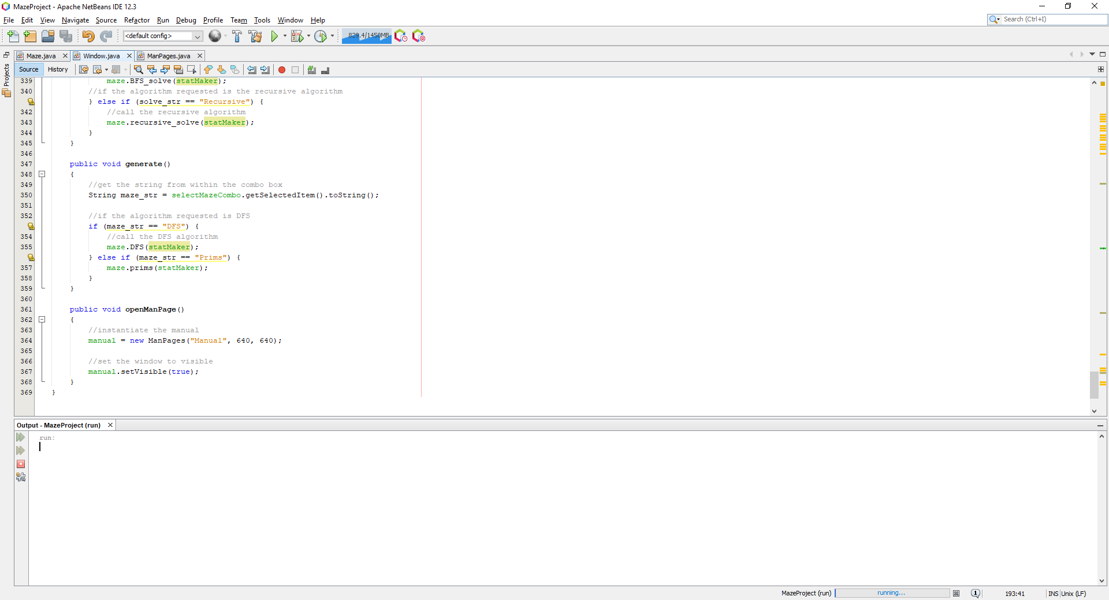

Where when this code is run, it produces the following:

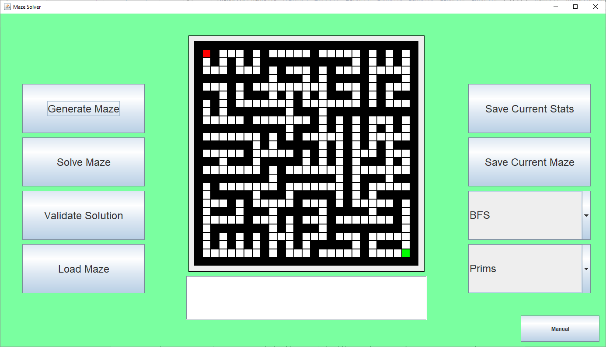

Where maze is unsolvable, but it is heading in the right direction to creating a maze. I decided to take a different approach where initially it grabs cells which are walls that are of distance 2 away from the starting cell, and adding these walls to a list. Then for each loop, select a random wall, and with the wall, get all the cells of distance 2 away which are paths, randomly select one of these paths and then set the randomly selected wall to a cell, and connect this new path to the randomly select adjacent path, whilst adding all the newly found walls which are of distance 2 to that wall, which is as shown:

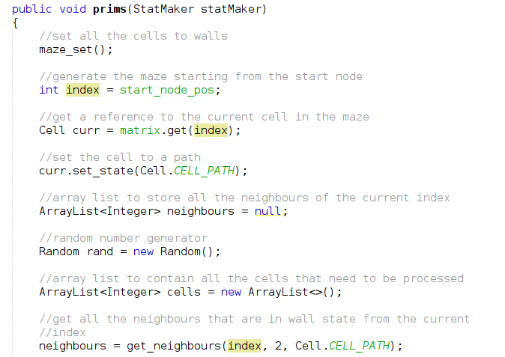

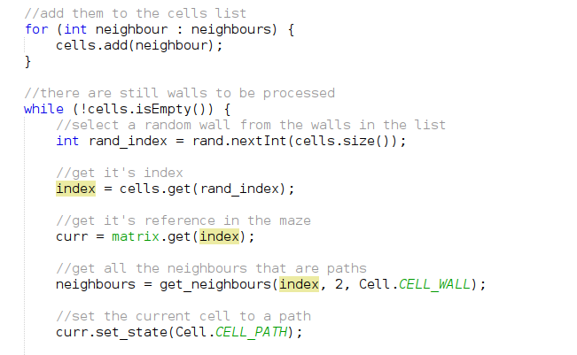

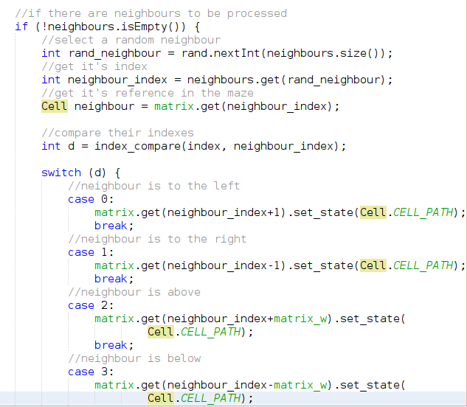

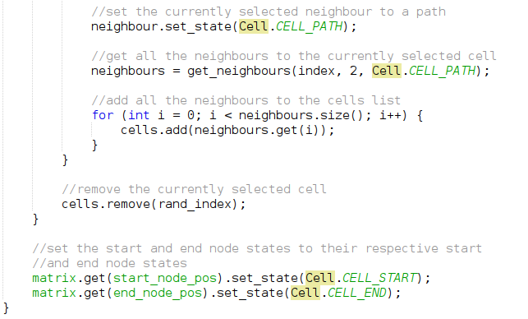

Which when run, produces the following:

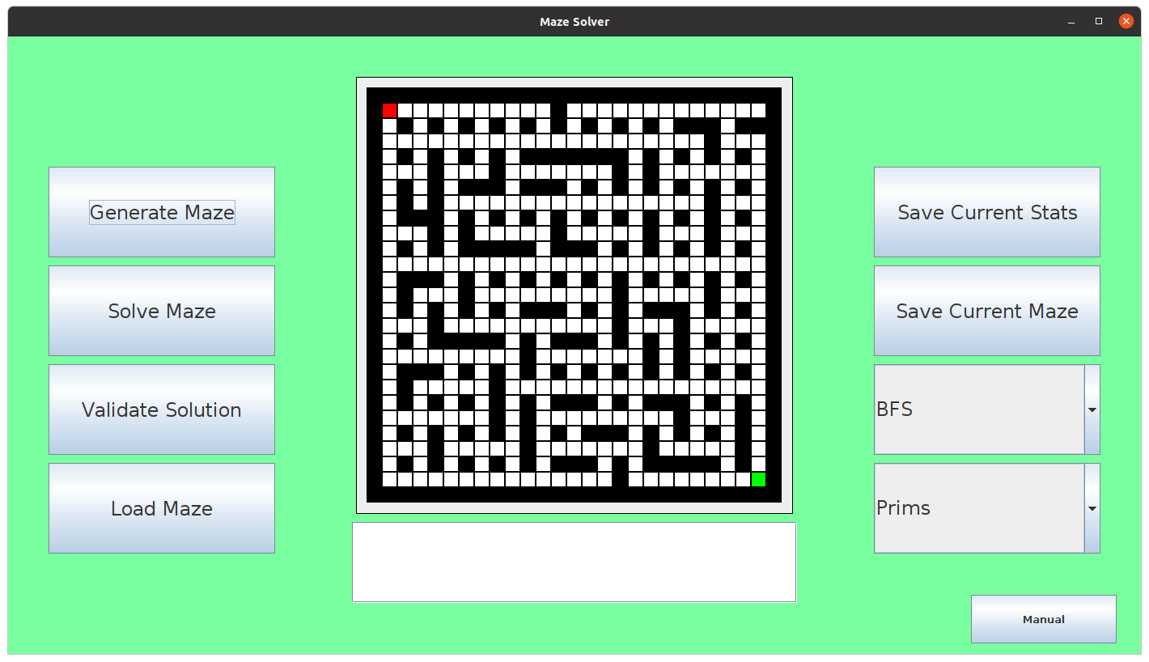

Which is still not exactly what is intended of the implementation. Also, after many generations using this algorithm, it is possible to get mazes which have no solutions, which shouldn’t happen:

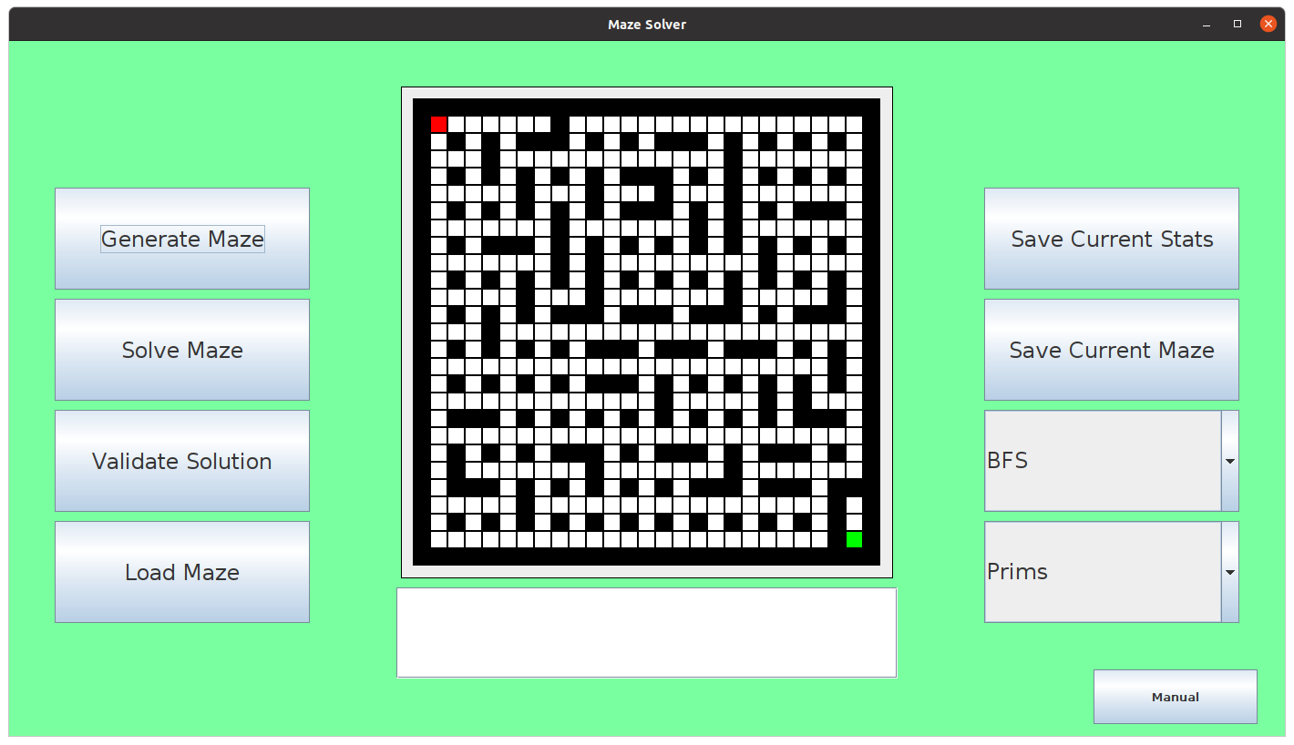

Where it is obvious that the end node is isolated, and can’t possibly be reached. There is still obviously something wrong with my implementation which causes this type of issue and this type of maze structure which does not represent prim’s algorithm. Meaning it is unsuccessful for test #6.

Finally, I tried an approach, which didn’t use any of the pre-built algorithms, checking to see if they were the problem and now storing the pairs of cells inside the array list to make it easier to manipulate the adjacent cells. This was implemented as follows:

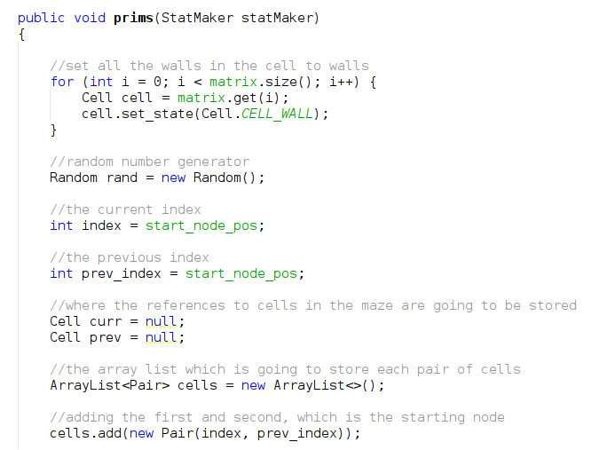

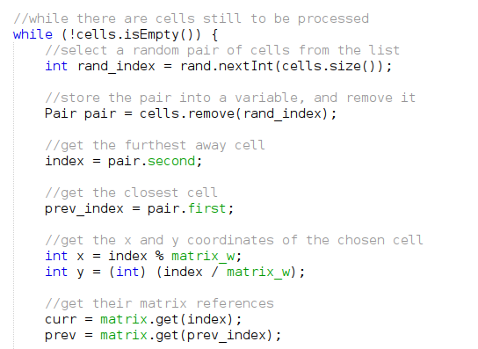

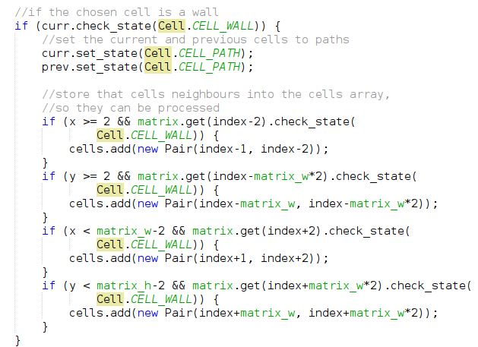

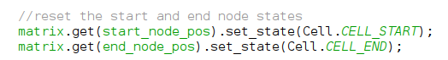

And when running this code produces the following:

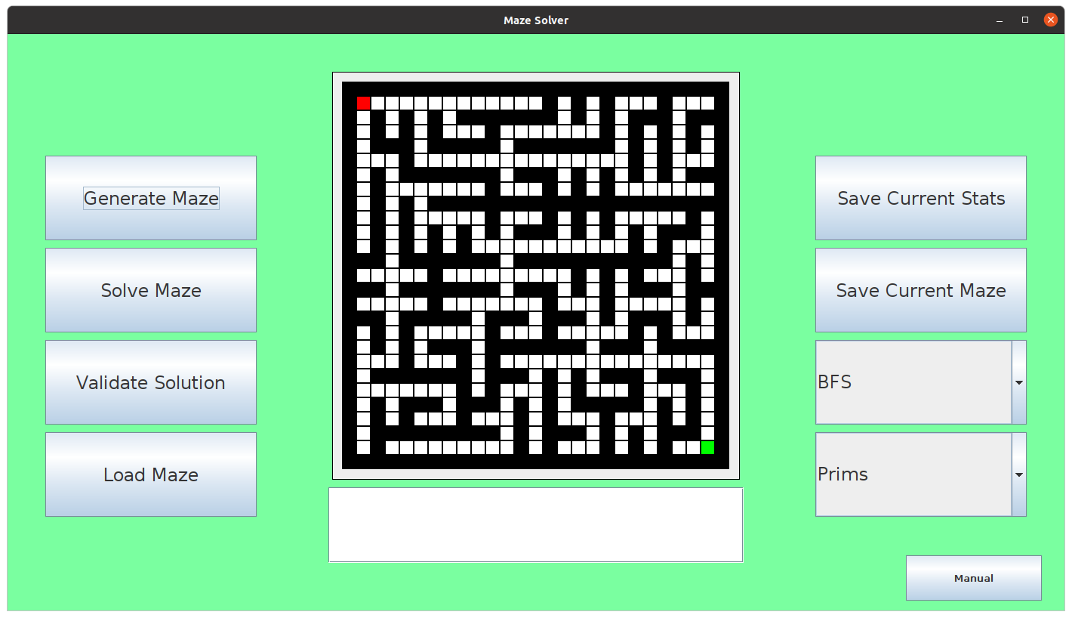

Which is what was intended and is therefore successful for test #7.

Now, there is a final part of my success criteria that I want to complete which is based around the showing the user frame by frame the process of which the algorithms go through. So, firstly I wanted to work on the frame-by-frame process for each of the maze generation functions by implementing some form of scheduling procedure which would display each frame every second. I wanted to implement this delayed functionality firstly to the prims algorithm, in order to toggle whether the user wants to see the algorithm fast or slow will depend on the state of a toggle button, which I added:

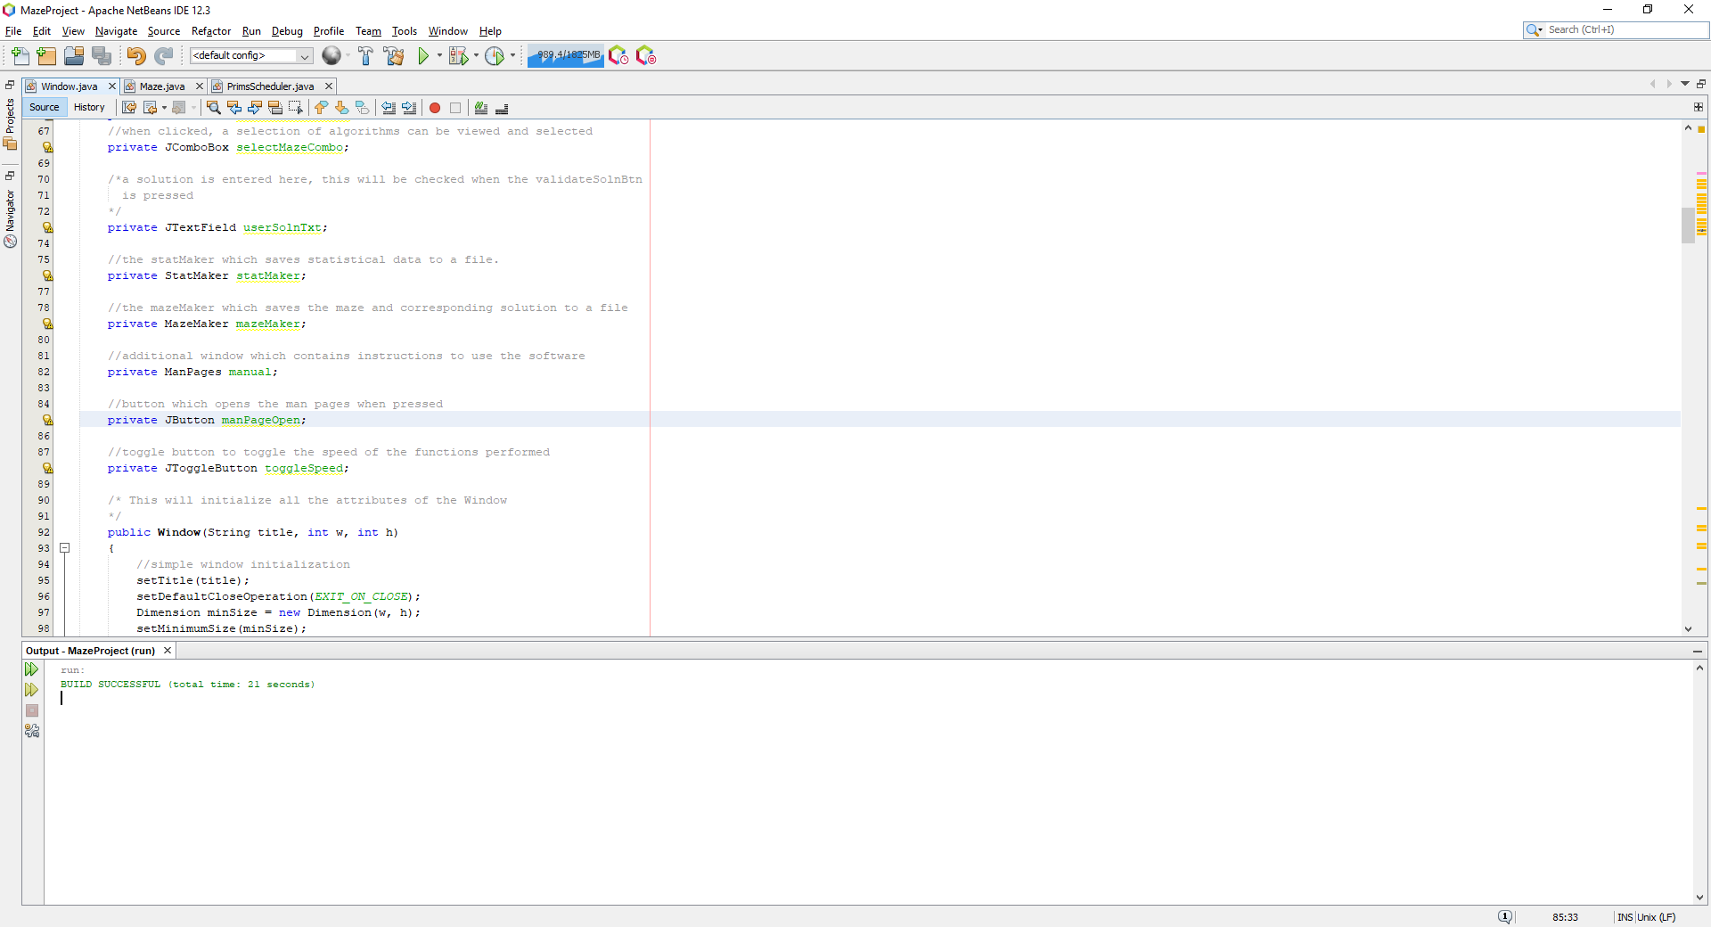

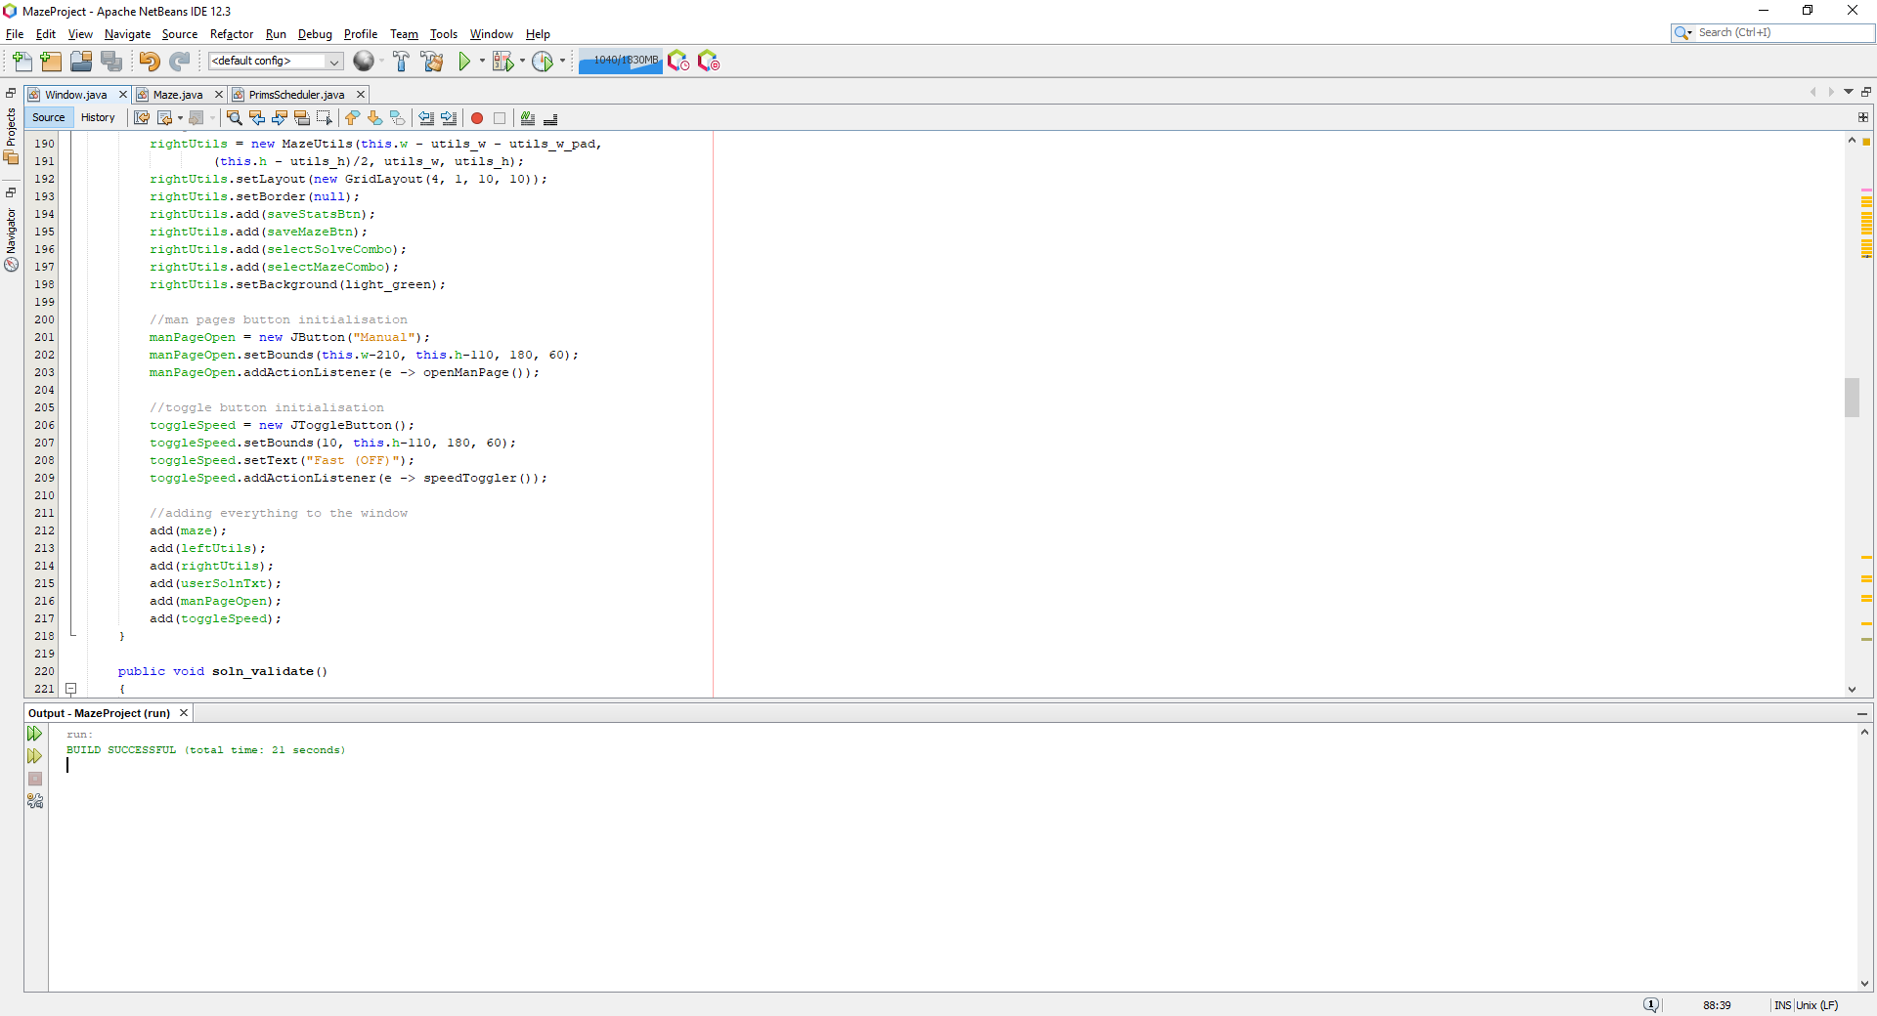

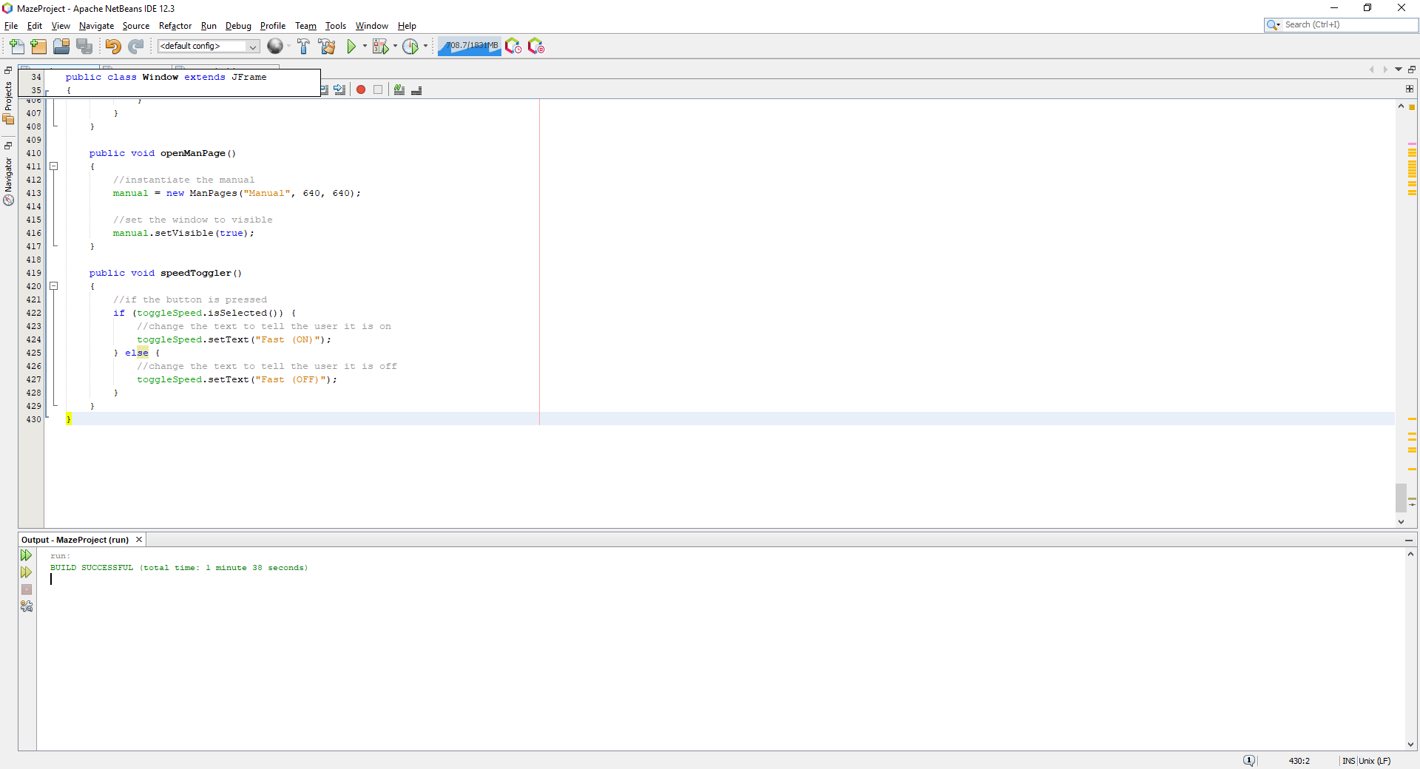

Where this is how the button looks in the window:

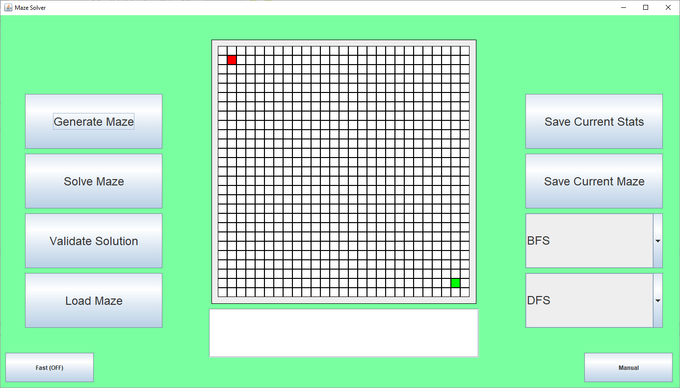

And when clicked:

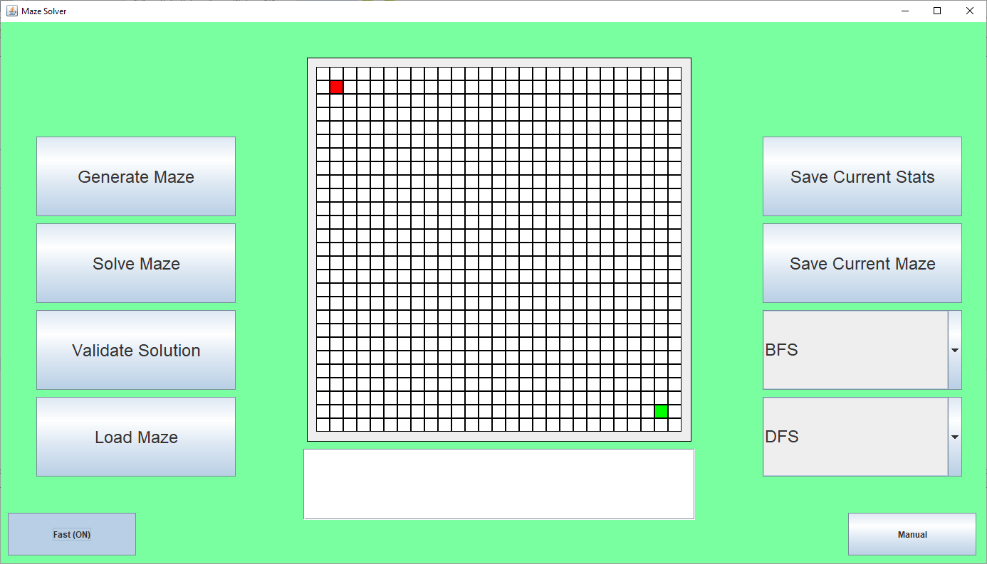

Then, to implement prims algorithm which will run slowly, it would require a new function which implements prims algorithm but only produces a single stage of the generation progress each call, this can be done by changing the prims algorithm function’s while loop into an if statement, and to just call the function until there are no more cells in the list to be processed:

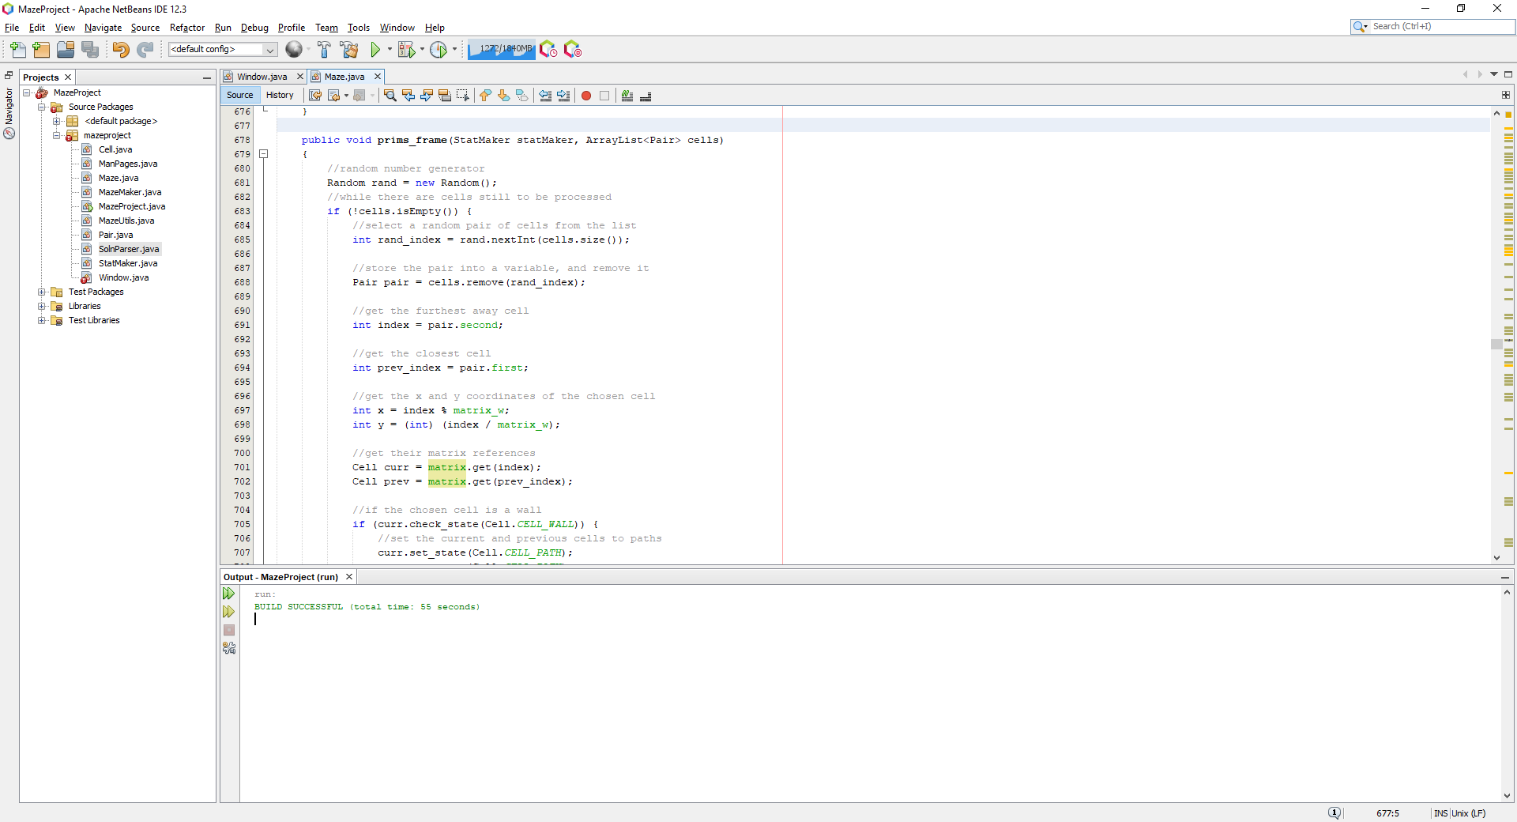

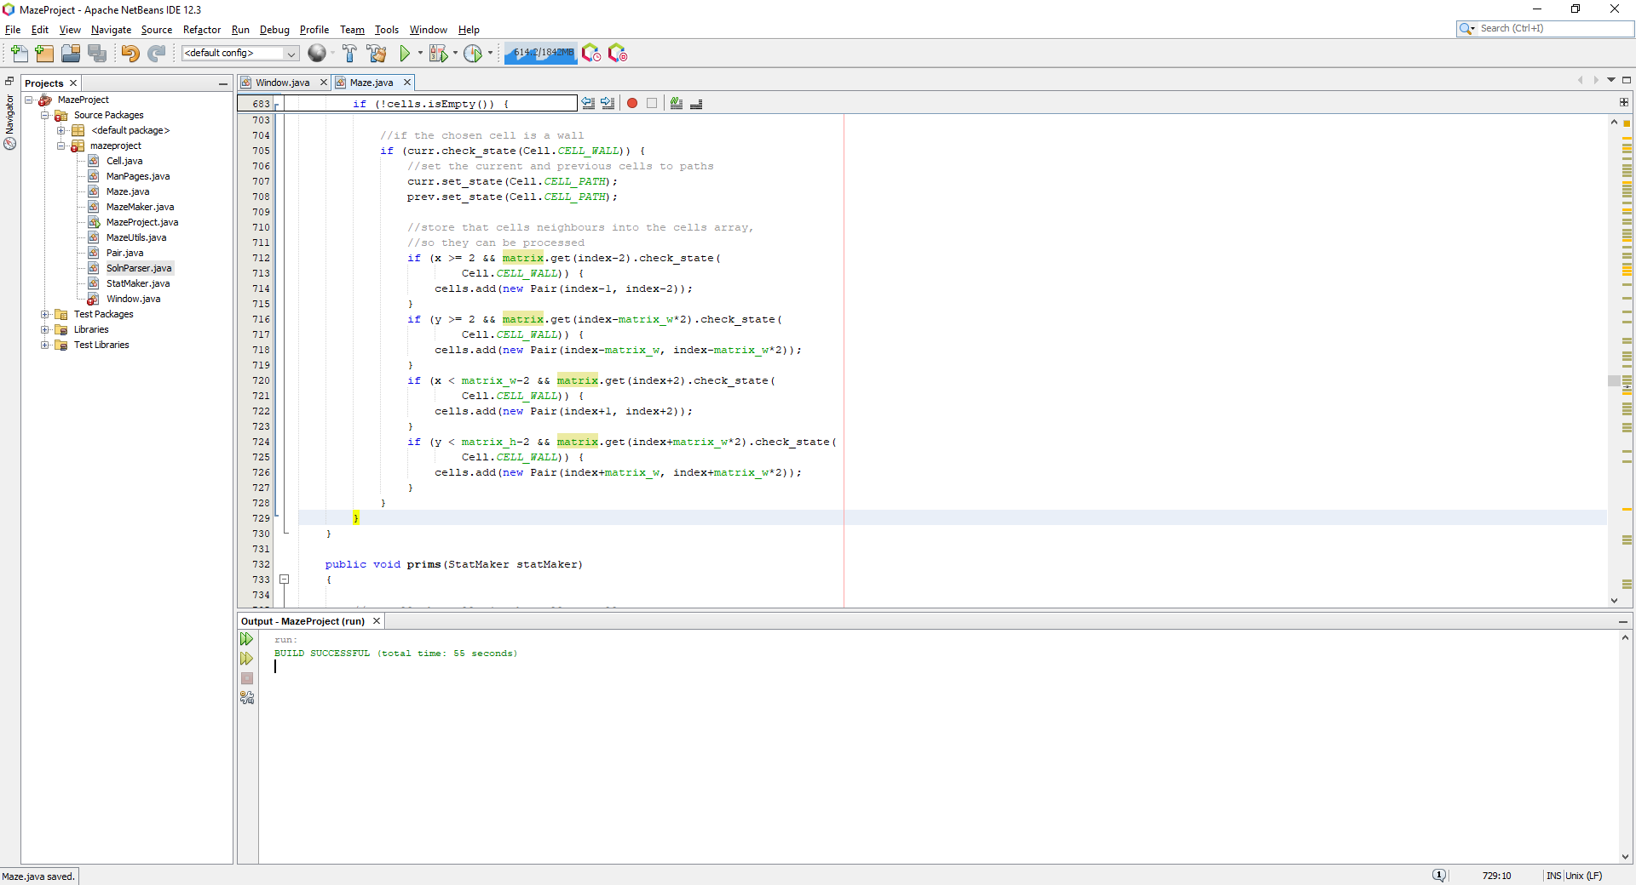

Where this new function called prims_frame is simply the exact same as the previous prims function except that it takes in an extra argument which is going to be a global list which will contain all the cells which are to be visited, because if the array was created inside the function, the cells would be lost.

Now, when the user selects in the combo box to user prims algorithm to generate the maze, it will now also check if the user has pressed the speed button to increase the speed of the algorithm or not, I later realised that the button being pressed would toggle whether it was slow or not, where I have changed the code to change and set the text to ‘Slow (OFF)’ and ‘Slow (ON)’.

The scheduling of the prims_frame function is as follows:

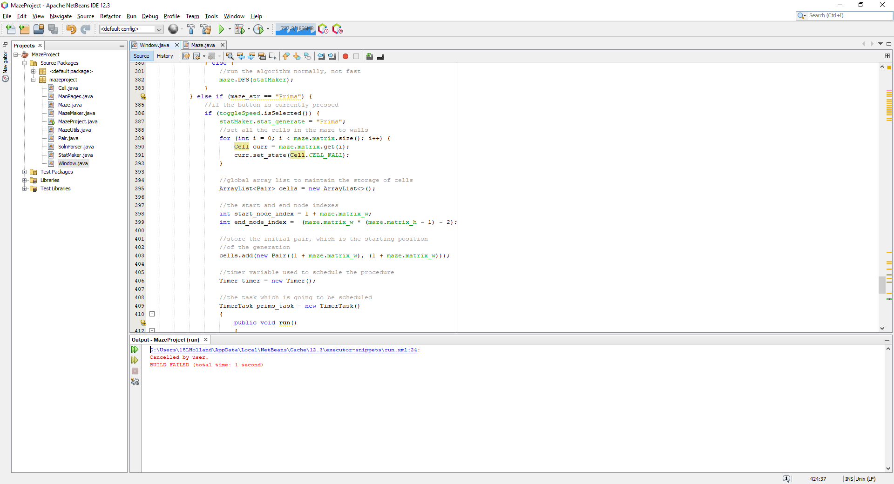

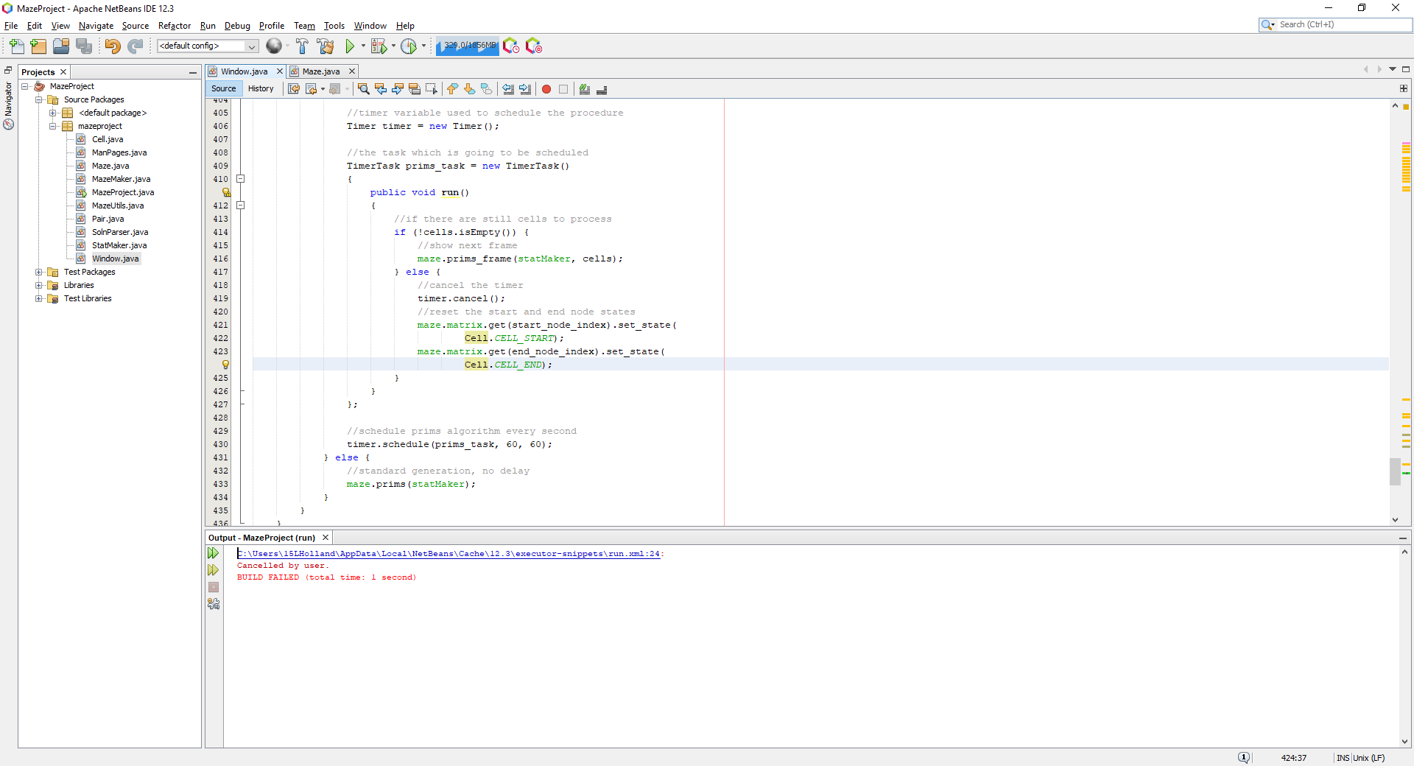

Where this will call the function every 60 milliseconds to display each stage of the process every 60 milliseconds. When the program runs and the toggle speed button is pressed, it shows the following:

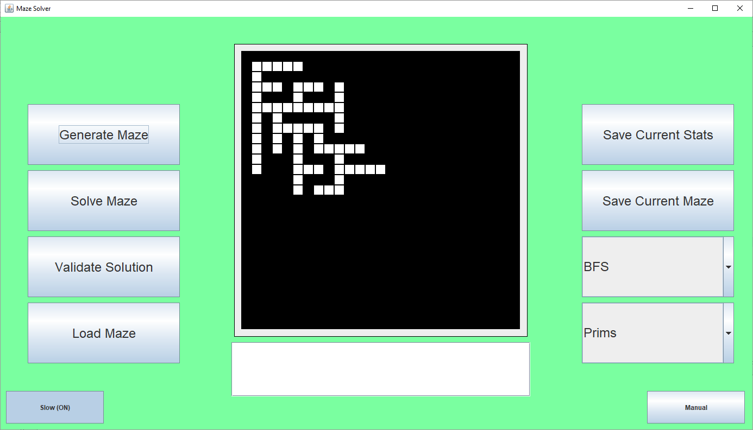

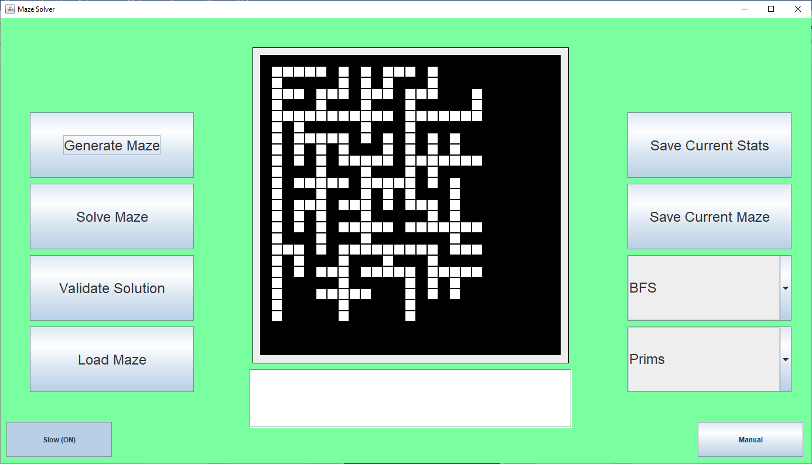

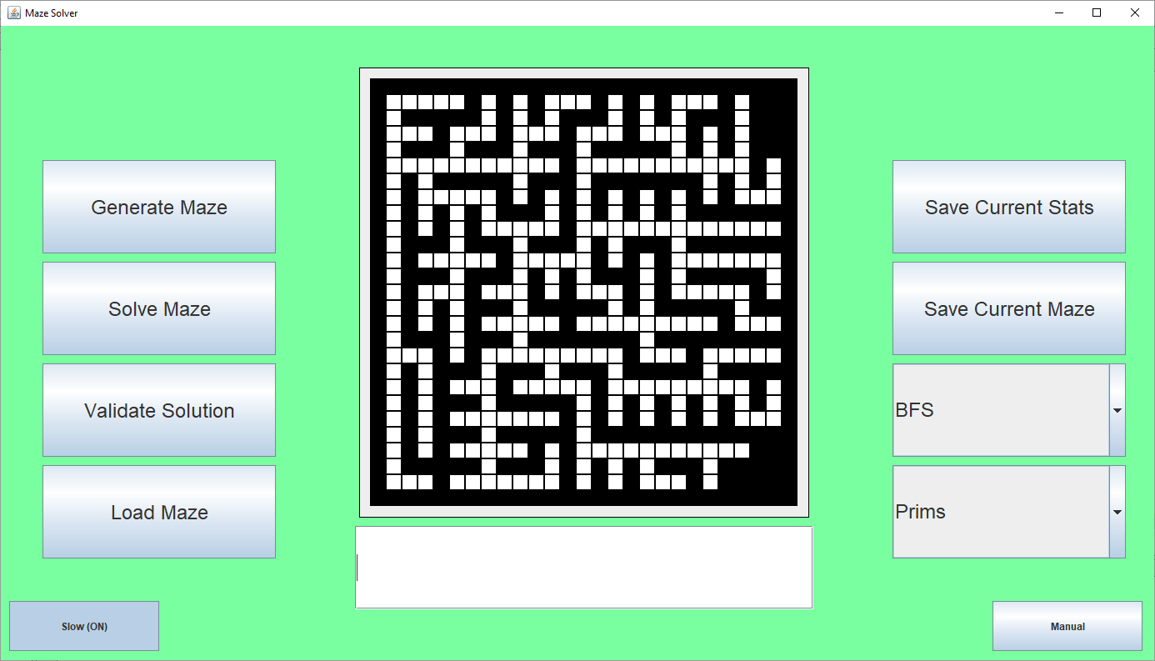

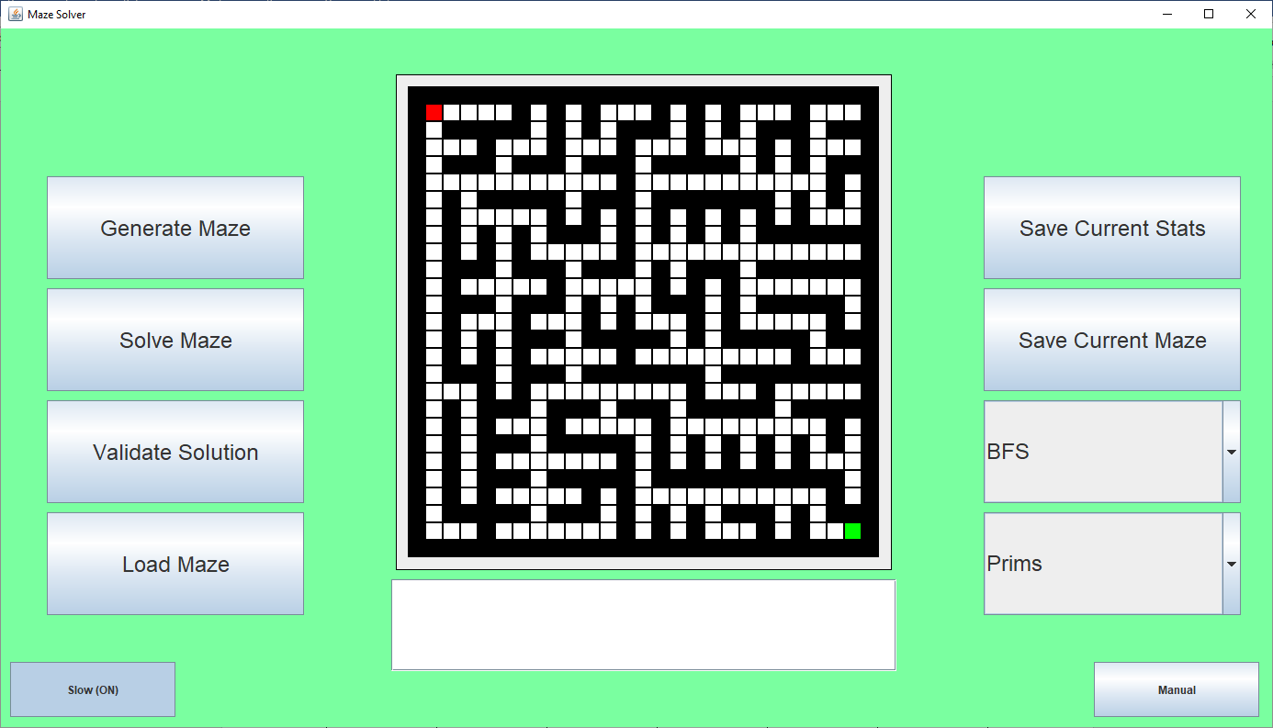

Where the algorithm is displaying the process very slowly and is clearly displaying the process which prims algorithm goes through to the user. This is successful for test #8.

I then wanted to implement this same procedure to allow for a slow visualisation for DFS. This works very similar to the implementation of prims slow generation and is as follows:

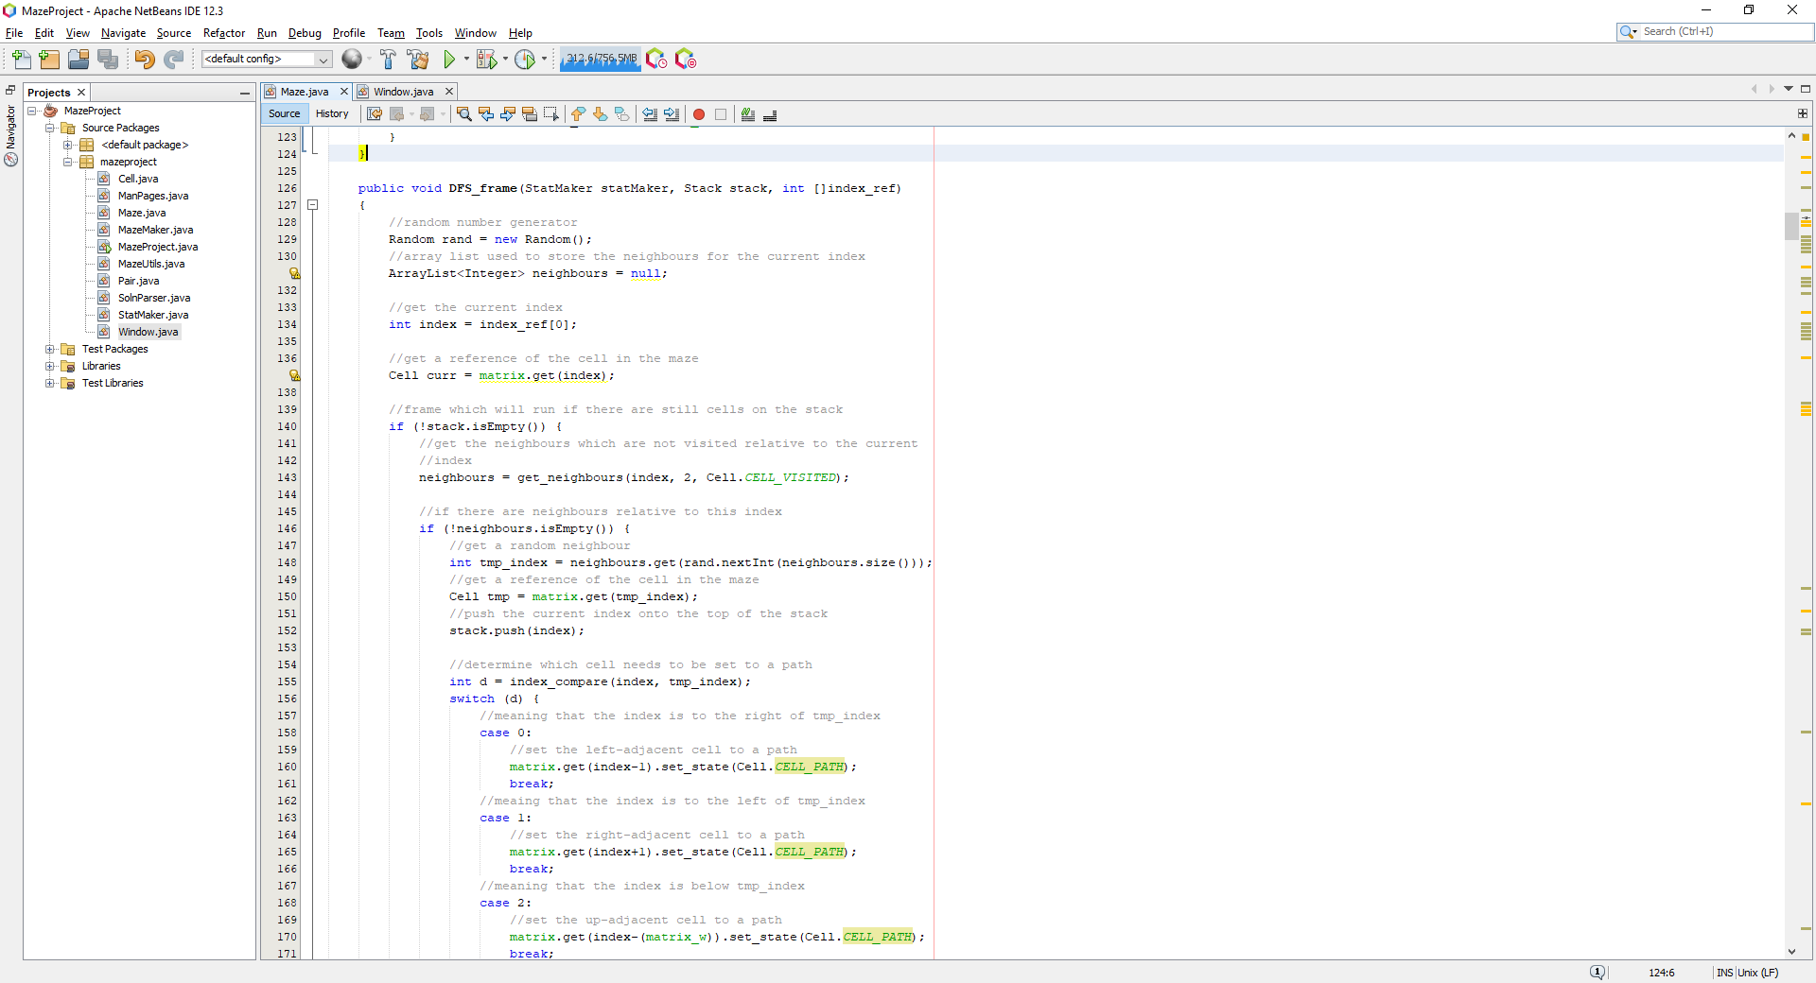

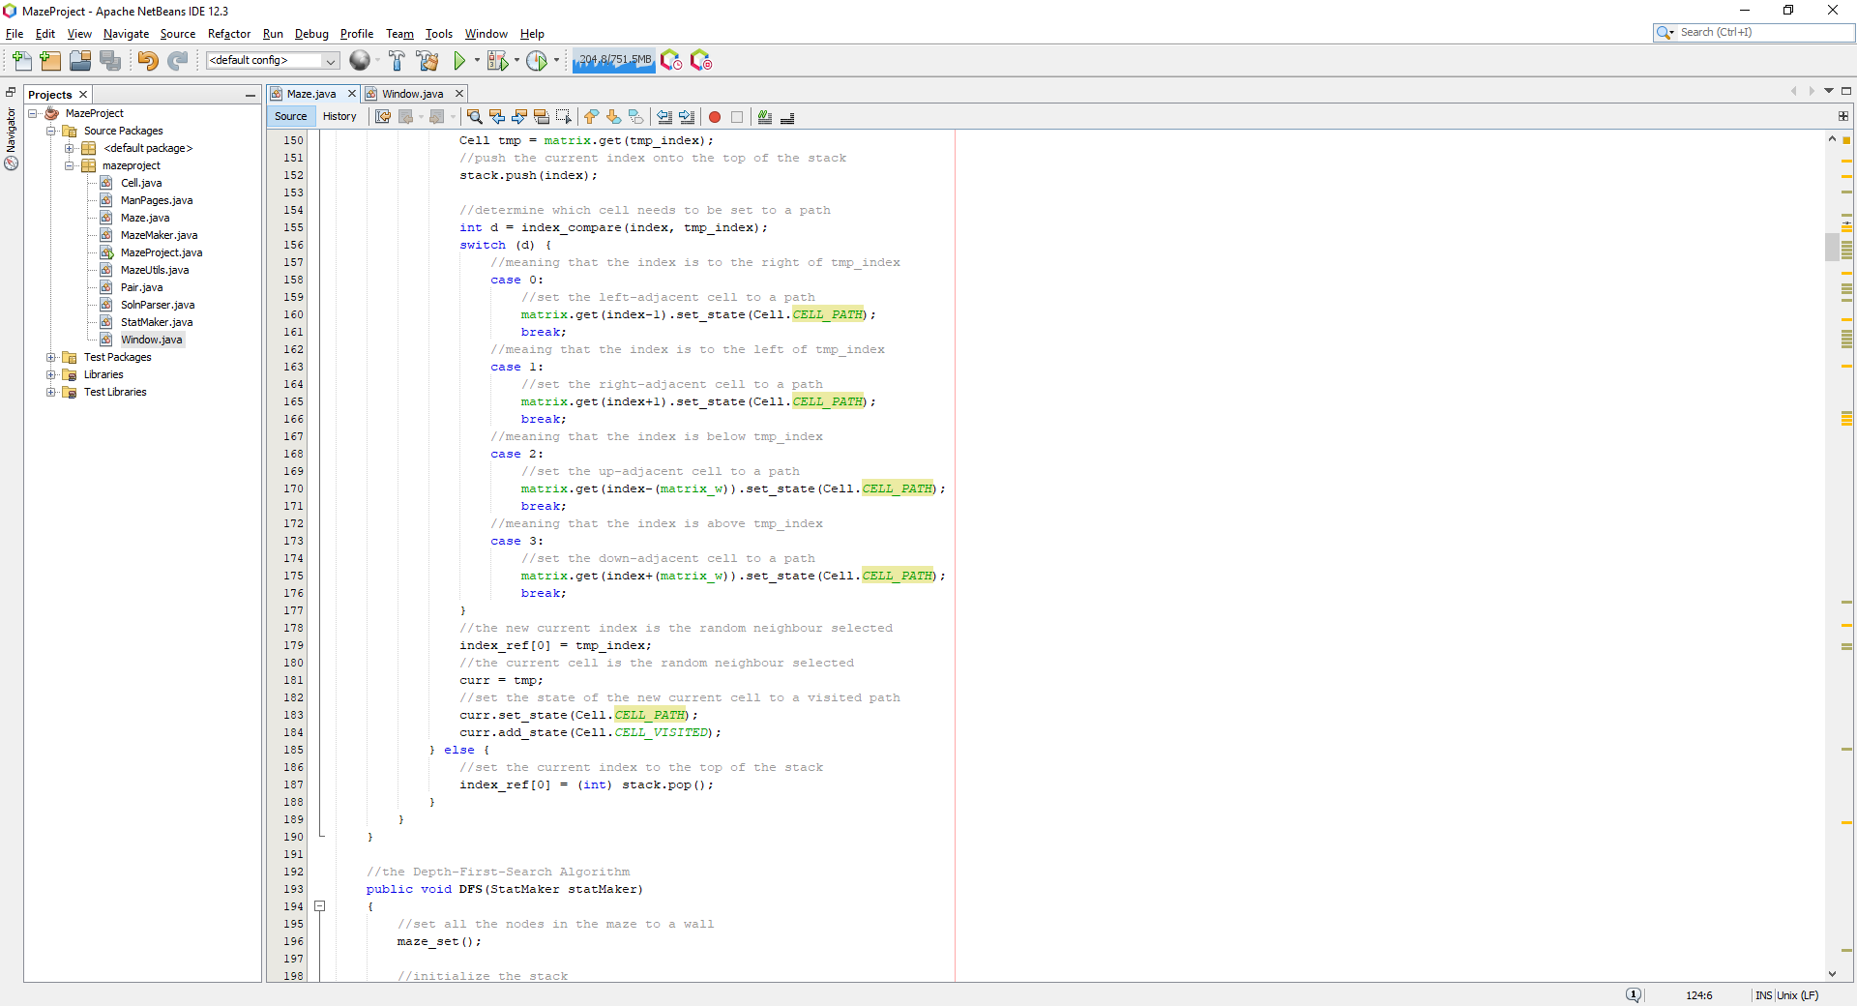

Where this function will simply act the same as the DFS function would usually but instead of a while loop, it now just consists of an if statement. The index_ref variable is an array and is needed because java does not allow programmers to pass primitive integers by reference, so I decided to make it an array of 1 element, allowing me to pass the index by reference, so the current index is saved between calls to the function. Then, I needed to integrate this into the window function, so when the user has pressed the slow visualisation button, the DFS algorithm will be presented in a slow visual way:

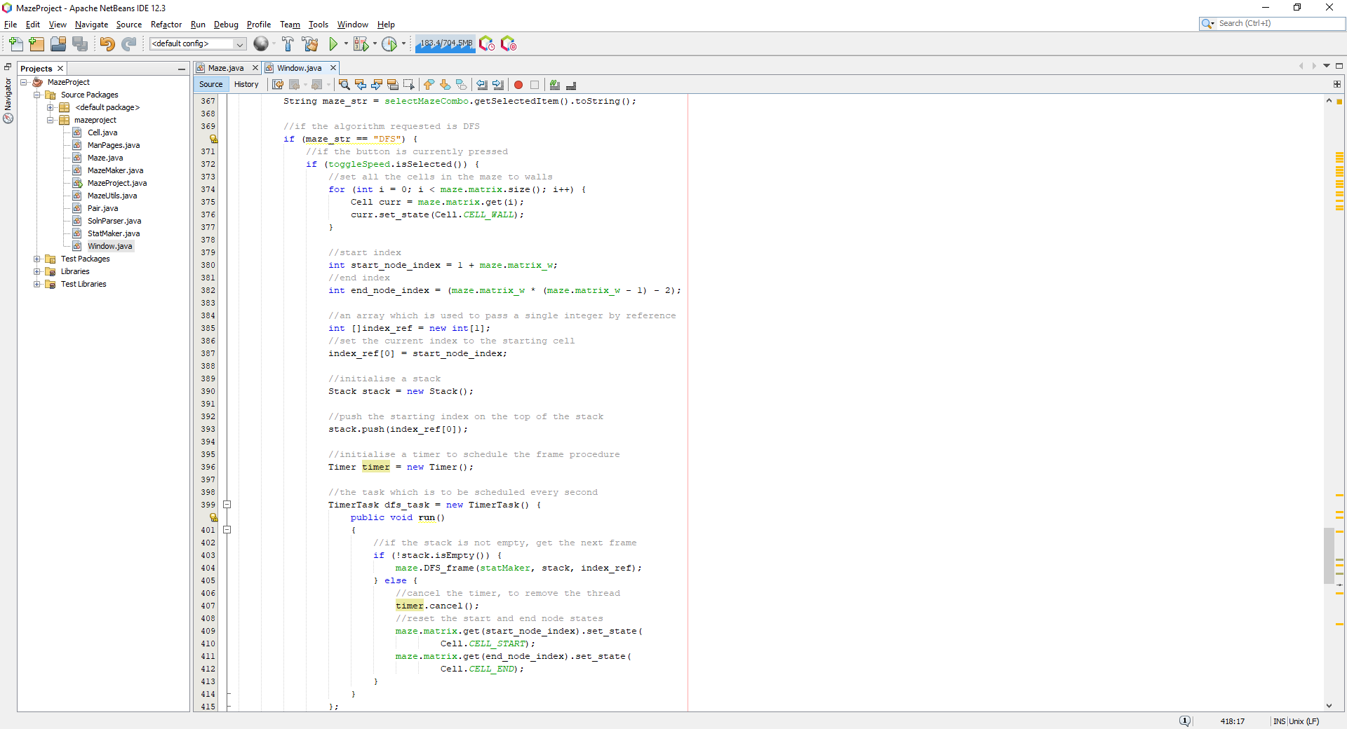

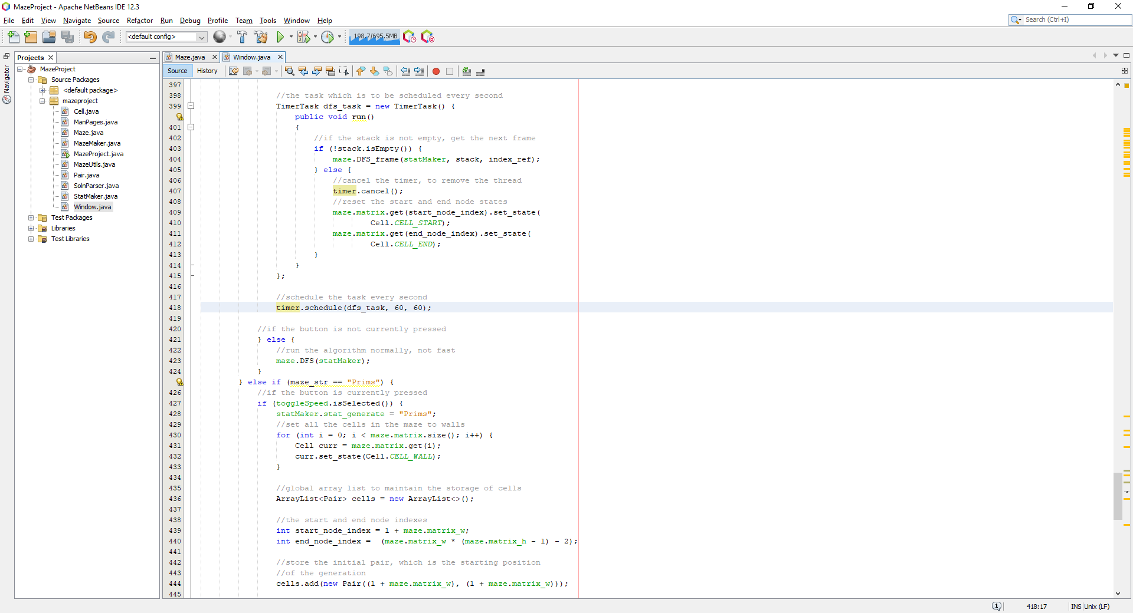

Where now, when running the DFS algorithm with the button now pressed, it displays the following:

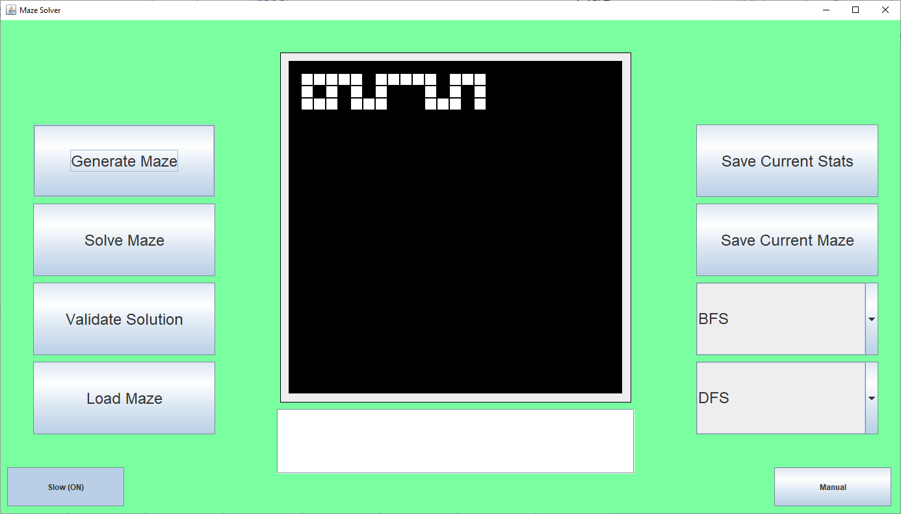

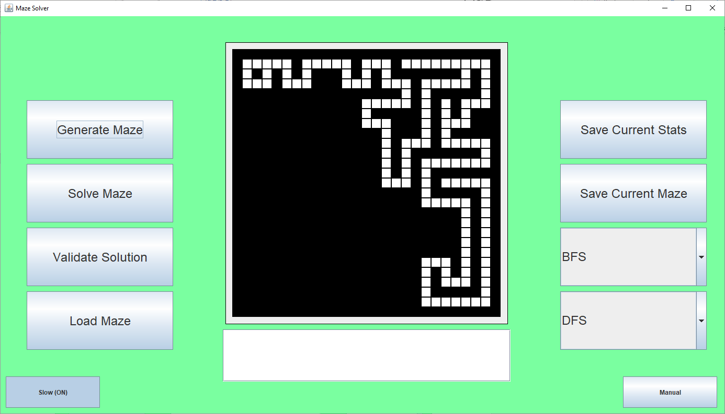

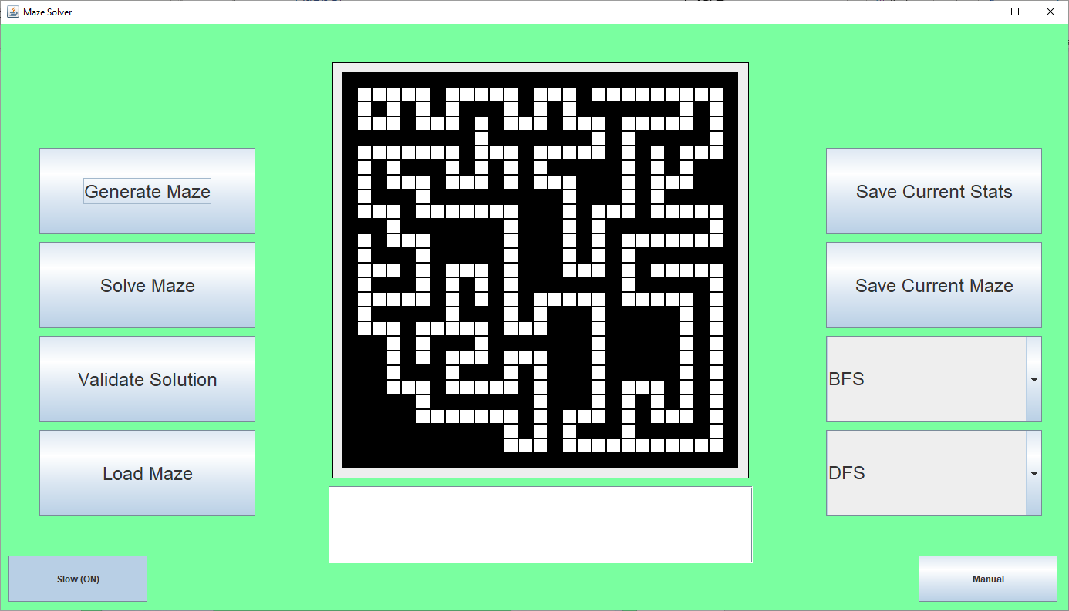

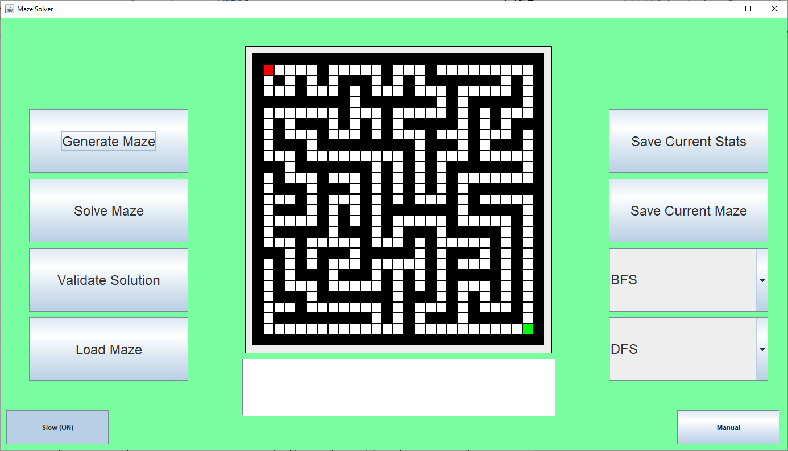

Where these are a few frames from the algorithm. This is successful for test #9.

Finally, I am now going to implement the same slow visualisation for the maze solving algorithms, starting with BFS:

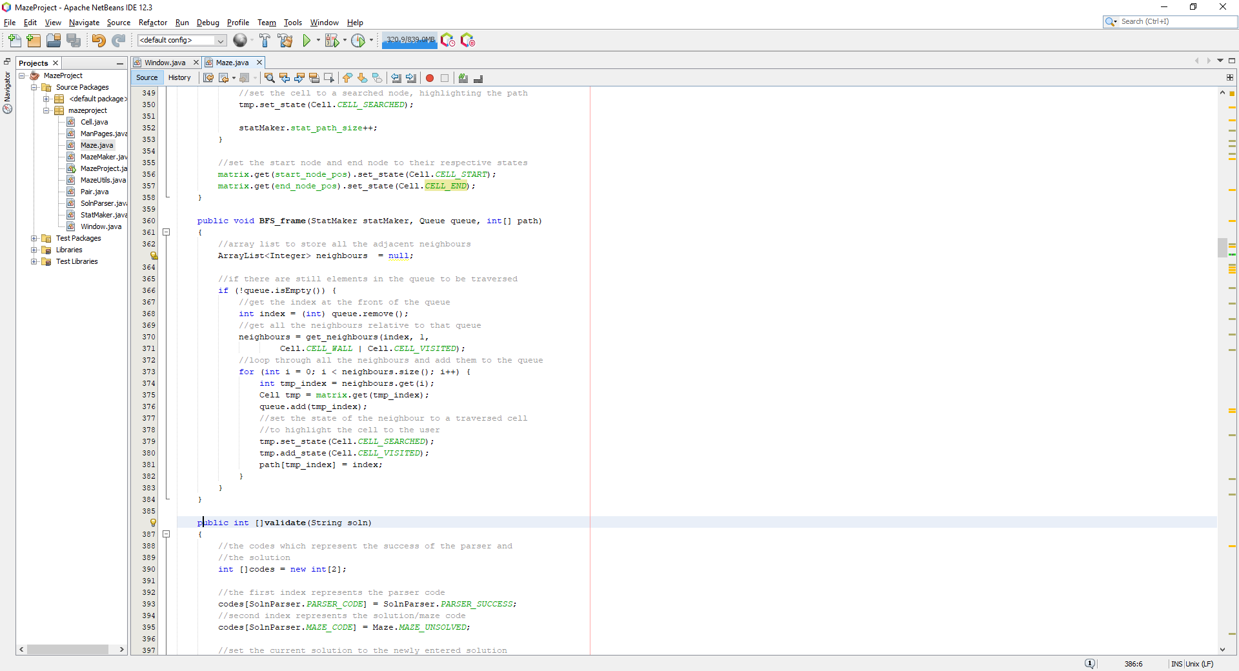

Where this procedure acts the same way as the normal BFS procedure functions, but it has extra arguments which are used to save the state of the queue and the path between procedure calls. I then integrated this function into the window class so when the slow visualisation button is pressed, the BFS_frame function is called instead:

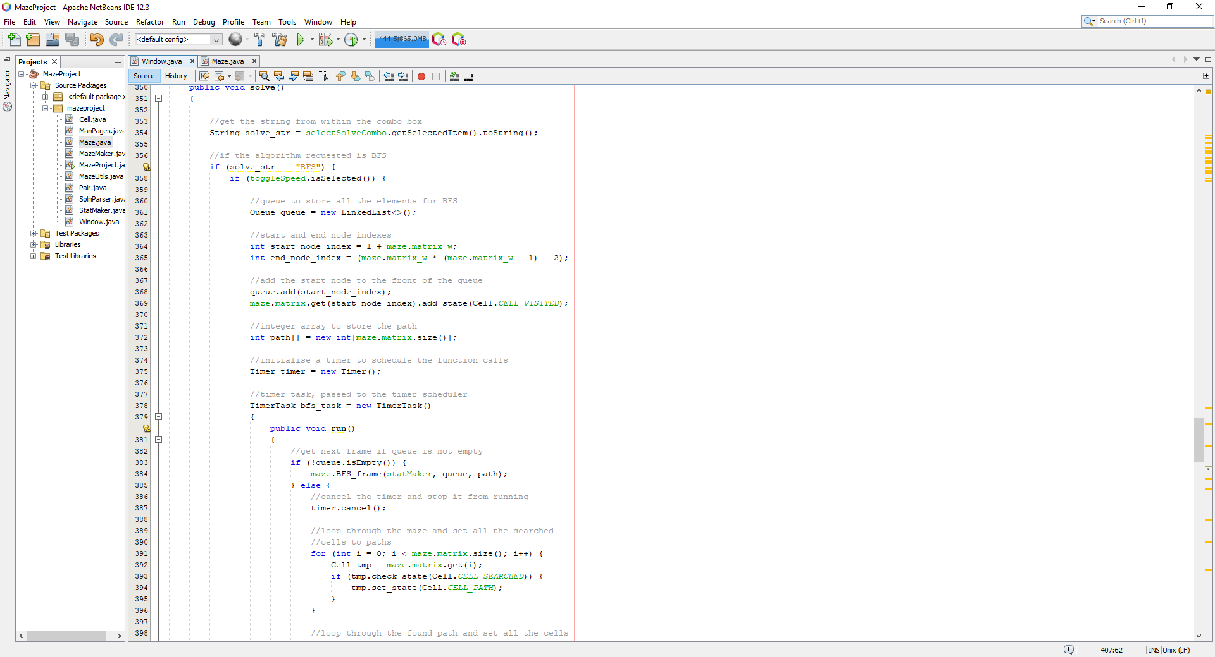

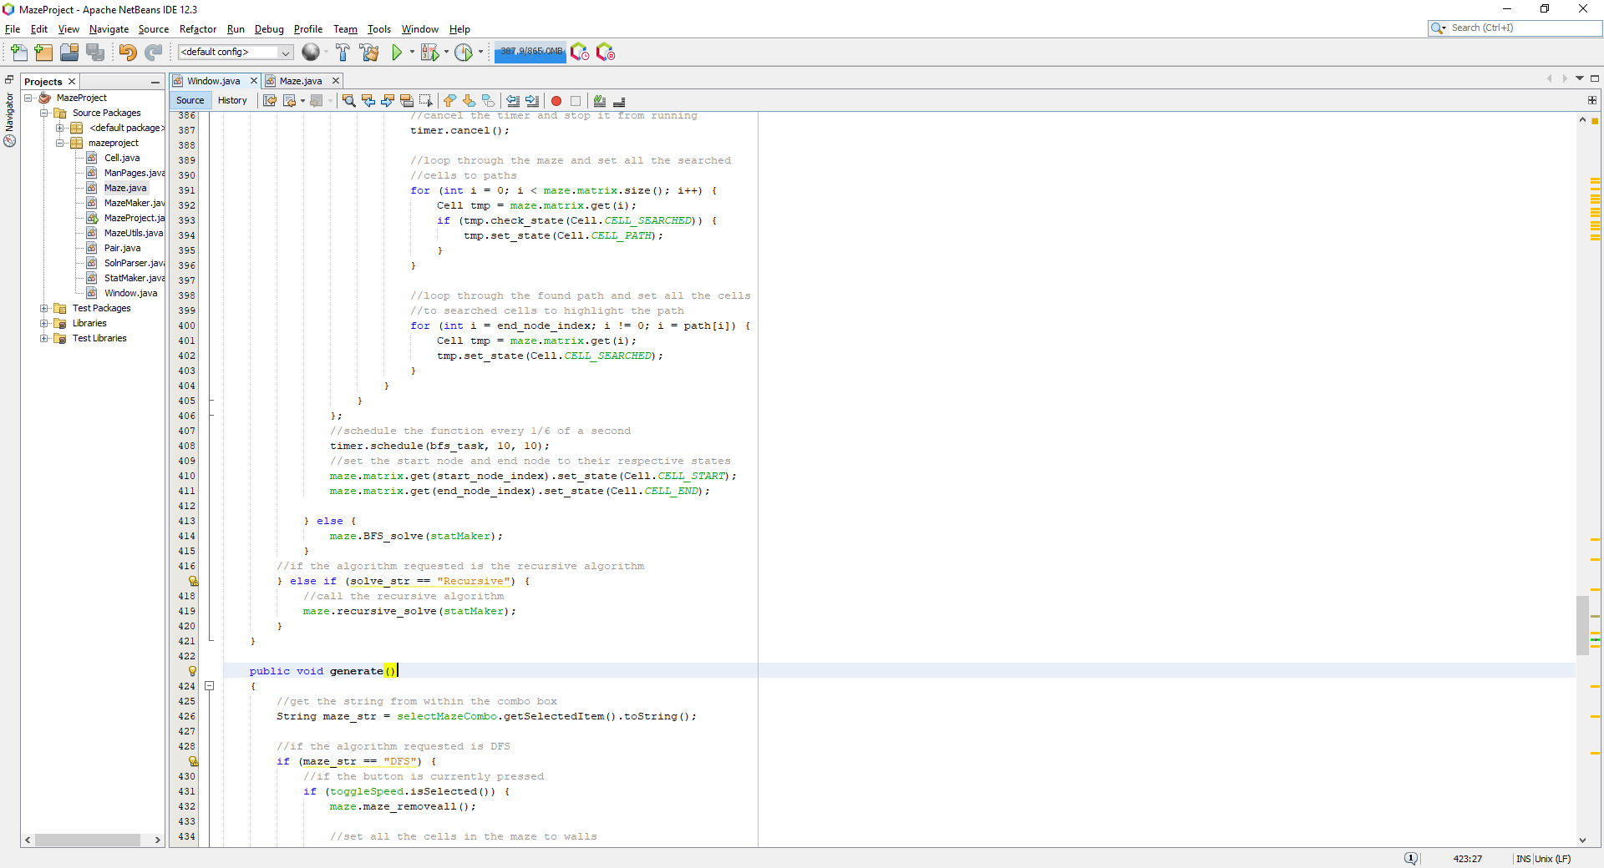

Where this now presents the slow visualisation of the BFS algorithm if the slow visualisation button is pressed, when running this, it presents the following:

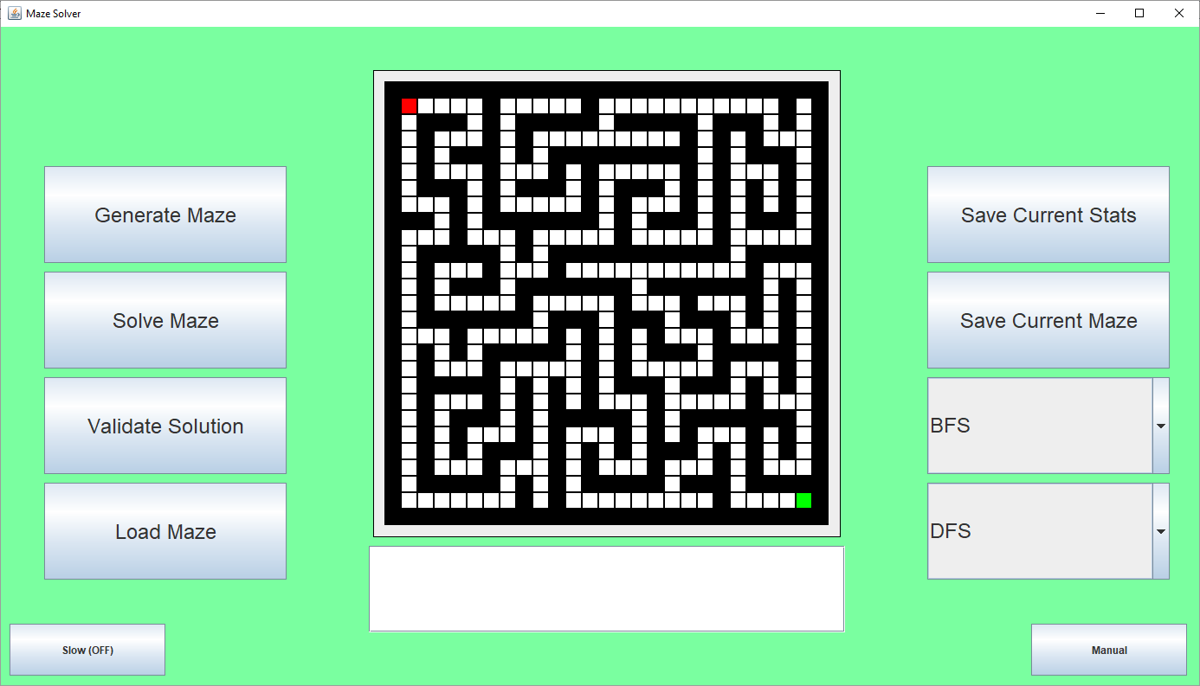

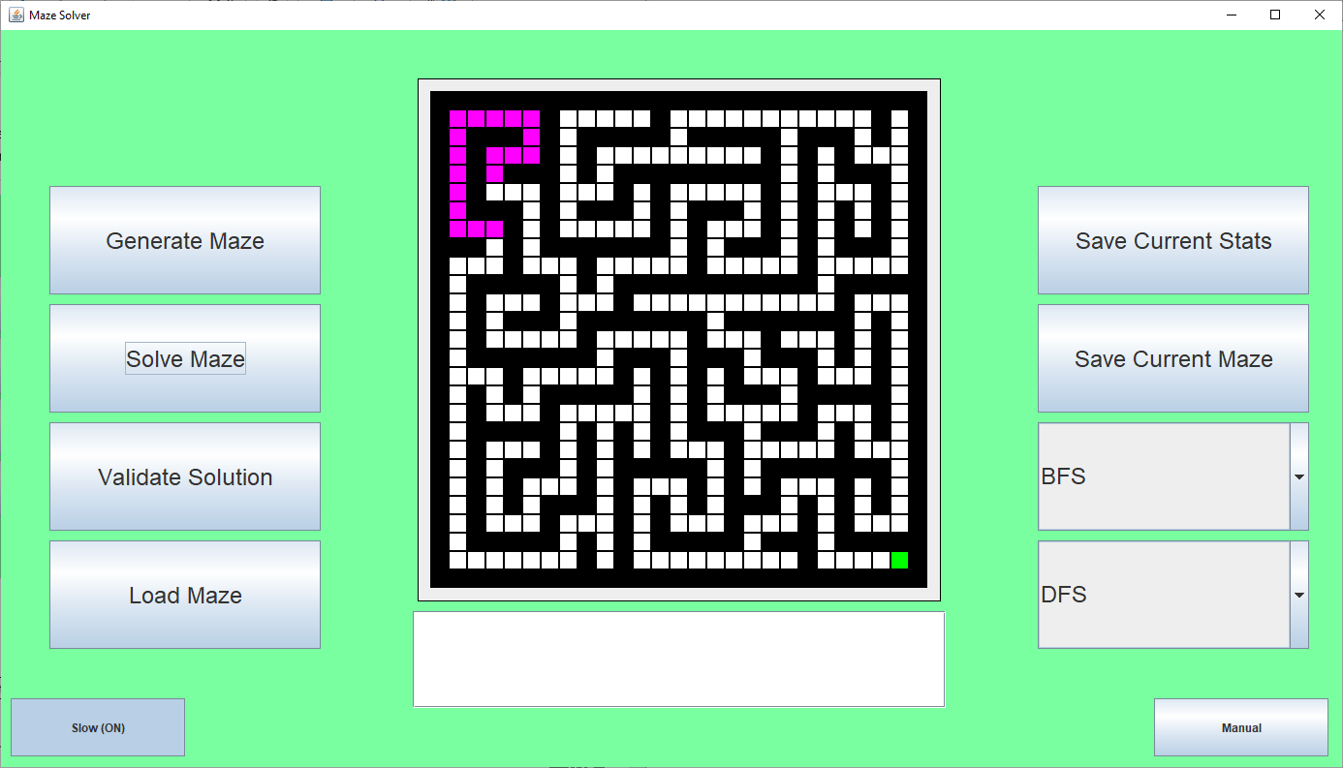

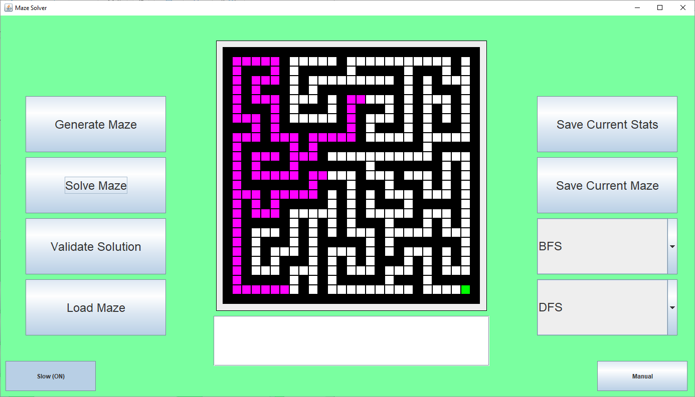

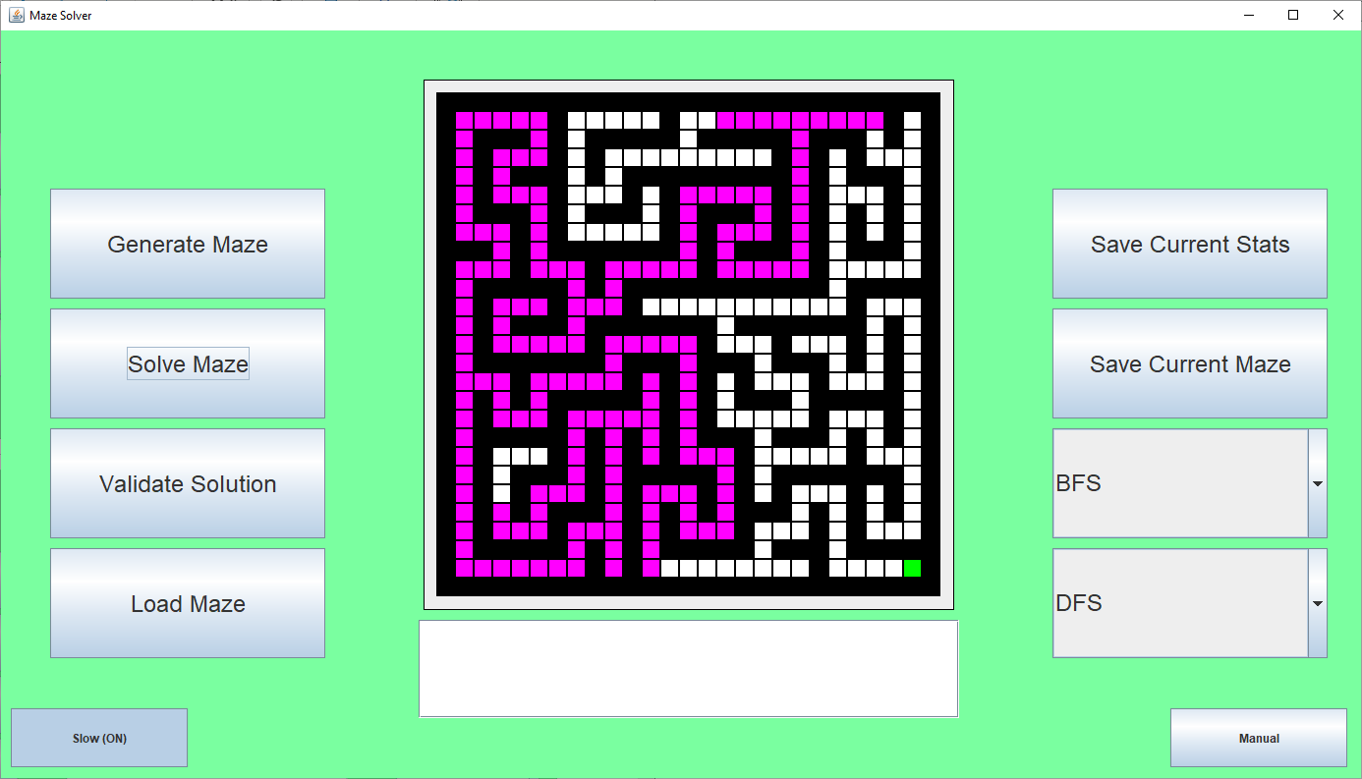

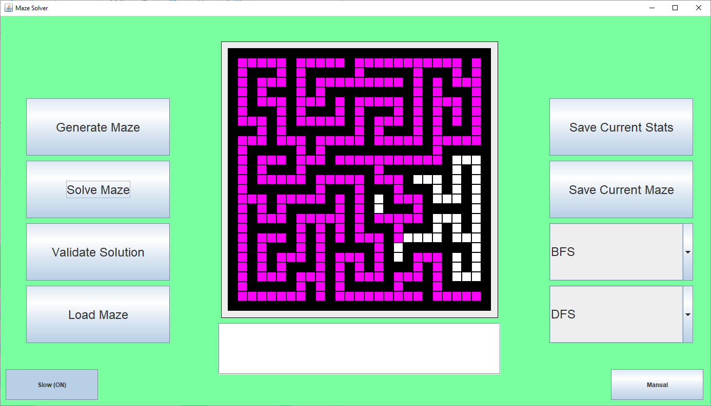

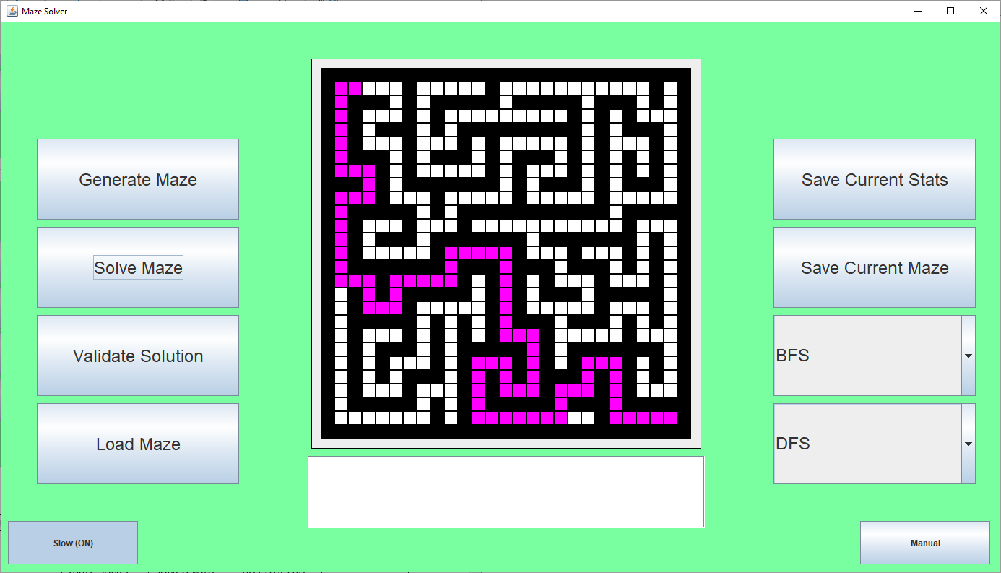

Where once all the nodes have been traversed, it displays the final, shortest path which was found. However, it is obvious that there was some kind of error with the algorithm as there is a stray cell which has been highlighted which there shouldn’t be. Running another maze generation algorithm after this produces the following:

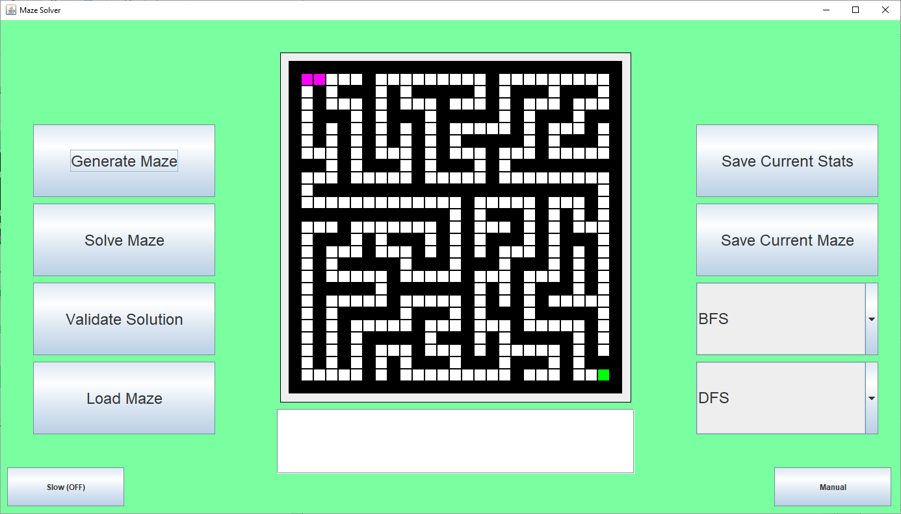

Where the 2 cells for the starting node and the node to the left are still highlighted. When trying to use prims algorithm, it produces the following:

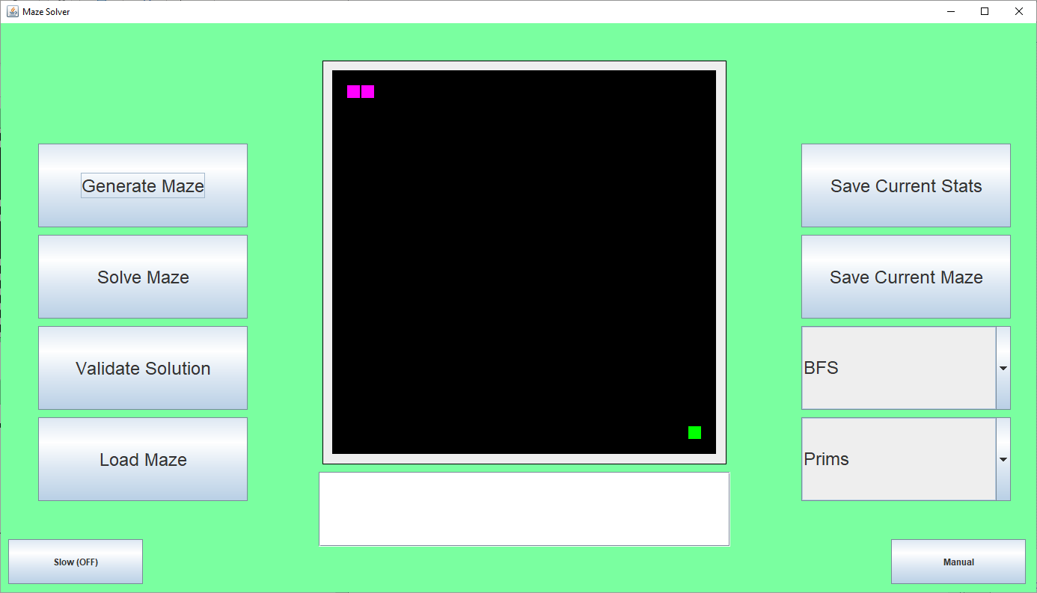

Meaning that the path could not even be generated because of those cells. This is a big error and needs to be fixed. I removed the final 2 lines of code once the thread is closed and now the code works, this is what was changed:

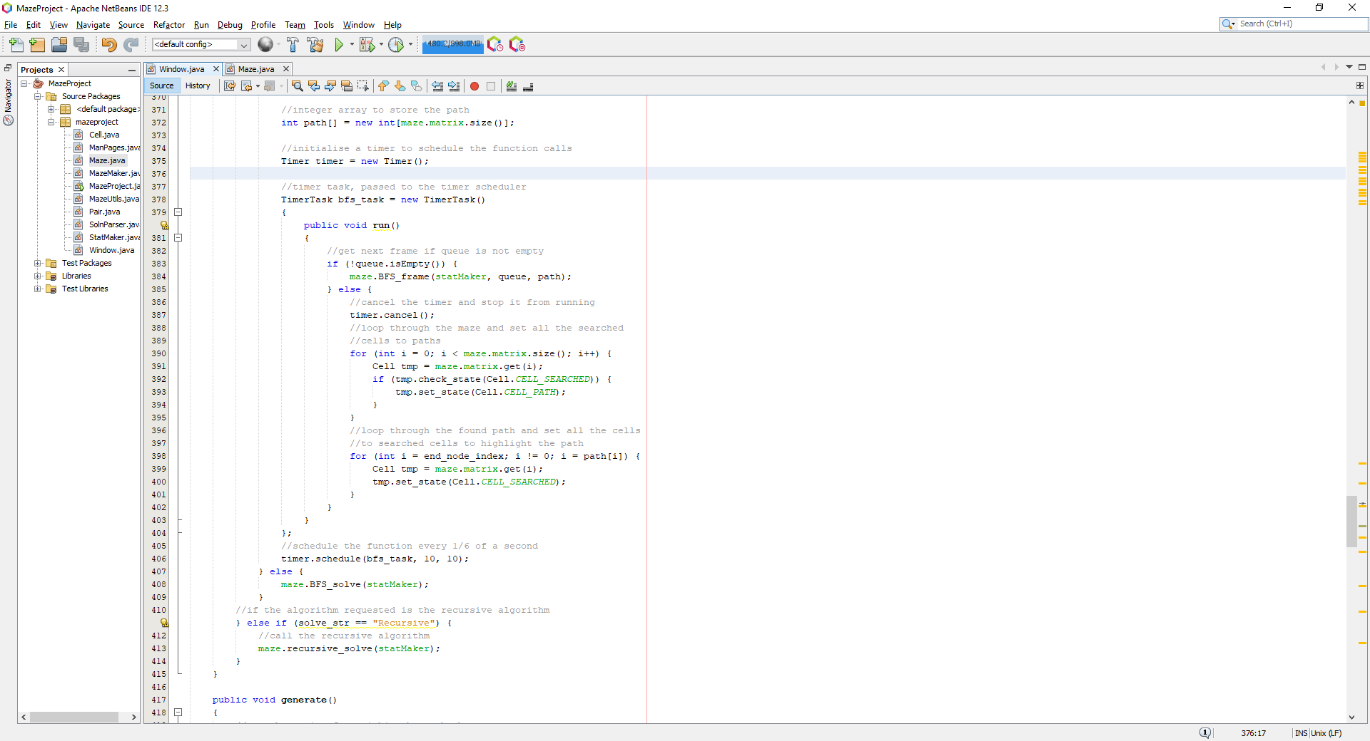

Where now, nothing after schedule is called, it simply continues to the else statement which can be seen in the previous screenshot. Where now, when running this, it produces the following:

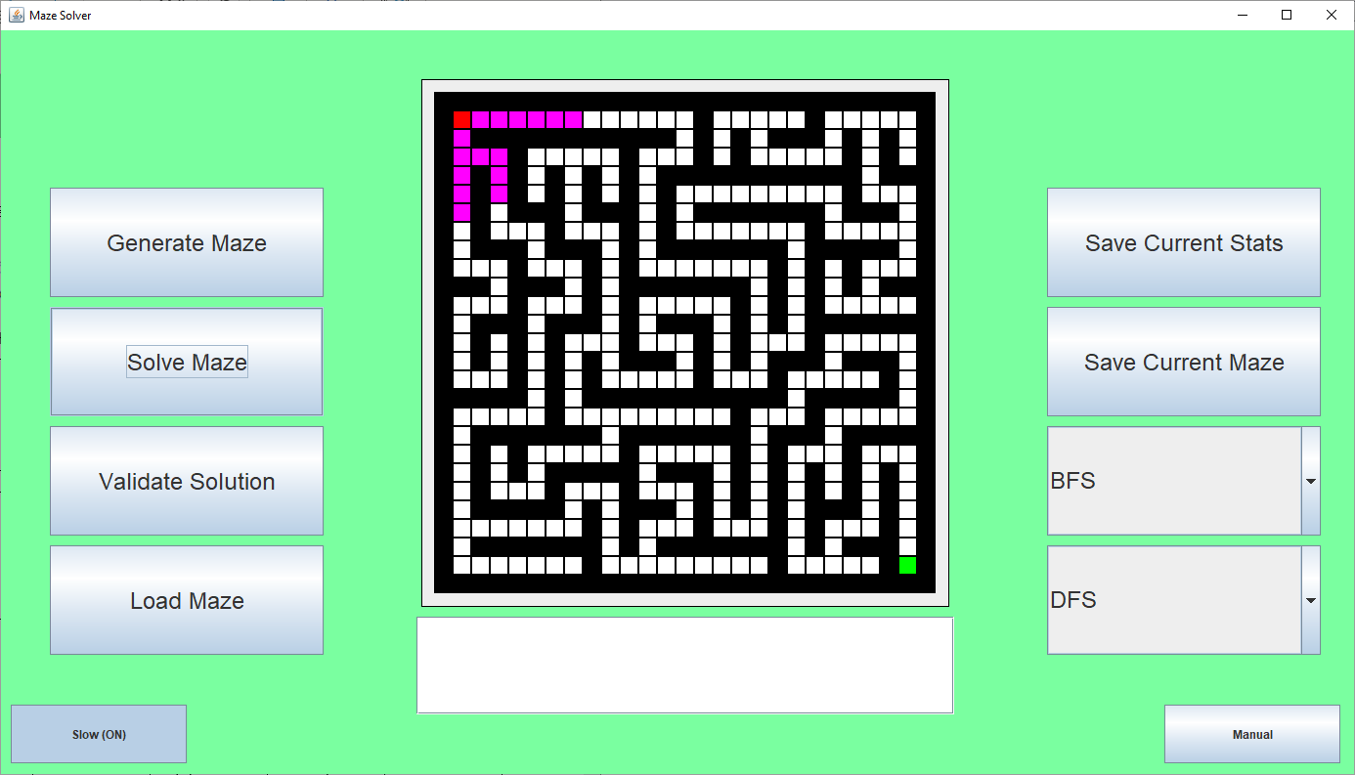

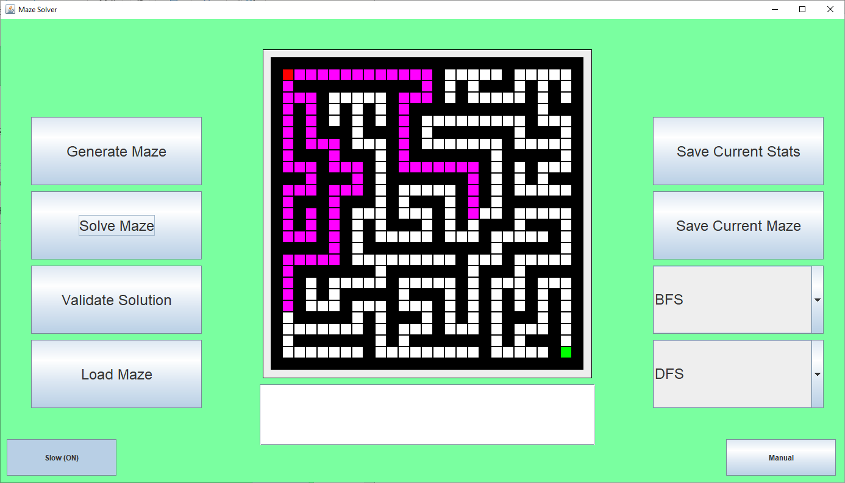

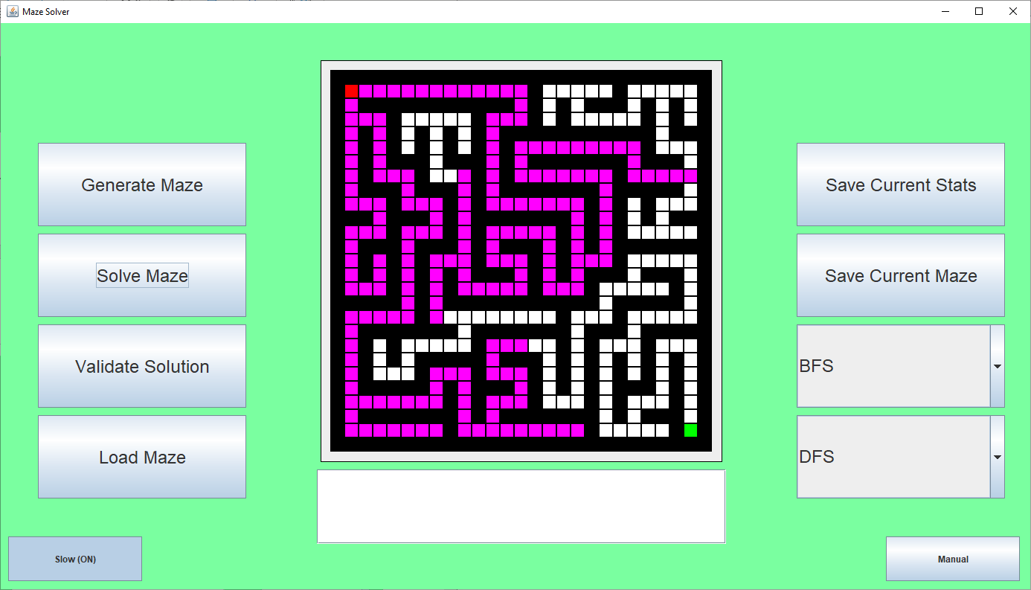

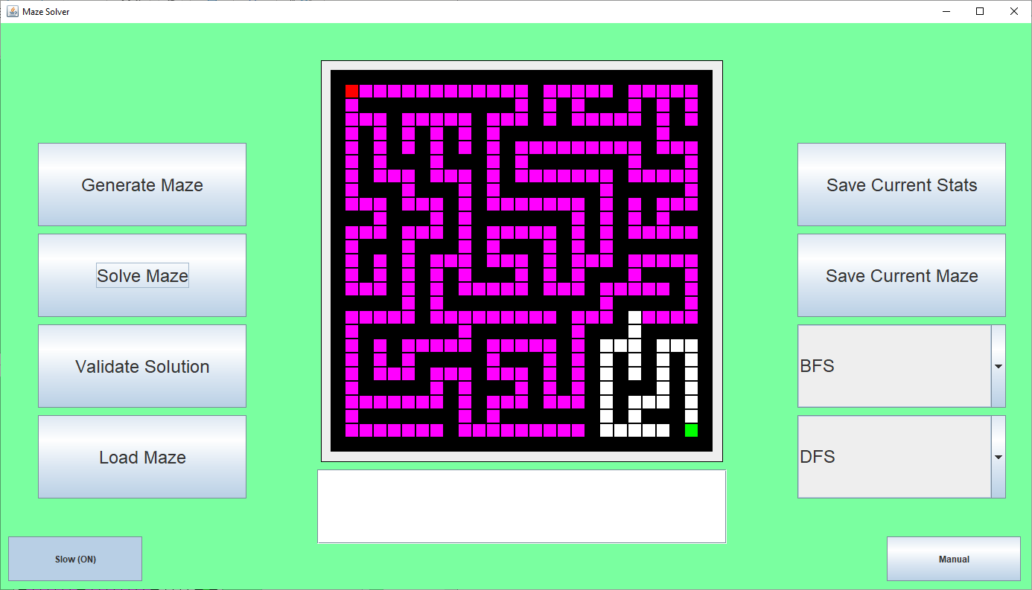

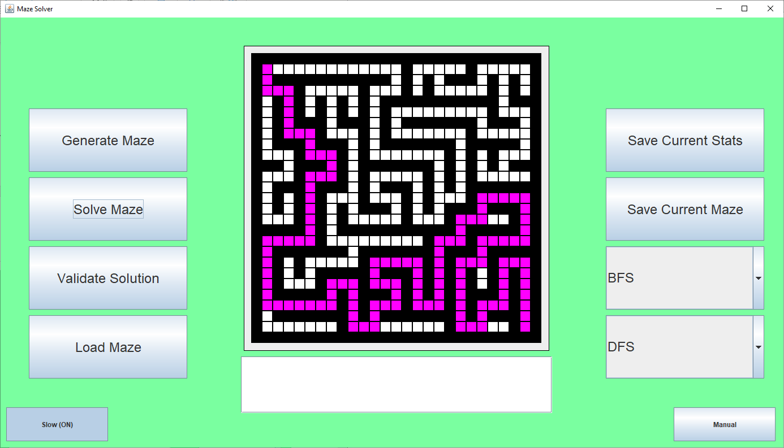

Then generating another maze after this with prims produces the following:

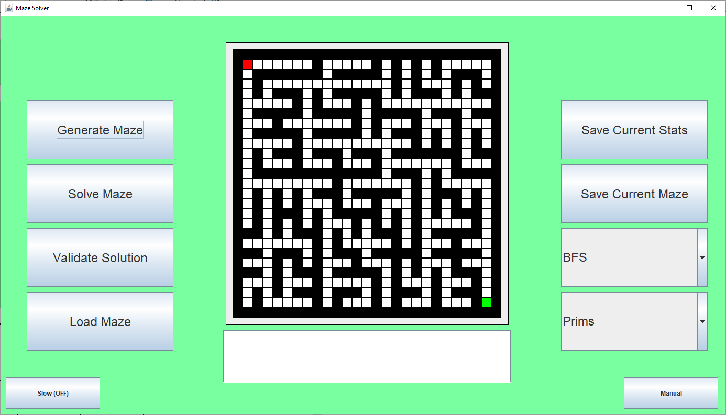

Which is successfully generated.

### Testing

#### Test Table

|  |  |  |  |  |  |
| --- | --- | --- | --- | --- | --- |
| Test # | Test Type | Test Data | Expected | Actual | Success (?) |
| 1 | Normal | Use the recursive maze solver algorithm to solve the maze | The maze should be solved with no errors presented | The maze is solved, and no errors are presented | Success |
| 2 | Normal | Use the prims algorithm to generate a maze | A maze should be generated as expected and should contain one possible solution | A maze is not generated, a series of walls are scattered around the matrix and contains generations which cause there to be no valid solutions | Unsuccessful |
| 3 | Normal | Click the manual button and see if the 0th page loads | The 0th page should load as expected with the buttons rendered to the left and the descriptions loaded the left | The 0th page loads as expected with the buttons to the left and the description to the right | Success |
| 4 | Normal | Click the manual button and check to see if each page is generated as expected | The pages should present their respective information | The final page causes error, causing overlap between each page | Unsuccessful |
| 5 | Normal | Click the manual button and check to see if each page is generated as expected | The pages should represent their respective information | The pages are generated as intended with no errors between transitions | Success |
| 6 | Normal | Press the generate maze button when prim’s algorithm is selected | The algorithm should produce a maze which is solvable | The algorithm does not generate an authentic maze, and has possibilitiesss of being unsolvable | Unsuccessful |
| 7 | Normal | Press the generate maze button when prim’s algorithm is selected | The algorithm should produce a maze which is solvable | The algorithm is now generating mazes as expected, and it generates mazes with at least 1 solution | Success |
| 8 | Normal | Select the button to toggle the slow visualisation | The algorithm should display a frame-by-frame animation which shows how prims algorithm works | The algorithm displayed each frame of prims algorithm and was clear what was happening | Success |
| 9 | Normal | Select the button to toggle the slow visualisation | The algorithm should display a frame-by-frame animation which shows how the DFS algorithm works | The algorithm displayed each frame of the DFS algorithm and was clear what was happening | Success |

### Evaluation

In this section, I designed more algorithms which can be used to interface with the maze environment such as a recursive maze solver and I used prim’s algorithm to generate more mazes. I was having various issues when initially implementing prim’s algorithm, but the outcome does not differ as much from the pseudocode originally created. I added the manual which will give users of the software a brief introduction of the components within the software, what they do and how to use them, as well as informing the user on less obvious notations such as the maze solution syntax which allows users to enter custom solutions.

This is the final cycle of development and is the end of the development phase of this project, the final thing is to perform final tests and improvements before consolidating that the software is in fact finished.

# Bibliography

1. Hybesis Urna. (2019). *Maze generations: Algorithms and Visualizations.* Available: https://medium.com/analytics-vidhya/maze-generations-algorithms-and-visualizations-9f5e88a3ae37. Last accessed 21st May 2021.
2. Anon. (2021). *Binary Tree | Set 1 (Introduction).* Available: https://www.geeksforgeeks.org/binary-tree-set-1-introduction/. Last accessed 21st May 2021.
3. Sunjay Varma. (2016). *Visualizing Maze Generation.* Available: https://sunjay.dev/2016/06/30/visualizing-maze-generation. Last accessed 21st May 2021.
4. Anon. (2021). *Maze Generator.* Available: http://www.mazegenerator.net/. Last accessed 26th May 2021.
5. Anon. (2021). *Think Labyrinth: Maze Algorithms.* Available: http://www.astrolog.org/labyrnth/algrithm.htm. Last accessed 26th May 2021.
6. Anon. (2021). *Think Labyrinth: Maze Psychology.* Available: http://www.astrolog.org/labyrnth/psych.htm. Last accessed 26th May 2021.
7. xefer. (2021). *Maze Generator.* Available: https://xefer.com/maze-generator?odnfomjfllndjodgodg. Last accessed 28th May 2021.
8. Anon. (2021). *Huffman encoding.* Available: http://homes.sice.indiana.edu/yye/lab/teaching/spring2014-C343/huffman.php. Last accessed 28th May 2021.
9. zeiss. (2021). *Design Principles Reloaded: 13 Important Usability Principles.* Available: https://blogs.zeiss.com/digital-innovation/en/13-important-usability-principles/. Last accessed 30th Jun 2021.
10. Anon. (August 27, 2021). *Java Graph Tutorial - How to Implement The Graph Data Structure.* Available: https://www.softwaretestinghelp.com/java-graph-tutorial/. Last accessed 20th September 2021.
11. Anon. (19 Feb, 2021). *Implementing a LinkedList in Java.* Available: https://www.geeksforgeeks.org/implementing-a-linked-list-in-java-using-class/. Last accessed 20th September 2021.
12. Anon. (2012). *swing - How to present a simple alert message in java.* Available: https://stackoverflow.com/questions/9119481/how-to-present-a-simple-alert-message-in-java. Last accessed 12th November 2021.
13. Anon. (2021). *Count number of ways to reach destination in a Maze with BFS.* Available: https://www.geeksforgeeks.org/count-number-of-ways-to-reach-destination-in-a-maze-using-bfs/. Last accessed 19th November 2021.
14. Oracle. (2021). *Class JFileChooser.* Available: https://docs.oracle.com/javase/7/docs/api/javax/swing/JFileChooser.html. Last accessed 22nd Nov 2021.
15. Anon. (2021). *How to automatically break the text of a JLabel.* Available: https://www.generacodice.com/en/articolo/2181041/how-to-automatically-break-the-text-of-a-jlabel-with-8230-when-it-gets-too-long-with-miglayout. Last accessed 28th Nov 2021.